Brewing Research Topic

2017314712 김우진

1. Pick an area in HCI that you are interested. Briefly describe the area you picked.

I am interested in change of people’s perception or behavior because of other lives in house. For example: like dogs, fish, plants etc.

2. Based on the area you pick, formalize a specific research question in Human Computer Interaction.

Are appearance of indoor plants effect on people’s behavior or people’s perception.

3. Further narrow down your research hypothesis, and try to narrow it down to some independent variable(s).

Will the appearance of indoor plants effect on people's perceptions.

IV: indoor plants -> number of plants, shape of plants, color of plants

4. Specify your research question into a testable hypothesis, with measurable dependent variable(s).

Will the appearance of indoor plants effect on people's perceptions of subjective well-being.

DV: people’s perception on subjective well being

5. Design your experiment based on within or between subject design.

1) Prepare plants many kinds of plants ex)

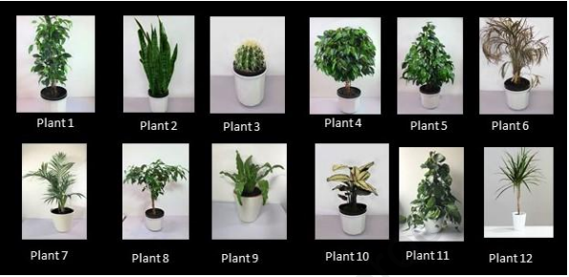

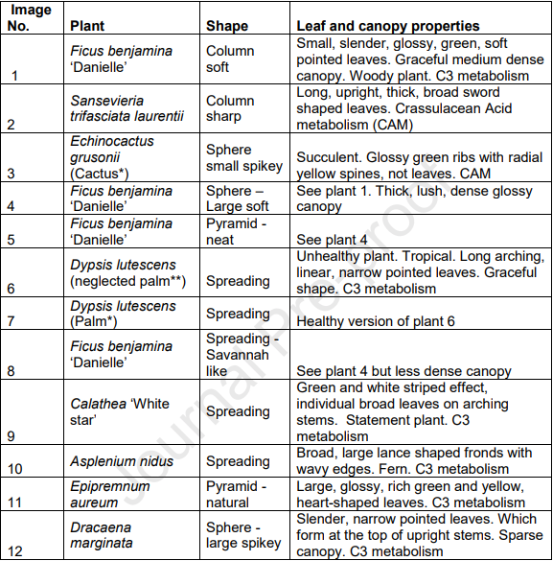

2) Participants are chosen randomly

3) Get responses from participants for 2month period

4) Check mean scores for Beauty, Interesting, Soft, Relaxing and Depressing

6. Try to perform an initial literature search on academic database such as PyscInfo and ScienceDirect.

I found a literature about this topic at ScienceDirect

<https://www.sciencedirect.com/science/article/pii/S0360132322003882>

7. Based on your literature search, is your research question being explored previously by other scientists?

It was explored by other scientists. In the literature it says the findings show that the physical appearance of the plant had a significant impact on participants’ responses, their aesthetic preference and the perceived benefit of the plant for subjective well-being, indoor air quality and humidity.