Java programming assignment4

2017314712

3.5 What’s the purpose of keyword new? Explain what happens when you use it.

Keyword new creates a new object of the specified class. For example: we have a class Customer. To create a instance of class Customer, we have to write- Customer customer=new Customer();

3.6 What is a default constructor? How are an object’s instance variables initialized if a class has only a default constructor?

Default constructor is a method defined in class which is called as an when the instance of class is created. Instance variables of a class are assigned default values in the default constructor.

3.10 Explain why a class might provide a set method and a get method for an instance variable.

Instance variables are declared private in a class. To assign or change the values of this instance variables of a class getMethod() and setMethod() are required in a class.

3.11 Modify class GradeBook (Fig. 3.10) as follows:

a) Include a String instance variable that represents the name of the course’s instructor.

b) Provide a set method to change the instructor’s name and a get method to retrieve it.

c) Modify the constructor to specify two parameters—one for the course name and one for the instructor’s name.

d) Modify method displayMessage to output the welcome message and course name, followed by "This course is presented by: " and the instructor’s name.

Use your modified class in a test application that demonstrates the class’s new capabilities.

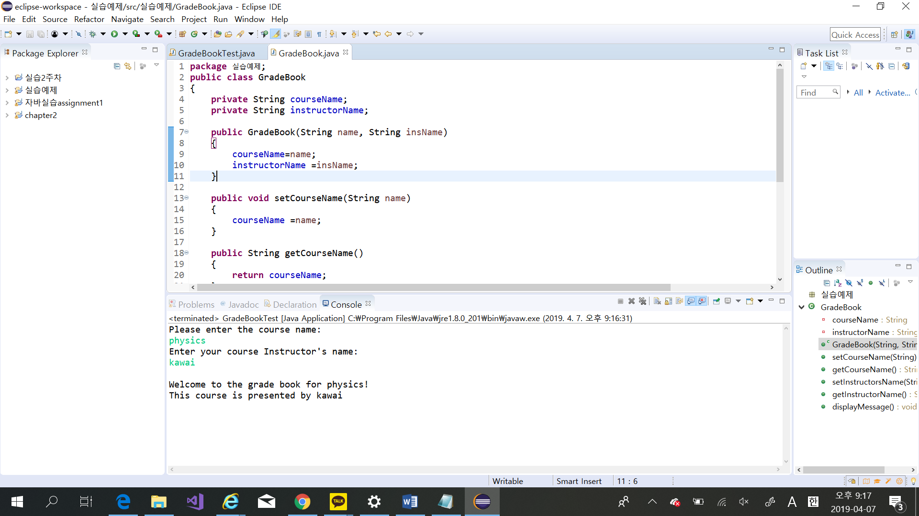

(2)코드

**package** 실습예제;

**import** java.util.Scanner;

**public** **class** GradeBookTest {

**public** **static** **void** main(String[] args) {

Scanner input = **new** Scanner(System.***in***);

GradeBook myGradeBook=**new** GradeBook("Course Name","Instructor's name");

System.***out***.println("Please enter the course name: ");

String name=input.nextLine();

myGradeBook.setCourseName(name);

System.***out***.println("Enter your course Instructor's name: ");

String insName=input.nextLine();

myGradeBook.setInstructorsName(insName);

System.***out***.println();

myGradeBook.displayMessage();

}

}

**package** 실습예제;

**public** **class** GradeBook

{

**private** String courseName;

**private** String instructorName;

**public** GradeBook(String name, String insName)

{

courseName=name;

instructorName =insName;

}

**public** **void** setCourseName(String name)

{

courseName =name;

}

**public** String getCourseName()

{

**return** courseName;

}

**public** **void** setInstructorsName(String insName)

{

instructorName=insName;

}

**public** String getInstructorName()

{

**return** instructorName;

}

**public** **void** displayMessage()

{

System.***out***.printf("Welcome to the grade book for %s!\nThis course is presented by %s\n", getCourseName(),getInstructorName());

}

}

3.13 Create a class called Invoice that a hardware store might use to represent an invoice for an item sold at the store. An Invoice should include four pieces of information as instance variables—a part number (type String), a part description (type String), a quantity of the item being purchased(type int)and a price per item(double).Your class should have a constructor that initializes the four instance variables. Provide a set and a get method for each instance variable. In addition, provide a method named get Invoice Amount that calculates the invoice amount (i.e., multiplies the quantity by the price per item), then returns the amount as a double value. If the quantity is not positive, it should be set to 0. If the price per item is not positive, it should be set to 0.0. Write a test application named Invoice Test that demonstrates class Invoice’s capabilities.

public class Ex03_13 {

    private String partNumber;

    private String partDescription;

    private int quantityOfItemPurchased;

    private double pricePerItem;

    public Ex03_13 (String number, String description, int quantity, double price) {

        partNumber = number;

        partDescription = description;

        quantityOfItemPurchased = quantity;

        pricePerItem = price;

    }

    public void setPartNumber (String number) {

        partNumber = number;

    }

    public String getPartNumber () {

        return partNumber;

    }

    public void setPartDescription (String description) {

        partDescription = description;

    }

    public String getPartDescription () {

        return partDescription;

    }

    public void setQuantityOfItemPurchased (int quantity) {

        quantityOfItemPurchased = quantity;

    }

    public int getQuantityOfItemPurchased () {

        return quantityOfItemPurchased;

    }

    public void setPricePerItem (double price) {

        pricePerItem = price;

    }

    public double getPricePerItem () {

        return pricePerItem;

    }

    public double getInvoiceAmount () {

        double calculateTotalAmount;

        calculateTotalAmount = quantityOfItemPurchased * pricePerItem;

        return calculateTotalAmount;

    }

 }

import java.util.Scanner;

public class Ex03_13_Test {

    public static void main (String [] args) {

 Ex03_13 invoice = new Ex03_13 (" ", " ", 0, 0.0);

 Scanner input = new Scanner (System.in);

        String item;

        String description;

        int quantity;

        double price;

        System.out.print ("Enter Number: ");

        item = input.nextLine();

        invoice.setPartNumber(item);

        System.out.print ("Enter Description of Item Purchased: ");

        description = input.nextLine();

        invoice.setPartDescription(description);

        System.out.print ("Enter The Quantity of Item Purchased: ");

        quantity = input.nextInt();

 if (quantity > 0)

        invoice.setQuantityOfItemPurchased(quantity);

        System.out.print ("Enter The Price Per Item: ");

        price = input.nextDouble();

 if (price > 0)

        invoice.setPricePerItem (price);

        System.out.printf ("The Total Amount for all items purchased = $%.2f\n",

                invoice.getInvoiceAmount());

    }

}