StudentCodes

Install:

Windows:
Copy the StudentCodes\dist\StudentCodes.exe file to whereever you want to put it, run the program.

Other:
In a terminal:
pip requirements.txt
python StudentCodes.py

Bonus: The following will build a single executable for OSX or Linux.
pip install pyinstaller
pyinstaller.exe --onefile --windowed .\StudentCodes.py

Use:

Paste text which includes emails into the top section, and text including codes in the bottom
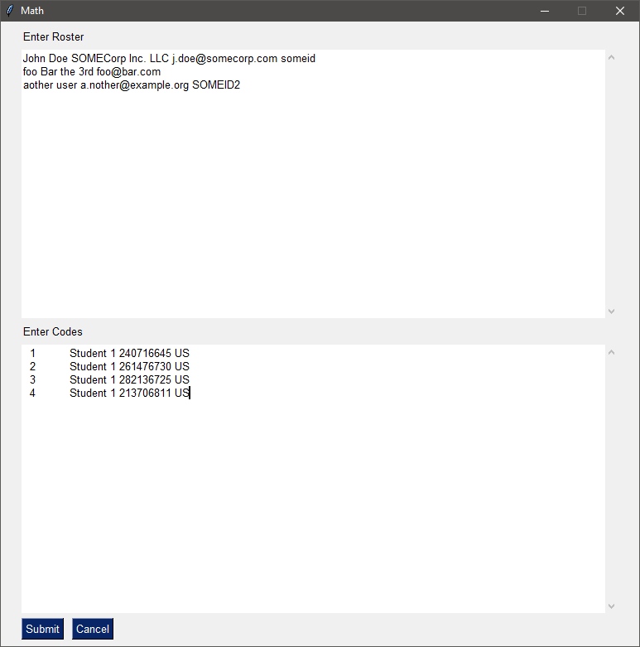
Click submit, and you will have nicely formatted codes you can give your students, or email to them.
