Nicholas Brodsky

Abstract

[Draw your reader in with an engaging abstract. It is typically a short summary of the document.   
When you’re ready to add your content, just click here and start typing.]

PTL – digital datasheet

Documentation

Table of Contents

1 Menu 2

1.1 File 3

1.1.1 New 3

1.1.2 Open 3

1.1.3 Save 3

1.1.4 Exit 3

1.2 Edit 3

1.2.1 Remarks Document (IP) 4

1.2.2 Specification Requirements 4

1.3 View (IP) 4

1.4 Create 4

1.4.1 Hard Copy 4

1.4.2 Test Report 4

2 Form 5

2.1 As Received 5

2.2 After Thermal Stress 5

3 Examination 6

3.1 Structure Title(s) 6

3.2 Recorded Data 7

3.2.1 Coupon Identification 7

3.2.2 Measurements 7

3.2.3 Observations 8

3.3 Requirements 8

3.3.1 Single Measurement Single Requirement 8

3.4 Remarks 8

4 Separate Windows 9

4.1 Open Job 9

4.2 Edit Remarks Document 9

4.3 Edit Specification Requirements 9

4.4 Test Report Structure 9

4.5 Measurement Zoom 9

4.6 Requirement Structure 9

4.7 Remarks Document 9

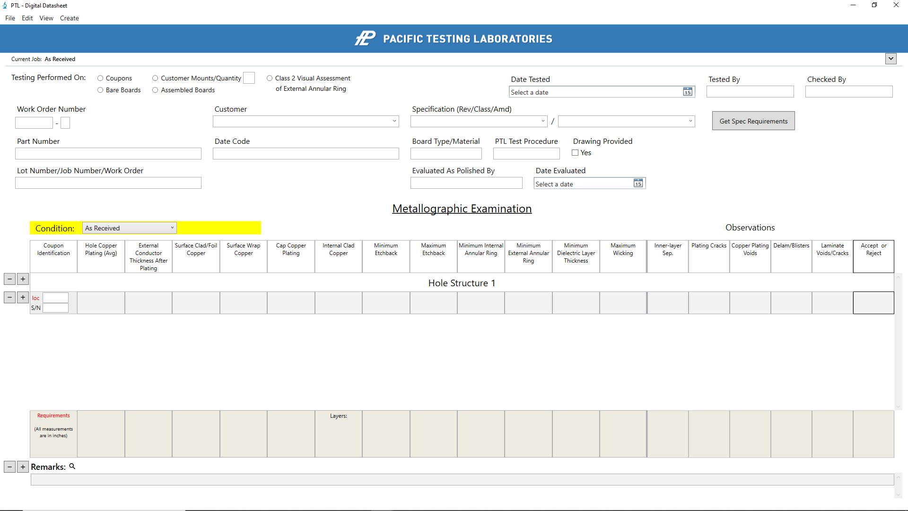PTL Digital Datasheet

# Menu



## File

### New

* Creates a new empty job template window.
  + **New Window**: Opens a new window separate from the current one.
  + **This Window**: Removes all data from current job window to create a blank template.
    - Any unsaved data will be lost!

### Open

* Opens the “Open Job” window to select desired job to open (complete information in 4.1 Open Job section).

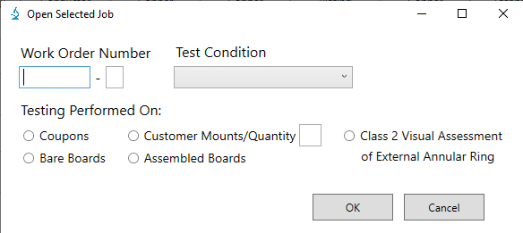

### Save

* Save current job data.

### Exit

* Closes job window.

## Edit

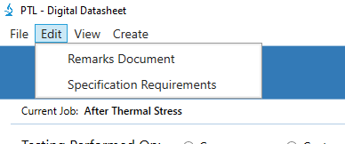

### Remarks Document (IP)

* Opens “Edit Remarks Document” window to update the remarks document.

### Specification Requirements

* Opens “Edit Specification Requirements” window to update the specification requirements (complete information in 4.3 Edit Specification Requirements section).

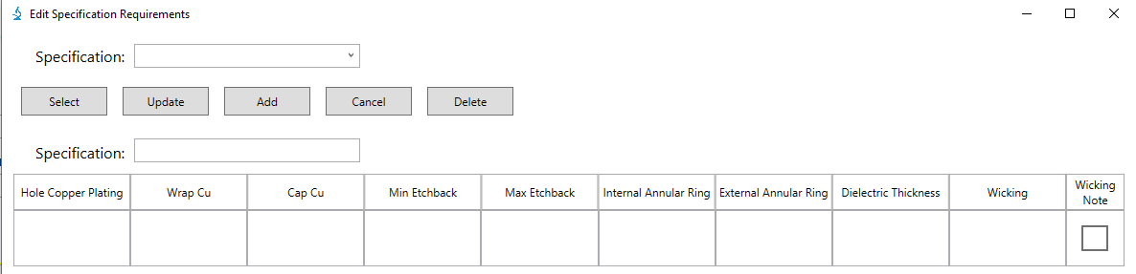

## View (IP)

## Create

### Hard Copy

* Copies and formats current job data into a printable version of the datasheet.

### Test Report

* Copies and formats current job data into final test report (data section only)

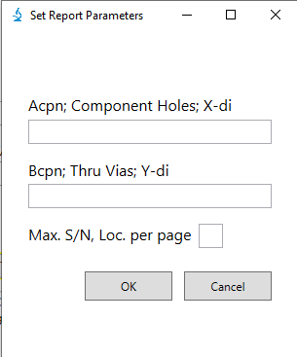

* + If the current job has more than 6 serial numbers or multiple structures, the “Test Report Structure” window will open (complete information in 4.4 Test Report Structure section).
    - User will enter number of serial numbers per page and/or desired structure title format to display on final report.

# Form

## As Received

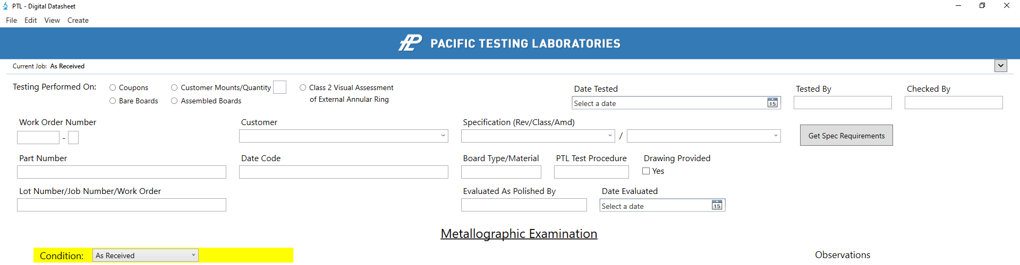

## After Thermal Stress

* Contains same standard form fields as original hard copy datasheet.
* Changing the Test Condition to “After Thermal Stress” will reveal the thermal stress specific additional fields.
* Each job is made unique by three required form fields.
  + Work Order Number, Testing Performed On, & Test Condition.
    - At least these three fields must be filled to be able to save the job.
* “Get Spec Requirements” button:
  + Auto-fill requirements based on given specification(s). Complete details in Requirements section.
* The small arrow button on the top right directly above the form will toggle the form when clicked for more visibility of the measurement/observation section when recording data.
* Top left label above the form displays current job even when form is hidden.
  + Displays: Work Order Number, Testing Performed On, Customer, & Test Condition.
    - Label is updated as these fields are updated.

# Examination

* Main components (top down):
  + Measurement & observation titles, structure title(s), recorded data, requirements, remarks.

## Structure Title(s)

* Replace default “Hole Structure #” with actual structure title.
  + Each structure title must be unique (no duplicates).
* Required format:
  + ex: B1cpn; Blind Vias; #1-3, 4-6; X-di
  + Each section of the complete structure title must be separated with a semicolon ‘;’.
  + Second part of the structure title must be the type of hole.
    - As in the previous example: Blind Vias
      * This is needed to corelate specific requirements to set structures (more info in requirement section).
* The two buttons, ‘minus’ and ‘plus’, are to add/remove structure titles from the recorded data section. Only the top structure title has the buttons.
  + Clicking the add button will add and new structure section underneath the last row of the currently last structure section followed by one blank row for recorded data.
  + Clicking the remove button removes sections from the bottom up.
    - **NOTE**: This will completely (irreversibly) remove the currently last structure section along with any recorded data for that section with it.
* If there are multiple structures, you can add as many sections as needed, enter all the serial numbers and locations for the first one, right click the structure title add button and select “Set to each structure.”
  + This will duplicate the complete section for the first structure and auto generate and auto fill the remaining structure sections to match the first.
  + You will be prompted with a warning question about continuing.
    - If you select ‘Yes’ the process will continue, if you select ‘No’ you will return as you were.
      * **NOTE**: Selecting ‘Yes’ will overwrite any recorded data you have outside of the first structure section.

## Recorded Data

* Contains (left to right) add/remove buttons, coupon identification, measurement section, and observation section.

### Coupon Identification

* This first field (furthest left) in each recorded data row.
* Contains fields for serial number and location.
  + Each row must contain at least a serial number.
* Within each unique structure section, you cannot have any duplicate serial number and location combinations.

### Measurements

* Each measurement textbox has auto-formatting properties (take affect when clicking the mouse outside of the textbox):
  + If you enter invalid text (i.e., random letters) it will create a red border.
  + Simply entering a whole number will place the decimal four places to the left for the standard entry.
    - To avoid this, entering the number as a decimal manually will allow you to determine the exact output you want to however many decimal places.
  + The background color will be set to the basic row color or yellow based on an accept/reject parameter set by the corelated requirement (same column).
* By right clicking a field, you will see a menu of selections.
  + Normal Background & Yellow Background are the first two.
    - Allows you to manually set the background if you need to avoid the autoformatting set by the specific requirement.
  + Add/Remove Note:
    - This allows you to toggle a small textbox in the upper-right corner of the measurement textbox to add any notes.
  + Zoom (further detail in ‘Measurement Zoom’ section):
    - Creates a magnified set of measurement fields matching the row the menu item is selected in.
* To separate multiple measurements within the same field, use the ‘Enter’ key.
* Adding ‘N/A’ or ‘*’ to any measurement will automatically add that same value to every empty textbox in that same column and within that same structure section.

### Observations

* Each observation textbox has auto-formatting properties (take effect when changing the text within the textbox):
  + The way they format are split between the individual observation fields and the ‘Accept/Reject’ field.
  + The individual observation fields can contain: ‘?’, ‘*’, ‘A’, and ‘R’.
    - When setting any of these fields to R, the ‘Accept/Reject’ field for this row will also be set to R and the background color of both textboxes will be set to yellow.
  + The ‘Accept/Reject’ field can contain: ‘?’, ‘*’, ‘A’, ‘A*’, and ‘R’.
    - When setting this field to A, every individual observation field within the same row will also be automatically set to A.
    - When setting this field to R, the background color of this textbox will be set to yellow.

## Requirements

* While the specific requirements are added directly into each requirement textbox, there are general formats along with six specific formats in which they need to be entered in order to accurately corelate with the associated measurement field and correctly register a pass or fail.
* When right-clicking a requirement textbox, you will have a menu with two options.
  + **Set to Structure**: ‘Requirement Structure’ window will open allowing you to set the current requirement based on provided structures (complete information in 3.3.6 Structure Requirement section).
  + **Combine/Separate Requirements**: This either combines the selected requirement with the one to its immediate right or divides it, depending on its current state (complete information in 3.3.7 Double Column Requirement section).

### General Requirement Format

* To be able to register a pass/fail with the associated measurement, the requirement must have at least one decimal number (less than 1) and either a ‘min’ or a ‘max’ to make the correct comparison to the measurement.
* When needing additional requirements within the same textbox, use the ‘Enter’ key to separate requirements.
  + NOTE: Do not use the ‘Enter’ key to simply move to the next line. Any text on its own line will be treated as an individual requirement.

### Single Measurement Single Requirement

* With one measurement and one requirement, the measurement will be evaluated to the requirement in the same column based on the decimal value and min or max setting.

### Single Measurement Double Requirement

* With one measurement and two requirements, the measurement will be evaluated to each requirement (separated with the ‘Enter’ key) individually.
  + If the measurement fails from either requirement it is considered a reject.

### Double Measurement Single Requirement

* Here, both measurements (separated with the ‘Enter’ key) will be evaluated to the requirement.
  + If either measurement fails it is considered a reject.

### Double Measurement Double Requirement

* With two measurements and two requirements, each measurement will be evaluated individually to the requirement matching the line the measurement is on.
  + If either measurement fails it is considered a reject.

### Structure Requirement

* For a measurement to be evaluated by the correct requirement based on its hole structure, the requirement must be preceded by the hole structure(s) matching each structure section.
  + You can do this manually by typing the structure exactly as it is written in the second part of the structure title section, followed by a colon and then the requirement.
  + You may also have the format set automatically by right clicking the requirement textbox, selecting “Set to Structure” and filling out the values in the pop-up window. Which ever method you choose, the format of the requirement will be the same and must match for any associated measurements to be evaluated correctly.

After opening structure requirement window, enter requirement for each listed structure.

Completed structure requirement format.

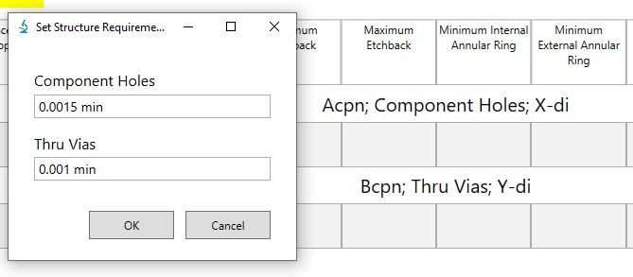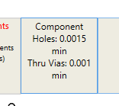

### Double Column Requirement

* To stretch a requirement over a span of two columns, right click the requirement textbox and select “Combine/Separate Requirement” to toggle from one column or two based on current state.

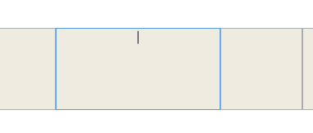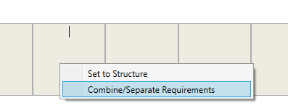

* + To combine two requirement columns, right click the left requirement and select the option (the requirements are merged from left to right).
  + To separate, right click the current two-span column and select the option causing the requirement to split into its normal state.
* When the two columns are combined, the format of the written requirement remains the same, but will be compared to the addition of the two measurements over which the column spans.

### Auto-Fill Requirements

* In the form, next to the specification entries, the button “Get Spec Requirements” enables you to auto-fill your requirements based on the specifications selected.
  + When you click the button, any requirements you have available (currently empty) will initially be filled with the requirements from the first specification entered. If there are any requirements still available (currently empty), they will then be filled by the second specification entered (if a second one was given).
* To use the auto-fill functionality, the specification must be selected from the dropdown items given and the first specification must be given. Even if there is only one specification provided from the job, it must be entered into the datasheet in the first entry.
* NOTE: Some of the requirements provided by the specifications have multiple options, therefore the full set of possible values will be given leaving it to the user to decern between them and keep only what is necessary. If there are any updates you would like to make with the requirements given, or any specifications that need to be added, this can be done using the “Edit Specification Requirements” window (complete information in 4.3 Edit Specification Requirements section).

## Remarks

* The Remarks section contains add/remove buttons, a search icon, and however many needed fields for entering the remarks (none initially).
* To add a remark to the current job, the add button will create an empty textbox directly after the current last one to enter your remark.
  + After adding a remark, you must enter some text in order to be able to add a new remark (if the last remark is still empty, the add button will not do anything).
* To remove a remark, click the remove button.
  + This will delete the last remark available.
* Clicking on the search icon will open the “Remarks Document” window (Complete details in Remarks Document section).
  + This allows you to use the remarks documentation to autofill the next available remark with some entry in the document.

# Separate Windows

## Open Job

* This window provides the three sections you must input in order to find and open a previous job. Each section must be filled in order to find the job and if there is a match, next to the “Ok” button, you will see a green checkmark, otherwise you will see a red X.

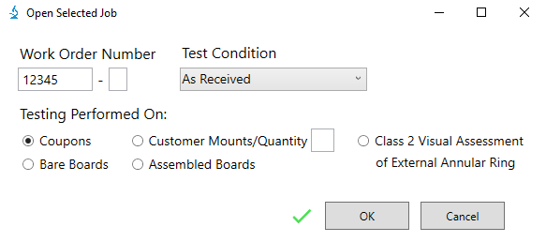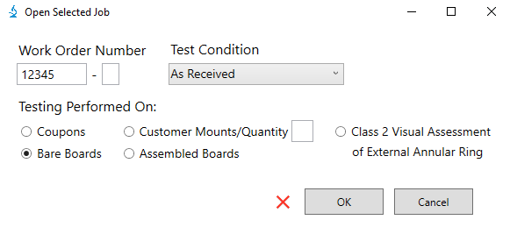

Open Job window when the input values are a match for a previously saved job.

Open Job window when input values are not a match for a previously saved job.

* When you click the “OK” button, all the data, from the job you selected from the most recent save will be entered into the datasheet looking just as it did during that last save. Selecting the “Cancel” button will close this window and return you to the datasheet as if nothing happened.

## Edit Remarks Document

* In Progress

## Edit Specification Requirements

* 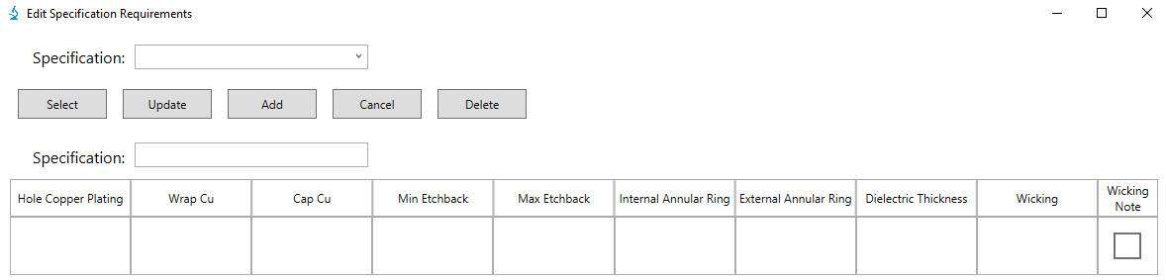This window allows you to update, add, or remove any of the provided specifications and their associated requirements.
* After you have made some edit to any specification, you will be notified if the operation completed successfully, or if there was any issue during the process.

### Update Specification

* To update a given spec, use the “Specification” dropdown to find and choose your desired spec to update and click the “Select” button.
* This will add the spec to the “Specification” textbox and any associated requirements will be added directly underneath to the appropriate requirement textbox.
* You can edit the text within any of populated requirements or add a new requirement to an empty textbox. When you are satisfied with your changes click the “Update” button and your changes will be saved.

### Add Specification

* To add a new spec, type the name of the specification in the “Specification” textbox, add in any requirements where appropriate, and click the “Add” button.

### Delete Specification

* To remove a given spec, use the “Specification” dropdown to find and choose your desired spec to remove and click the “Delete” button.

## Test Report Structure

* Once you have finished the examination and the datasheet is complete, you can then transfer and format the data into the final test report. If the current job contains only one structure and is six serial number or less, the data from the job will be structured into the test report automatically; however, if there are multiple structures or more than six serial numbers, the “Test Report Structure” window will open, and you must enter the information to set how the data will be structured.
* 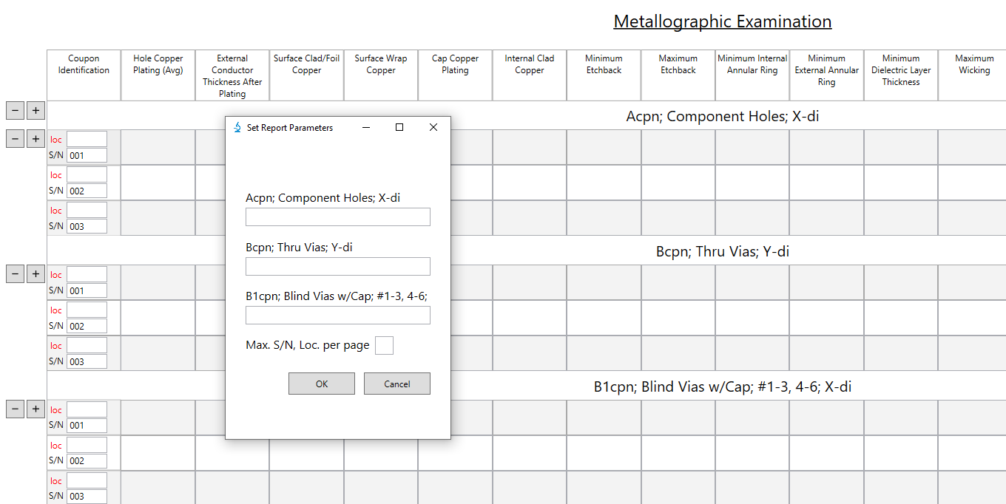In this example there are three unique structures and three serial numbers. When the “Test Report Structure” window opens, you will see a list of available structures with textboxes directly underneath each one and a textbox for the number of serial numbers/locations to add per page on the test report.
  + The value you give in the textbox for each structure is exactly how it will be labeled on the test report.
  + The number entered for serial number/location per page will be how the data is split up on the test report.
    - NOTE: This number is NOT lines of measurements for each page in the test report. Because on the test report the data for each structure is grouped by its serial number/location, every unique serial number/location will have as many rows to it as there are structures. In this example, each serial number will have three rows, so entering ‘1’ in the textbox would display three rows of measurements.

## Measurement Zoom

## Requirement Structure

## Remarks Document