Battery System Control Unit

|  |  |  |  |  |
| --- | --- | --- | --- | --- |
| Document ID: | Some ID | Current version: | 0 | |
| Issue Date: | DD/MM/YYYY |  |  | |
|  | | | | |
| Prepared By: | Approved By: | | | |
| AUTHOR | REVIEWER | | | |
| Version History | | | | |
|  | Date | Version | Comments |  |
|  |  |  |  |  |
|  |  |  |  |  |
|  |  |  |  |  |
|  |  |  |  |  |
|  |  |  |  |  |
|  |  |  |  |  |
| Printed copies of this document are uncontrolled and may not be the latest version | | | | |
|  | | | | |
| Copyright and Legal Notices | | | | |

# Overview

*General need and purpose, overall description, Constraints, Assumptions.*

This battery system control unit is for the purpose of managing a battery system in order to use it for system balancing, ancillary services and other commercial programmes. The unit will be installed alongside the battery and will control various aspects of it's running, including switching between charge states, maintaining optimum state of charge and managing the system within key operating parameters such as temperature, current and voltage constraints.

# Functional Requirements

*What does it need to do? What are its function and components?*

* Monitor DC Voltage
* Monitor DC Current
* Monitor AC Voltage
* Monitor AC Current
* Measure and monitor the State of Charge of the Cells
* Measure and monitor the temperature of the Cells
* Switch the battery system to charge, discharge and to a resting state
* Switch between states if temperature parameters are breached

## Performance, Availability, Scalability, Extensibility

*How well does it have to do these things? How critical is it?*

* This system is for a single phase set-up in this current version
* It must switch off if high temperatures are reached
* It should fail safe: i.e. turn off the battery charging if it fails
* it should restart itself if the network connection is lost
* It should be resilient to attack from the open web

# Architecture

*System, Logical & Process / Service Orientation, Physical, Hardware & Software, Communications, Security*

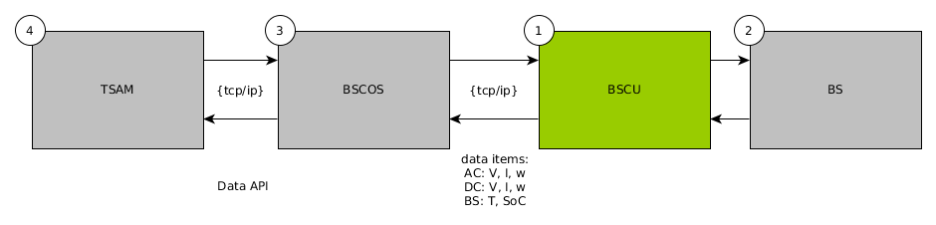

Figure 1: Wider System Diagram

1: The Battery System Control Unit

2: Battery System

3: Battery System Control & Optimisation Server

4: External 3rd Party Server e.g. Tempus Smart Aggregation Manager

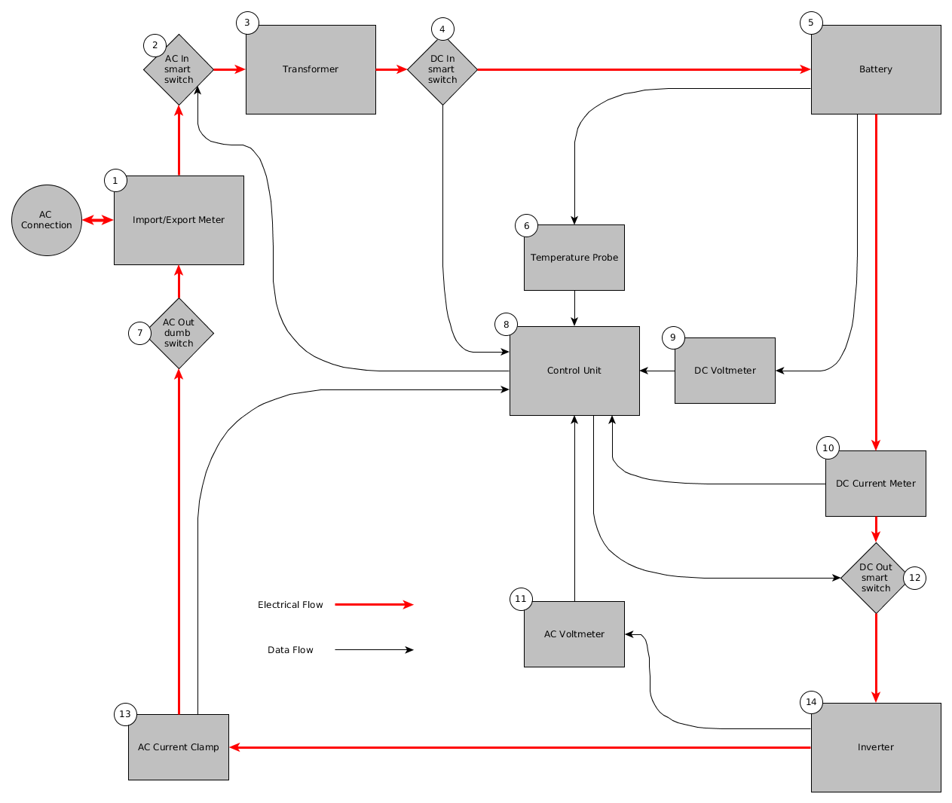

Figure 2: Battery System Physical Diagram

1. Import Export Meter

2. AC In Smart Switch

3. Transformer

4. DC Input Smart Switch

5. Battery

6. Temperature Probe

7. AC Out Dumb Switch

8. Control Unit Core

9. DC Volt meter

10. DC Current Meter

11. AC Voltmeter

12. DC Out Smart Switch

13. AC Current Clamp

14. Inverter

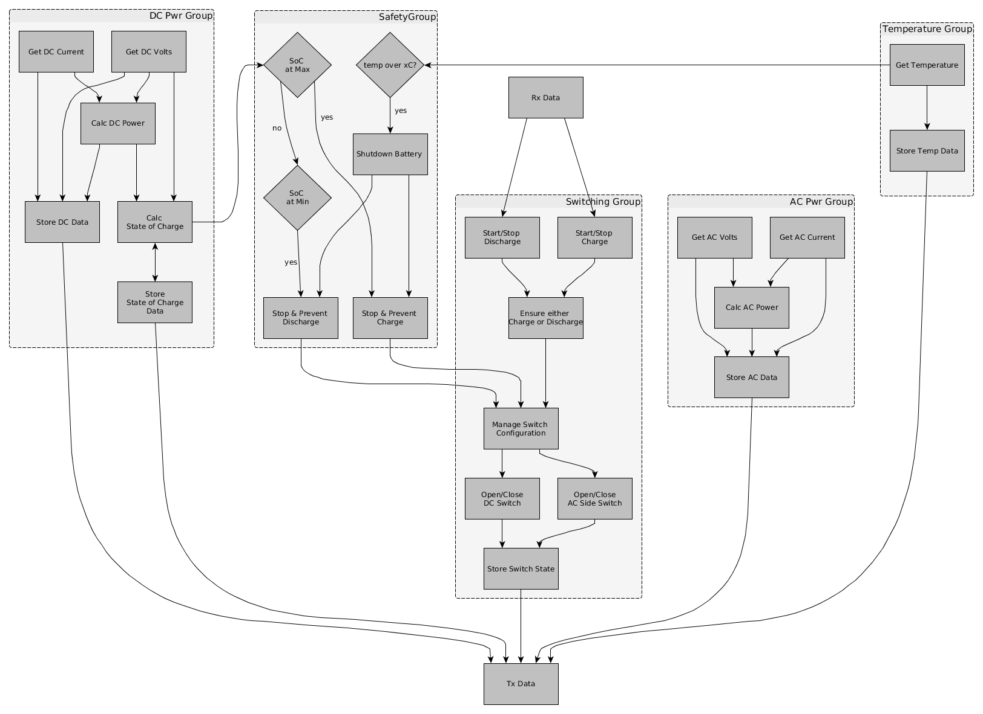

Figure 3: Battery System Control Unit Logic Diagram

This logic forms the basis for the firmware of the BSCU.

## Interfaces

*Human, Machine*

The system will be interfaced to via an API for m2m communications: BSCU to BSCOS

The system will be interfaced to via a web page for human access from the BSCOS

# User scenarios

*Who does what, when? Use cases, specific edge cases?*

The key user scenarios are based around switching the battery system to provide services to the grid and to the owner operator. The signals are provided by the control and optimisation server.

This system needs only to respond to the signals and to ensure that safety criteria are met.

# Data Models

*What data items are required to be created, managed & stored?*

The data items for the BSCU are:

# Development Strategy

*Development scope & approach, partners, assurance, testing*

# Annex 1 – Related Technical Documentation