Nicholas,

The correct answer is given for the following problems from the formative assessment. Please go ahead and figure out what you did wrong. Try to do the whole problem over and justify the correct answer.

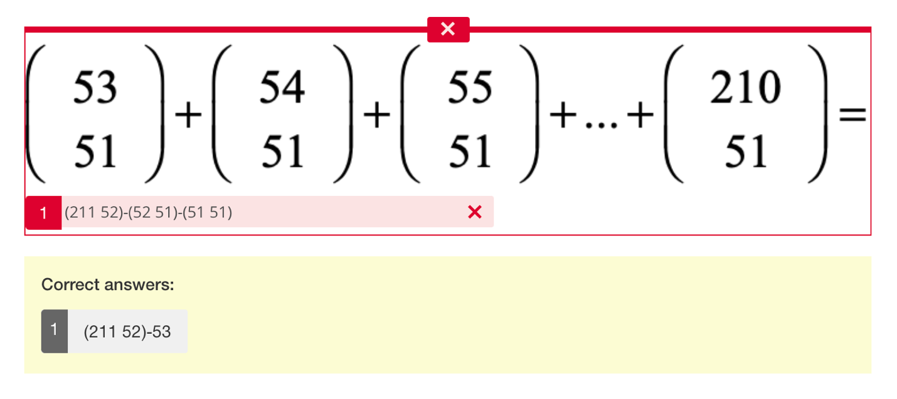

Nice Job on the free response