Introduction
Modern legal work involves substantially more than simple document retrieval or text generation. Human attorneys operate through a layered analytical process that includes identifying document types, extracting relevant entities, recognizing legal concepts, mapping doctrinal relationships, retrieving applicable precedent, answering legal questions, and ultimately producing structured legal documents for review. While existing Large Language Models (LLMs) demonstrate strong general-language capabilities, their effectiveness in higher-order legal reasoning tasks remains an open research question.
This research proposes a structured framework for evaluating legal AI systems through a sequence of progressively complex legal tasks designed to mirror real-world legal workflows. Rather than treating legal reasoning as a single monolithic capability, this framework decomposes legal cognition into measurable subtasks that range from low-level extraction to higher-level doctrinal reasoning and legal drafting. The proposed experimental structure evaluates whether SaulLM can identify legal entities, recognize abstract legal concepts, understand relationships between concepts and doctrine, retrieve relevant precedent, answer context-grounded legal questions, and generate coherent legal documents.
The primary goal of this research is to evaluate whether specialized legal language models can move beyond surface-level language prediction toward structured legal understanding. Additionally, this framework establishes a foundation for future work involving Large Concept Models (LCMs), legal ontologies, and graph-based representations of legal knowledge.

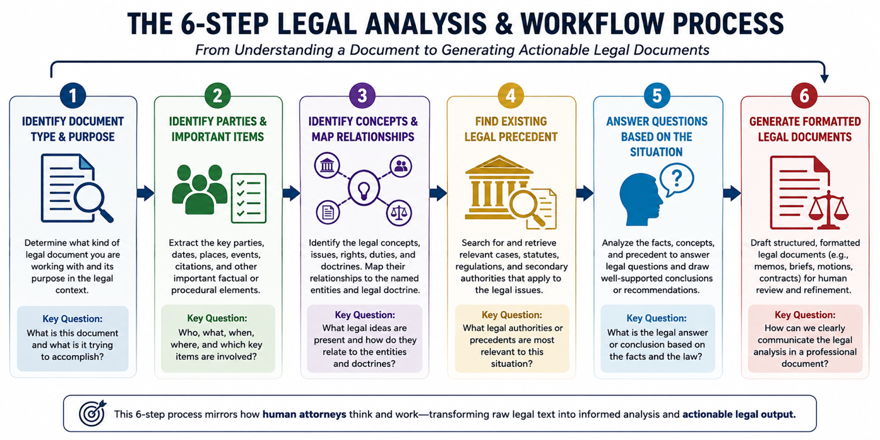

Experimental Framework

1. Legal Text Classification (LTC)
This experiment evaluates SaulLM’s ability to classify legal documents into structured legal categories. Legal practice depends heavily on recognizing the type and purpose of a document before substantive analysis can begin. The model will be tested on its ability to identify legal domains, clause types, procedural filings, and doctrinal categories using datasets such as LEDGAR and LexGLUE.
The primary research question is whether SaulLM understands structured legal taxonomies and whether it can distinguish between legally similar but functionally distinct categories. This task serves as the foundational stage of legal analysis because proper classification informs downstream reasoning and retrieval tasks. Strong performance would suggest that the model can organize legal information into meaningful conceptual structures rather than relying solely on statistical language patterns.

2. Named Entity Recognition (NER)
This experiment evaluates SaulLM’s ability to identify and extract legally relevant entities from unstructured legal text. Examples include parties, judges, courts, statutes, dates, legal citations, and procedural references. The task measures the model’s token-level and span-level understanding of legal terminology and document structure.
The primary research question is whether SaulLM can reliably isolate critical legal information from complex legal language. In legal workflows, accurate extraction is essential because downstream tasks such as precedent retrieval and legal reasoning depend on the accurate identification of entities and references. This experiment also evaluates whether the model recognizes legal language patterns that differ significantly from general-domain NLP tasks.

3A. Legal Concept Identification (LCI)
This proposed task evaluates SaulLM’s ability to identify abstract legal concepts within legal text. Unlike NER, which focuses on explicit entities, LCI focuses on identifying doctrinal ideas such as negligence, intent, causation, fiduciary duty, standing, or procedural fairness.
The primary research question is whether SaulLM can recognize legal meaning beyond surface-level terminology. Legal concepts are often implied rather than explicitly stated, making this task substantially more difficult than traditional extraction. Successful performance would suggest that the model possesses some degree of conceptual legal understanding and can identify doctrinal themes embedded within factual narratives and legal arguments.

3B. Legal Concept Relation Mapping (LCRM)
This proposed task evaluates SaulLM’s ability to map relationships between legal entities, concepts, facts, and doctrines. The experiment focuses on whether the model can connect legal actors and events to the doctrines, duties, rights, and procedural structures that govern them.
The primary research question is whether SaulLM understands how legal concepts interact within a broader legal framework. Rather than simply recognizing isolated concepts, the model must identify relational structures such as causation, liability, contractual obligations, procedural dependencies, or constitutional conflicts. This task represents an intermediate step between extraction and higher-order legal reasoning and closely aligns with the development of graph-based legal ontologies and Large Concept Models.

4. Legal Precedent Retrieval (LPR)
This proposed task evaluates SaulLM’s ability to retrieve legally relevant precedent based on factual scenarios, legal questions, or doctrinal issues. Given a legal dispute or issue, the model must identify cases, statutes, or authorities that are most relevant to the presented situation.
The primary research question is whether SaulLM understands legal similarity and doctrinal relevance. Attorneys rarely search for identical factual situations; instead, they search for analogous reasoning and applicable authority. This experiment therefore tests whether the model can perform semantic legal retrieval rather than keyword matching alone. The task also evaluates whether the model can distinguish between highly relevant precedent and superficially similar but legally irrelevant cases.

5. Legal Question Answering (LQA)
This experiment evaluates SaulLM’s ability to answer legal questions grounded in legal text, factual scenarios, and retrieved authorities. The model will be tested on its ability to synthesize information and generate legally coherent responses while minimizing hallucination.
The primary research question is whether SaulLM can produce accurate legal reasoning supported by the provided legal context. Unlike general-domain QA systems, legal question answering requires the integration of doctrine, precedent, procedural context, and factual interpretation. This experiment measures whether the model can reason within legal constraints rather than merely generating plausible language outputs.

6. Legal Document Generation (LDG)
This experiment evaluates SaulLM’s ability to generate structured legal documents for human review. Examples include legal memoranda, briefs, motions, summaries, and contractual clauses. The task measures both formatting quality and substantive legal coherence.
The primary research question is whether SaulLM can transform extracted entities, legal concepts, precedent, and reasoning into professionally structured legal writing. This task represents the final stage of the legal workflow and serves as a synthesis task incorporating all prior capabilities. Strong performance would suggest that the model can assist legal professionals not only in information retrieval and reasoning, but also in practical legal drafting workflows.

