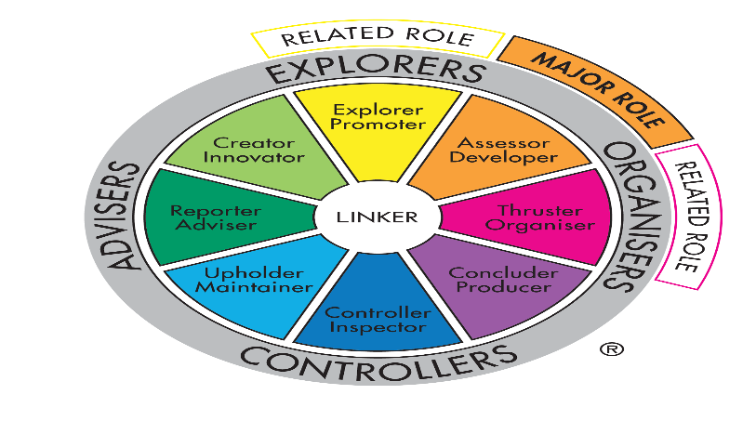

TEAM PROFILE

OF MAGICIAN” S ASSISTANCE







The MAGIC ASSISTANCE Team Management Profile highlights an individual's Meyers Briggs.

And related areas of work preferences on the G1T21 Team Ideal Job

And Management Wheel for Meyers Briggs Test.

## About the team

### Heather Bowden

Heather: [Assignment 1 (hchybowden.github.io)](https://hchybowden.github.io/)

Ideal Job Cyber Security



**David**

David:  <https://s3334339.github.io/Assignment01/>

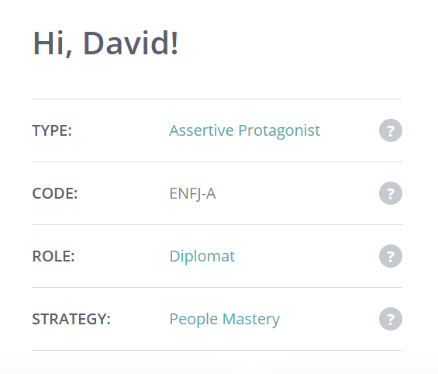

**Joshua**

Joshua: <https://jtelfer123.github.io/My-It-Profile/>

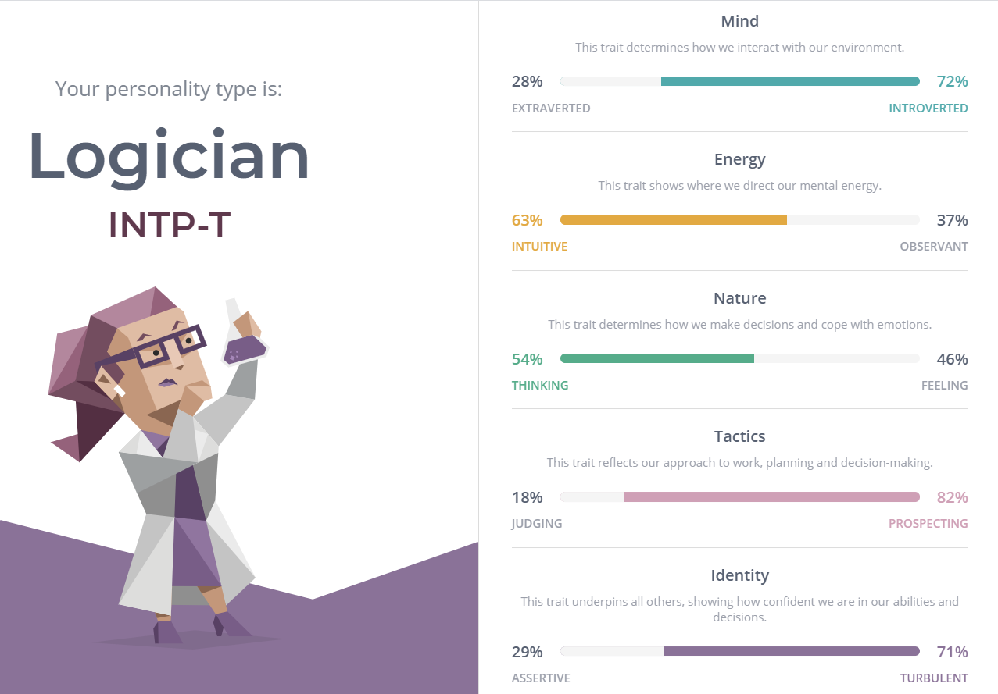

**Solomon**

Solomon: <https://github.com/s9811482/Assignment-01>

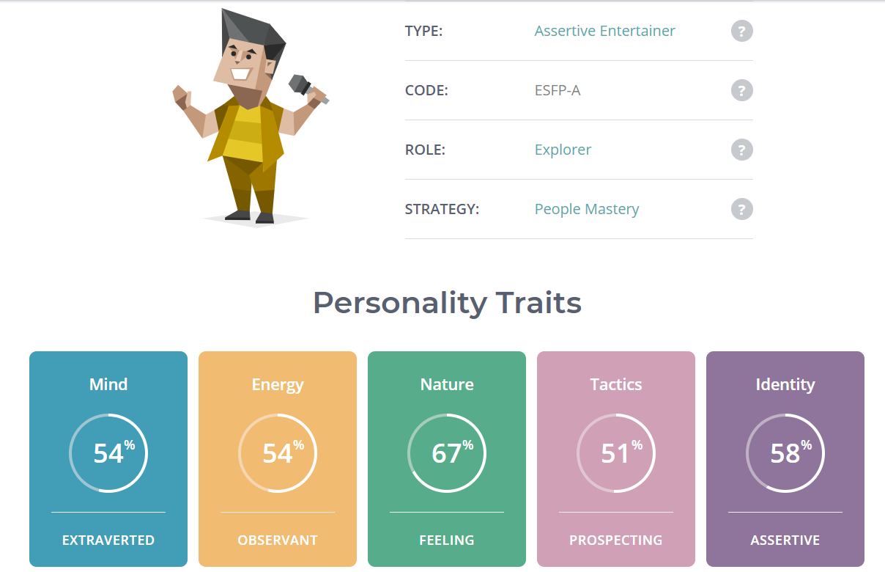

**Kobi**

Kobi: <https://github.com/s3905543/my-portfolio.github.io>

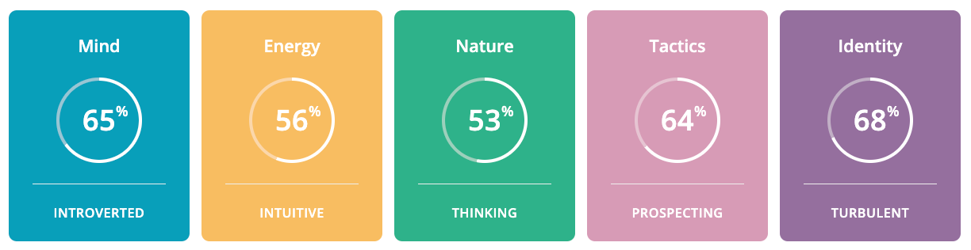

**Nichol**as

Nicholas: <https://github.com/nicholasdugan/IT-assessment>

