*Reviewer #1 (Remarks to the Author):  
  
In this manuscript the authors examined sampling behavior in full information stopping problems. First, in a pilot study, they showed that the participants’ sampling rate is lower (numerically) than that of a Bayesian ideal observer model that relied on the objective price values (undersampling bias), but higher than that of an ideal observer model that relied on the subjective values (oversampling bias). Then, in their main study, they showed that the sampling rate of the participants did not significantly change across different task features. However, the classification of the participants’ performance (undersampling or oversampling) changed as a result of the model it was compared to: a comparison to model 1 (objective values) resulted in undersampling bias (or no bias at all), while a comparison to model 2 (subjective values) flipped the results. The authors suggest that this pattern of results stems from differences in the prior distributions of the objective (model 1) and the subjective values (model 2).  
  
The results are novel and interesting and the manuscript is well-written and easy to follow. I have a few suggestions that I hope would help to improve it.*

We appreciate the reviewer’s positive response and constructive attitude towards improving the manuscript. Please note that the narrative has developed further, compared to this summary, as a result of the new analyses and empirical data, which have been introduced in the response to the reviewers’ and editor’s comments.

*1. Payoff schemes – I found the different payoff schemes (Reward 1 & Reward) a bit problematic. The authors mention that “payoff schemes at their most potent cannot switch between under- versus over-sampling biases” (Supplementary Text C). However, the different payoff schemes can almost completely eliminate the bias. That is, to change the classification of behavior from under/oversampling bias to no bias at all.*

It is true that incentivisation scheme may not be able to (by itself) completely change the bias from undersampling to oversampling, using our previously-submitted paradigms. Nevertheless, part of our main narrative indeed claims that participants generally are reluctant to increase their sampling rates. Thus, in the new manuscript, we move this incentivisation issue to the forefront (as, we suspect, the reviewer is suggesting we should do) and we now draw the interpretation that this is an example where it is optimal under some incentivisation schemes to increase the sampling rate and participants do not do this. This interpretation is consistent with the reviewers (correct) observation that “the different payoff schemes can almost completely eliminate the bias. That is, to change the classification of behavior from under/oversampling bias to no bias at all”. Based on our new computational models, participants may be reluctant to increase their sampling rates because of a pessimistic prior expectation about upcoming samples.

*2. Statistical backup – In several places the authors interpret the results based on visual inspection without backing up their claims with statistical analyses. For example, in Figure 4A the subjective values are presented as a function of the objective prices, and the relationship between them is described as ‘sigmoidal’. However, this relationship should be examined more quantitatively. For instance, the authors could fit a mixed model sigmoidal function to the data and compare its fit to other models (e.g., linear model, decaying exponential function, etc.). In addition, the authors mention that the prior distributions in Figure 4B are different, but do not show a significant difference between them (e.g., using a Kolmogorov–Smirnov test). Finally, in Supplementary Text C, the authors compare different conditions without performing any statistical analyses (for example, is the mean sampling rate in Model 1 – reward 1significantly higher than the mean sampling rate in Model 1 – reward 2? etc.).*

In light of the changed results, these comparisons of subjective versus objective values are now moot and so no longer reported in our manuscript. Our newly analysed results (e.g., the newly-added Studies 2 and 3) suggest that the use of subjective and objective values in the ideal observer model produces relative small and inconsistent differences, compared to factors like the payoff scheme or sequence length.

*3. Additional Analyses/discussions – In my opinion, several statistical analyses/discussions could be added to better understand the data and strengthen the manuscript: Learning effects – Did the participants show any learning effects during the studies? For example, did they move from undersampling to oversampling across trials (or vice versa)?*

As with all of our studies using full information problem paradigms, and as has been previous reported in the literature (Lee, 2006), there are no compelling learning effects to report in our data. We have added some content to the Discussion stating this.

We show below plots of participants’ sampling rates in each of our studies as a function of sequence number (As the ideal observer treats each sequence independently, there can be no ideal observer differences in sampling rate). In some of these plots, there appears to be a hint of a slight decrease in sampling rate, but any such effect appears small (mainly within the error bars, which are 95% confidence intervals of each mean) and do not replicate well over studies. We feel it would be a risk to attempt to draw an inference on the basis of these results.

While learning effects are certainly an interesting research question in their own right (and presumably the reason they have already received attention in the literature before this), it is not clear to what extent learning effects would directly support or deny our main conclusions.

Pilot baseline and Pilot full

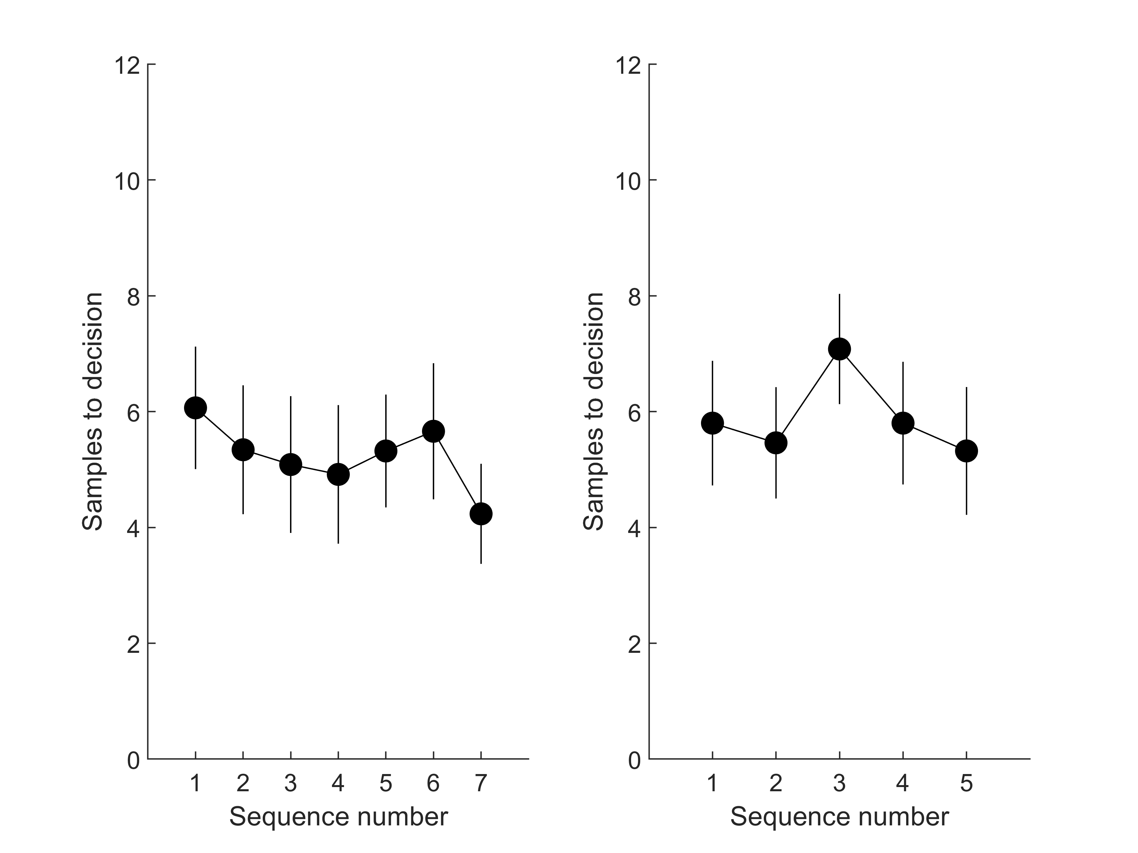

Study 1 baseline, squares, timing and payoff

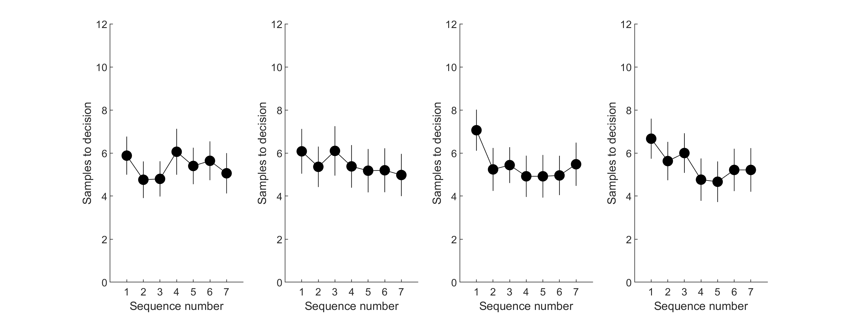

Study 1 ratings and full

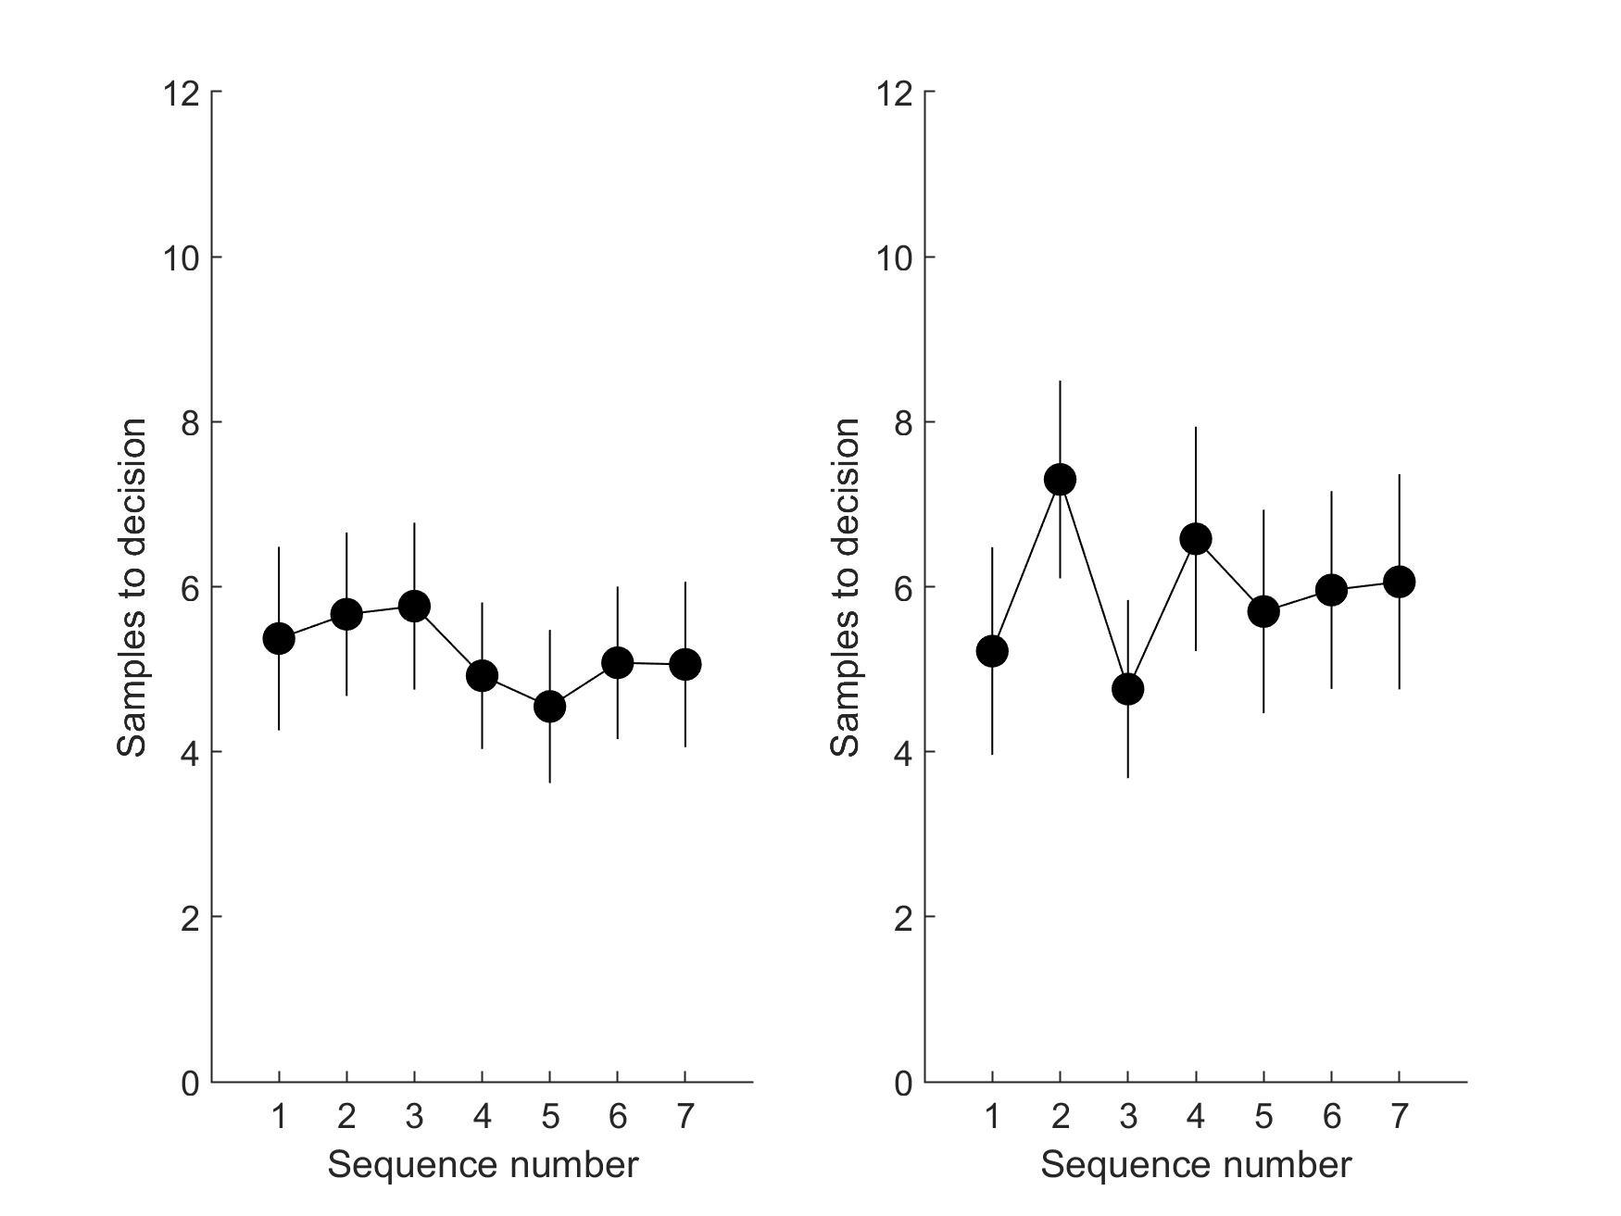

Study 2

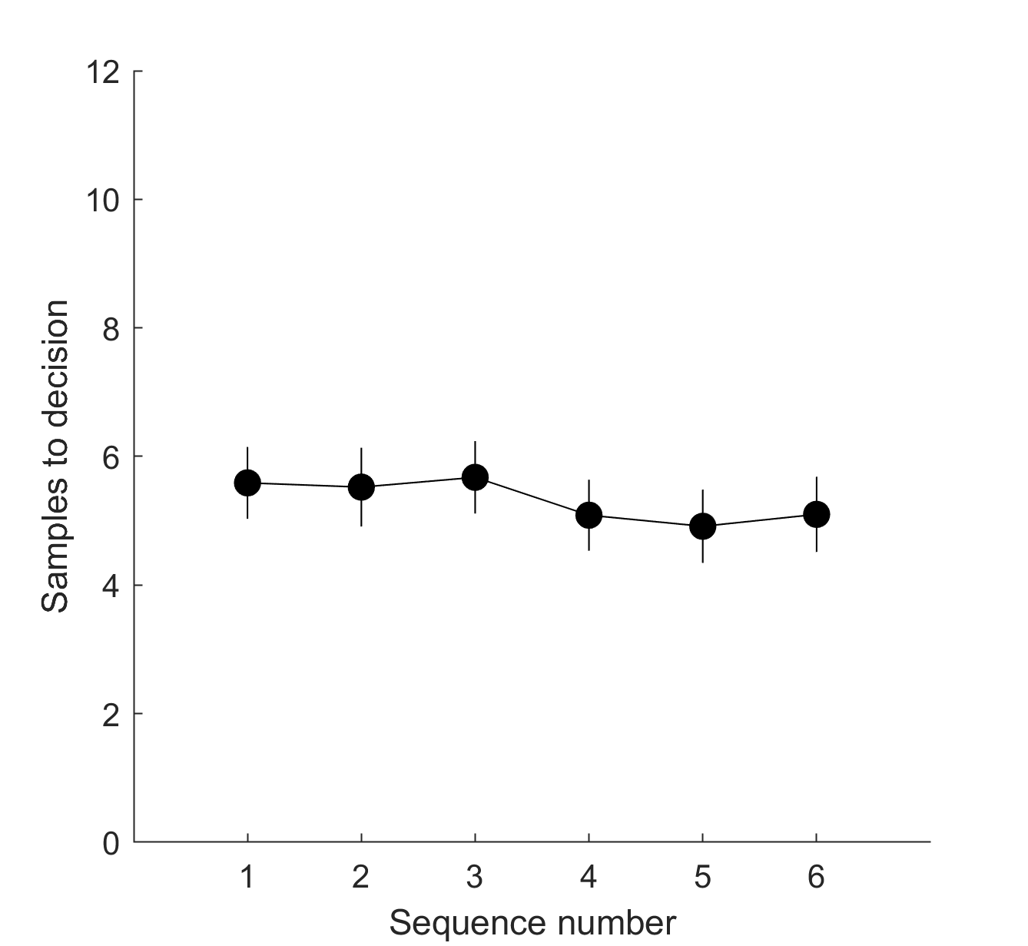

Study 3, sequence length 10 and sequence length 14

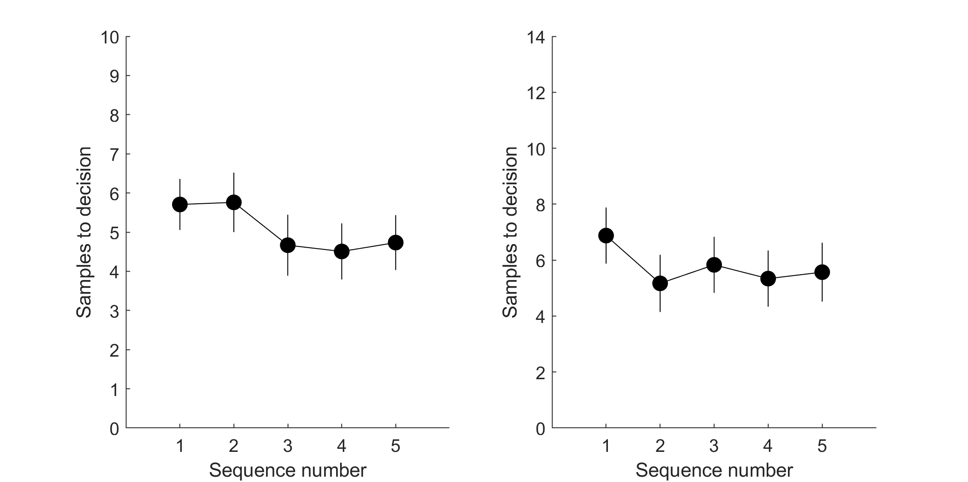

*·*

*Bayesian models – Models 1 & 2 provide benchmarks to which participants' sampling rate is compared. Could the authors add a discussion (or analysis) about whether these models can also account for the cognitive mechanisms underlying the behavior of the participants.*

The largest change to the new manuscript is the introduction of these theoretical computational models, as requested. In response to this request by both reviewers and the editor, we have included some of our new work, which was indeed designed exactly to “account for the cognitive mechanisms underlying the behavior of the participants”. We show that suboptimal decisions on this task are theoretically accounted for by biased expectations of future option values.

*·Sampling efficiency – It would be interesting to compare the mean payoff obtained by the participants to that obtained by the optimal models.*

In the Supplementary Materials, we have added plots of the mean rank of the chosen prices for each condition / study. This new analysis adds an important dimension to our narrative, as it can be seen that participants perform close to optimally, despite sampling less than optimally.

*· Rating consistency – Each price was presented twice at the rating phase. What was the correlation between the two ratings?*

The correlations (now reported in the respective Methods sections) are Pilot full: 0.83, Study 1 full: 0.87, Study 1 ratings: 0.81, Study 2: 0.85, Study 3 10 options: 0.88, Study 3 14 options: 0.84.

*· Subjective vs. Objective values – The authors speculate that participants sampling rate would be affected by the distribution of subjective perception of prices (e.g., £550 is roughly equal to £400, p. 10/ first paragraph). This can be empirically examined by comparing participants the sampling rate of participants with a relatively linear relation between the subjective values and objective prices, to participants with a more ‘curvy’ relation.*

As we have changed our claims with respect to subjective versus objective values, this comparison is now moot.

*· Effect Size – The authors reported only significance levels, but not effect sizes.*

We report effect sizes for all comparisons involving human behaviour in the new Figure S4 in the Supplementary materials that visualises the effect sizes for all pairwise comparisons in Study 1 (i.e., the null effects, in which participants appear to sample at nearly the same rate over conditions).

*4. Code availability – As this manuscript compares human sampling behavior to that of ideal observer models, it would be great if the authors could make the code used to implement the ideal observers publically available.*

<https://github.com/nicholasfurl/Model_fitting_hybrid_study>

*Reviewer #2 (Remarks to the Author):*  
  
*## Summary*  
  
*The paper investigates full information optimal stopping problems, specifically when people oversample/undersample in this scenario. The author first hypothesized that the number-based tasks led to undersampling and picture-based tasks led to oversampling (as reported by previous studies). But oversampling was observed in the number-based task in the Pilot study, which indicates that pictorial stimuli may not be the only reason causing oversampling. The goal of the Main study is to isolate which task feature leads to oversampling in number-based tasks. They found the human sampling rate is unchanged in all six conditions (i.e., Baseline, Full, Squares, Payoff, Timing, and Ratings). The conclusion about over versus undersampling is determined by the implementation of the model. The paper implemented two models with different prior generating distributions for the Bayesian optimality model. Model 1 uses objective prices as the prior generating distribution, and Model 2 uses subjective evaluations of prices.*

This accurate summary of our previous submission no longer holds in its entirety for the new submission. Our two new studies, reanalysis of our existing data and the addition of our theoretical model building and comparison has shifted our narrative and conclusions.

We still contend that participants adopt a relatively rigid sampling strategy. Though we show that manipulations within our paradigm can shift the sampling rates of the ideal observer and of the participants, the former is affected more easily than the latter.

As requested by this reviewer, we show that manipulations of our paradigm can in fact shift participants’ sampling rate to some degree. In the new Study 3, we replicate a previous finding using a version of our paradigm (Costa & Averbeck, 2015) that participants sample more for longer sequences. But in that previous study, and in our replication of it, the ideal observer increased its sampling rates numerically more than participants, leading to greater undersampling at longer sequence lengths.

Moreover, the ideal observer samples more when the incentivisation schemes rewards only the top three ranks than the full conditions, where the incentivisation schemes reward any choice (proportional to its option value). Although our paradigm is capable of shifting the ideal observer’s sampling rate and we can statistically detect this shift, these are not the case for participants. Undersampling is greater in conditions where the incentivisation schemes rewards the top three ranked choices, because the ideal observer increases its sampling rates and participants not so much.

As in the previously submitted manuscript, a number of other methods features failed to affect the sampling rates for either the ideal observer or for the participants. We now report Bayesian tests, which have sufficient sensitivity to show statistical evidence favouring the null model of equal means over models where means differ.

Following this reviewer’s advice, we now provide theoretical models to explain why participants do not raise their sampling rates as much as we might expect them to. Models that undersample because they adopt too pessimistic a prior distribution over predicted option values best fit participants’ sampling behaviour, compared to a number of competing models of suboptimal choices on our task.

## Review  
  
*The potential contributions of the paper are to show that some task features are insignificant in affecting human sampling biases and that the conclusions about under/oversampling are completely model-based. However, the paper falls short in several places. It is not clear that the study itself was sensitive enough to detect any changes in behavior so it gives low confidence in the conclusion that human sampling is unaffected by task features.*

We have provided the requested new study to show successful experimental manipulation of participants’ sampling rates.

We now report Bayesian tests, which are sufficiently sensitive to show positive statistical evidence for equivalent means between the various methods conditions in question.

We further note that our design was sensitive enough to detect changes in ideal observer behaviour (at least for the different payoff schemes), even when it finds no differences in participants’ sampling rates.

*The paper does not give any insight as to why there is a difference between the Bayesian optimal models and human behavior; the only conclusion here is that participants under sample the Bayesian optimal model, but even that conclusion, as the paper establishes, is completely model-based.*

Our revised manuscript now gives “insight as to why there is a difference between the Bayesian optimal models and human behavior”. We have built a number of models that could explain undersampling and, in the new manuscript, we fit them to participants’ decisions. The ensuing model comparison replicates highly across the studies and conditions in suggesting that participants do not increase their sampling rates in the same conditions as the ideal observer does because they subjectively expect future samples to be lower valued than they should.

*Finally, overall the paper was very difficult to parse.*

We are submitting effectively an entirely new paper. Nevertheless, we are of course happy to entertain any specific or constructive suggestions for rewriting.  
  
  
  
  
## Comments  
  
*1. **Sensitivity to task features.** The author state, “Our Pilot Study shows that oversampling is not limited to tasks that present option values as pictures but can also occur for some tasks using numeric stimuli to communicate option value. Our Main Study then attempted to systematically isolate which task feature leads to oversampling on number-based tasks.” The idea here was that there were several features in the experimental protocol that apparently differed between the current numeric version and the past numeric versions that established undersampling. The Main study then changed these features to see if that could explain the difference between the current result and the past result. But, one reasonable issue here is a sensitivity issue. Could it be that in this particular study, participants are just relatively insensitive to these task features? That is, they should show that the study could actually prompt changes in behavior and that the study can detect it. That would give confidence in the conclusion that participants are insensitive to task changes.*

Costa & Averbeck (2015) using the methods we adapted for our study, already showed that sequence length increases participants’ sampling rates. We now replicate this finding in Study 3. Therefore, some manipulations using this paradigm can indeed affect participants’ behaviour. We have pre-registered and *a priori* powered Study 3, as requested by the editor.

Our Study 2 is sufficiently sensitive to detect positive evidence for null models where means are equal, using Bayes Factors (Figure 2).

We note that our paradigm methods did suffice to modulate the ideal observer’s sampling rate in response to payoff scheme and sequence length, even if participants showed no modulation (payoff scheme) or less modulation (sequence length), suggesting the design elements capable of modulating sampling for an ideal observer are nevertheless present.

We note that no evidence has been (explicitly) mentioned that confirms any specific problem with our paradigm that would prevent detection of participant shifts in sampling.

*2. **Model 1 and Model 2** A real struggle in this paper is the use of Model 1 and Model 2 and the definition of undersampling and oversampling. Over many, many reads. Here is what I understand. Model 1 is the Bayesian Optimal model with objective values. Model 2 is the Bayesian Optimal Model with subjective values. Many papers showed in these optimal search tasks that people under sample with references to the Bayesian Optimal Model with objective values (Model 1). A couple of papers (Furl et al., 2019; van de Wouw et al., 2022) came out using images instead of numeric values, which meant researchers needed to collect subjective values of the images to run the Bayesian Optimal Model. But, comparing behavior to this model led to the conclusion that people oversample. This paper set up a situation where both Model 1 and Model 2 could be used, establishing that the conclusion of undersampling (with reference to Model 1) and oversampling (with reference to Model 2) is completely model-based. This is useful information, but honestly, it takes a lot of effort for the reader to figure this conclusion out. The writing obscures this because it flips between Model 1 and Model 2. But, there could be a lot more work done to make that clear. For instance, in the Pilot study, it is really confusing to read that “Our Pilot Study shows that oversampling is not limited to tasks that present option values as pictures but can also occur for some tasks using numeric stimuli to communicate option value. Our Main Study then attempted to systematically isolate which task feature leads to oversampling on number-based tasks.” But, as a reader, you are looking at Figure 1 and Model 1 and saying there is no oversampling.*  
  
We suspect that the new manuscript may not pose the same challenges, as we have abandoned the Model 1 / Model 2 notation and, more generally, the new narrative is no longer rooted in comparisons of these two model types.

*A deeper issue here is that, in the end, the main conclusion of the paper is that the conclusion of over vs undersampling is completely model-based. But, this is not that interesting because it is true by definition.*

Given the conclusions drawn from the new empirical data and theoretical models, this comment is now moot.

*There is really little to no insight as to why human behavior differs from the optimal math solution. The paper's opening suggests it is going to investigate this, but the studies do not do this. The main study seems to have been designed to do this, but really all we learn is that changes in the experimental task features did not have any impact. And as mentioned above, there is a real issue here that it could be that the experiment itself just can’t show or detect any changes in human behavior.*

The new manuscript is now centred on theoretical model fits and comparisons that give insight into “why human behavior differs from the optimal math solution”.

*The paper could also generate models that closely replicate human stopping behavior and find the best model by comparing the models' results with human behavior. The authors seemed to try to do this with, for instance, the subjective value version of the Bayesian model. But, then, the experiments give us no information about why there are differences between human behavior and the models.*

We have followed this reviewer’s advice and, indeed, our new model comparison has highlighted a possible computational mechanism for explaining undersampling bias, which replicates well across a number of studies.

As this reviewer prefers, the new manuscript is now centred on theoretical model fits and comparisons that give insight into “why there are differences between human behavior and the models”.

*Moreover, it isn’t really clear if the Bayesian optimal models would have predicted any changes based on the manipulations in the main study.*  
  
The ideal observer sampling rates for the different manipulations in the main study (now labelled Study 1 in the new manuscript) are visible in Figures 4 and 5.  
  
  
  
### Minor Comments  
  
*1. The difference between 1 and 10 is not the same as between 1000 and 1010.*

This sentence is no longer in the manuscript.  
  
  
  
*2. "Although full information problems lack the many restrictive assumptions of the secretary problem, they cannot employ such a simple rule to derive optimal performance for comparison with human performance. "*   
  
*3. The paper states that secretary problem is a simpler problem of full information problems, and the simple mathematical rule of the sceretary problem cannot used to derive optimal performance for comparison with hunman performance. But the sceretary problem is known as the "no-information game", the assumptions of the no information game are very different from those of the full information game. Thus, the optimal solution of no information game is of course not applicable to the full information game.*

The reviewer appears to agree with us that optimal solution to the Secretary solution does not apply to full information problems. To avoid any misunderstanding, the revised manuscript provides more thorough comparison of these different decision problems in the Methods, when we introduce the cut off (CO) model, which is derived from the solution to the secretary problem. We also give more text over to a critical discussion of the merits of Peter Todd’s and Geoffrey Miller’s (1999) claim that the CO model should be applied beyond the secretary problem.