RUNNING HEAD: sequential decision strategies

Participants use a mixture of strategies to solve sequential decision problems

Didrika S. van de Wouw, Ryan T. McKay, Nicholas Furl

Royal Holloway, University of London

Corresponding author:

Nicholas Furl

Department of Psychology

Royal Holloway, University of London

Egham, TW20 0EX, United Kingdom

[Nicholas.furl@rhul.ac.uk](mailto:Nicholas.furl@rhul.ac.uk)

Data and code availability: <https://github.com/nicholasfurl/Model_fitting_imageTasks>

Abstract

Full-information best choice problems typify many real-world decisions. Participants face a sequence of decision options and must accept or reject each option at the time it is encountered. The challenge is to use prior knowledge of the distribution of option values to predict whether continued sampling might result in a higher-valued option than the one currently on offer. On these tasks, biases are apparent when human decisions are compared against mathematical optimality solutions. Specifically, tasks involving choices about options presented as images appear to evoke an oversampling bias, in which participants perform suboptimally by rejecting optimal choices and continuing to sample new ones. Using computational modelling of ten datasets spanning five choice domains, we demonstrate two dominant sampling strategies. These strategies, which explained the overly long searches, involved a combination of overly optimistic predictions about future option values and an intrinsic perception that sampling itself has reward value. These strategies, and their associated systematic biases, could manifest in real-world decisions such as shopping, choosing dating partners or trustworthy job candidates.

Introduction

In many real-life situations, decision options appear in sequence and must be selected or rejected at the time of encounter. In the classic example of the “fiancé problem”, the astronomer Kepler allegedly interviewed multiple candidates for a new wife. When he proposed to one of them, he found himself duly rejected, as the chosen candidate did not appreciate that he had continued interviewing after first meeting her. Such decision problems have garnered considerable multidisciplinary interest. Mathematicians (e.g., Ferguson, 1989) have identified means of calculating “optimal stopping” solutions (i.e., on which sample should an agent stop sampling options and commit to a choice?). The approach of comparing these mathematical optimality benchmarks (here, termed an “ideal observer” model) against choice behaviour has been adopted within the behavioural sciences, such as in studies of mate choice in behavioural ecology (Castellano et al., 2012; Castellano & Cermelli, 2011) and economic choices in cognitive science (Baumann et al., 2020) and neuroscience (Costa & Averbeck, 2015).

We here consider perhaps the most generalisable and realistic version of optimal stopping problems: the full information problem (Lee, 2006). Consider a full information problem for hiring a new employee. The employer can use prior knowledge about the probability distribution that generates employees of varying quality (i.e., the generating distribution of option values). Then, the employer interviews a known number of job candidates one at a time such that the quality of each candidate is revealed only at the time of interview. After each interview, the employer must decide whether to hire the candidate or reject them and interview a new one. In this example we may assume that rejected candidates are quickly hired by competitors and so once rejected, cannot be recalled as an available option later.

The current state-of-the-art ideal observer (i.e., optimal solution) for the full information problem (Costa & Averbeck, 2015) is an evolution of the long-standing Gilbert and Mosteller (1966) solution. The ideal observer knows the mean and variance of a normally distributed prior of the potential option values. Then, using this generating distribution, the expected reward value of future samples if the agent were to continue sampling can be computed. This expected value functions as a varying choice threshold which the current option value on offer must exceed to be chosen.

Although many previous studies of optimal stopping problems (e.g., Baumann et al., 2020; Cardinale et al., 2021; Costa & Averbeck, 2015; Goldstein et al., 2020; Guan & Lee, 2018; Guan & Stokes, 2020) asked participants to search for the best number (e.g., price), some recent work introduced an image-based full information problem. In Furl et al. (2019), participants considered face images presented in sequence, and attempted to select the most attractive face (with the constraint that rejected options could not be returned to). Interestingly, participants were biased towards sampling too many options, relative to the ideal observer. A subsequent study (van de Wouw et al., 2022) demonstrated oversampling for additional image-based domains: foods and vacation destinations. In the current paper, we investigated hypothetical sources of this oversampling bias by fitting computational models to participants’ choice behaviour using ten datasets, including data from Furl et al. (2019), van de Wouw et al. (2022) plus three new datasets, testing new choice domains.

We build on previous approaches to modelling full information problems. Lee (2006) devised a model whose free parameters (estimated via fits to participant choice data) are the choice thresholds used at each sequence position. These models suggest humans use a linearly collapsing threshold (Baumann et al., 2020). Although such a modelling procedure would be useful for identifying how optimal and biased thresholds might differ, this formulation (without some modification) does not explicitly demonstrate the mechanism by which bias alters the thresholds. Here, we examined models that explicate the computational path connecting bias and the ensuing biased thresholds and sampling behaviour, subsequently entering these models into formal model comparison for every dataset.

The first such model is the *cutoff model* (Todd & Miller, 1999), which is inspired by the optimal solution to a particular variant of optimal stopping problem, which is related to, but distinct from, the full information problem (Ferguson, 1986; Freeman, 1983). This “secretary problem” permits a relatively elegant optimal solution, if one makes several assumptions. Although these assumptions are not satisfied by our full information tasks, we nevertheless consider this model here with the aim of being exhaustive. Todd and Miller (1999) have proposed that people use heuristics, such that an easy-to-calculate solution (e.g., the secretary problem solution) that only approximates optimality would be psychologically plausible. The cut off model determines its choice threshold based on the earliest samples it encounters. Before reaching a specific cutoff point in the sequence, the model does not make any choices, effectively setting the choice threshold to infinite during this period. The optimal cutoff is 1/*e* ≈ 37% through the sequence. After the cutoff, the choice threshold becomes fixed at the best value observed so far. The cut off model therefore modifies an optimal threshold computation (albeit for a slightly different problem) and parameterises this computation to simulate or incorporate potential biases into the model. We theorise that participants could oversample by employing a sub-optimally late cutoff.

For the other models we compared, we also modified an optimal computation – this time, the full information problem’s ideal observer (Costa & Averbeck, 2015) – and parameterised it to embody computational theories of oversampling. In the *cost to sample model*, we set one of the model quantities, the cost to sample (See General Methods) to be a free parameter. This parameter is referred to as a “cost”, as it was originally designed to model situations where participants are extrinsically charged money or points for sampling new options. However, when the cost to sample value is fitted to participant data as a free parameter, it can theoretically take on any value, including positive (costs) and negative (reward) values. That is, even though our studies herein never enforce any ground truth cost (or reward) for sampling, participants may nevertheless subjectively perceive sampling as costly or rewarding and thereby adjust for this perception in their sampling behaviour. We hypothesise in the case of oversampling bias that participants would adopt *negative* costs to sample; that is, they would feel more *rewarded* the more they sample. Indeed, the facial attractiveness task (Furl et al., 2019) resembles seemingly addictive dating apps like Tinder, where users may enjoy considering sequences of face images. To maintain continuity with the more traditional use of “cost to sample” as the name of this model quantity, we will retain the name “cost to sample model”, even though “reward to sample” might appear to be more apt a description of our hypothesis as it related to this model.

We also parameterised this ideal observer to develop the *biased prior model*. Here, the free parameter is a constant added to the mean of the prior generating distribution. Positive values of this parameter would bias the model to have overly optimistic expectations about future option values and therefore be motivated to continue sampling. In the Supplementary Materials, we describe two further models, which were excluded from model comparison as their parameters recovered poorly.

For all ten datasets, we fitted cost to sample, cut off and biased prior models and submitted them to formal model comparison. To anticipate our results: we replicated oversampling bias in all ten datasets. Participants’ sampling strategies across domains may be a mix of cost to sample and biased prior models.

General Methods

Paradigm for all datasets

All data collection protocols were approved by the Royal Holloway, University of London College Ethics Board. For all datasets, we measured participants’ preferences for the options in advance of the decision task by using a phase 1 ratings task, where participants viewed the entire empirical “generating distribution” of images, each of which might or might not appear later as options in the decision task. Participants rated each image for “attractiveness” more than once and the multiple ratings were averaged to obtain one stable subjective value estimate per image. We find average correlations across ratings of > .8 for all our datasets. We used these subjective value estimates in three ways. First, we inputted as option values to our computational models the subjective values of the same options that a corresponding participant received. Second, we programmed the mean and variance of that model’s generating distribution with the mean and variance of its corresponding participants’ subjective value distribution. As is described below, the model uses this distribution to predict upcoming option values. Third, we gauged the overall success of decision making by using each participant’s own subjective values to identify the rank of the chosen options, relative to other images in the same sequence. By using the subjective value estimates as described above, we were able to build bespoke models and measurements, tailored to each participant’s personalised preferences.

Next, each participant and their corresponding model engaged with several sequences of eight image options each, which were randomly sampled without replacement from the images shown in phase 1. These two types of agent (participants and models) decided whether to choose that option or, instead, reject it, rendering the option inaccessible and producing the next option. Upon choice of an option, all remaining options became inaccessible, yet participants still needed to button press in response to grey squares, which replaced the remaining options. The grey squares were designed to dissuade participants from attempting to finish the study early by sampling fewer options. Nevertheless, our existing data suggest that the presence of these grey squares do not affect participants’ sampling rates (van de Wouw et al., 2023). If either a participant or model reached the final option in a sequence, that option automatically became their choice. A post-sequence feedback display showed the chosen image and solicited from the participant a rating of the reward value for this image. This rating activity only functioned to provide feedback to the participant and was not analysed.

Facial attractiveness dataset 1

Behavioural performance and demonstration of oversampling bias for this dataset were previously reported as Study 2 in Furl et al. (2019). We chose a sample of 20 participants based on the effect size observed in Study 1 reported in Furl et al. (2019). Participants were instructed that they would encounter face images of individuals interested in dating them and that the participant’s goal was to try to choose the most attractive dates possible. Participants opted to choose dates from either male or female face sets. Participants in phase 1 rated 426 face images (Bainbridge et al., 2013) for facial attractiveness. Each image was rated three times on an integer scale from 1 to 9. After a brief distractor task, in which participants solved difficult arithmetic problems, they engaged with 28 optimal stopping sequences. For each participant, the paradigm generated a fresh random selection (without replacement) of sequence options from phase 1 for every sequence. The facial attractiveness dataset 1 paradigm was programmed in MATLAB R2020b (2010) using the COGENT 2000 toolbox http://www.vislab.ucl.ac.uk/cogent.php and data were collected in person in a laboratory setting.

Matchmaker dataset

Analysis of the matchmaker dataset has not been previously published. The paradigm was originally designed to test whether oversampling would replicate when facial attractiveness decisions were divorced from personal mate choice, where participants choose dates for themselves. To test whether participants change strategy when making mate choice decisions for others, we asked participants to imagine they were professional matchmakers and to choose the most attractive faces they could on behalf of a (fictitious) client, who has employed them to select suitable dates. Methods were identical to facial attractiveness dataset 1 aside from these instructions. We enrolled 20 participants (equal gender split), the same sample size as facial attractiveness dataset 1, who each chose which gender of face they would like to match for their client. Data were collected in person in a laboratory setting.

Trustworthiness dataset 1

Analysis of trustworthiness dataset 1 has not been previously published. We attempted to replicate oversampling in a paradigm where the option values were still face images but the facial characteristic being maximised by choice was different from attractiveness. We chose a characteristic, trustworthiness, that seemed relevant to real-world contexts, as decisions in contexts like courtrooms can be influenced by facial trustworthiness (Olivola et al., 2014). Participants chose a face gender for the task, as in the previous datasets. They started the task by rating faces for trustworthiness in phase 1 and then, in the optimal stopping task, trying to choose the most trustworthy-appearing face they could. Methods were identical to face attractiveness dataset 1 and matchmaker dataset, except for these instructions. Most of the 20 participants (the same sample size as facial attractiveness dataset 1) were female (*N* = 18). Data were collected in person in a laboratory setting.

Trustworthiness dataset 2

Analysis of trustworthiness dataset 2 has not been previously published. This replication study aimed to validate the evidence for oversampling in our previous studies by obtaining an equivalent result of oversampling bias using a larger sample of participants with more data collected per participant. We enrolled from the online Prolific platform (Prolific, 2014) 64 participants between the ages of 18 and 35 years old from the majority English-speaking countries United Kingdom, Ireland, United States, Canada, Australia, and New Zealand. The paradigm was designed and hosted on the Gorilla Experiment Builder platform (Anwyl-Irvine et al., 2020). Participants in phase 1 chose whether they wanted to rate male or female faces and then rated the same images used in our previous studies for trustworthiness. Three images of all of the identities were arranged into a random sequence and each image was rated using a 100-point sliding scale, where the slider position was initially hidden and only appeared when the participant made a selection via mouse click. The optimal stopping task immediately followed phase 1, without any intervening distractor task. In the optimal stopping task, participants attempted to choose the most trustworthy face possible. Options were randomly sampled without replacement from the face identities rated in phase 1. Each of the 40 sequences used the same fixed order of options for every participant, although these fixed sequences were presented in a different random order for every participant. Options that remained unsampled in each sequence after choice were replaced by grey squares, which the participant needed to page through via button press. Upon sequence completion, a feedback screen was displayed, as already described for the datasets above.

Facial attractiveness dataset 2, foods dataset 1 and vacations dataset 1

These three datasets and their demonstrations of oversampling bias, relative to the ideal observer model, were previously reported in van de Wouw et al. (2022). They shared identical methods with trustworthiness dataset 2, apart from the following exceptions. Seventy-five participants per dataset were recruited from Prolific. In these online studies, we increased the sample size, relative to the datasets described above, to adapt the study to online data collection conditions: shorter studies with decreased numbers of optimal stopping sequences (only five) per participant. Participants rated 90 images in phase 1 for “attractiveness”, each twice, before immediately engaging with the optimal stopping sequences. In facial attractiveness dataset 2, participants were instructed to choose the most attractive face that they could. In foods dataset 1, stimuli included photographs of prepared meals, taken from the image set described in Blechert et al. (2019). In vacations dataset 1, stimuli included images of popular vacation sites (e.g., the Eiffel Tower) taken from a royalty-free image database ([www.shutterstock.com](http://www.shutterstock.com)). For all datasets, participants were instructed to choose as attractive an option as possible.

Facial attractiveness dataset 3, foods dataset 2 and vacations dataset 2

These three datasets demonstrated that oversampling replicates across the three image-based domains, a finding also reported in van de Wouw et al. (2022). The studies were respectively identical to facial attractiveness dataset 2, foods dataset 1 and vacations dataset 1, aside from the participant sample. Data were collected in-person on campus at Royal Holloway, University of London open days from prospective undergraduate candidates and their families. There were 32 participants in facial attractiveness dataset 3, 28 in foods dataset 2, and 36 in vacations dataset 2. The lower sample sizes obtained here relative to facial attractiveness dataset 2, foods dataset 1 and vacations dataset 1 was based on both observations of the effects sizes in those previous datasets.

Ideal observer optimality model

The ideal observer used here is a discrete-time finite-horizon Markov process (Cardinale et al., 2021; Costa & Averbeck, 2015; Furl et al., 2019; van de Wouw et al., 2022). It computes a utility *u* for states *s* at samples *t*, which is taken as the maximal action value, out of available actions *a*. *u* depends in part on the integral over possible future states, weighted by the probability of transitioning into them from the current state {"mathml":"<math style=\"font-family:stix;font-size:16px;\" xmlns=\"http://www.w3.org/1998/Math/MathML\"><mstyle mathsize=\"16px\"><msub><mi>p</mi><mi>t</mi></msub><mfenced><mrow><mi>j</mi><mo>|</mo><msub><mi>s</mi><mi>t</mi></msub><mo>,</mo><mi>a</mi></mrow></mfenced></mstyle></math>","origin":"MathType for Microsoft Add-in"} This latter term therefore is computed based on the generating distribution, described above. The model uses backwards induction to derive utility values for the case where the agent chooses to sample again. See Baumann et al. (2020) for an intuitive description of backwards induction.

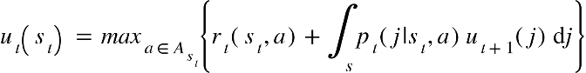

*u* also depends on {"mathml":"<math style=\"font-family:stix;font-size:16px;\" xmlns=\"http://www.w3.org/1998/Math/MathML\"><mstyle mathsize=\"16px\"><msub><mi>r</mi><mi>t</mi></msub><mo>(</mo><msub><mi>s</mi><mi>t</mi></msub><mo>,</mo><mi>a</mi><mo>)</mo></mstyle></math>","origin":"MathType for Microsoft Add-in"} the reward to be obtained for action *a* in the current state. If the agent chooses to decline and sample another option, then {"mathml":"<math xmlns=\"http://www.w3.org/1998/Math/MathML\" style=\"font-family:stix;font-size:16px;\"><msub><mi>r</mi><mi>t</mi></msub><mo>(</mo><msub><mi>s</mi><mi>t</mi></msub><mo>,</mo><mi>a</mi><mo>)</mo></math>","origin":"MathType for Microsoft Add-in"} merely equals *C*, the cost to sample. For all ten datasets, *C* = 0 in the ideal observer, as we never extrinsically rewarded or penalised participants for sampling. However, if the agent chooses one of the options, then the {"mathml":"<math xmlns=\"http://www.w3.org/1998/Math/MathML\" style=\"font-family:stix;font-size:16px;\"><msub><mi>r</mi><mi>t</mi></msub><mo>(</mo><msub><mi>s</mi><mi>t</mi></msub><mo>,</mo><mi>a</mi><mo>)</mo></math>","origin":"MathType for Microsoft Add-in"} term in the above formula instead depends on the function *R*, which maps each option’s relative rank *h* onto its reward value.

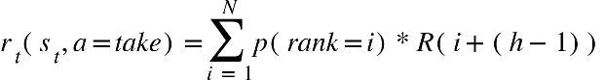

As participants were instructed to choose the best options they could, the ideal observer model’s choices were always rewarded according to the value of the chosen option (i.e., the average rating that participant gave to the chosen value).

The ideal observer’s generating distribution, before any options are sampled, is assigned a prior mean *μ0*, degrees of freedom *κ* for that prior mean, a prior variance *σ*20, and degrees of freedom *ν* for that prior variance. *μ0* and *σ*20 were fixed to the mean and variance of the phase 1 rating distribution. The ideal observer then uses Bayes rule to update *μ0* and *σ*20 upon experiencing each new option value in each sequence.

Fitted models

A theoretically motivated free parameter was fit for each model. For the cut off model, we fit the cutoff value, initialised it to the optimal cutoff value for the secretary problem (which equals 3 options for our 8 option sequences) and bounded it between two (to allow for a learning period of at least one option) and seven (to allow at least one option beyond the learning period to be available for choice). For the cost to sample model, we fit the free cost to sample parameter, initialised it to its optimal value 0 and bounded it between -100 and 100. For the biased prior model, we fit a constant added to the prior mean *μ0*, initialising this constant to its optimal value of 0 and bounded it between -100 and 100. All models additionally included the Softmax inverse temperature parameter *β* as a free parameter. During fitting, *β* had an initial value of 1 and was bounded between 0 and 200. Quality of model fit, in the form of the negative log likelihood, summed over each participants’ choices, was derived using probabilities computed from action values passed through the Softmax function. We used fminsearchbnd.m in MATLAB (Mathworks, Natick MA) for fitting. Parameter recovery is reported in the Supplementary Materials. We computed two metrics for purposes of model comparison. First, we submitted individual participant Bayesian information criterion (BIC) values to the Bayesian analogue of the *t*-test, which involves computing Bayes factors *BF*, to test for mean differences in BIC between pairs of models. Second, we determined which model had the best BIC for the most participants.

Transparency and Openness

All the datasets and analysis code that reproduces the figures can be found at <https://github.com/nicholasfurl/Model_fitting_imageTasks>.

Results

The columns of Figure 1 respectively show Bayesian analyses of the datasets where participants search for attractive faces as dates for themselves: facial attractiveness datasets 1, 2 and 3. All three datasets replicated each other, in the sense that they all show robust oversampling by participants, relative to the ideal observer, as previously reported (Furl et al., 2019, van de Wouw et al., 2022) (Figure 1, top row, black and grey bars and points). All three datasets also suggest contributions of both cost to sample and biased prior strategies. Both cost to sample and biased prior models, once fitted to behavioural data, approximate participants’ sampling rates, though the cut off model underestimates these (Figure 1, top row). Cost to sample and biased prior model BIC values are statistically better than cut off model BIC values in all three datasets, though there is little evidence for any statistical differences between the BIC values for cost to sample and biased prior models (Figure 1, middle row). Cost to sample and biased prior models are the best-fitting models to a considerable fraction of participants in all three datasets, with each of the two models accounting for roughly half the participants in facial attractiveness datasets 1 and 3 and a relatively clearer advantage for the biased prior model in facial attractiveness dataset 2 (40 participants for the biased prior model versus 25 for the cost to sample model). Additional analysis of these datasets, including ranks of chosen items and model parameter estimates, is shown in Supplementary Figure S4.

Figure 1. Human performance and model comparison for facial attractiveness datasets 1 (left column), 2 (centre column) and 3 (right column). Points in the first and second rows show data corresponding to individual participants, while bars show their mean values. In the first row, human and ideal observer bars are demarcated by grey lines when *BF10* > 3 (i.e., a Bayesian test shows at least moderate evidence for different means). Human and IO never showed *BF01* > 3 (at least moderate evidence for equal means). The second row shows Bayesian information criterion values (lower values indicate better model fit) for participants (points) and their mean values (bars). Black horizontal lines indicate when *BF01* > 3 (at least moderate evidence for equal means). When *BF10* > 3 (at least moderate evidence for different means), the horizontal line is coloured the same as the bar of the better model, suggesting that cost to sample (violet) and biased prior (red) models were always superior to the cut off model. The third row demonstrates that the biased prior model most often best fits the majority of participants, though the cost to sample model also accounts for many participants’ choices.

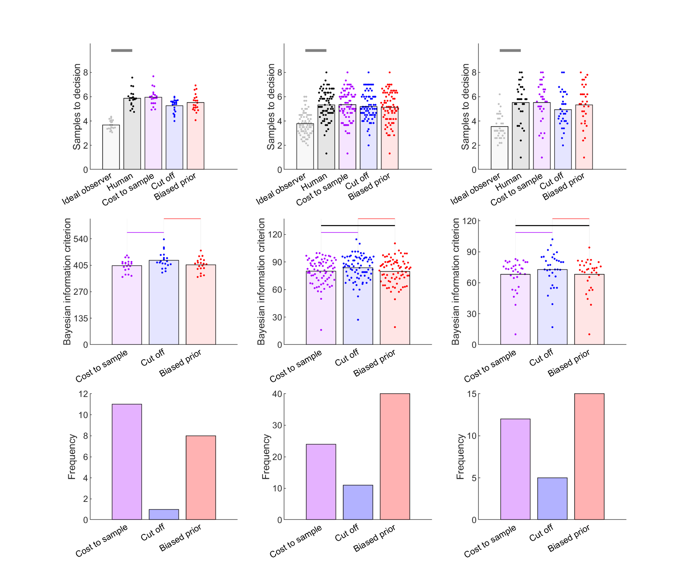

Figure 2 shows results for the three datasets that involved decisions about facial stimuli but were not searches for the most attractive face for oneself: matchmaker, trustworthiness 1 and trustworthiness 2. We replicate robust oversampling for all three datasets (Figure 2, top row, black and grey bars and points). These three new datasets show some differences from the datasets in Figure 1, as the cost to sample model appears to make a stronger contribution than the biased prior model. In matchmaker dataset and trustworthiness dataset 2, the cost to sample model shows statistically better BIC scores than either biased prior or cut off models (Figure 2, middle row). The cost to sample model further “wins” more participants than the biased prior model in all three datasets. It is therefore possible that people are optimistic when it comes to searching for an attractive mate for themselves, but less so when making other face-based decisions, where the reward value of sampling might be more influential. Additional analysis of these datasets, including ranks of chosen items and model parameter estimates, is shown in Supplementary Figure S5.

Figure 2. Human performance and model comparison for matchmaker dataset (left column), trustworthiness dataset 1 (centre column) and trustworthiness dataset 2 (right column). Points in the first and second rows show sampling corresponding to individual participants, while bars show their mean values. In the first row, human and ideal observer bars are demarcated by grey lines when *BF10* > 3. The second row shows Bayesian information criterion values (lower values indicate better model fit) for participants (points) and their mean values (bars). Black horizontal lines indicate when *BF01* > 3. When *BF10* > 3, the horizontal line is coloured the same as the bar of the better model. The proliferation of violet lines therefore suggests that the cost the sample model tends to fit significantly better than other models. The third row corroborates the finding that the cost to sample model best-fits the most participants’ data in all three datasets, though the biased prior model also best accounts for many participants’ choices.

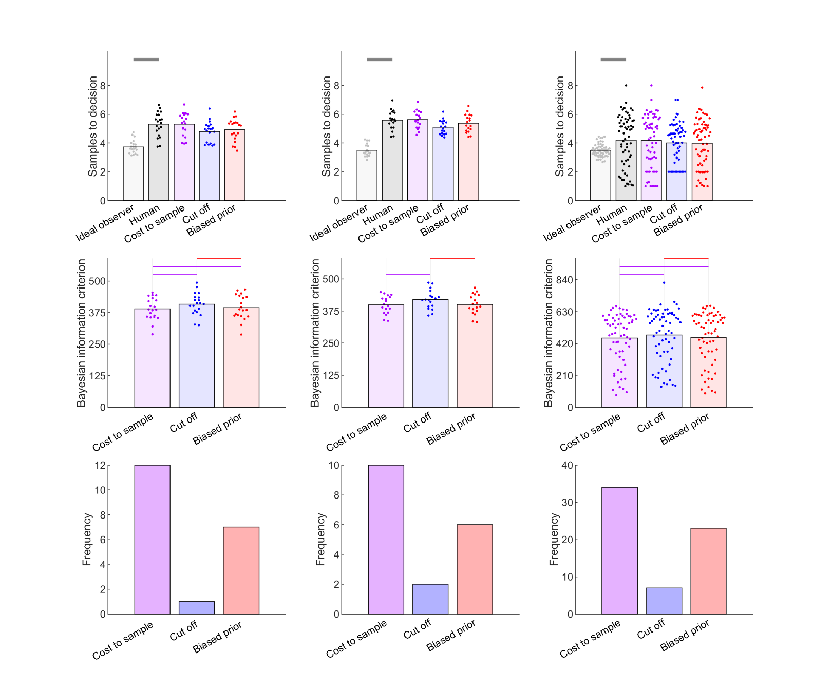

Figure 3 shows data for the datasets involving non-face image stimuli: foods and vacation destinations. The top row reproduces the results from van de Wouw et al. (2022) that all four datasets replicate robust oversampling. The middle and lower rows of Figure 3 show that three of the four datasets – foods dataset 1, foods dataset 2 and vacations dataset 1 – show substantial contributions of the cost to sample and biased prior models. For these datasets cost to sample and biased prior models both show significantly better BIC scores than the cut off model, with no evidence for statistical differences between cost to sample and biased prior model BICs (middle row, Figure 3). In both foods datasets, the biased prior model best-fits more participants (~5) than the cost to sample model. The data for vacations is more inconsistent, as the biased prior model best-fits the most participants in vacations dataset 1 while the cost to sample model best-fits the most participants in vacations dataset 2. We suspect this disagreement comes about because both strategies contribute when the domain is vacation destinations. Additional analysis of these datasets, including ranks of chosen items and model parameter estimates, is shown in Supplementary Figure S6.

Figure 3. Human performance and model comparison for (columns from left to right): foods datasets 1 and 2, vacations datasets 1 and 2. Points in the first and second rows show sampling corresponding to individual participants, while bars show their mean values. In the first row, human and ideal observer bars are demarcated by grey lines when *BF10* > 3. The second row shows Bayesian information criterion values (lower values indicate better model fit) for participants (points) and their mean values (bars). Black horizontal lines indicate when *BF01* > 3. When *BF10* > 3, the horizontal line is coloured the same as the bar of the better model. The proliferation of violet and red lines suggests that, for both foods and vacations domains, cost to sample and biased prior models are both strong contributors. This result is corroborated by the third row, which shows that cost to sample and biased prior models both best fit substantial portions of the participant sample.

Discussion

We built computational theories to explain biased oversampling in image-based full information optimal stopping problems. These theories were tested against ten datasets of participant choices in formal model comparisons. We did not find one dominant model for all datasets. It seems more likely that participants use multiple strategies, even within a specific domain (e.g., facial attractiveness), though the mixture of strategies may vary by domain. All datasets showed some contributions of cost to sample and biased prior models. However, evidence seemed to favour the biased prior over the cost to sample model to some degree for searches for attractive dates for oneself and for foods, while the evidence favoured the cost to sample over the biased prior model for searches for faces with other characteristics (attractive dates for another or trustworthy-appearing faces), and the evidence was more ambiguous for vacation destinations. We can reject the cut off model in favour of parameterised versions of the full information optimal solution like cost to sample and biased prior models. We also designed two more new computational theories, the biased values and biased reward models, but needed to reject them based on poor parameter recovery (See Supplementary Materials).

Our technique for parameterising the optimality models of the secretary problem (cut off model) and the full information problem (cost to sample and biased prior models) allowed us to simultaneously explain how participants can be highly accurate and still have that accuracy tempered by different types of systematic error. Indeed, participants’ ranks of chosen options (Figures S4-S6) show that, across datasets, participants achieve their second or third favourite options in each sequence on average, even if they are held back from achieving more by their proclivity to continue sampling past more highly ranked options.

The models we consider here build on other approaches (e.g., Lee, 2006; Baumann et al., 2020), in that that they more completely specify how choice thresholds are computed for each option. That is, our models detail how thresholds are computed and how biasing factors like an intrinsic cost to sample (or, more precisely, a personal feeling of reward associated with sampling) or prior beliefs influence these threshold computations. The aforementioned previous approaches estimate thresholds directly from behavioural data without also theoretically positing how the thresholds come to be computed by participants nor why they come to have the threshold values that they do. Nevertheless, although our models take a step further by specifying the influence of biasing factors on threshold computations, they could also be further developed by future research as well. For example, they simply estimate the extent of bias (e.g., cost to sample or biased prior) directly from participants’ behaviour data, without explicitly specifying the reasons these biases occur. In other words, the reasons why participants might perceive a reward value for sampling, even when they are not extrinsically rewarded in the studies, or the reasons why participants might have overoptimistic expectations about forthcoming options remain the next steps for future research.

For now, although we show evidence that some participants over sample in part because they find sampling intrinsically rewarding, we can only speculate why participants find sampling intrinsically rewarding. Sampling through and viewing many appealing and interesting images such as faces, foods or vacation destinations may have its own reward value, beyond just the achievement of a high-quality choice. Although there was on the whole somewhat more evidence for participants’ use of the biased prior model, the reasons that participants might use a biased prior strategy seem less obvious. The solution may lie in how the prior distribution is learned by participants. For example, participants may selectively remember high quality options that they hope to select later while forgetting less interesting options. This selective learning of certain high-quality items could occur during encounters with stimuli (e.g., faces) in the outside world before the study, or during phase 1 within the study. We note, though, that our preliminary results suggest that the presence or absence of an initial rating phase (phase 1) does not affect sampling rates at least on economic full information tasks (van de Wouw et al., 2023). Another possibility is that exposure to the deluge of media content outside of the study, especially commercial advertising, might positively bias participants’ expectations about the attractiveness of images depicting faces, foods or vacation destinations. We recommend that future studies concentrate on examining how participants form expectations about reward from statistical distribution learning, and to test whether optimistic prior expectations about images might arise in contexts more generally than just optimal stopping problems.

Our results, especially the robust finding of oversampling bias, were remarkably consistent across what amount to rather diverse datasets. Though the core methods embodying image-based full information problems were always present, the paradigm details markedly varied. Perhaps most importantly, the tasks varied by domain. Our preliminary hypothesis, based on oversampling in facial attractiveness tasks (Furl et al., 2019), was that oversampling arises from a predisposition to use a high-threshold when choosing mates, a phenomenon claimed to hold for animals by the behavioural ecology literature (Valone et al., 1996). This preliminary hypothesis proves false. Instead, oversampling is a broader phenomenon that generalises beyond personal mate choice and extends to mate choices for others (matchmaker dataset), other judgments about faces (trustworthiness datasets 1 and 2) and beyond faces altogether (foods datasets 1 and 2 and vacations datasets 1 and 2). Interestingly, the oversampling bias we replicated multiple times herein frequently does not arise for full information tasks (e.g., Baumann et al., 2020) or secretary problem tasks (e.g., Seale & Rappoport, 1997) where participants must search through sequences of numbers for the best one (e.g., prices in economic domains). We suspect that it is the image-based nature of the option value presentation that, at least in part, instigates this oversampling bias.

In addition to the searches involving different domains, the ten datasets also vary in whether they were conducted in the lab, sampled from a mostly student population (facial attractiveness dataset 1, matchmaker and trustworthiness dataset 1), online, sampled from a Prolific general population (trustworthiness dataset 2, facial attractiveness dataset 2, foods dataset 1, vacations dataset 1) or in-person, sampled from university open day attendees (facial attractiveness dataset 3, foods dataset 2, vacations dataset 2). The datasets also varied in sample size from 20 (facial attractiveness dataset 1, matchmaker dataset and trustworthiness dataset 1) to 75 (Facial attractiveness dataset 2, foods dataset 1 and vacations dataset 1). The number of sequences per participants varied from only five (Facial attractiveness datasets 2 and 3, foods dataset 1 and 2 and vacations dataset 1 and 2) to 40 (trustworthiness dataset 2). There was also no systematic relationship between the best-fitting models and the number of times potential options were rated in phase 1 or whether there was an intervening distractor task between phase 1 and the full information decision task. We note however that our first three studies (facial attractiveness dataset 1, matchmaker dataset and trustworthiness dataset 1) all used the same methods, sample sizes and (mainly student) participant populations and these were the datasets that showed a slight advantage for the cost to sample over the biased prior model. Perhaps student populations are relatively more susceptible to the reward value of sampling facial stimuli (as with dating apps like Tinder). Following on from our demonstration that oversampling might constitute a mix of different strategies, a fruitful line of research might be to confirm whether the mixture of strategies varies among different populations.

In sum, our study demonstrates the utility of a modelling-based approach. We show here that more than one computational strategy (i.e., the cost to sample and biased prior models) can give rise to the same apparent behavioural effect – oversampling. Moreover, fitting parameterised models can help identify individuals disposed to use these different strategies. Here, we use this approach to show (a) how oversampling generalises across several image-based choice domains; (b) the use of both cost to sample and biased prior strategies in these domains; and (c) how to identify participants using each strategy. With increasing use of online and smartphone applications, from ordering a meal online to choosing a date on Tinder, more and more decisions are made by accepting and rejecting sequences of images. By studying these types of searches, providers and users of services involving such searches can better understand and perhaps even improve the performance of searches in real world settings like these.

References

Anwyl-Irvine, A. L., Massonnié, J., Flitton, A., Kirkham, N., & Evershed, J. K. (2020). Gorilla in our midst: An online behavioral experiment builder. *Behavior Research Methods, 52,* 388–407. <https://doi.org/10.3758/s13428-019-01237-x>

Baumann, C., Singmann, H., Gershman, S. J., & von Helversen, B. (2020). A linear threshold model for optimal stopping behavior. *Proceedings of the National Academy of Sciences, 117,* 12750–12755. <https://doi.org/10.1073/pnas.2002312117>

Bainbridge, W. A., Isola, P., & Oliva, A. (2013). The intrinsic memorability of face photographs. *Journal of Experimental Psychology: General, 142,* 1323–1334. <https://doi.org/10.1037/a0033872>

Blechert, J., Lender, A., Polk, S., Busch, N. A., & Ohla, K. (2019). Food-Pics_Extended — An Image Database for Experimental Research on Eating and Appetite: Additional Images, Normative Ratings and an Updated Review. *Frontiers in Psychology, 10,* 307. <https://doi.org/10.3389/fpsyg.2019.00307>

Cardinale, E. M., Pagliaccio, D., Swetlitz, C., Grassie, H., Abend, R., Costa, V., Averbeck, B. B., Brotman, M. A., Pine, D. S., Leibenluft, E., & Kircanski, K. (2021). Deliberative choice strategies in youths: Relevance to transdiagnostic anxiety symptoms. *Clinical Psychological Science*, *9,* 1–11. <https://doi.org/10.1177/2167702621991805>

Castellano, S., Cadeddu, G., & Cermelli, P. (2012). Computational mate choice: Theory and empirical evidence. *Behavioural Processes, 90,* 261–277. <https://doi.org/10.1016/j.beproc.2012.02.010>

Castellano, S., & Cermelli, P. (2011). Sampling and assessment accuracy in mate choice: A random-walk model of information processing in mating decision. *Journal of Theoretical Biology, 274,* 161–169. <https://doi.org/10.1016/j.jtbi.2011.01.001>

Costa, V. D, & Averbeck, B. B. (2015). Frontal-parietal and limbic-striatal activity underlies information sampling in the best choice problem. *Cerebral Cortex,* *25,* 972–982. <https://doi.org/10.1093/cercor/bht286>.

Ferguson, T. S. (1989). Who solved the secretary problem? *Statistical Science, 4*, 282–289. <https://doi.org/10.1214/ss/1177012493>

Freeman, P. R. (1983). The secretary problem and its extensions: A review. *International Statistical Review / Revue Internationale de Statistique, 51*, 189–206. <https://doi.org/10.2307/1402748>

Furl, N., Averbeck, B. B., & McKay, R. T. (2019). Looking for Mr(s) Right: Decision bias can prevent us from finding the most attractive face. *Cognitive Psychology, 111,* 1–14. <https://doi.org/10.1016/j.cogpsych.2019.02.002>

Gilbert, J. P., & Mosteller, F. (1966). Recognizing the maximum of a sequence. *Journal of the American Statistical Association, 61*, 35–73. <https://doi.org/10.2307/2283044>

Goldstein, D. G., McAfee, R. P., Suri, S., & Wright, J. R. (2020). Learning When to Stop Searching. *Management Science, 66,* 1375–1394. <https://doi.org/10.1287/mnsc.2018.3245>

Guan, M., & Lee, M. D. (2018). The effect of goals and environments on human performance in optimal stopping problems. *Decision, 5,* 339–361. <https://doi.org/10.1037/dec0000081>

Guan, M., & Stokes, R. (2020). A cognitive modeling analysis of risk in sequential choice tasks. *Judgment and Decision Making ,15,* 823–850.

Lee, M. D. (2006). A hierarchical Bayesian model of human decision-making on an optimal stopping problem. *Cognitive Science, 30,* 1–26. <https://doi.org/10.1207/s15516709cog0000_69>

MATLAB. (2010). version 9.9.0 (R2020b). Natick, Massachusetts: The MathWorks Inc.

Olivola, C.Y., Funk, F. & Todorov, A. (2014). Social attributions from faces bias human choices. *Trends in Cognitive Sciences, 11,* 566-570. <https://doi.org/10.1016/j.tics.2014.09.007>

Prolific. (2014). Available at: <https://www.prolific.co>

Seale, D. A., & Rapoport, A. (1997). Sequential decision making with relative ranks: An experimental investigation of the "secretary problem". *Organizational Behavior and Human Decision Processes, 69,* 221–236. <https://doi.org/10.1006/obhd.1997.2683>

Valone, T.J., Nordell, S.E., Giraldeau, L-A. & Templeton, J.J. (1996). The empirical question of thresholds and mechanisms of mate choice. *Evolutionary Ecology, 10,* 447-455. <https://doi.org/10.1007/BF01237729>

van de Wouw, S., McKay, R., Averbeck, B. J., & Furl, N. (2022). Explaining human sampling rates across different decision domains. *Judgment and Decision Making,* *17*, 487-512. <https://doi.org/10.1017/S1930297500003557>

van de Wouw, D. S., McKay, R., & Furl, N. (2021, September 14). Methodological Remarks Regarding Optimal Stopping Tasks and the Implications for Sampling Biases. https://doi.org/10.31234/osf.io/5j74d