Initial problems with webpage diagnosed by WAVE:

* ‘Home’ and ‘Links’ images missing alternative text
* 5 missing form labels
* Low Contrast between text and background colors
* No heading structure
* No page Regions
* Redundant links
* Positive Tabindex value

Problems:

1. Headings
   1. Description: No Headings are Present in the HTML
   2. Estimated Severity: Very, without headings it can be difficult for accessibility tools to cleanly move through the file
   3. How to Fix: Made the banner the main header and the “links” and “sign-up” div secondary headers

1. Detected by Automatic Evaluator: Yes
2. Alternative Text for Images
   1. Description: “Pics” “Home” and “Links” Button lack Alternative Text
   2. Estimated Severity: Mild. Without the text, the Website is still navigable, if somewhat awkward.
   3. How to Fix: Add the “alt” tag to each of the image with the relavent information written in

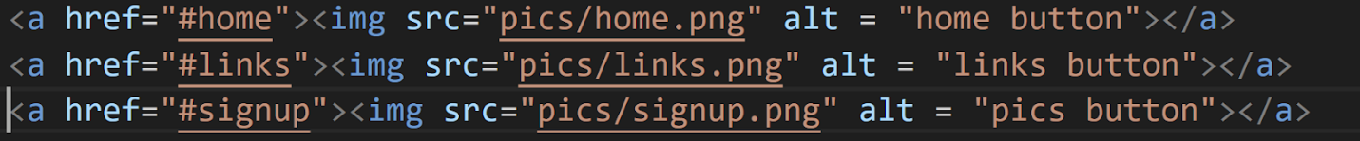

1. Detected by Automatic Evaluator: Yes
2. Form Labels
   1. Description: Each form entry under “Sign Up!” lack a form label
   2. Estimated Severity: Very, a user with sight impairment would have a difficult time using the Sign up function of the website, which is very important in the use of the website
   3. How to Fix: Add labels to each of the forms, replacing any old, non-label text



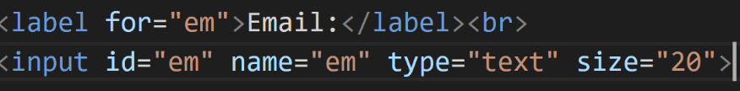

1. Detected by Automatic Evaluator: Yes
2. Form Widgets Without Semantics
   1. Description: The spam sign-up box and the videoplayer are both simply listed as divs, without the proper context behind them
   2. Estimated Severity: Mild, the lack of clearly defined role could introduce confusion for screen readers.
   3. How to Fix: Add a role to both of the buttons, marking them.





1. Detected by Automatic Evaluator:
2. Video Captions
   1. Description: Video lacks video captioning
   2. Estimated Severity: Severe, for those with hearing impairment, the video is totally inaccessible.
   3. How to Fix: Upload video to youtube, generate captions, then embed video into the website

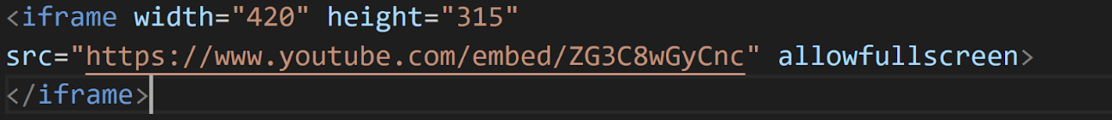

1. Detected by Automatic Evaluator: No
2. Audio Descriptions
   1. Description: Embedded video does not contain audio description of the graph which is shown
   2. Estimated Severity: Somewhat, while the video can still be understood without the graph, important context is lost to the listener
   3. How to Fix: Add an additional couple seconds to the beginning of the video and add a tts track giving an audio description
   4. Detected by Automatic Evaluator: No
3. Tab Order & Visible Focus
   1. Description: The video is marked with “tabindex =5” which messes up the flow of the website,  the checkmark and play buttons are not being properly tabbed through. Additionally, the top row is non-accessible as they are not being outlined
   2. Estimated Severity: Severe, the user cannot properly tab index through the website
   3. How to Fix: Remove the tabindex marking on the video, add tabindex to the checkmark div, change outline color to black for navigation.



1. Detected by Automatic Evaluator: Yes
2. Color Contrast
   1. Description: All of the text for the links are low contrast, a light gray against a white background. The Sign up forms also initially had this issue but were fixed in replacing the markings with form labels.
   2. Estimated Severity: Somewhat, this makes traversal through the website difficult for those with either poor eyesight or poor color differentiation.
   3. How to Fix: Change the font color to be of greater contrast. In this case change the color of a in css to black

1. Detected by Automatic Evaluator: Yes
2. Keyboard Access
   1. Description: The checkmark box for spam is unable to be clicked outside of a mousepress
   2. Estimated Severity: Severe, this totally locks some users out of this button’s functionality.
   3. How to Fix: Add javascript function checking keydown instead of just keypress

1. Detected by Automatic Evaluator: No
2. Information Conveyed only Via Color
   1. Description: In case of sign-up failure due to a lack of name provided, the only indication of the error is changing the color of the “Name” text
   2. Estimated Severity: Severe, this error can potentially affect a wide variety of users— anyone who is unable to differentiate colors, or otherwise has other visual impairments will be unable to tell the cause of their error sign-up
   3. How to Fix: Create a pop-up message explaining that a form needs to be filled in.

1. Detected by Automatic Evaluator: No

**MISC ADDITIONAL ISSUES:**

1. Invalid Link
   1. Description: Link did not have any corresponding text, making it an empty link
   2. Estimated Severity: severe, An empty link means that the feature is accessible to no user.
   3. How to Fix: Add a link



1. Detected by Automatic Evaluator: Yes
2. Language Indicator
   1. Description: There is no language indication at the beginning of the html document
   2. Estimated Severity: Mild
   3. How to Fix: add a language indication

1. Detected by Automatic Evaluator: Yes