Like I said earlier, this post is a sort of introduction to programming, however, it is not a typical, "Hello World" introduction. We will be using C++ and inline Assembly to investigate what exactly is going on in a program and C++. The following will be explained:

- what a C++ program is and looks like to a computer
- what variables are and how the stack and memory works
- what functions are and how they work
- how pointers work
- how math and logic works, such as when you evaluate an equation

What a C++ program is and what it looks like to the computer

C++ and any programming language is just a bunch of words and syntax used to describe a process for the computer to perform.

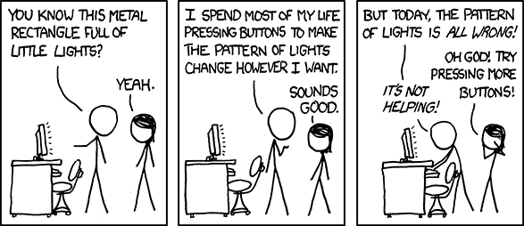
source: https://imgs.xkcd.com/comics/computer_problems.png

You write a bunch of stuff, and the computer does exactly what you commanded it to. That said, while a program is a series of words and syntax to us, to the computer, it ends up being quite different. Computers only understand numbers, so somewhere between when a program is written and when it is executed by the computer, it gets interpreted from the programming language into numbers – Machine Code.

For example, the following program:

r = x + x * y / z - z * x

Looks like this in Machine Code:
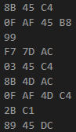
Programming languages exist for a several reasons:

- to provide an alternative to writing in Machine Code
- to make writing maintainable and manageable code bases possible
- to allow programmers to express themselves in different ways
- to accomplish a task with efficiency given a language customized to that task

Finally, the basic C++ program that writes, "Hello World!", to the console screen:

int main(){
std::cout << "Hello World!";
return 0;
}

In Machine Code, it looks like this:
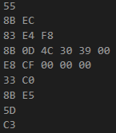

C++ is quite the improvement.

The language that translates closely to Machine Code is Assembly Language. While both Machine Code and Assembly Language are unpractical to work with, Assembly Language is actually something people do use, and we are going to use it to link what's going on in the computer to what's going on in C++.

Before we can move into Assembly, however, we need to review some basics of how programs work.

Memory

As we know, computers work with numbers, and a program is ultimately a bunch of numbers. The numbers are stored in the the computer in a place called memory, and lots of them, more numbers than you could count in your lifetime. It can be thought of as an array, grid or matrix where each cell contains a number and is a specific location in memory.

A visualization of memory.

These cells exist in sequence and that sequence describes its location. For instance, we could start counting memory at cell 1, and go to cell 7, and each of those locations could be referred to by their sequence number: 1 to 7.

The numbers in memory can represent one of two things:

- a Machine Code or operand used to execute a command
- some sort of Variable - an arbitrary value to be used by, or that has been saved by, a program

In programming languages such as C++, variables are referred to using names rather than their sequence number, and Machine Code is abstracted away with verbose language.

A snippet of C++ that declares three variables and prints them out.
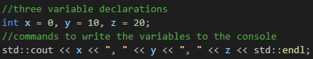
The same snippet in Assembly; for glancing only.
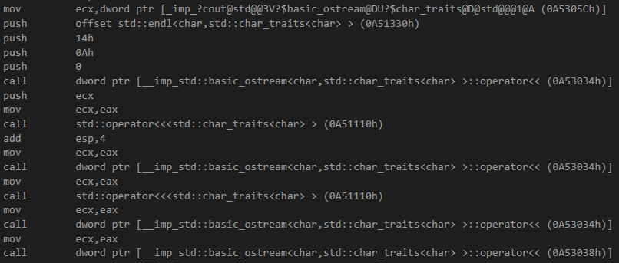

The Stack: a type of Memory for Variables

Whenever a Variable is declared, it gets allocated in an area of Memory called the Stack. The Stack is a special type of Memory which is essential to how a C++ program executes. When a Variable enters scope, it gets allocated onto the Stack, and then later, when it exits scope, it's removed from the Stack. The Stack grows in size as Variables enter scope and shrinks as Variables exit scope.

In C++, curly braces “{ “ and “ } “ are used to define a variable's scope, also known as a block or epoch.

A C++ program with several blocks:

void main(){ //begin block a:

//x is allocated, stack size goes to 1
int x = 0;

{ // begin block b:

// k, l and m are allocated, stack size goes to 4
int k = 2, l = 3, m = 4;

// an example operation
x = k + l + m;

} // end of block b, stack size shrinks back to 1

// - back to block a - y is allocated, stack size goes to 2
int y = 0;

{ // begin block c:

// l and o are allocated, stack size goes to 4
int l = 12, o = 2;

// an example operation
y = l * o;

} // end of block c, stack size shrinks back 2

// - back to block a - z is allocated, stack size goes to 3
int z = 0;

// an example operation
z = x - y;

// write result, z, to the console
std::cout << z << std::endl;

} // end of block a, stack shrinks to size 0

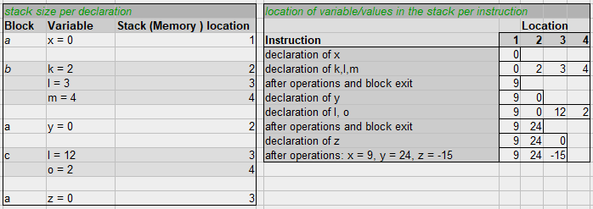

x86 Assembly Brief

Assembly is really simple. Simple but lengthy and hard to work with because of its lengthiness. Lets jump right in.

A line of Assembly consists of a command and its operands. Operands are numbers of course, but these numbers can refer to a few different things: Constants ( plain numbers ), Memory locations (such as a reference to a Stack Variable), and Registers, which are a special type of Memory on the processor.

The Stack's current location is in the esp register. The esp register starts at a high memory location, the top the stack, such as 1000, and as it grows, the register is decremented, towards say, 900 and 500, and eventually to point where the stack can grow no further. General purpose registers include eax and ebx, and are used to store whatever.

There are two commands that manipulate the stack directly:

- push [operand]
put the operand value onto the stack, and decrement esp

- pop [operand]
remove a value from the Stack and stores it in the operand register, and increment esp

Registers:

- esp
the Stack's top, moves up or down depending on pushes/pops, or plain adds/subtracts.
- eax, ebx
general purpose registers

Given these two instructions we can create and destroy stack variables. For instance, similar to the program above but without the example equations:

_asm{

push 0 //create x, with a value of 0

push 2 //create k
push 3 //create l
push 4 //create m
pop eax //destroy m
pop eax //destroy l
pop eax //destroy k

push 0 //create y

push 12 //create l
push 2 //create o
pop eax //destroy o
pop eax //destroy l

push 0 //create z

pop eax //destroy z
pop eax //destroy y
pop eax //destroy x
}

Adding in the example equations requires some additional commands:

- add
adds the operand to the eax register
- sub
subtracts the operand from the eax register
- mul
multiplies the operand by the eax register
- mov
copies a value from a Register to Memory or vice versa.

_asm{

push 0 //create x, with a value of 0

push 2 //create k
push 3 //create l
push 4 //create m

//k + l + m;
mov eax, [esp + 8] // copy k into eax
add eax, [esp + 4] // add l to eax
add eax, [esp] //add m to eax

pop ebx //destroy m - we do not care about ebx
pop ebx //destroy l
pop ebx //destroy k

//store the value in x
mov [esp], eax

push 0 //create y

push 12 //create l
push 2 //create o

// l * o
mov eax, [esp + 4] //copy l into eax
mul [esp] //multilpy o by eax

pop ebx //destroy o
pop ebx //destroy l

//store the value in y
mov [esp], eax

pop ebx //destroy o
pop ebx //destroy l

push 0 //create z

//x - y;
mov eax, [esp + 8]
sub eax, [esp + 4]

mov [esp], eax //write to z; z = -15

pop ebx //clear z
pop ebx //clear y
pop ebx //clear x
}

- When working with esp, there can be addition or subtraction of an offset that is a multiple of 4. It's a multiple of 4 because on x86 ( 32 bit systems ), the stack is int-aligned to 4 bytes.
- The brackets on esp or another variable result in the dereferenced value. The actual value of the esp register is merely esp, whereas [esp] is the value pointed to by the esp register.

Because the Stack grows downward, to access a value pushed earlier, we need to add to esp, while the very top of the stack is just esp. Instead of poping from the Stack, if you don't care about getting that value, you can add to esp instead.

//pop copies [esp] to the operand register before //incrementing esp

pop ebx //clear z //4 bytes
pop ebx //clear y //4 bytes
pop ebx //clear x //4 bytes

//equivelant to, but not caring about the stack contents

add esp, 12 // clear z through x //4 * 3 bytes

