Homework 2

15331191 廖颖泓

1. 模型的性能度量

(1) M1的Confusion Matrix如下所示

|  |  |  |  |
| --- | --- | --- | --- |
|  | PREDICTED CLASS | | |
| ACTUAL  CLASS |  | Class = + | Class = - |
| Class = + | 2 | 2 |
| Class = - | 2 | 4 |

查准率 (precision) = 2 / (2 + 2) = 0.5

查全率 (recall) = 2 / (2 + 2) = 0.5

假正例率 (FPR) = 2 / (2 + 4) = 0.33

F-measure = 2 * 0.5 * 0.5 / (0.5 + 0.5) = 0.5

准确率(accuracy) = (2 + 4) / 10 = 0.6

(2) M2的Confusion Matrix如下所示

|  |  |  |  |
| --- | --- | --- | --- |
|  | PREDICTED CLASS | | |
| ACTUAL  CLASS |  | Class = + | Class = - |
| Class = + | 1 | 3 |
| Class = - | 1 | 5 |

查准率 (precision) = 1 / (1 + 1) = 0.5

查全率 (recall) = 1 / (1 + 3) = 0.25

假正例率 (FPR) = 1 / (1 + 5) = 0.17

F-measure = 2 * 0.5 * 0.25 / (0.5 + 0.25) = 0.33

准确率(accuracy) = (1 + 5) / 10 = 0.6

M1和M2的准确率、查准率相等，M1的查全率和F-measure大于M2，假正例率小于M2，所以M1的在这个测试集上表现更好。

(3) M1的Confusion Matrix如下所示

|  |  |  |  |
| --- | --- | --- | --- |
|  | PREDICTED CLASS | | |
| ACTUAL  CLASS |  | Class = + | Class = - |
| Class = + | 4 | 0 |
| Class = - | 4 | 2 |

查准率 (precision) = 4 / (4 + 4) = 0.5

查全率 (recall) = 4 / (4 + 0) = 1

假正例率 (FPR) = 4 / (4 + 2) = 0.67

F-measure = 2 * 0.5 * 1 / (0.5 + 1) = 0.67

准确率(accuracy) = (4 + 2) / 10 = 0.6

阈值为0.5和阈值为0.2的准确率、查准率相等，阈值为0.2的查全率和F-measure大于阈值为0.5，假正例率大于阈值为0.5。ROC曲线上的点(FPR, TPR)越接近左上角点(0, 1)，这个点对应的阈值产生的分类效果越好。结合(4)中的ROC曲线，阈值为0.2对应的点(1,0.76)比阈值为0.5对应的点(0.33,0.5)离左上角点(0,1)更远一点，所以相对来说阈值为0.5的M1模型分类效果更好。

(4) 调用Matlab中的函数plotroc(targets,outputs)绘制ROC曲线，得到下图

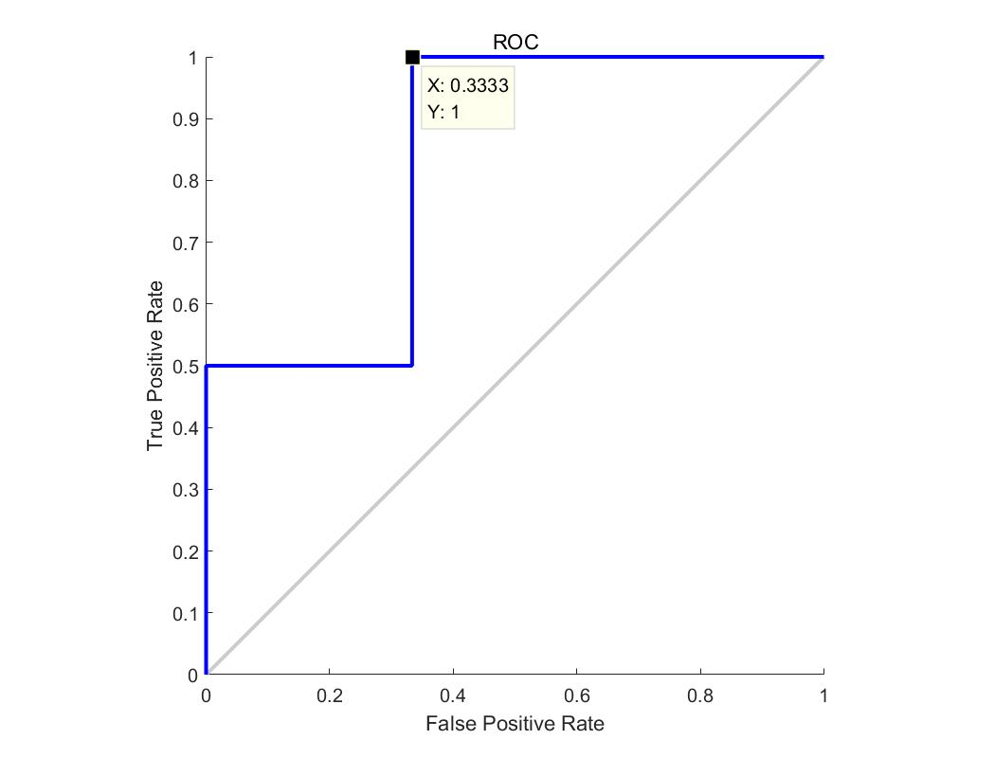

ROC曲线上的点(FPR, TPR)越接近左上角点(0, 1)，这个点对应的阈值产生的分类效果越好。结合该图，该曲线上的点(0.33, 1)最接近点(0, 1)，此时调用Matlab中的函数roc(targets,outputs)求出对应的阈值为0.44。

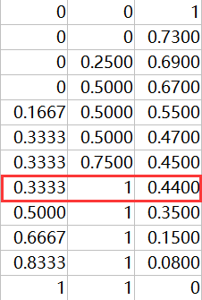

1. 神经网络
2. 训练样本点分布如下图所示

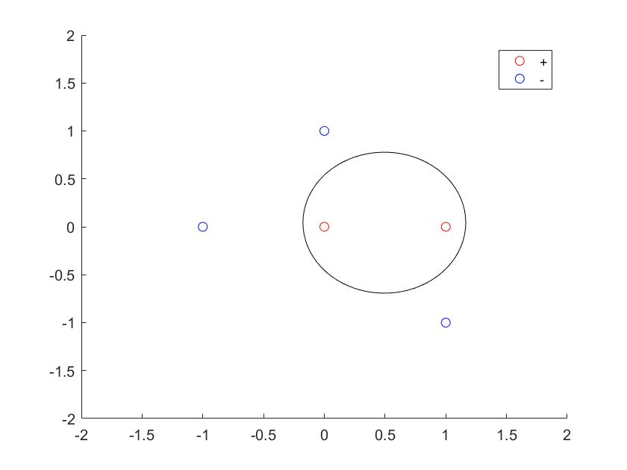

根据样本点的分布，无法得到一个能够将训练集正实例点和负实例点完全正确分开的分离超平面，所以此训练样本集不是线性可分。

(2) 如下图所示，如果将Sigmoid函数换成线性函数y = wx+b，神经网络每一层的结果都是一个线性变换的结果，无论经过多少层的变换，始终得到一个线性变换的结果，说明神经网络退化成一个线性分类器。结合(1)，线性分类器无法处理数据线性不可分的情况，这就导致神经网络无法处理线性不可分的数据。

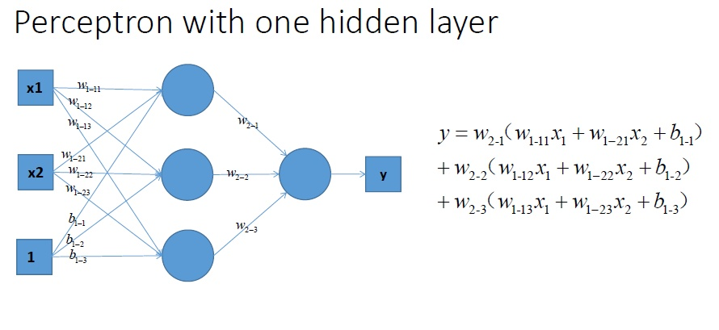

(3) 结合下图，使用前馈算法计算

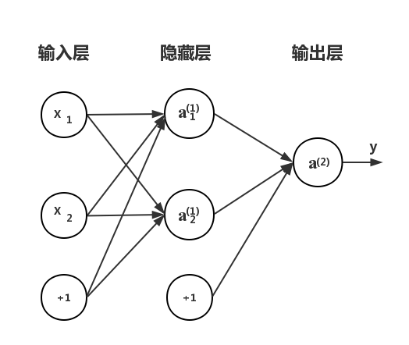

，

，

，

，

(考虑到矩阵加法，故增加列数来满足计算的需要)

=

=

使用反向传播算法计算

=

=

=

=

=

=

=

=

=

=

=

=

=

=

=

因为链式法则对参数求偏导得到梯度再进行梯度下降，初始化所有参数为0会导致参数值不发生变化，每一层参数都是一样的。

(4) 神经网络架构图如图所示



为了让该网络可以正确地分类数据点，用训练样本集训练该网络，这个过程在Tensorflow深度学习框架上实现，预测输出值大于0.5时为+，小于等于0.5时为-，经过40000次迭代，最终输出相应的参数W1，W2，b1和b2。由于初始化参数为0不容易收敛，故初始化参数时使用随机数的方法初始化，如下图所示。

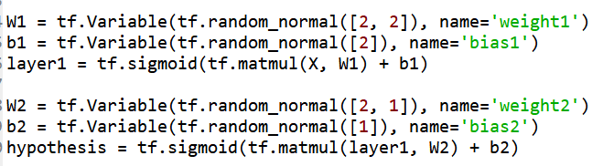

得到的结果为

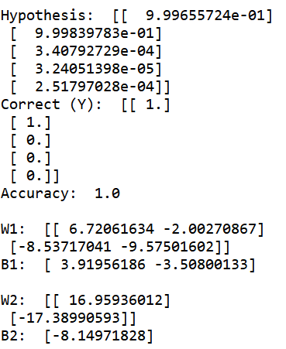

可见准确率为1，可以正确分类训练样本集。得到的参数具体如下(答案可能因为矩阵转置有所差异)：

，

，

1. 决策树

(1)

P(+) = 4/10 = 0.4

P(-) = 6/10 = 0.6

Entropy(Class) = - 0.4log0.4 – 0.6log0.6 = 0.67

属性A：

P(T) = 7/10 = 0.7

P(F) = 3/10 = 0.3

P(+|T) = 4/7

P(-|T) = 3/7

P(+|F) = 0/3 = 0

P(-|F) = 3/3 = 1

GAIN(A) = Entropy(Class) – 0.7(-(4/7)log(4/7)-(3/7)log(3/7)) – 0.3(-0log0-1log1) = 0.67 – 0.478 – 0 = 0.192

属性B：

P(T) = 4/10 = 0.4

P(F) = 6/10 = 0.6

P(T|+) = 3/4 = 0.75

P(F|+) = 1/4 = 0.25

P(T|-) = 1/6

P(F|-) = 5/6

GAIN(B) = Entropy(Class) – 0.4(-0.75log0.75-0.25log0.25) – 0.6(-1/6log1/6-5/6log5/6) = 0.67 –0.22 – 0.27 = 0.18

因为GAIN(A) > GAIN(B)，所以应该选择属性A进行划分。

(2)

P(+) = 4/10 = 0.4

P(-) = 6/10 = 0.6

Gini(Class) = 1 – 0.4 * 0.4 - 0.6 * 0.6 = 0.48

属性A：

P(T) = 7/10 = 0.7

P(F) = 3/10 = 0.3

P(+|T) = 4/7

P(-|T) = 3/7

P(+|F) = 0/3 = 0

P(-|F) = 3/3 = 1

GINI(T) = 1 – (4/7)2 – (3/7)2 = 0.49

GINI(F) = 1 – (0)2 – (1)2 = 0

GINI(A) = 0.49 * 0.7 + 0 * 0.3 = 0.34

GAIN(A) = 0.48 – 0.34 = 0.14

属性B：

P(T) = 4/10 = 0.4

P(F) = 6/10 = 0.6

P(+|T) = 3/4 = 0.75

P(-|T) = 1/4 = 0.25

P(+|F) = 1/6

P(-|F) = 5/6

GINI(T) = 1 – (0.75)2 – (0.25)2 = 0.375

GINI(F) = 1 – (1/6)2 – (5/6)2 = 0.28

GINI(B) = 0.375 * 0.4 + 0.28 * 0.6 = 0.318

GAIN(B) = 0.48 – 0.318 = 0.162

因为GAIN(A) < GAIN(B)，所以应该选择属性B进行划分。

(3)

P(+) = 4/10 = 0.4

P(-) = 6/10 = 0.6

Classification Error(Class) = 1 – max(0.4,0.6) = 0.4

属性A：

P(T) = 7/10 = 0.7

P(F) = 3/10 = 0.3

P(+|T) = 4/7

P(-|T) = 3/7

P(+|F) = 0/3 = 0

P(-|F) = 3/3 = 1

GINI(T) = 1 – max(4/7, 3/7) = 3/7

GINI(F) = 1 – max(0,1) = 0

Classification Error(A) = 3/7 * 0.7 + 0 * 0.3 = 0.3

GAIN(A) = 0.48 – 0.3 = 0.18

属性B：

P(T) = 4/10 = 0.4

P(F) = 6/10 = 0.6

P(+|T) = 3/4 = 0.75

P(-|T) = 1/4 = 0.25

P(+|F) = 1/6

P(-|F) = 5/6

GINI(T) = 1 – max(0.75, 0.25) = 0.25

GINI(F) = 1 – max(1/6,5/6) = 1/6

Classification Error(B) = 0.25 * 0.4 + 1/6 * 0.6 = 0.2

GAIN(B) = 0.48 – 0.2 = 0.28

因为GAIN(A) < GAIN(B)，所以应该选择属性B进行划分。