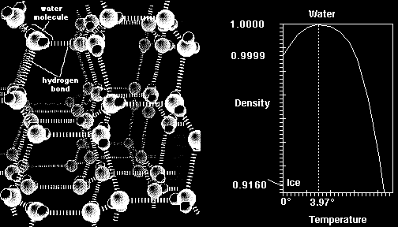

ft) and the Temperature Density Relationship for Water (Right)
This figure illustrates a model of the molecular structure of ice (left). Notice how individual water molecules are all present at the maximum distance from adjacent molecules due to hydrogen bonding. Hence, water exhibits its minimum density when it is in the form of ice. The transformation of ice to water is accompanied by the breaking of some of the hydrogen bonds, leading to a dramatic increase in density. The graph at right illustrates the anomalous temperature:density interrelationship for water. Note that the lowest density is at 0° but the maximum density is at 3.97°. Because of this relationship, ice floats.

Gary Anderson.

