Project

Project Steps

Project Definition

Author: Nicholas Ndung’u

Date: 29:06:2023

Version: V 1.0

Topic: Using DHT Sensor to check temperature and humidity of the environment of a robot.

2. Project Design

3. Connect the components.

4. Program the Microntroller

5. Observe and Report.

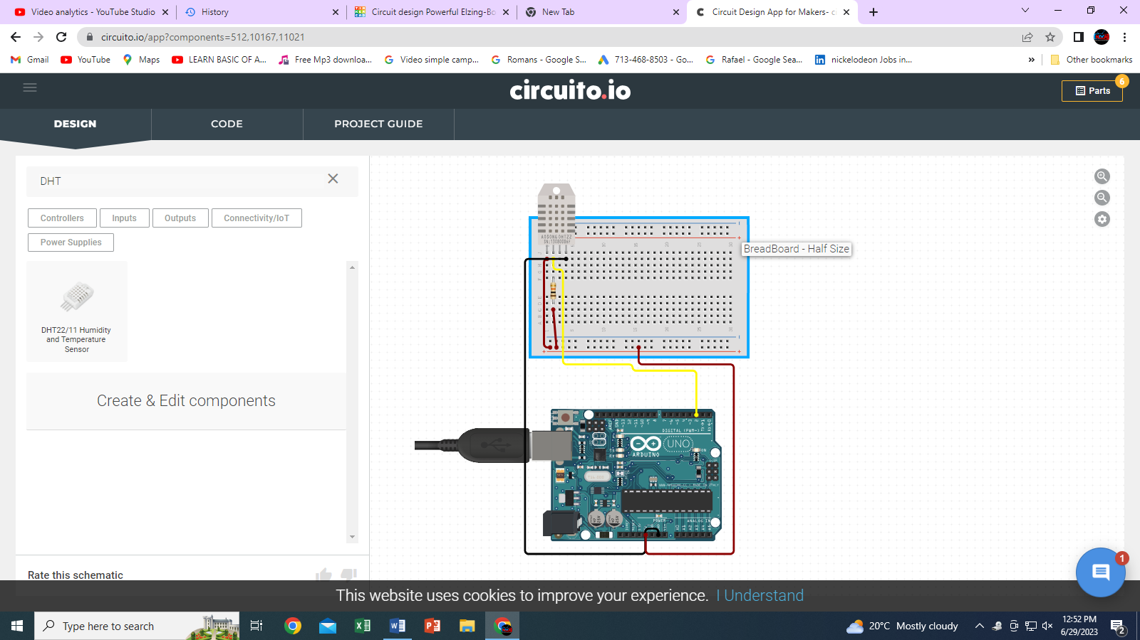3.connect the component

|  |  |  |
| --- | --- | --- |
| WIRE | DHT | MCU |
| Black | -or GND |  |
| Gray | OUT |  |
| White | +or+ve |  |

4. Program the microntroller

5. Observe and report

