R Notebook

# Bibliometric analysis using the bibliometrix R package  
# https://bibliometrix.org/documents/bibliometrix_Report.html  
  
## To cite bibliometrix in publications, please use:  
##   
## Aria, M. & Cuccurullo, C. (2017) bibliometrix: An R-tool for comprehensive science mapping analysis,   
## Journal of Informetrics, 11(4), pp 959-975, Elsevier.  
##   
##   
## https://www.bibliometrix.org  
##   
##   
## For information and bug reports:  
## - Send an email to info@bibliometrix.org   
## - Write a post on https://github.com/massimoaria/bibliometrix/issues  
##   
## Help us to keep Bibliometrix free to download and use by contributing with a small donation to support our research team (https://bibliometrix.org/donate.html)  
  
  
# Install the bibliometrix package  
#install.packages("bibliometrix", dependencies = TRUE)  
  
  
# Data loading and converting  
library(bibliometrix)

## To cite bibliometrix in publications, please use:  
##   
## Aria, M. & Cuccurullo, C. (2017) bibliometrix: An R-tool for comprehensive science mapping analysis,   
## Journal of Informetrics, 11(4), pp 959-975, Elsevier.  
##   
##   
## https://www.bibliometrix.org  
##   
##   
## For information and bug reports:  
## - Send an email to info@bibliometrix.org   
## - Write a post on https://github.com/massimoaria/bibliometrix/issues  
##   
## Help us to keep Bibliometrix free to download and use by contributing with a small donation to support our research team (https://bibliometrix.org/donate.html)  
##   
##   
## To start with the shiny web-interface, please digit:  
## biblioshiny()

myfile <- "20221111-analysis-corpus-web-of-science-export.txt"  
  
# Converting the loaded files into a R bibliographic dataframe  
M <- convert2df(file=myfile, dbsource="wos",format="plaintext")

##   
## Converting your wos collection into a bibliographic dataframe  
##   
## Done!  
##   
##   
## Generating affiliation field tag AU_UN from C1: Done!

# Section 1: Main Findings  
#options(width=160)  
results <- biblioAnalysis(M)  
summary(results, k=10, pause=F, width=130)

##   
##   
## MAIN INFORMATION ABOUT DATA  
##   
## Timespan 1994 : 2023   
## Sources (Journals, Books, etc) 65   
## Documents 105   
## Annual Growth Rate % 0   
## Document Average Age 5.15   
## Average citations per doc 15.18   
## Average citations per year per doc 3.506   
## References 7213   
##   
## DOCUMENT TYPES   
## article 93   
## article; early access 8   
## article; proceedings paper 4   
##   
## DOCUMENT CONTENTS  
## Keywords Plus (ID) 348   
## Author's Keywords (DE) 445   
##   
## AUTHORS  
## Authors 220   
## Author Appearances 224   
## Authors of single-authored docs 38   
##   
## AUTHORS COLLABORATION  
## Single-authored docs 39   
## Documents per Author 0.477   
## Co-Authors per Doc 2.13   
## International co-authorships % 26.67   
##   
##   
## Annual Scientific Production  
##   
## Year Articles  
## 1994 1  
## 1995 2  
## 1997 1  
## 2000 1  
## 2004 1  
## 2005 1  
## 2006 2  
## 2007 2  
## 2008 2  
## 2010 1  
## 2011 5  
## 2012 2  
## 2014 1  
## 2015 1  
## 2016 4  
## 2017 4  
## 2018 5  
## 2019 12  
## 2020 15  
## 2021 15  
## 2022 18  
## 2023 1  
##   
## Annual Percentage Growth Rate 0   
##   
##   
## Most Productive Authors  
##   
## Authors Articles Authors Articles Fractionalized  
## 1 BOJE DM 2 DASHPER K 2.0  
## 2 DASHPER K 2 WADDOCK S 1.5  
## 3 TALLBERG L 2 ANDERSEN PB 1.0  
## 4 WADDOCK S 2 BEACHAM J 1.0  
## 5 ALKIRE L 1 BOOTH DE 1.0  
## 6 ANDERSEN PB 1 BROSNAN SF 1.0  
## 7 ARA E 1 CARLEY KM 1.0  
## 8 ASHFORTH BE 1 COYLE D 1.0  
## 9 AZAMBUJA R 1 EYONG JE 1.0  
## 10 BARNACLE ML 1 FONTENELLE IA 1.0  
##   
##   
## Top manuscripts per citations  
##   
## Paper DOI TC TCperYear NTC  
## 1 STARIK M, 1995, J BUS ETHICS 10.1007/BF00881435 228 8.14 1.81  
## 2 PHILLIPS RA, 2000, J BUS ETHICS 10.1023/A:1006041929249 121 5.26 1.00  
## 3 ROBINSON S, 2020, J BUS RES 10.1016/j.jbusres.2019.08.038 61 20.33 3.39  
## 4 INTRONA LD, 2011, INFORM ORGAN-UK 10.1016/j.infoandorg.2011.03.001 59 4.92 1.92  
## 5 ZHU DH, 2020, INT J CONTEMP HOSP M 10.1108/IJCHM-10-2019-0904 56 18.67 3.11  
## 6 DALE K, 2015, ORGANIZATION 10.1177/1350508414558721 53 6.62 1.00  
## 7 NEWLANDS G, 2021, ORGAN STUD 10.1177/0170840620937900 47 23.50 3.65  
## 8 HAWKINS G, 2011, ECON SOC 10.1080/03085147.2011.602295 46 3.83 1.49  
## 9 HUMPHRIES C, 2014, ORGANIZATION 10.1177/1350508414527253 44 4.89 1.00  
## 10 ASHFORTH BE, 2020, ACAD MANAGE REV 10.5465/amr.2016.0496 42 14.00 2.33  
##   
##   
## Corresponding Author's Countries  
##   
## Country Articles Freq SCP MCP MCP_Ratio  
## 1 USA 21 0.2019 17 4 0.1905  
## 2 UNITED KINGDOM 19 0.1827 13 6 0.3158  
## 3 AUSTRALIA 11 0.1058 10 1 0.0909  
## 4 FINLAND 8 0.0769 6 2 0.2500  
## 5 GERMANY 6 0.0577 6 0 0.0000  
## 6 FRANCE 4 0.0385 2 2 0.5000  
## 7 NORWAY 4 0.0385 2 2 0.5000  
## 8 SWEDEN 4 0.0385 3 1 0.2500  
## 9 AUSTRIA 3 0.0288 2 1 0.3333  
## 10 CANADA 3 0.0288 2 1 0.3333  
##   
##   
## SCP: Single Country Publications  
##   
## MCP: Multiple Country Publications  
##   
##   
## Total Citations per Country  
##   
## Country Total Citations Average Article Citations  
## 1 USA 650 30.95  
## 2 UNITED KINGDOM 299 15.74  
## 3 AUSTRALIA 167 15.18  
## 4 NORWAY 103 25.75  
## 5 CHINA 57 19.00  
## 6 GERMANY 33 5.50  
## 7 NETHERLANDS 33 11.00  
## 8 NEW ZEALAND 33 11.00  
## 9 ITALY 32 32.00  
## 10 PORTUGAL 28 28.00  
##   
##   
## Most Relevant Sources  
##   
## Sources Articles  
## 1 ORGANIZATION 9  
## 2 JOURNAL OF BUSINESS ETHICS 8  
## 3 ECOLOGICAL ECONOMICS 5  
## 4 LEADERSHIP 4  
## 5 FUTURES 3  
## 6 GENDER WORK AND ORGANIZATION 3  
## 7 JOURNAL OF BUSINESS RESEARCH 3  
## 8 MANAGEMENT LEARNING 3  
## 9 ORGANIZATION STUDIES 3  
## 10 ECONOMY AND SOCIETY 2  
##   
##   
## Most Relevant Keywords  
##   
## Author Keywords (DE) Articles Keywords-Plus (ID) Articles  
## 1 ANTHROPOCENE 5 TECHNOLOGY 10  
## 2 ARTIFICIAL INTELLIGENCE 5 ETHICS 9  
## 3 ACTOR-NETWORK THEORY 4 MANAGEMENT 9  
## 4 ANIMALS 4 ORGANIZATION 9  
## 5 ANTHROPOMORPHISM 4 ANIMALS 8  
## 6 ETHICS 4 POLITICS 8  
## 7 POSTHUMANISM 4 FUTURE 5  
## 8 SUSTAINABILITY 4 KNOWLEDGE 5  
## 9 AGENCY 3 POWER 5  
## 10 ETHICS OF CARE 3 WORK 5

# Visualize main findings  
plot(x=results, k=10, pause=F)

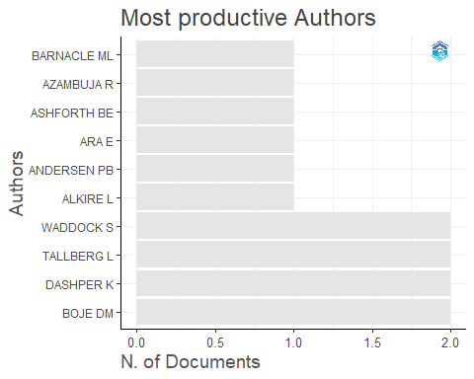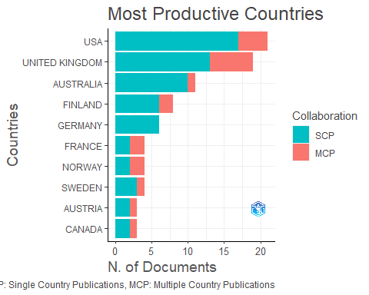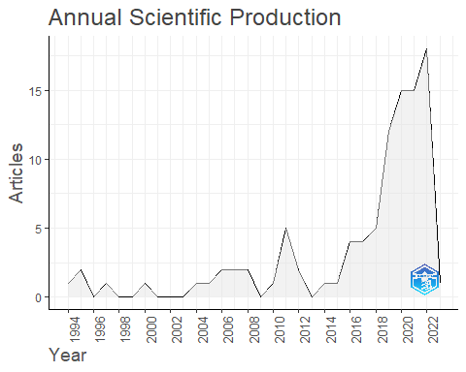

## Warning: Removed 1 rows containing non-finite values (`stat_align()`).

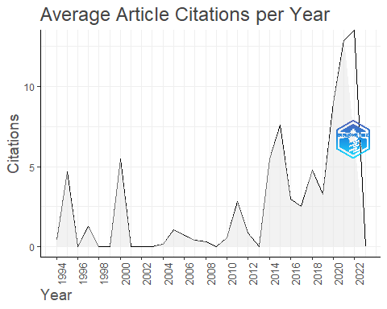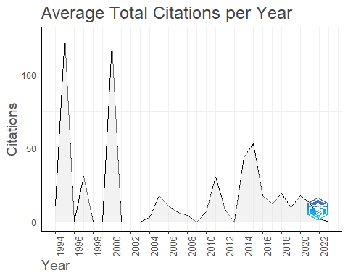

# Most cited references  
CR <- citations(M, field = "article", sep = ";")  
cbind(CR$Cited[1:20])

## [,1]  
## ANONYMOUS, NO TITLE CAPTURED 16  
## BARAD K., 2007, M UNIVERSE HALFWAY Q 11  
## HARAWAY D., 2008, SPECIES MEET 9  
## LATOUR B., 2007, REASSEMBLING SOCIAL 8  
## BARAD K, 2003, SIGNS, V28, P801, DOI 10.1086/345321 7  
## LATOUR B., 2005, REASSEMBLING SOCIAL 7  
## EPLEY N, 2007, PSYCHOL REV, V114, P864, DOI 10.1037/0033-295X.114.4.864 6  
## HAMILTON L, 2016, ORGANIZATION, V23, P330, DOI 10.1177/1350508416629448 6  
## HARAWAY DONNA, 1991, SIMIANS CYBORGS WOME 6  
## ORLIKOWSKI WJ, 2007, ORGAN STUD, V28, P1435, DOI 10.1177/0170840607081138 6  
## CALLON M, 1986, SOCIOL RE MONOGR, P196, DOI 10.1111/J.1467-954X.1984.TB00113.X 5  
## HARAWAY DJ., 2003, COMPANION SPECIES MA 5  
## O'DOHERTY DP, 2016, ORGANIZATION, V23, P407, DOI 10.1177/1350508416629450 5  
## PLUMWOOD V., 2002, ENV CULTURE ECOLOGIC 5  
## STEFFEN W, 2015, SCIENCE, V347, DOI 10.1126/SCIENCE.1259855 5  
## WIRTZ J, 2018, J SERV MANAGE, V29, P907, DOI 10.1108/JOSM-04-2018-0119 5  
## AAKER JL, 1997, J MARKETING RES, V34, P347, DOI 10.2307/3151897 4  
## ARAUJO T, 2018, COMPUT HUM BEHAV, V85, P183, DOI 10.1016/J.CHB.2018.03.051 4  
## BARAN BE, 2016, ORGANIZATION, V23, P351, DOI 10.1177/1350508416629456 4  
## BENNETT J, 2004, POLIT THEORY, V32, P347, DOI 10.1177/0090591703260853 4

# Section 2: Intellectual structure of the field  
  
# Co-citation analysis of references  
NetMatrix <- biblioNetwork(M, analysis = "co-citation", network = "references", sep = ";")  
net=networkPlot(NetMatrix, n = 50, Title = "Co-Citation Network", type = "fruchterman", size.cex=TRUE, size=20, remove.multiple=FALSE, labelsize=1,edgesize = 10, edges.min=5)

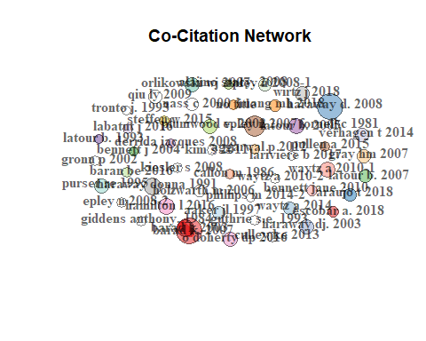

netstat <- networkStat(NetMatrix)  
summary(netstat,k=10)

##   
##   
## Main statistics about the network  
##   
## Size 7163   
## Density 0.014   
## Transitivity 0.847   
## Diameter 6   
## Degree Centralization 0.105   
## Average path length 3.401   
##

# Co-citation analysis of sources  
M=metaTagExtraction(M,"CR_SO",sep=";")  
NetMatrix <- biblioNetwork(M, analysis = "co-citation", network = "sources", sep = ";")  
net=networkPlot(NetMatrix, n = 50, Title = "Co-Citation Network", type = "auto", size.cex=TRUE, size=15, remove.multiple=FALSE, labelsize=1,edgesize = 10, edges.min=5)

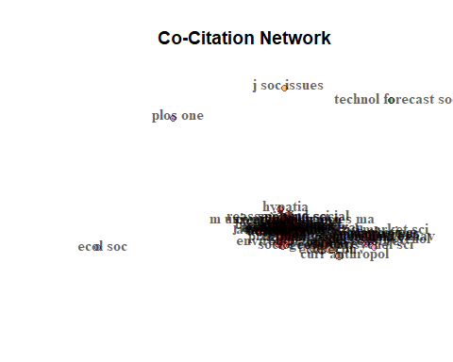

netstat <- networkStat(NetMatrix)  
summary(netstat,k=10)

##   
##   
## Main statistics about the network  
##   
## Size 4083   
## Density 0.023   
## Transitivity 0.427   
## Diameter 4   
## Degree Centralization 0.333   
## Average path length 2.344   
##

# Section 3: Historiograph - Direct citation linkages  
histResults <- histNetwork(M, sep = ";")

##   
## WOS DB:  
## Searching local citations (LCS) by reference items (SR) and DOIs...  
##   
## Analyzing 7847 reference items...  
##   
## Found 21 documents with no empty Local Citations (LCS)

options(width = 130)  
net <- histPlot(histResults, n=20, size = 5, labelsize = 4)

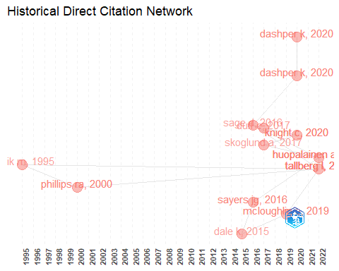

##   
## Legend  
##   
## Label  
## 1 STARIK M, 1995, J BUS ETHICS DOI 10.1007/BF00881435  
## 2 PHILLIPS RA, 2000, J BUS ETHICS DOI 10.1023/A:1006041929249  
## 3 DALE K, 2015, ORGANIZATION DOI 10.1177/1350508414558721  
## 4 SAGE D, 2016, ORGANIZATION DOI 10.1177/1350508416629449  
## 5 SAYERS JG, 2016, ORGANIZATION DOI 10.1177/1350508416629454  
## 6 DUFF C, 2017, ORGANIZATION DOI 10.1177/1350508416687765  
## 7 SKOGLUND A, 2017, ORGANIZATION DOI 10.1177/1350508416666938  
## 8 MCLOUGHLIN E, 2019, GENDER WORK ORGAN DOI 10.1111/GWAO.12247  
## 9 DASHPER K, 2020, TOUR MANAG PERSPECT DOI 10.1016/J.TMP.2020.100678  
## 10 DASHPER K, 2020, GENDER WORK ORGAN DOI 10.1111/GWAO.12344  
## 11 KNIGHT C, 2020, CULT ORGAN DOI 10.1080/14759551.2019.1622544  
## 12 TALLBERG L, 2022, J BUS ETHICS DOI 10.1007/S10551-021-04840-1  
## 13 HUOPALAINEN A, 2022, ORGANIZATION DOI 10.1177/1350508420961533  
## Author_Keywords  
## 1 <NA>  
## 2 <NA>  
## 3 DISABILITIES; EMBODIMENT; ENTANGLEMENT; ETHICS; LEVINAS; MATERIALITIES; MERLEAU-PONTY  
## 4 ACTOR-NETWORK THEORIES; ANIMAL GEOGRAPHIES; CONSTRUCTION; ORGANIZATIONAL BOUNDARIES; ORGANIZATIONAL SPACES AND TIMES  
## 5 ANIMAL ETHICS; ANIMAL PHILOSOPHY; ANIMAL RIGHTS; FACTORY-FARMED ANIMALS; KAFKA; ORGANISATION OF ANIMALS  
## 6 ASSEMBLAGE; CREATIVE WORK; CREATIVITY; DIVERSITY; POSTHUMANISM  
## 7 ANIMAL STUDIES; DOMESTIC ANIMALS; FIRST DOG; MANAGEMENT TECHNIQUES; MICHEL FOUCAULT; POSTHUMAN BIOPOLITICS; US GOVERNING  
## 8 DIRTY WORK; EMOTION WORK; HEGEMONIC MASCULINITY; MULTISPECIES ETHNOGRAPHY; SLAUGHTERHOUSE  
## 9 ANIMALS; HOLIDAYS; HORSES; MULTISPECIES ETHNOGRAPHY; POWER; TOURISM  
## 10 EMOTIONAL LABOUR; HORSES; MULTISPECIES; NON-HUMAN ANIMALS; SERVICE WORK; TOURISM  
## 11 NON-HUMAN ANIMALS; ORGANISATIONAL ACTORS; POLICING; POLICE DOGS; POSTHUMANISM; PERFORMATIVITY  
## 12 ANIMALS; AFFECTIVE EMBODIMENT; ETHNOGRAPHY; ETHICS OF CARE; STAKEHOLDER THEORY  
## 13 CRITIQUE; FEMINIST DOG-WRITING; HUMANIMAL ENTANGLEMENTS; POST-HUMANISM; POST-QUALITATIVE WRITING; TRANSFORMATION  
## KeywordsPlus  
## 1 <NA>  
## 2 <NA>  
## 3 DISABILITY  
## 4 NETWORK; WILDLIFE; FISH  
## 5 ORGANIZATION; ANIMALS; MANAGEMENT; ETHICS; EMBODIMENT; FEMINIST; LEVINAS; HISTORY; BODIES; KAFKA  
## 6 INDUSTRIES; ORGANIZATION  
## 7 ORGANIZATIONAL ANALYSIS; POWER; FOUCAULT; ETHICS; MANAGEMENT; NEOLIBERALISM; SUBJECTIVITY; ALIENATION; SECURITY; CRITIQUE  
## 8 DIRTY WORK; ANIMAL-WELFARE; MASCULINITY; EUTHANASIA; INDUSTRY; LABOR  
## 9 EQUESTRIAN TOURISM; PET; ANIMALS; LEISURE; LIVES; WILLINGNESS; CONSTRAINTS; COMMUNITY; QUALITY; TRAVEL  
## 10 GENDER STEREOTYPES; ANIMALS; WORK; SCIENCE; ORGANIZATION; MANAGEMENT; ELEPHANTS; SOCIOLOGY; FEMINISM; LEISURE  
## 11 THEREFORE I AM; POLITICAL ECOLOGY; PUBLIC MANAGEMENT; ANIMALS; CONSTRUCTION; PERFORMATIVITY; ORGANIZATION; RELEASE; LIVES  
## 12 WORK; ETHICS; BODIES  
## 13 FEMINIST; ORGANIZATION; ETHNOGRAPHY; POSTHUMAN; POLITICS; ANIMALS; MATTER; WORK; TIME; BABY  
## DOI Year LCS GCS  
## 1 10.1007/BF00881435 1995 4 228  
## 2 10.1023/A:1006041929249 2000 2 121  
## 3 10.1177/1350508414558721 2015 2 53  
## 4 10.1177/1350508416629449 2016 3 24  
## 5 10.1177/1350508416629454 2016 3 24  
## 6 10.1177/1350508416687765 2017 1 18  
## 7 10.1177/1350508416666938 2017 3 13  
## 8 10.1111/gwao.12247 2019 2 13  
## 9 10.1016/j.tmp.2020.100678 2020 1 7  
## 10 10.1111/gwao.12344 2020 2 13  
## 11 10.1080/14759551.2019.1622544 2020 1 2  
## 12 10.1007/s10551-021-04840-1 2022 2 5  
## 13 10.1177/1350508420961533 2022 2 3

# Section 4: The conceptual structure - Co-Word Analysis  
NetMatrix <- biblioNetwork(M, analysis = "co-occurrences", network = "keywords", sep = ";")  
net=networkPlot(NetMatrix, normalize="association", n = 50, Title = "Keyword Co-occurrences", type = "fruchterman", size.cex=TRUE, size=20, remove.multiple=F, edgesize = 10, labelsize=5,label.cex=TRUE,label.n=30,edges.min=2)

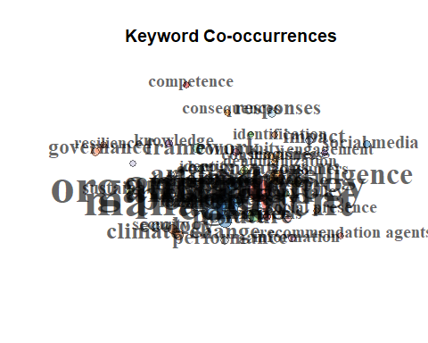

netstat <- networkStat(NetMatrix)  
summary(netstat,k=10)

##   
##   
## Main statistics about the network  
##   
## Size 348   
## Density 0.028   
## Transitivity 0.488   
## Diameter 7   
## Degree Centralization 0.127   
## Average path length 3.233   
##

# Co-word Analysis through Correspondence Analysis  
suppressWarnings(  
 CS <- conceptualStructure(M, method="MCA", field="ID", minDegree=5, clust=5, stemming=FALSE, labelsize=15,documents=20)  
)

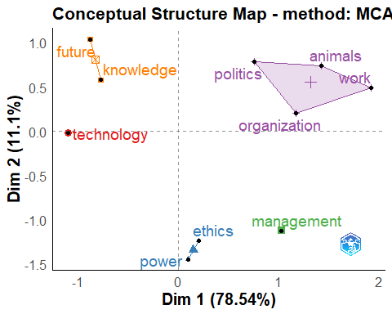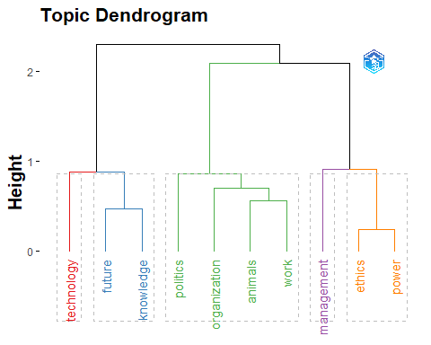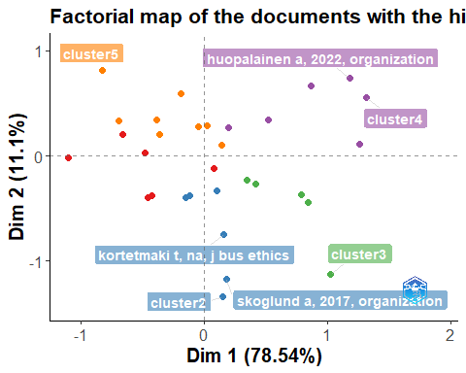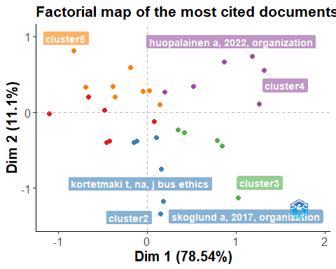

# Section 5: Thematic Map  
Map=thematicMap(M, field = "ID", n = 250, minfreq = 4,  
 stemming = FALSE, size = 0.7, n.labels=5, repel = TRUE)  
plot(Map$map)

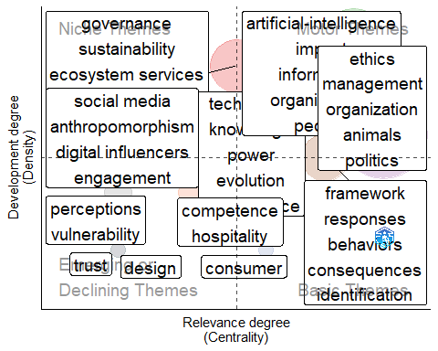

# Cluster description  
Clusters=Map$words[order(Map$words$Cluster,-Map$words$Occurrences),]  
library(dplyr)

##   
## Attaching package: 'dplyr'

## The following objects are masked from 'package:stats':  
##   
## filter, lag

## The following objects are masked from 'package:base':  
##   
## intersect, setdiff, setequal, union

CL <- Clusters %>% group_by(.data$Cluster_Label) %>% top_n(5, .data$Occurrences)  
CL

## # A tibble: 39 × 9  
## # Groups: Cluster_Label [11]  
## Occurrences Words Cluster Color Cluster_Label Cluster_Frequency btw_centrality clos_centrality pagerank_cent…¹  
## <dbl> <chr> <dbl> <chr> <chr> <dbl> <dbl> <dbl> <dbl>  
## 1 3 governance 1 #E41A1C80 governance 16 295. 0.00143 0.00619  
## 2 3 sustainability 1 #E41A1C80 governance 16 585. 0.00158 0.00664  
## 3 2 ecosystem services 1 #E41A1C80 governance 16 121. 0.00146 0.00441  
## 4 2 innovation 1 #E41A1C80 governance 16 537. 0.00149 0.00422  
## 5 2 political ecology 1 #E41A1C80 governance 16 409. 0.00156 0.00476  
## 6 2 resilience 1 #E41A1C80 governance 16 191. 0.00141 0.00583  
## 7 2 values 1 #E41A1C80 governance 16 378. 0.00153 0.00562  
## 8 10 technology 2 #377EB880 technology 49 4118. 0.00195 0.0160   
## 9 5 knowledge 2 #377EB880 technology 49 494. 0.00157 0.00549  
## 10 5 power 2 #377EB880 technology 49 1013. 0.00177 0.00902  
## # … with 29 more rows, and abbreviated variable name ¹​pagerank_centrality

# Section 6: The social structure - Collaboration Analysis  
  
# Author collaboration network  
NetMatrix <- biblioNetwork(M, analysis = "collaboration", network = "authors", sep = ";")  
net=networkPlot(NetMatrix, n = 50, Title = "Author collaboration",type = "auto", size=10,size.cex=T,edgesize = 3,labelsize=1)

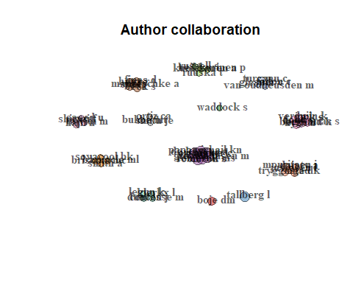

netstat <- networkStat(NetMatrix)  
summary(netstat,k=15)

##   
##   
## Main statistics about the network  
##   
## Size 220   
## Density 0.009   
## Transitivity 0.986   
## Diameter 2   
## Degree Centralization 0.023   
## Average path length 1.028   
##

# Institutional collaboration network  
NetMatrix <- biblioNetwork(M, analysis = "collaboration", network = "universities", sep = ";")  
net=networkPlot(NetMatrix, n = 50, Title = "Edu collaboration",type = "auto", size=4,size.cex=F,edgesize = 3,labelsize=1)

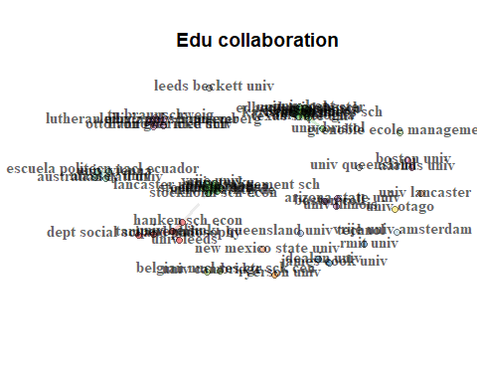

netstat <- networkStat(NetMatrix)  
summary(netstat,k=15)

##   
##   
## Main statistics about the network  
##   
## Size 145   
## Density 0.013   
## Transitivity 0.892   
## Diameter 5   
## Degree Centralization 0.05   
## Average path length 1.946   
##

# Country collaboration network  
M <- metaTagExtraction(M, Field = "AU_CO", sep = ";")  
NetMatrix <- biblioNetwork(M, analysis = "collaboration", network = "countries", sep = ";")  
net=networkPlot(NetMatrix, n = dim(NetMatrix)[1], Title = "Country collaboration",type = "circle", size=10,size.cex=T,edgesize = 1,labelsize=0.6, cluster="none")

