# Descriptive Analysis Results

## Publications by year and journal

See Figure 1 in (Williams et al., 2017)

Figure 1: Publications per year.

Table : Sources by number of articles, with Web of Science categories and impact factors for each journal.

|  |  |  |  |  |
| --- | --- | --- | --- | --- |
| **Source Title** | **Articles** | **WoS Categories** | **Journal Impact Factor (JIF) 2021** | **Best JIF Quartile** |
| Organization | 9 | Management | 3.301 | Q2 (2017-2020)  2021 (current): Q3 |
| Journal of Business Ethics | 8 | Business; Ethics | 6.331 | Q1 – 2018  2021 (current): Q2 |
| Ecological Economics | 5 | Ecology; Economics; Environmental Sciences; Environmental Studies | 6.536 | Q1 (2017-2021)  2021 (current): Q1 |
| Leadership | 4 | Management | 3.183 | Q3 (2017 and 2021)  2021 (current): Q3 |
| Futures | 3 | Economics; Regional & Urban Planning | 3.788 | Q1 (2017-2020)  2021 (current): Q2 |
| Gender Work and Organization | 3 | Management; Women's Studies | 5.428 | Q2 (2017-2021 except 2020)  2021 (current): Q2 |
| Journal of Business Research | 3 | Business | 10.969 | Q1 (2018-2021)  2021 (current): Q1 |
| Management Learning | 3 | Management | 3.738 | Q3 (2017-2021)  2021 (current): Q3 |
| Organization Studies | 3 | Management | 5.524 | Q1 (2017 and 2018)  2021 (current): Q2 |
| Economy and Society | 2 | Economics; Sociology | 4.182 | Q1 (2017 and 2021  2021 (current): Q1 |
| Human Relations | 2 | Management; Social Sciences, Interdisciplinary | 5.658 | Q1 (2018)  2021 (current): Q2 |
| Journal of Hospitality and Tourism Management | 2 | Hospitality, Leisure, Sport & Tourism; Management | 7.629 | Q1 (2018-2021)  2021 (current): Q1 |
| Journal of Organizational Change Management | 2 | Management | 2.096 | Q3 (2017)  2021 (current): Q4 |
| Safety Science | 2 | Engineering, Industrial; Operations Research & Management Science | 6.392 | Q1 (2018 and 2019)  2021 (current): Q2 |
| Technological Forecasting and Social Change | 2 | Business; Regional & Urban Planning | 10.884 | Q1 (2018-2021)  2021 (current): Q1 |
| Tijdschrift voor Economische en Sociale Geografie | 2 | Business & Economics; Geography | 4.194 | Q1 (2021)  2021 (current): Q1 |
| Tourism Management Perspectives | 2 | Environmental Studies; Hospitality, Leisure, Sport & Tourism; Management | 12.879 | Q1 (2019-2021)  2021 (current): Q1 |
| Misc. | 48 (1 each) | Various |  |  |
| Total, Articles= | 105 |  |  |  |

Source for 5th column: From Journal Citation Reports. Searched each journal and scrolled to the section titled «Rank by Journal Impact Factor» to identify FIJ Quartiles for 2017-2021 (Simon Pek, 2021.11.29)

## Top cited articles

See Table 3 in (Williams et al., 2017)

Table : Authors, publication outlets, and citation metrics for most-cited articles.

|  |  |  |  |  |
| --- | --- | --- | --- | --- |
| **Authors, Year** | **Journal** | **Total Citations1** | **Average Citations/Year2** | **Journal Impact Factor 2021** |
| Starik, M. (1995) | Journal of Business Ethics | 228 | 8.44 | 6.331 |
| Phillips, RA; Reichart, J (2000) | Journal of Business Ethics | 121 | 5.50 | 6.331 |
| Robinson, S et al., (2020) | Journal of Business Research | 61 | 30.5 | 10.969 |
| Introna, LD; Hayes, N (2011) | Information and Organization | 59 | 5.36 | 5.387 |
| Zhu, DH; Chang, YP (2020) | Intl J of Contemporary Hospitality Mgmt | 56 | 28.00 | 9.321 |
| Dale, K; Latham, Y (2015) | Organization | 53 | 7.57 | 3.301 |
| Newlands, G (2021) | Organization Studies | 47 | 47.00 | 5.524 |
| Hawkins, G (2011) | Economy and Society | 46 | 4.18 | 4.182 |
| Humphries, C; Smith, ACT (2014) | Organization | 44 | 5.50 | 3.301 |
| Ashforth, BE et al., (2020) | Academy of Management Review | 42 | 21.00 | 13.865 |
| Pizzi, G; Scarpi, D; Pantano, E (2021) | Journal of Business Research | 32 | 32.00 | 10.969 |
| Bell, E; Vachhani, SJ (2020) | Organization Studies | 32 | 16.00 | 5.524 |
| Carley, KM (1997) | Annals of Operations Research | 31 | 1.24 | 4.820 |
| Sheppard, VA; Fennell, DA (2019) | Tourism Management | 28 | 9.33 | 12.879 |
| Scoville-Simonds, M (2018) | World Development | 28 | 7.00 | 6.678 |
| Beacham, J (2018) | Organization | 25 | 6.25 | 3.301 |
| Washington, H; Maloney, M (2020) | Ecological Economics | 24 | 12.00 | 6.536 |
| Sage, D. et al., (2016) | Organization | 24 | 4.00 | 3.301 |
| Sayers, JG (2016) | Organization | 24 | 4.00 | 3.301 |
| Faber, M. et al., (1995) | Ecological Economics | 24 | 0.89 | 6.536 |

1 Retreived from Web of Science on November 11, 2022.

2 Total Citations / (2022-Year of Publication).

## Keyword frequency bibliometrics

See

* Section 3.5 of (Linnenluecke et al., 2020)
* Figure 5 in (López-Medina et al., 2021)
* Fig 3 (Ferreira et al., 2014)

Figure 2: Keyword co-occurrence network graph.

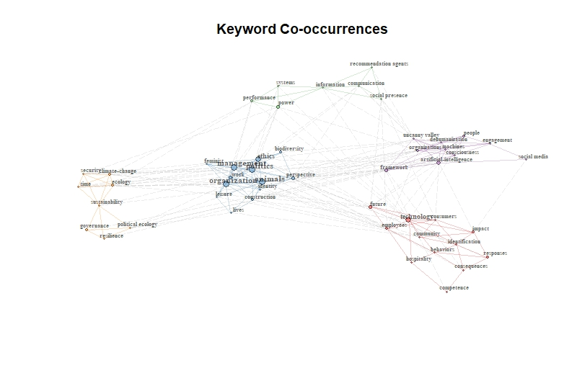

## Co-occurrence bibliometrics

See

* Section 3.5 of (Linnenluecke et al., 2020)

Figure 3: Historical direct citation network plot.

## Co-authorship bibliometrics

See Figure 2 in (López-Medina et al., 2021)

Figure 4: Author collaboration network graph.

Figure 5: Publication co-citation network graph.

Figure 6: Source title co-citation network graph.

### Country Collaborations

Figure 7: Number of publications by country affiliation, created with the bibliometrix package in R. SCP = Single country paper, where all authors from the same country. MCP = Multicountry paper, where authors are from more than one country.

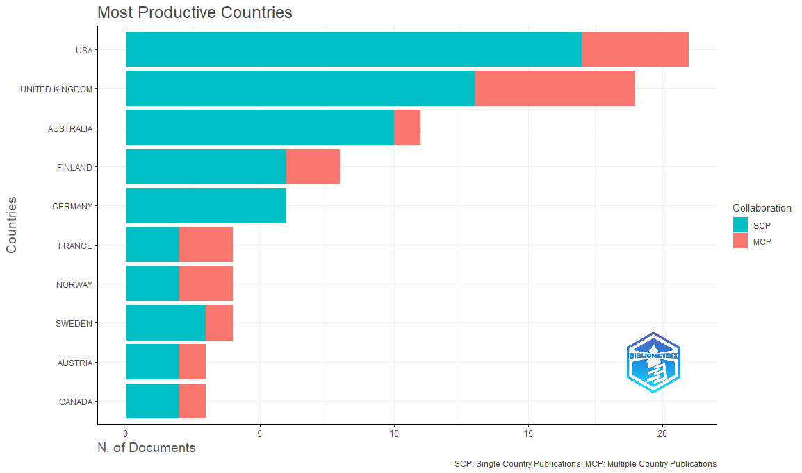

Figure 8: Ties between countries are country affiliations of paper co-authors. The size of the node gets larger as ____________________. Created using the bibliometrix package in R.

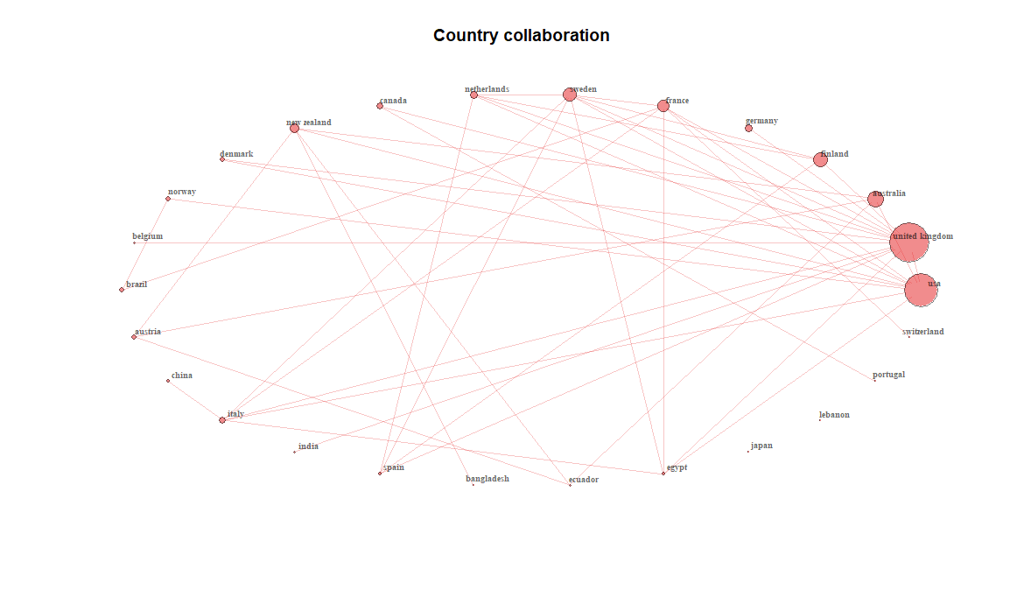

# References

Ferreira, M. P., Santos, J. C., de Almeida, M. I. R., & Reis, N. R. (2014). Mergers & acquisitions research: A bibliometric study of top strategy and international business journals, 1980–2010. *Journal of Business Research*, *67*(12), 2550–2558. https://doi.org/10.1016/j.jbusres.2014.03.015

Linnenluecke, M. K., Marrone, M., & Singh, A. K. (2020). Conducting systematic literature reviews and bibliometric analyses. *Australian Journal of Management*, *45*(2), 175–194. https://doi.org/10.1177/0312896219877678

López-Medina, T., Mendoza-Ávila, I., Contreras-Barraza, N., Salazar-Sepúlveda, G., & Vega-Muñoz, A. (2021). Bibliometric Mapping of Research Trends on Financial Behavior for Sustainability. *Sustainability*, *14*(1), 117. https://doi.org/10.3390/su14010117

Williams, A., Kennedy, S., Philipp, F., & Whiteman, G. (2017). Systems thinking: A review of sustainability management research. *Journal of Cleaner Production*, *148*, 866–881. https://doi.org/10.1016/j.jclepro.2017.02.002