Lab 1: Unity Setup
CSE 3541: Computer Game and Animation Techniques
Dr. Naeem Shareef
Section 11668
Spring 2025

Nicholas McCracken
January 21st, 2025

Table of Contents
1. Introduction 3
2. Scene Structure 4
2.1. Environment 4
2.2. Character Design 4
2.3. Cameras 7
2.4. Input Bindings 7
3. Scripts 10
3.1. Camera 10
3.1.1. Camera Switcher 10
3.1.2. Follow With Offset 11
3.1.3. Update Camera Handler 12
3.2. Character 12
3.2.1. Base Character Updater 12
3.2.2. Character Manager 13
3.2.3. Character Switcher 14
3.2.4. Update Character Handler 15
3.3. Gameplay 15
3.3.1. Input Manager 15
3.3.2. Quit Handler 16
3.4. Player 17
3.4.1. Movement Control 17
3.4.2. Player Respawner 17
3.4.3. Respawn Handler 19
4. Discussion and Conclusion 20
5. References 22

- Introduction
The purpose of this lab was to explore the fundamentals of game development using the Unity game engine and C# programming language, focused on creating a simple 3D scene. This lab emphasized the use of Unity’s new input system which was leveraged to map user interactions to various input devices, including keyboard and gamepad. By constructing a scene featuring multiple custom characters, cameras, a floor, and walls, the lab provided a practical foundation in building basic scene and game elements with user input.
The lab incorporated multiple different tasks using user input, including movement controls, resetting the position of a character, switching between four different camera views of a character, and quitting the game. The lab introduced best practices when developing in Unity, with Git version control and organization of assets and scripts within a Unity project. Additionally, two extra credits were completed within this lab: gravity and collisions (A), multiple characters with character switching (B). The scenes and scripts associated with these extra credits will be discussed further in sections two and three.
The next section will discuss the setup of the scene through narration of various screenshots within Unity. Section three will give an overview of all scripts and source code written for this lab, describing their purpose and the functionality they add to the lab. Section four will discuss the process of completing the lab, including my personal experience with Unity and C#. The fifth and last section will conclude the report with a high-level summary of the completed lab.

- Scene Structure
  - Environment
The 3D environment for this lab was constructed to provide a simple and functional space for the character to move. The environment consisted of a floor and two walls.
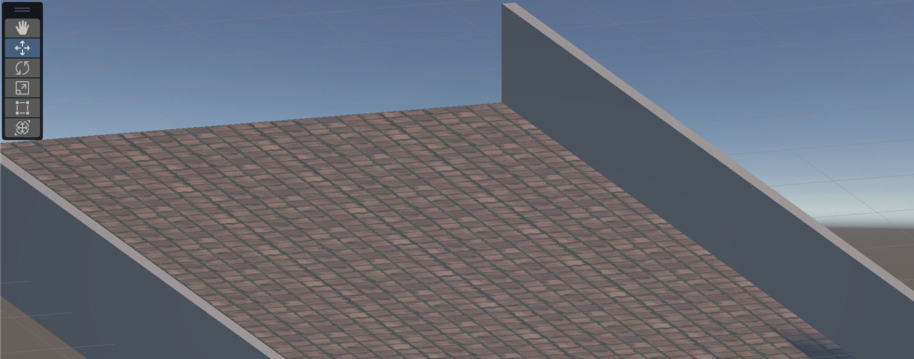
To create the floor above, a scaled Unity plane was used, which spanned (-25, 0, 0) to (25, 0, 100) using a scale of (5, 1, 10) for a total dimension of 50 by 0 by 100. A cobblestone texture was added to the floor, which was imported via the Unity Package Manager, to add perspective to the distance which a character has travelled. For the walls, two Unity cubes were used to form left and right boundaries, scaled to match the length of the floor and to exceed the height of the character. An empty GameObject, “Environment”, was used as a parent object to encapsulate the floor and walls for an organized structure in the Unity hierarchy.
  - Character Design
Four characters were created and placed within this scene to meet the extra credit requirements for multiple characters (B).
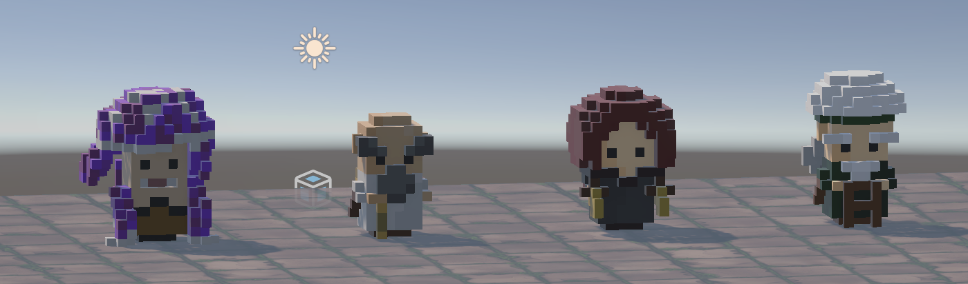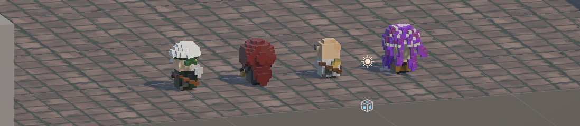
The four character models pictured here were created custom using the program MagicaVoxel. After a model was designed and colored, it was exported into an .obj file and a .png file. The .obj file was the character’s model, and the .png file was the character’s texture. Both files were then imported as assets into Unity, where the .obj file was used as a prefab for the character’s game object, and the .png was used to create a material which was mapped onto the character model prefab. Each of the four characters had a Unity object “Body” as their child, all of which was encapsulated within an empty GameObject, “Characters”, for organization.
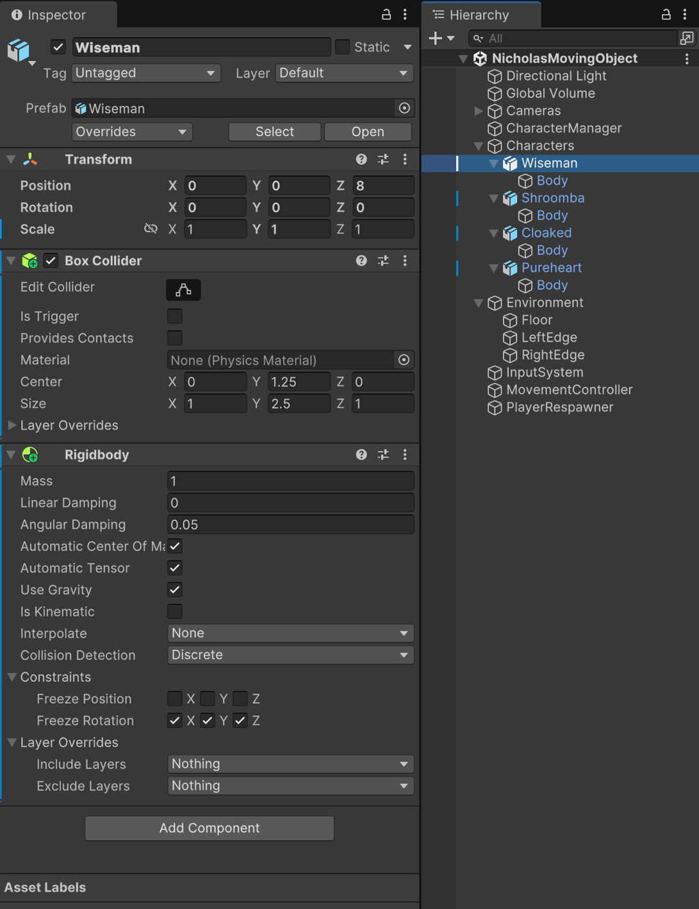
A box collider and rigidbody was added to each individual character, as can be seen above in the Unity inspector window. The box collider allows for collisions against the walls within the Unity scene, while the rigidbody allows the character to interact with Unity’s physics engine. Additionally, since the characters were created via MagicaVoxel and thus had complex geometry, the mesh collider associated with the “Body” child of each character was selected to be convex, which allowed the collision detection to conform to the character models. This enabled gravity and collisions within the lab’s scene, to meet criteria for extra credit (A).
  - Cameras
Four cameras were setup in the scene to follow a character, each with a unique perspective.
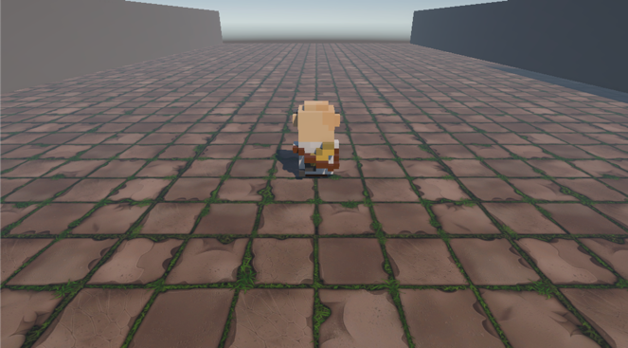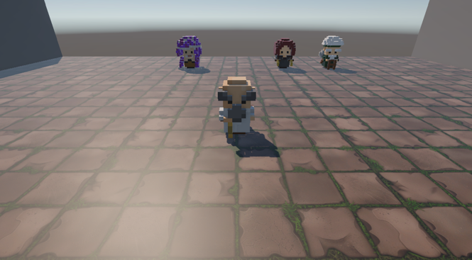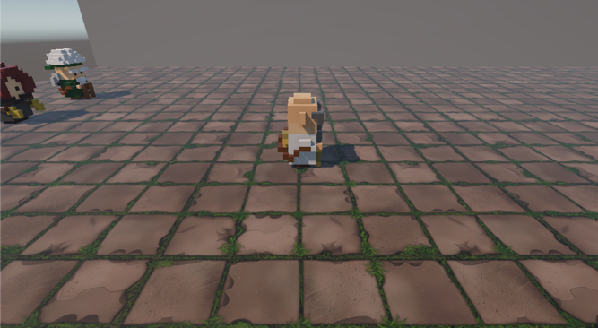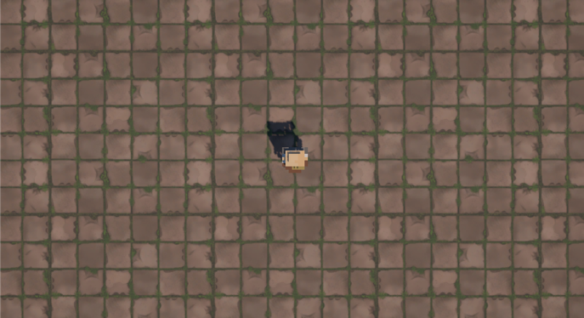
Each of the four camera angles are depicted above: rear-facing, front-facing, side, and top down. The rear facing camera provides a standard third person view, the front-facing camera is rotated 180 degrees around the y-axis to capture a front view, the side camera highlights lateral movement, and the top-down is configured as an orthographic camera to capture a bird’s eye view of the character within the scene. Each camera has a unique offset relative to the target character’s current position and follows the character as they move. Each camera can be cycled through as the game is running.
  - Input Bindings
Using Unity’s new Input System, user interactions were mapped to both keyboard and gamepad inputs.
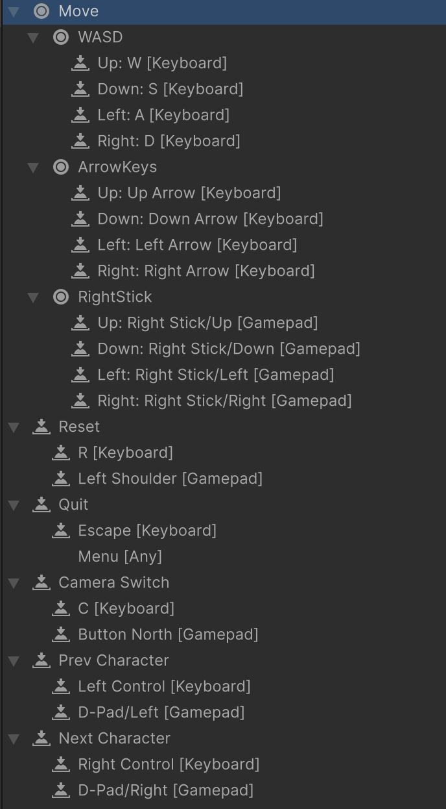
The various user interactions and their corresponding mappings are depicted above. A character can move in the scene using WASD, arrow keys, or the right stick on a gamepad. The user can reset their character’s position using R or left shoulder on a gamepad, which will place the character a small distance above their starting position, an enhancement made by the better respawn of extra credit (A). The user can end the game using Escape or Menu, which will return them to the editor. Cameras can be cycled through using C, starting at the default rear-view camera. Additionally, the user can cycle between the four characters using Left Control or D-Pad Left to return to the previous character, and Right Control or D-Pad Right to switch to the next character, as apart of extra credit (B). From this user input mapping, a user input actions script is autogenerated by Unity, which handles the code functionality for the inputs.
- Scripts
  - Camera
    - Camera Switcher
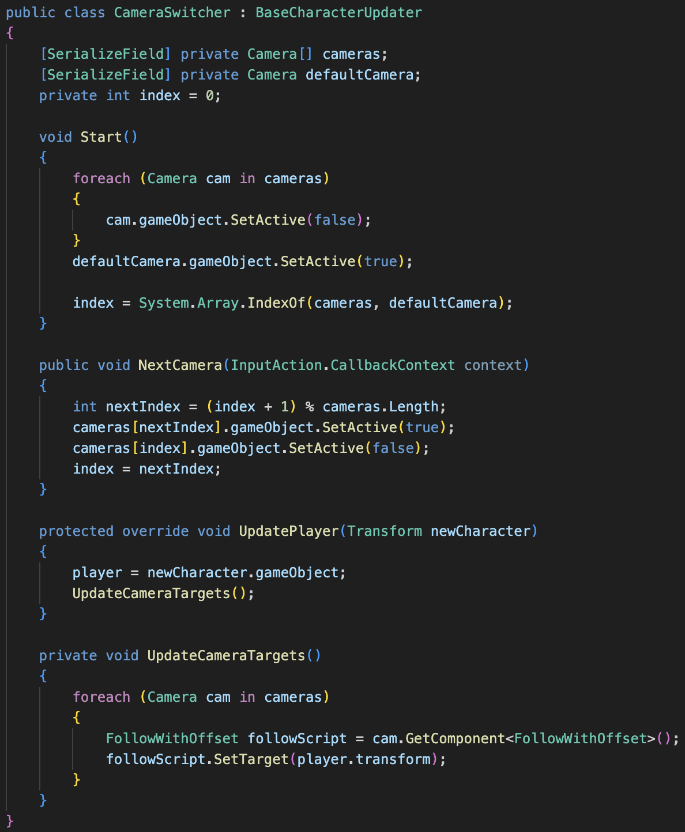
The CameraSwitcher script implements the logic for switching between multiple cameras. It extends the BaseCharacterUpdater to update the camera targets when the player character changes. The script is attached to the empty GameObject “Cameras” which is the parent object to all four cameras. Each camera object is stored within the cameras array, and the default camera is set to the rear-view camera. The Start method is called once the script instance is being loaded, which initializes the default camera as active and the other cameras as inactive. The NextCamera method switches to the next camera when the user interacts with the camera switch input. The UpdatePlayer and UpdateCameraTargets methods update each camera’s target to a new character whenever the player character changes.
    - Follow With Offset
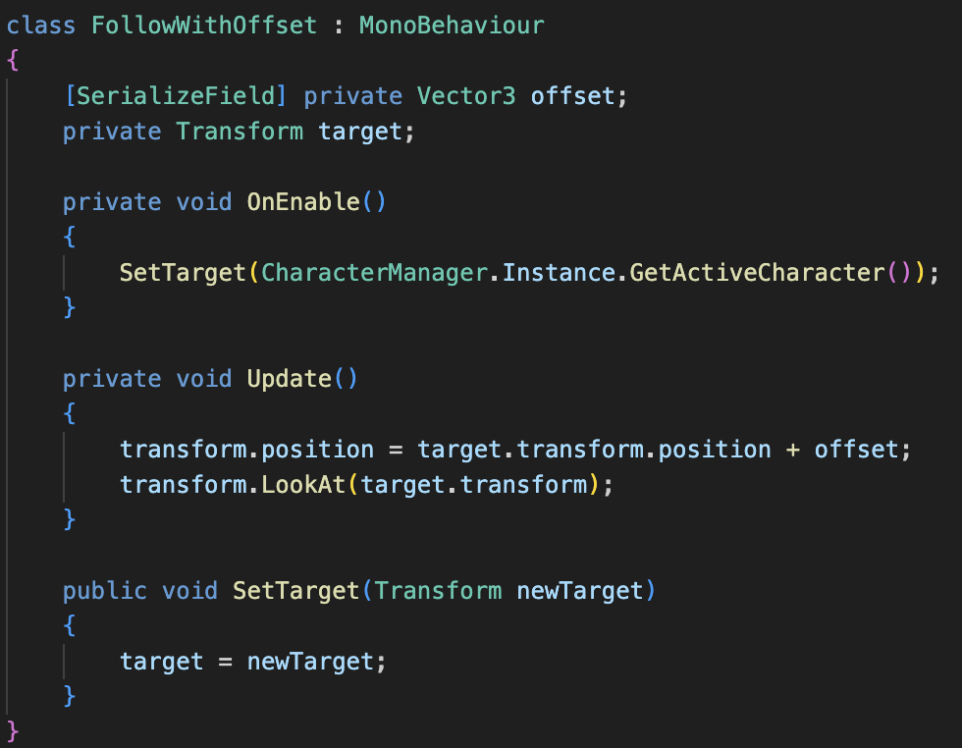
The FollowWithOffset script makes each camera follow a target (player character) with a specified offset. The script is attached to each of the four cameras. The OnEnable method is called when the script is enabled, and initializes to the active character from CharacterManager, which is always the default character “Wiseman” when the script is enabled. The Update script is called each frame and continuously updates the camera’s position and rotation to follow the player character. The SetTarget method sets a new target for the camera to follow, which is called whenever the player character changes.
    - Update Camera Handler
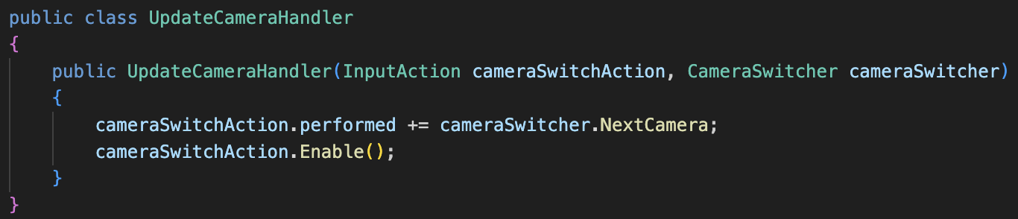
The UpdateCameraHandler script sets up the camera switch input action to call the NextCamera method of a CameraSwitcher instance when the action is performed, mapping input to implementation.
  - Character
    - Base Character Updater
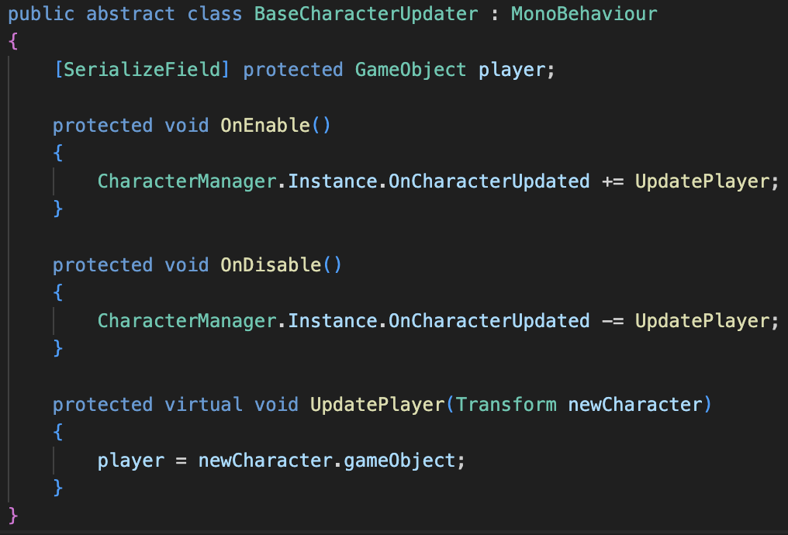
The BaseCharacterUpdater script is an abstract class that manages updates to the player character whenever the character changes. The OnEnable method subscribes the UpdatePlayer method to the OnCharacterUpdated event, which is used to signal to other scripts that the player character has changed. This is used to ensure scripts which handle cameras, movement, and respawning know which character to interact with, hence why the CameraSwitcher, MovementControl, and PlayerRespawner classes all inherit the BaseCharacterUpdater class. The OnDisable method undoes the method subscription performed by OnEnable to prevent unwanted behavior. The UpdatePlayer method is called whenever the OnCharacterUpdate event is triggered, which updates the player to a new character.
    - Character Manager
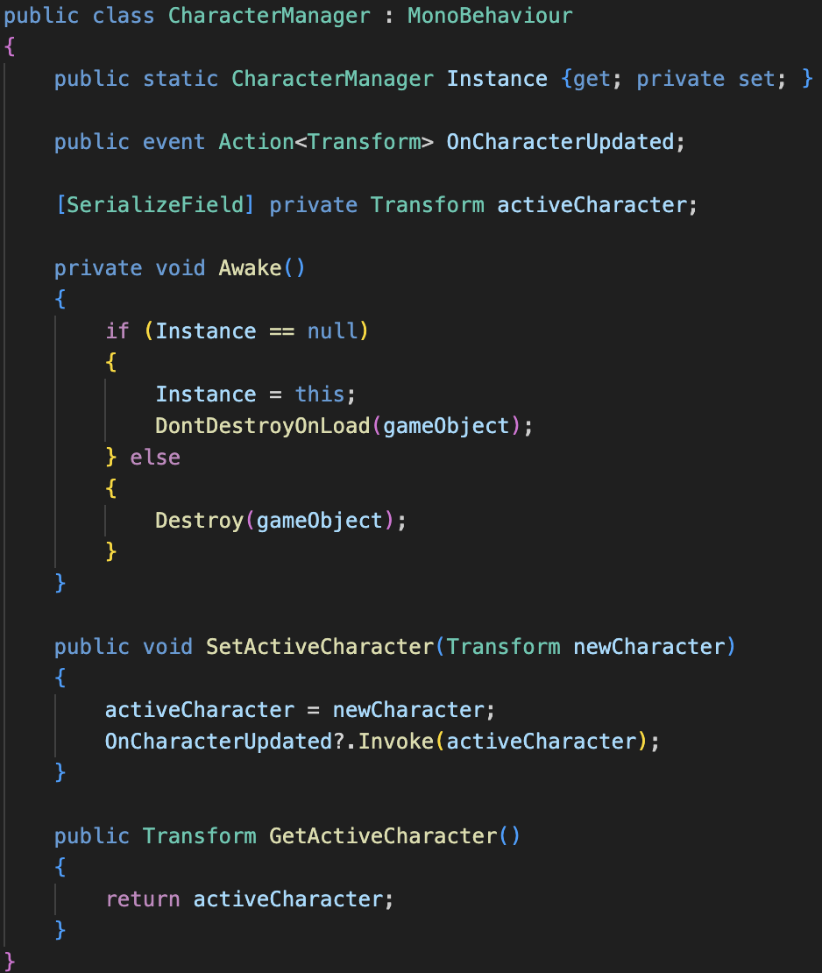

The CharacterManager script handled getting and setting the active character, which was used by various other scripts to determine which character to interact with based on which character the player had switched to, as apart of extra credit (B). The Awake method implemented a singleton pattern, ensuring that there was only a single instance of the CharacterManager class by destroying all other instances. This ensured there was only a single active character. The SetActiveCharacter method updated the active character and triggers the OnCharacterUpdated action, which invokes the UpdatePlayer method that was subscribed to it via the BaseCharacterUpdater script. This setup ensures all scripts derived from the BaseCharacterUpdater class are notified and updated with the new active character whenever it changes, enabling seamless character switching.
    - Character Switcher
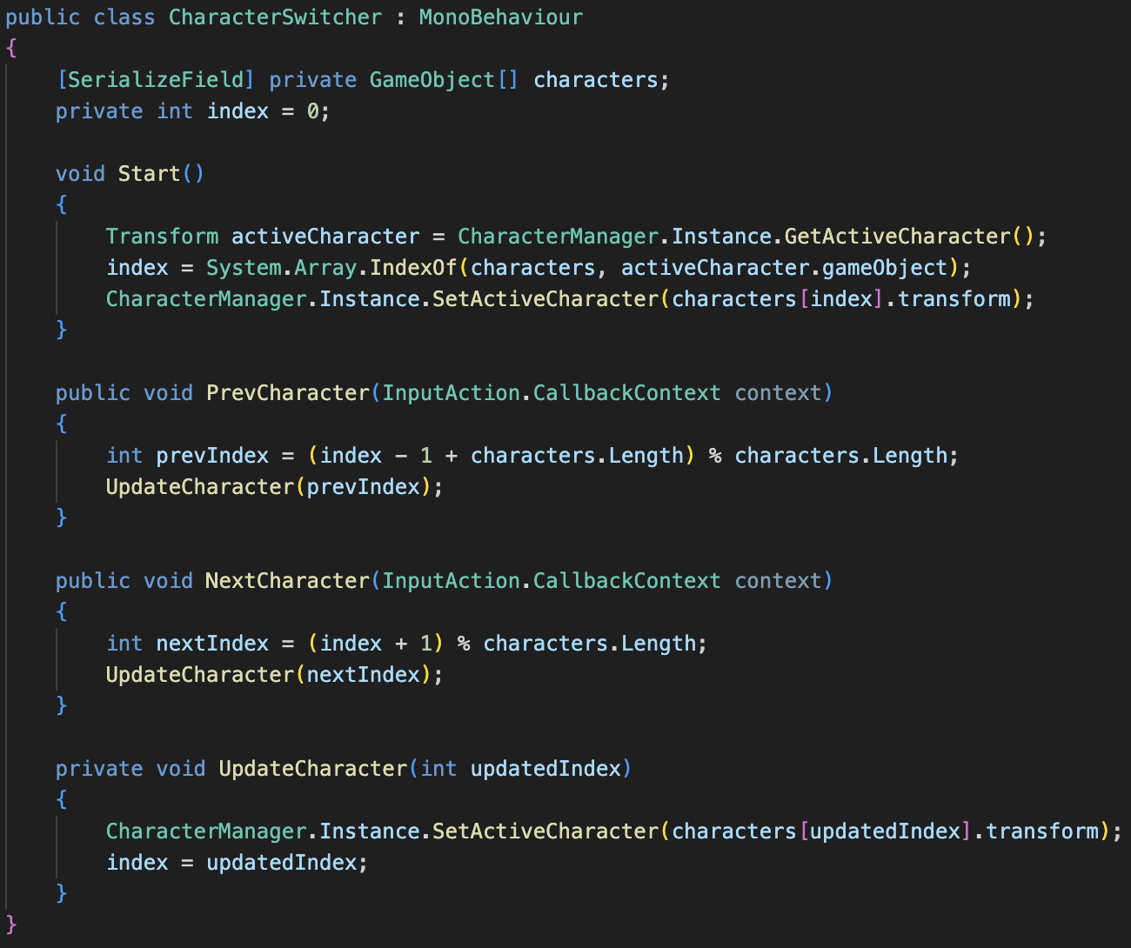
The CharacterSwitcher script implements the logic for switching between multiple characters. This script is attached to the empty GameObject “Characters” which is the parent to each of the four character objects. The characters array is populated with the said child character objects. This script is very similar to the CameraSwitcher, in that Start initializes the active character to be the default character of “Wiseman” from the CharacterManager Instance. Rather than just having a NextCharacter method like the CameraSwitcher’s NextCamera method, the CharacterSwitcher script also implements a PrevCharacter method, which enables switching to the previous character rather than the next character.
    - Update Character Handler
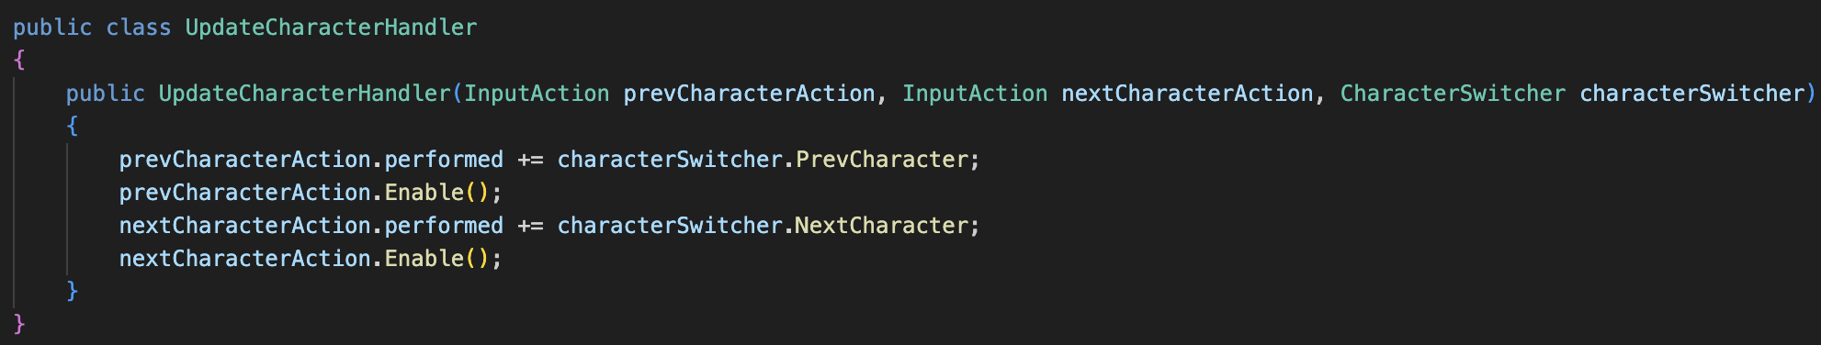
The UpdateCharacterHandler script sets up the previous and next character switch input actions to call the PrevCharacter and NextCharacter methods of a CharacterSwitcher instance when the action is performed, mapping input to implementation.
  - Gameplay
    - Input Manager

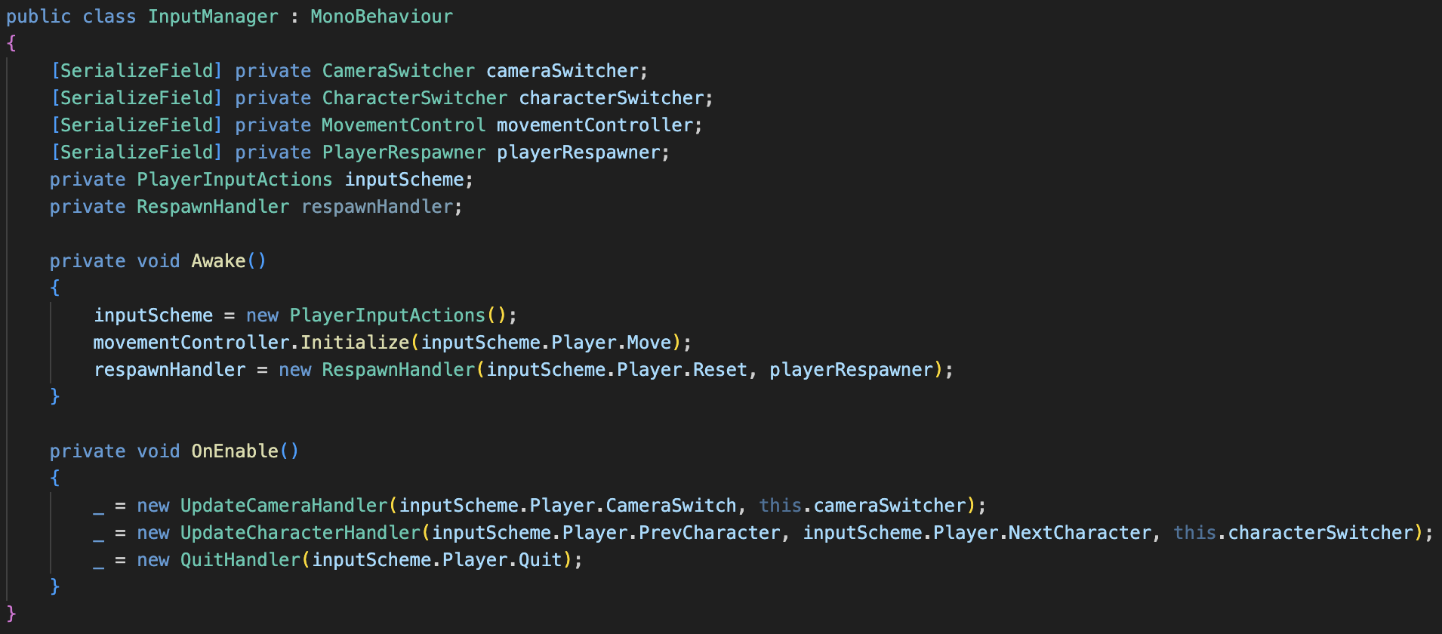
The InputManager script initializes and manages input actions for player movement, camera switching, character switching, respawning, and quitting. This essentially connects all of the functionality of the game together. The script s attached to an empty GameObject “InputManager”. The Awake method is called when the script instance is being loaded. It initializes the player input, movement controller, and respawn handler before the game starts. The OnEnable method initializes the camera switching, character switching, and quitting functions.

    - Quit Handler
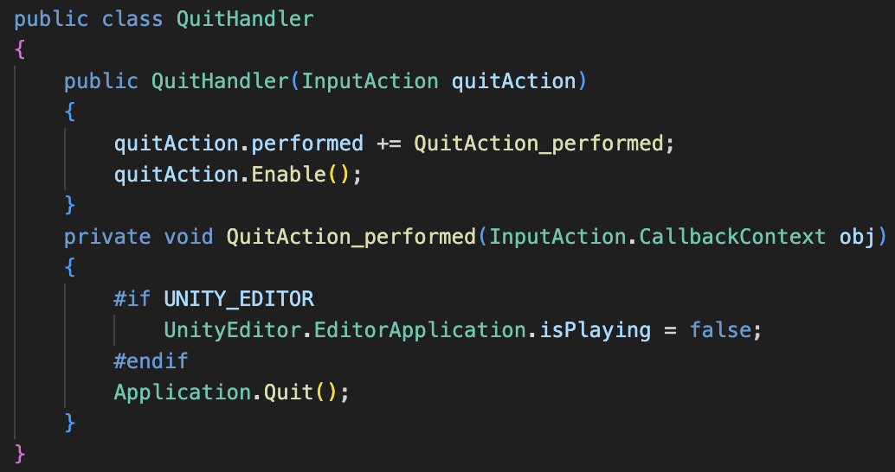
The QuitHandler script sets up the quit action to call the QuitAction_peformed method when the action is performed. The QuitAction_performed method will end the game session if in the Unity editor, and/or close the game if it is being played within an application.
  - Player
    - Movement Control
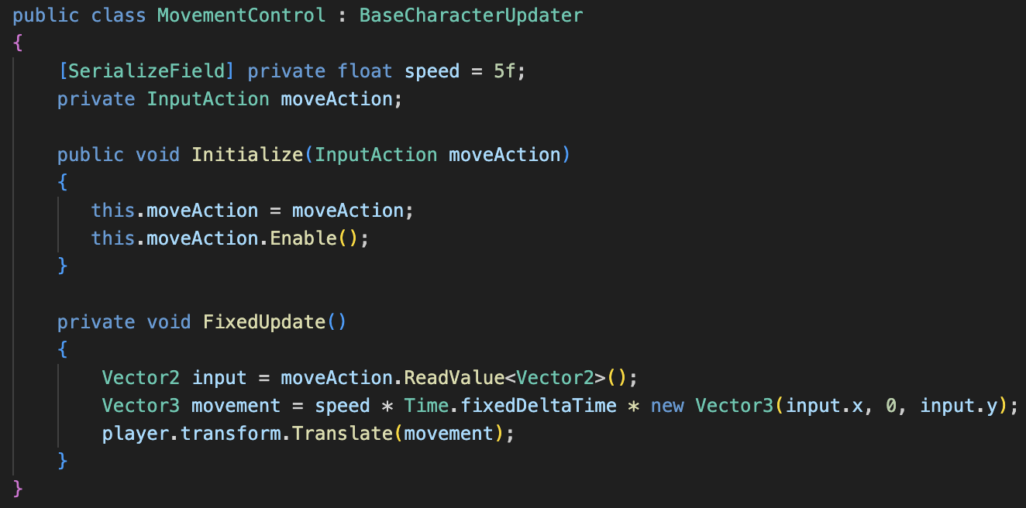
The MovementControl script handles player movement inputs. The script is attached to an empty GameObject “MovementControl”. The Initialize method enables the move InputAction to listen for input events. The FixedUpdate method is called at a fixed interval. It reads movement input and calculates a movement vector based on the input, speed, and change in time. The player’s position is translated by the calculated movement vector, allowing character movement.
    - Player Respawner
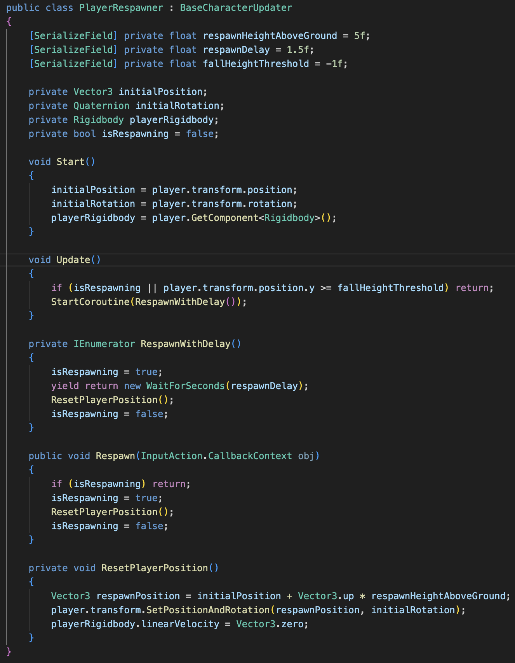
The PlayerRespawner script handles resetting the character position. It extends the BaseCharacterUpdater to update the character which is to be respawned when the player character changes. The script is attached to the empty GameObject “PlayerRespawner”. The Start method is called once the script instance is being loaded, which saves the initial position and rotation of the player character and initializes the player character’s rigidbody. The Update method is called once per frame, which checks if the character has fallen off the edge of the platform in the scene and respawns them after a delay if so. The RespawnWithDelay method waits for a specified time before resetting the player’s position. The Respawn method immediately resets the player position. The ResetPlayerPosition method resets the player’s velocity to zero. It also resets their position to be a short distance above the platform, such that they fall back down to the platform, as specified by the better respawn aspect of extra credit (A). This occurs due to gravity from Unity’s physics engine, enabled by the player character’s rigidbody.
    - Respawn Handler
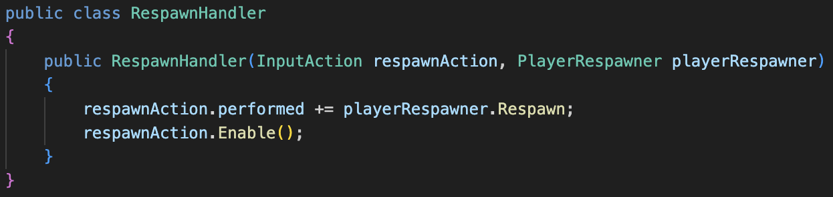
The RespawnHandler script sets up the respawn input action to call the Respawn method of a PlayerRespawner instance when the action is performed, mapping input to implementation.

- Discussion and Conclusion
I had no discussions with any class members while working on this lab. I had never worked with Unity, nor programmed in C# before this lab. Thus, I found this lab to be difficult but fair. Often, I became stuck due to my unfamiliarity with the Unity engine. I had trouble importing the MagicaVoxel character models and floor texture with the Package Manager. While I made some simple to remedy errors in hindsight, it was difficult to find help online as it seemed my issues were specific and unique. However, I am grateful for the time spent trying to diagnose these problems, as I feel much more comfortable with the Unity editor than I otherwise would have. The extra credits were the most challenging part of this lab.
I was discouraged from implementing local multiplayer, due to my implementation alongside character switching. I chose to implement character switching by keeping each character persistent on screen, then updating the camera, movement, and respawn scripts to track the new active character. Had I known this would essentially prevent me from being able to add local multiplayer, I would have done a character switching implementation which simply updated the model of the player character. In the future I’d recommend consolidating the character switching to be amongst three characters for ease of implementation, and guiding students towards a character switching implementation which updates the model rather than the entire character.
Due to the MagicaVoxel character models, I avoided any scaling of child objects for each character. When my characters moved past the end of the plane before the extra credit, they hovered in air, as they were not subject to any gravity or collisions. This meant they phased through walls as well. When adding a rigidbody to each character, they fell once in air. The box collider ensured the characters collided with the walls and each other, such that they could not fall off the platform. Scripts like the QuitHandler could be reused in any lab, as quitting will always be necessary, while the cameras, movement, and respawning scripts could potentially be used on future labs dependent on whether they use characters and user input to move. However, scripts involved with switching between cameras and characters are of much more niche use, only applicable whenever multiple cameras or characters are present.
All in all, I found the structure of the code and lab to be well organized. Though as I continued to implement extra credit features, I found it necessary to partition my scripts into folders. The code structure could benefit through stricter naming convention. For example, consolidating names with “respawn” or “reset” into a single term, as they mean the same thing. This occurs multiple times in the sample code snippets. By encouraging students to use a C# code linter/formatter, the code could be more consistent and easier to understand. I also think the version control would be more useful if a GitHub repository was used, rather than strictly using the Git command line tool. Since I used VSCode rather than Visual Studio, which is industry standard, I did not have access to the code metrics feature of Visual Studio. Providing instructions on adding VSCode extensions which implement C# code metrics would be another improvement. For future labs and projects within the course, I believe it would be ideal if they were structured in such a way that each lab built from the previous. I think this would lead to an incredible project at the end of semester, and I have found that courses designed in this way tend to teach me the most.

- References
[1] “Lab1-UnitySetup” Ohio State University Department of Engineering Education, [Online]. Accessed: 2025, January 21.

[2] “Unity Documentation,” Unity Technologies, [Online]. Available: https://docs.unity.com/. Accessed: 2025, January 21.

