EXECUTIVE SUMMARY FOR SCHOOL LEADERSHIP

Ticali Trio
A family-made practice game based on the reading and math programs AACPS uses
From [Your name], parent · October 2026
What it is  Ticali Trio is a learning game I made for my three children in Anne Arundel County Public Schools: a kindergartener, a 3rd grader and a 5th grader. It practices this year’s grade-level work in the programs AACPS uses (Amplify CKLA for reading and Reveal Math for math), explains why each answer is right, and shows those programs’ methods when a child is stuck. It is a single file that opens in a web browser on a laptop or desktop. It needs no internet connection, account or sign-in, and has no ads, tracking or purchases. It has not been reviewed or endorsed by AACPS or its teachers. I am sharing it for your information and would welcome your feedback.  To try it: on a laptop or desktop, save the attached file and double-click it (details on page 2). |  | 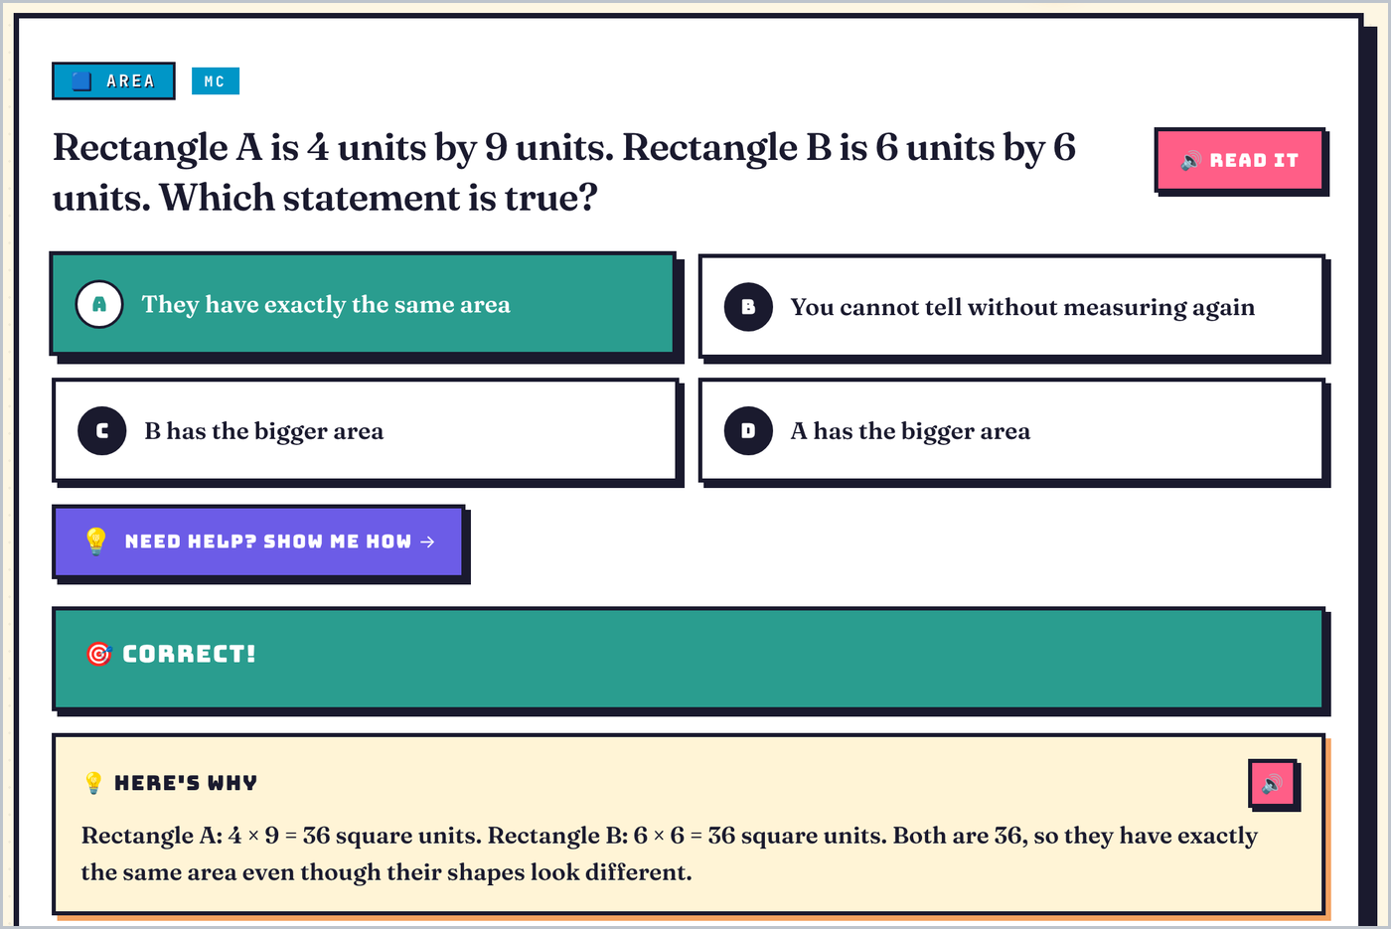  A 3rd grade question after a correct answer: “Here’s why” explains it, and “Show me how” is one tap away.

At a glance
237  topic packs, kindergarten to 5th grade | 10,400+  written questions, each with an explanation and step-by-step coaching | 780  thinking puzzles | 11  math packs with fresh questions every round | 40  Reading Road stops, with 251 story pages and 440 questions

What it is for
- Practice this year’s work, with last year’s kept for review and every grade from kindergarten to 5th one tap away.
- Understand, not just answer. Every answer, right or wrong, is followed by why. On most question types, a wrong answer gets a hint and a second try.
- Learn it the way the programs teach it. “Show me how” walks through the method step by step, using the question’s own numbers and words (for example, make a ten, the area model, arm blending, look back in the story). Every question has it.
- Think, not guess. Puzzles ask children to pick every answer that fits, put steps in order, sort, or answer and then prove it: the kinds of items on Maryland’s new MSTAR tests.
- Grow readers. The Reading Road follows the order Amplify CKLA teaches the sounds, with a story at every stop (read to the child at the first five; after that, decodable using only what the Road has taught so far) and questions about each story. In kindergarten and 1st grade, every question, answer and story can be read aloud, in the most natural voice the device offers, so a child who cannot read yet can play without a grown-up reading to them.
- Keep it fun and kind. Levels, trophies, a buddy, stickers that teach a fact, daily missions with a day streak, boss battles, math-fact sprints against the child’s own best, and a family goal the three children reach together. Siblings are never ranked. A pack is a round of ten questions. A wrong answer never takes progress away, and a missed day only starts a new day streak.

What it is based on
- Reading and writing: Amplify CKLA, which AACPS uses in K–5. Reading packs follow each grade’s CKLA units (2nd edition).
- Math: McGraw Hill Reveal Math, which AACPS uses in K–5, and Maryland’s revised math standards (adopted July 2025, in effect this school year).
- Science: Maryland’s NGSS-based standards. Maryland’s grade 5 science test (MISA) covers grades 3–5, so 4th grade science stays available to the 5th grader.
- Social studies: Maryland’s social studies framework, revised in 2025.
- Tests: formats like those on MSTAR, which replaces MCAP for grades 3–8 reading and math from spring 2027.
- Health: general elementary health content, leaving out family-life topics. AACPS’s health scope and sequence was not found.

How it was made, and its limits
The questions, explanations, coaching steps and stories were written by an AI assistant at my direction, working from official curriculum information that is publicly available. They were then checked by automated tests and by further AI review passes that re-solved every question.
Documents the AI assistant read in full (public PDF copies): Amplify’s CKLA curriculum maps and K–5 program guide; the openly licensed Core Knowledge teacher guides CKLA is built on; McGraw Hill’s Reveal Math alignment documents for grades 3–5; a Reveal Math pacing guide from a district in another state; and an AACPS family handout on math strategies.
Limits:
- It is not an AACPS product. AACPS, its teachers and the publishers Amplify and McGraw Hill have not reviewed or endorsed it.
- The AI assistant could not open several official websites (AACPS, MSDE, McGraw Hill, Amplify) directly while the game was built, so some details rest on search results that quote them.
- It did not use AACPS pacing guides, teacher editions or other licensed classroom materials.
- Two things could not be confirmed: which edition of Amplify CKLA (2nd or new 3rd) AACPS classrooms use this year (the reading packs follow the 2nd), and how AACPS maps Reveal Math onto Maryland’s revised standards.
- Read-aloud uses a voice from the device or browser, which says the short sounds /k/ and /t/ as “kuh” and “tuh” when it blends a word (“c... a... t”); the written explanations give a key word instead.
- A question can still be wrong. Corrections are welcome.

Privacy
No accounts, and no names beyond “Kindergarten,” “3rd Grade” and “5th Grade.” Progress stays in the device’s browser, and a child’s answers are never sent anywhere. When online, the page loads its typefaces from Google Fonts, and some browsers’ most natural read-aloud voices are online and receive the words read aloud: the game’s own, plus any buddy name a 3rd or 5th grader types. A parent can choose a voice built into the device instead.

How to open it
- On a laptop or desktop (Windows, Mac or Chromebook): save the attached file, Ticali_Trio_Family_Edition.html, then double-click it. It opens in your web browser. If your email system held the file back, please let me know.
- On an iPad, an emailed or downloaded copy opens in a preview that does not run the game (an iPad runs it only from a web address), so please use a laptop or desktop.
- On the title screen, For grown-ups: about this game explains what the game is, how it was made and its limits, and lists each grade’s packs. A grade’s card opens that child’s hub of packs; near the bottom of each hub, Explore Any Grade opens all of K–5. The small, faint word parent at the bottom right opens the parent dashboard (PIN 0000). Anything you do stays on your device and does not touch the children’s progress.
I would welcome any feedback, especially on how well it matches what is taught in your classrooms. Thank you.
[Your name], parent

