Front-End Web Design - Assignment 2 U3161734

Rationale

For this project I was required to create a website which would show the skills of CSS web design and how these attributes can be utilised to enhance the appearance of a basic HTML website.

To start this project, I begun with a basic HTML website which I had submitted for Assignment 1. After this I proceeded to begin styling the basic elements of the website including the <body>, <div>, <footer> and <nav> elements, primarily defining the dimensions and appearances of these elements to assist in defining the overall layout of the page.

Next, I set the size and appearance of the text elements, including <p>, <a>, <li>, <h1>, <h2>, <h3>.

After this I began to work on the more complex CSS.

This project presented some new content for me. The first was when I was introduced to the “reset”

Stylesheet, which I implemented during the week 4 tutorial. This helps to remove the in-browser style and I would then I set my own styles for the individual elements I used.

I asked for advice from Riley, my tutor, as to what could be improved and so have changed the following;

* Aligned the <p>, <h1>, <h2>, <h3>, <a> and the <li> to left to Improve readability
* Removed the <br> tags and instead, added extra padding at the bottom of the relevant elements
* Performed additional Research into other websites and layout conventions used
* Removed the <hr> tag which previously existed between the <body> and <footer> and replaced the <hr> with additional “padding-top” to the <footer> element
* Added additional comments into the CSS stylesheet “styles.css”, so the reader can better understand the approach I have taken
* Added some google fonts to the <p>, <h1>, <h2>, <h3>, <a>, <li> elements
* Made use of a colour triad to determine a suitable colour scheme for the website.
* Removed duplicate values for elements such as

Using;

“margin:1% 0 1% 0;”

instead of using;

“margin-top:1%;”

“margin-right:0;”

“margin-bottom:1%;”

“margin-bottom:0;”

In my opinion this has somewhat improved the overall aesthetics of the website and enhanced the readability.

In terms of the look and layout of the website, I have used some individual Google Fonts for the <p>, <h1>, <h2>, <h3> and <li>. I have also researched some other websites for some styling inspiration. I have used the W3 schools colour triad to select a colour scheme which has contrast and visual appeal. I have attached a screenshot of the colour triad website I used below.

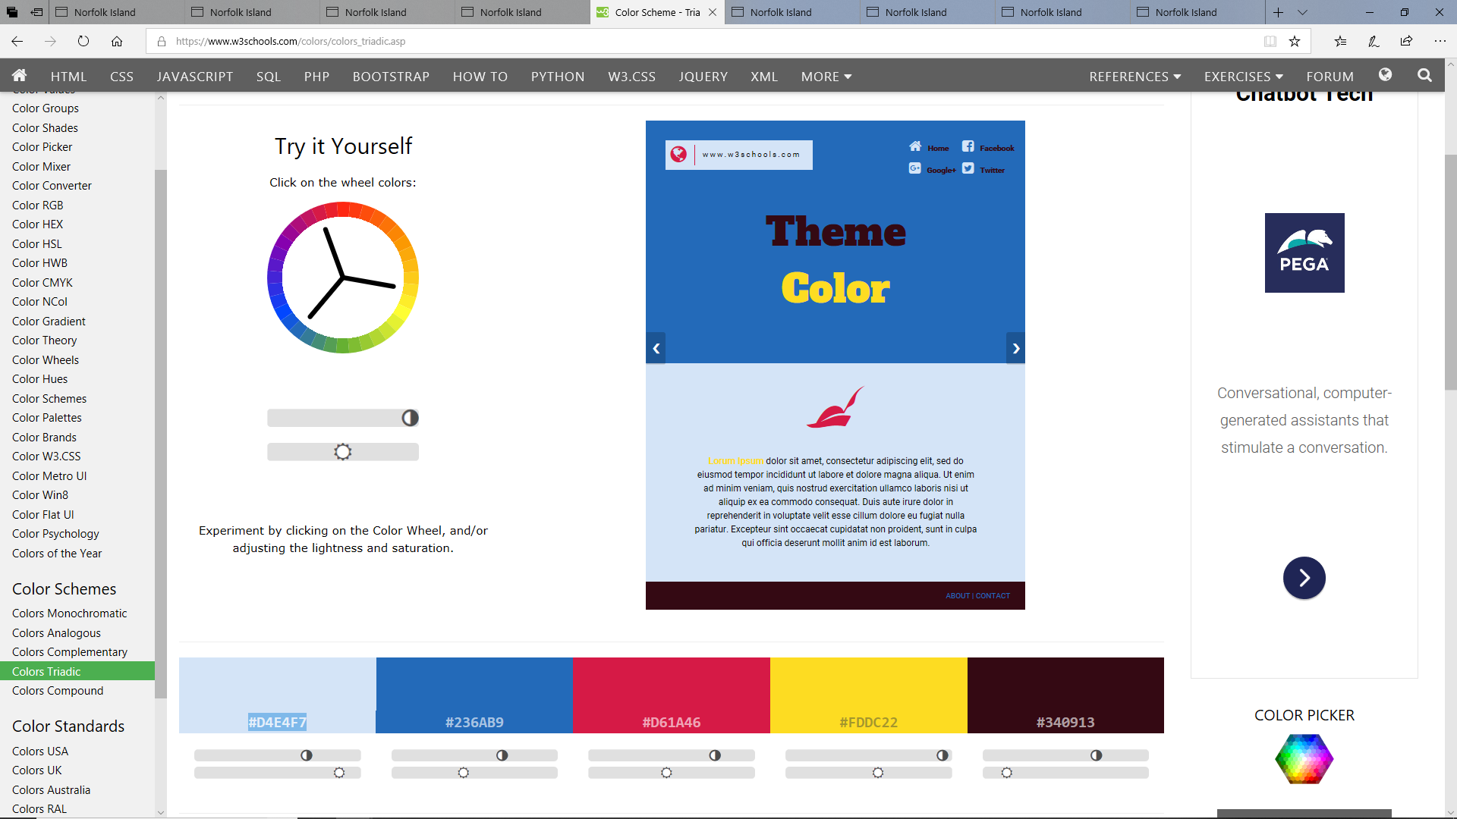

Figure : The W3 Color Triad I used to decide a color scheme for my design.

I also researched on the W3 school’s website how to implement gradients and have implemented a gradient for the background of the website. The gradient starts at the very top of the page as blue. As you scroll down the page, this transitions to pure black by the bottom of the page. Below is a screenshot showing the tutorial I used to learn how to implement the gradient effect using CSS.

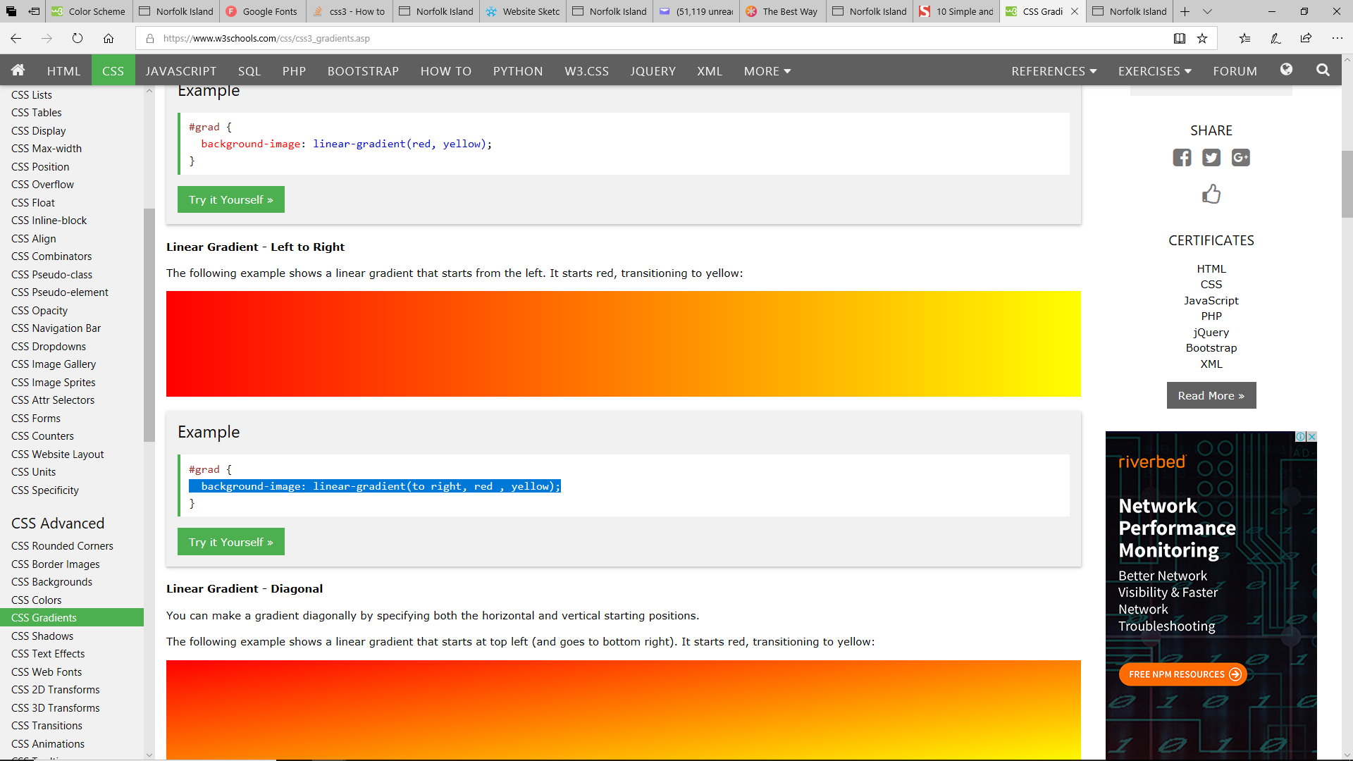

Figure : The tutorial on the W3 schools, which I used to help myself implement a gradient which can be seen present in the background of each webpage.

I performed some research into CSS layouts, again, using tutorials provided by the W3 schools website. Below is a screenshot of the interactive “try it now” interface used to learn more about CSSS layouts.

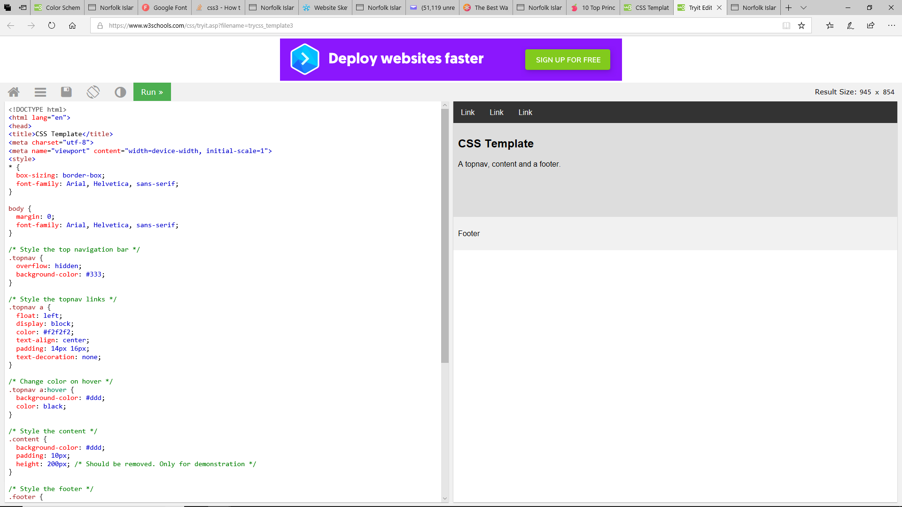

Figure : The tutorial I used for assistance in implementing a better CSS layout.

After performing the steps, I was still unhappy with the overall appearance of my website and so sought too research further, techniques. Below is the article I read to gain inspiration and insight into how to further improve my website.

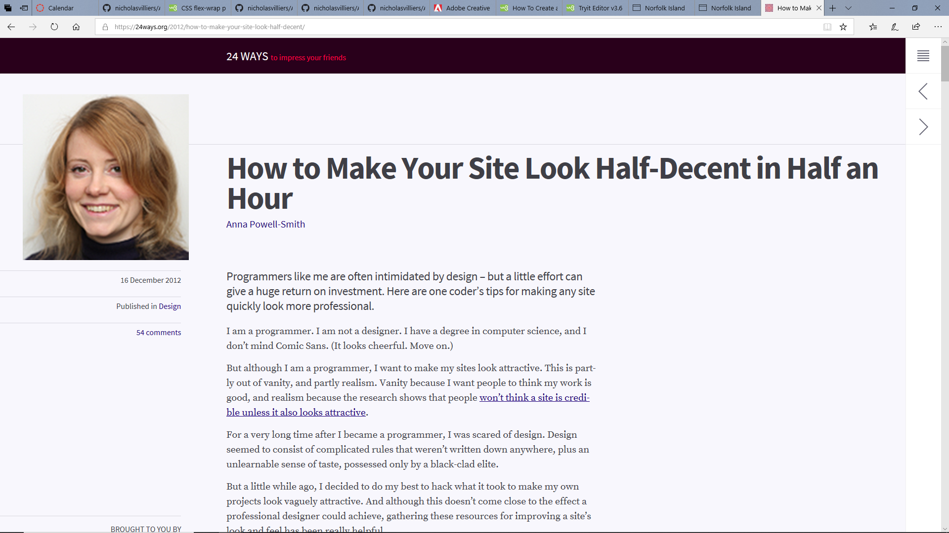

Figure : Is a screenshot of an article I read to help with improving the aesthetics and visual appeal of my website.

I initially had set the font-size property of the <p>, <h1>, <h2>, <h3> and <a> using “vw”, which refers to the “viewport width”, a concept we had not yet explored in class and so reverted these values to percentages, like we learnt in class.

I have implemented classes, as can be seen with the <a> element, where there are different classes ( .w3 and .top), dependant on their function or use. You will notice also I have implemented a CSS “hover” function, wherein the element changes colour once it is hovered upon.

I have tried to maintain uniformity between separate parts of each page and so have written the CSS so that the <footer> appears like the header and the body elements, with the same background colour, border radius, and width.

## References

W3schools.com. (2019). *Colour Scheme - Triadic*. [online] Available at: https://www.w3schools.com/colors/colors_triadic.asp [Accessed 13 Mar. 2019].

W3schools.com. (2019). *CSS Gradients*. [online] Available at: https://www.w3schools.com/css/css3_gradients.asp [Accessed 13 Mar. 2019].

Smashingmagazine.com. (2019). *10 Simple and Impressive Design Techniques — Smashing Magazine*. [online] Available at: https://www.smashingmagazine.com/2009/04/10-impressive-simple-design-techniques/ [Accessed 14 Mar. 2019].

W3schools.com. (2019). *Tryit Editor v3.6*. [online] Available at: https://www.w3schools.com/css/tryit.asp?filename=trycss_template3 [Accessed 14 Mar. 2019].

24ways.org. (2019). *How to Make Your Site Look Half-Decent in Half an Hour*. [online] Available at: https://24ways.org/2012/how-to-make-your-site-look-half-decent/ [Accessed 14 Mar. 2019].