**Endocrine disruption from plastic pollution and warming interact to increase the energetic cost of growth in fish**

Nicholas C. Wu, Alexander M. Rubin, and Frank Seebacher

*School of Life and Environmental Sciences A08, The University of Sydney, NSW 2006, Australia*

# Supplementary information

## *Repeatability of oxygen consumption*

We repeatedly measured oxygen consumption in a subset of adult zebrafish (*n* = 11) not used elsewhere in the experiment to verify the repeatability of oxygen consumption (MO2). Individual fish were kept individually in cylindrical baskets (1 l volume) that were suspended in 8 l tanks (four baskets per tank) to keep track individuals during the repeated measures. Fish were kept at 27 °C for 5 days before MO2 was measured, and were fed with fish flakes (Tetramin, VA, USA) until satiated six times per week. MO2 for each individual was measured following the methods in the main text. The first MO2 measurements were designated as Day 1. MO2 was then measured again the following day (Day 2), and one week after the first MO2 measurements (Day 8) for the same individuals.

Repeatability estimation (using fish ID as repeated measures) across the three time points was calculated with the ‘rptGaussian’ function in the *rptR* package (Stoffel et al., 2017) following the linear mixed model method. Parametric bootstrap iterations for confidence interval estimation was set at 1,000 bootstraps, and the number of randomizations for permutation-based null hypothesis testing was set to 1,000 permutations. Repeatability was high (*R* = 0.58, CI = [0.14–0.81], *P* = 0.001 likelihood ratio test) across the sampling period (Fig. S1).

**Supplementary tables**

**Table S1** Survival 24 h post-fertilisation. Egg survival in each petridish for each treatment combination (temperature and BPA exposure) is shown

|  |  |  |  |  |  |  |
| --- | --- | --- | --- | --- | --- | --- |
| **Petri dish** | **Temperature (**°C) | **BPA Treatment** | **# Alive** | **# Dead** | **Total** | **% Survival** |
| 1 | 24 | Control | 15 | 5 | 20 | 75 |
| 2 | 24 | Control | 18 | 2 | 20 | 90 |
| 3 | 24 | Control | 18 | 2 | 20 | 90 |
| 1 | 24 | Exposed | 15 | 5 | 20 | 75 |
| 2 | 24 | Exposed | 16 | 5 | 21 | 76 |
| 3 | 24 | Exposed | 18 | 2 | 20 | 90 |
| 1 | 30 | Control | 16 | 4 | 20 | 80 |
| 2 | 30 | Control | 17 | 3 | 20 | 85 |
| 3 | 30 | Control | 18 | 2 | 20 | 90 |
| 1 | 30 | Exposed | 15 | 5 | 20 | 75 |
| 2 | 30 | Exposed | 15 | 5 | 20 | 75 |
| 3 | 30 | Exposed | 19 | 1 | 20 | 95 |

**Supplementary Figures**



**Figure S1** Repeatability of oxygen consumption. Oxygen consumption (MO2) was measured repeatedly in the same individuals one (Day 2, n = 11 fish) and seven (Day 8, n = 9 fish) days after the initial measurement (Day 1). MO2 was highly repeatable across days.



**Figure S2** Growth in standard length. Length was determined by a significant three-way interaction between temperature (A 24 [blue symbols] and B 30oC [red symbols]), age (days post-fertilisation), and BPA exposure (open symbols = control, filled symbols = 10 micro g l-1 BPA). Curves (solid line = control; broken line = BPA exposure) show fitted Gompertz models. Means ± s.e. are shown (note that standard errors fall within the symbol height), and n = 15-18 fish per treatment.



**Figure S3** Individual mass growth trajectories. Fitted Gompertz models are shown for each individual fish in each treatment (A 24oC control; B 24oC BPA exposed; C 30oC control; D 30oC BPA exposed). Note that curves are extrapolated beyond the last day of measurement (140 dpf). R2 > 0.97 for each individual model fit.



**Figure S4** Individual metabolic rates. Fitted curves (Br = Boma) showing the relationship between oxygen consumption (Br) and body mass are shown for each individual in each treatment (A 24oC control; B 24oC BPA exposed; C 30oC control; D 30oC BPA exposed). Curves are extrapolated to 0.5 g, and R2 > 0.84 for each individual model fit.

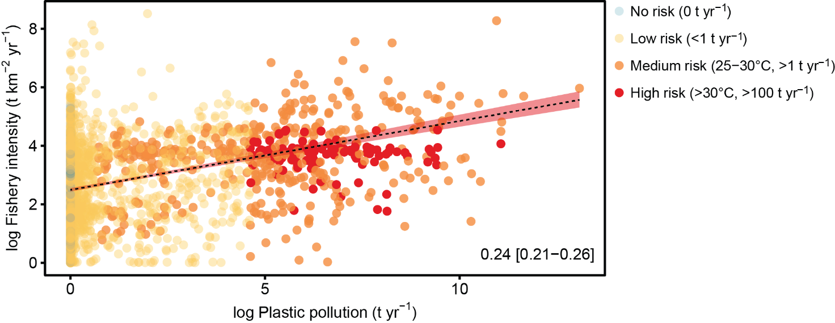

Figure S5 Relationship between mass of river plastic flowing into oceans (t yr⁻¹) and fishing intensity (t km⁻² yr⁻¹). Different coloured symbols indicate different risk estimates for each individual area shown. A Bayesian credible interval of the regression line (from the R package brms) is shown in the bottom-right corner (with 95% CI range).

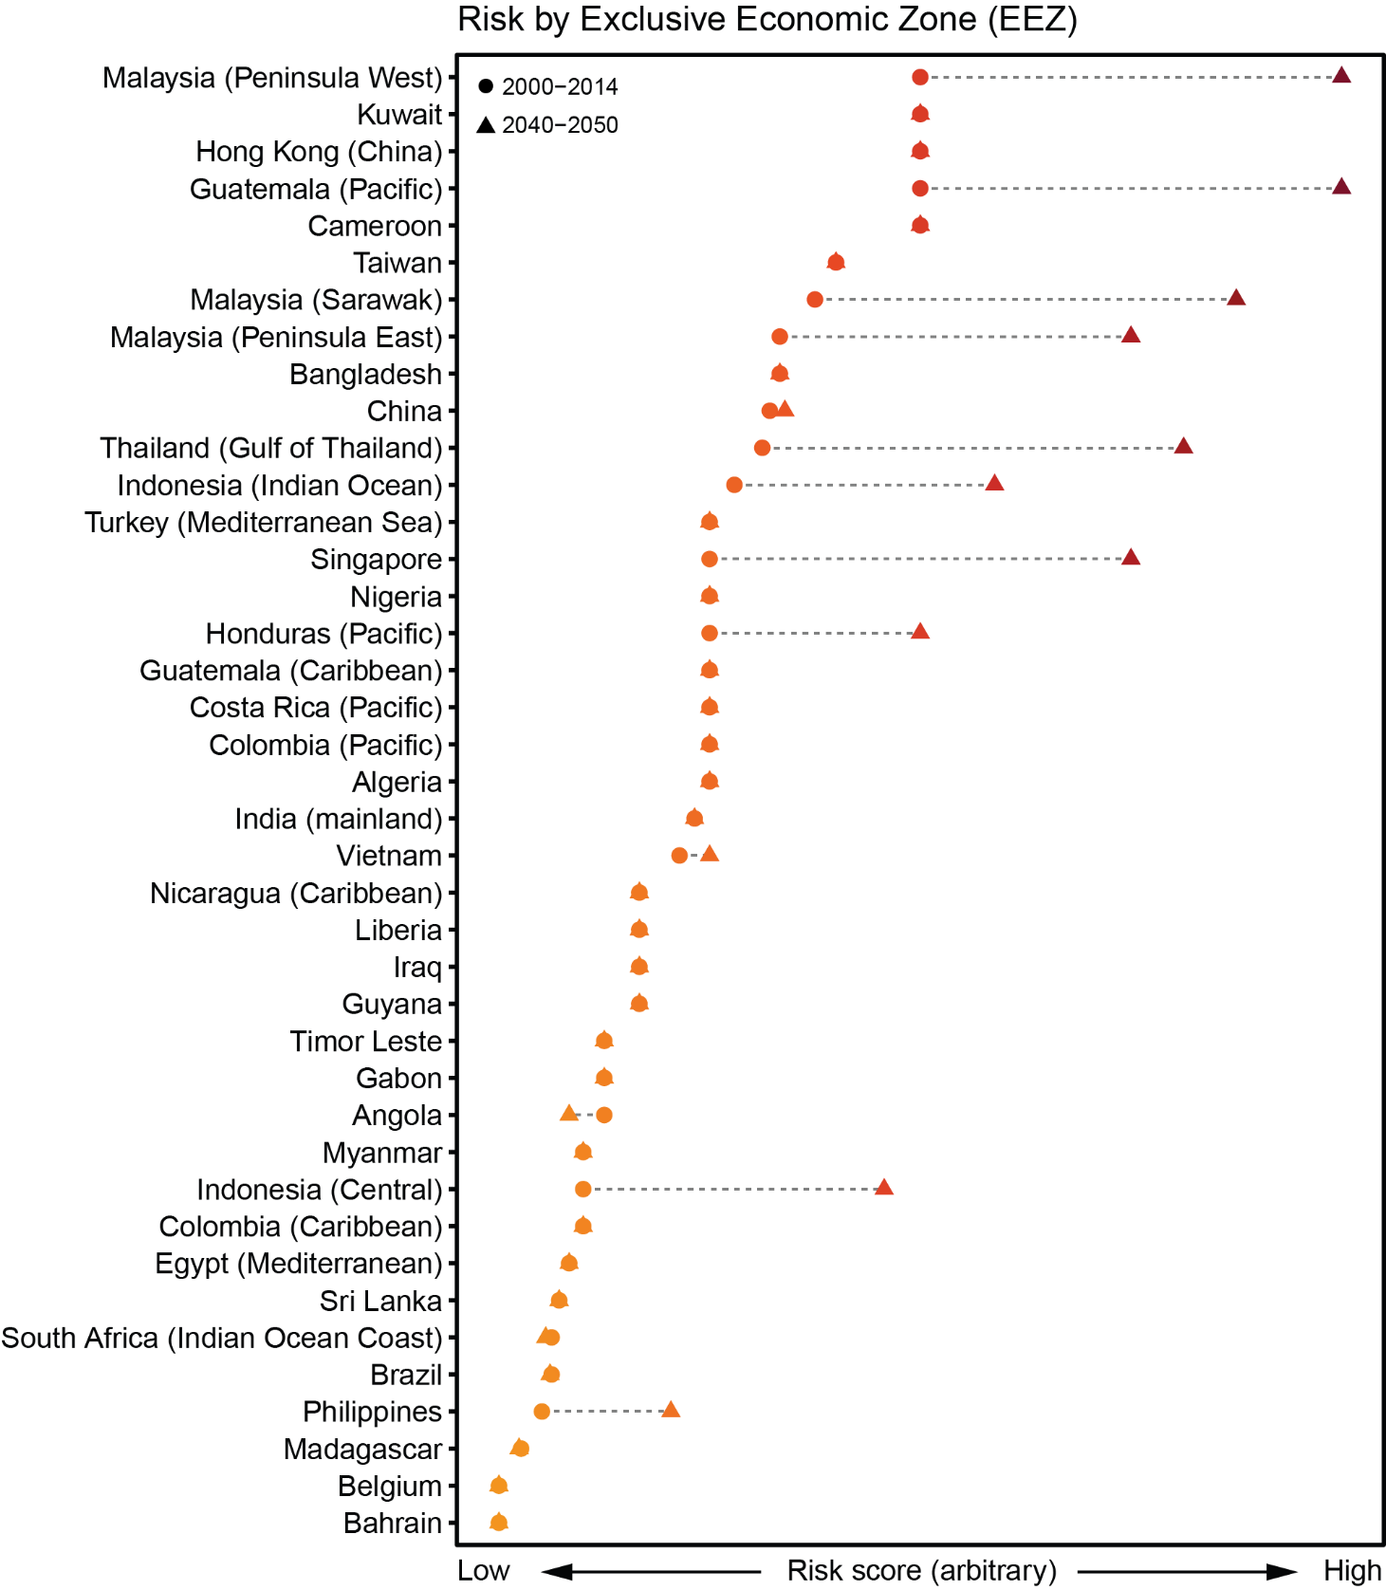

Figure S6 Top 40 exclusive economic zones (EEZ) at risk of high temperature and plastic pollution. Data shown are based on the current climate scenario (circles; 2000–2014) and near future climate scenario (triangles; 2040–2050). The risk score is arbitrarily based on the average categorised grid cells that occupy the coastal regions. The higher the score, the higher the risk (also indicated by a change in colour from yellow to red).

Supplementary references

# Stoffel, M. A., Goslee, S., Nakagawa, S. and Schielzeth, H. (2017). rptR: repeatability estimation and variance decomposition by generalized linear mixed-effects models. *Methods in Ecology and Evolution* 67, 1–6.