Software Installation

- Obtain the installation software from http://www.alopias.com/fortinet/ - There are two files, one for 32-bit Windows operating software and one for 64-bit version. Select the correct version for the OS you will be installing on.

FortiClientSetup_4.2.3.0271.exe – for 32-bit Windows OS
FortiClientSetup_4.2.3.0271_x64.exe - for 64-bit Windows OS

- Click on the file link to start the installation process. Select “Run” when asked to run or save.

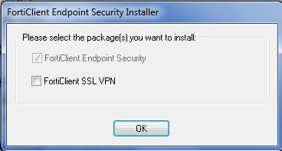

- Use the default package selected, click “OK”.
- Setup wizard starts. Click “Next”

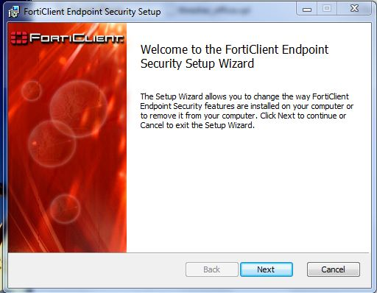
- Choose the “Free Edition” installation type, click “Next”

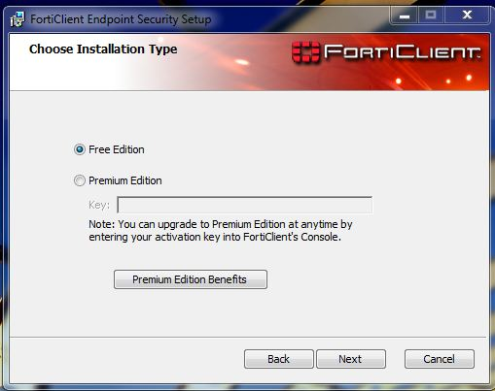

- Accept the end-user license agreement by putting a check mark in the check-box. Click “Next” to continue.

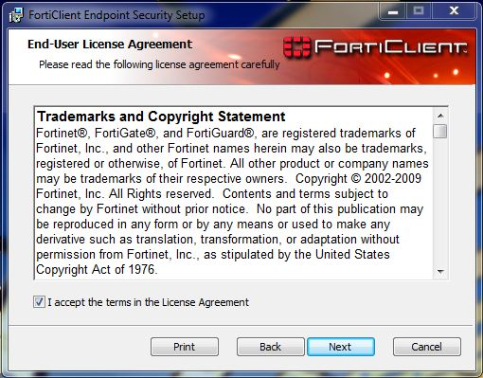

- Select “Custom” setup type. In the Custom Setup dialog windows, there are 5 features available. For the purpose of our installation, only the “IPSec VPN” will be used.
- For the un-used features, click on the harddrive symbol on the left of the name. You will see a drop-down list of selections. Select “X Entire feature will be unavailable”. Repeat the process for AntiVirus, Firewall, WebFilter and AntiSpam.

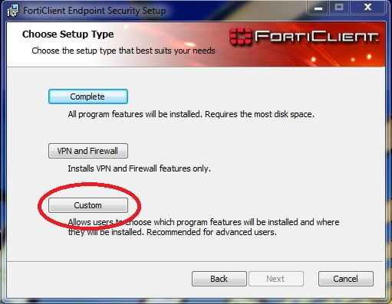

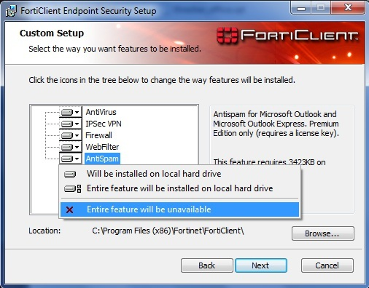

- The final screen will look like the picture above.

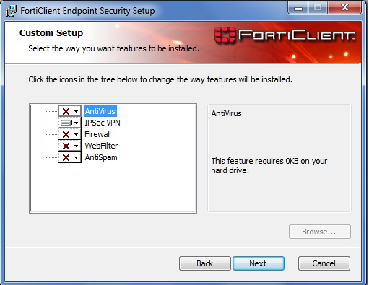

- Click “Next” to continue.
- Any modification or termination for the process should be done at this point. The installation will begin until it is finished. Click “Install” to begin.

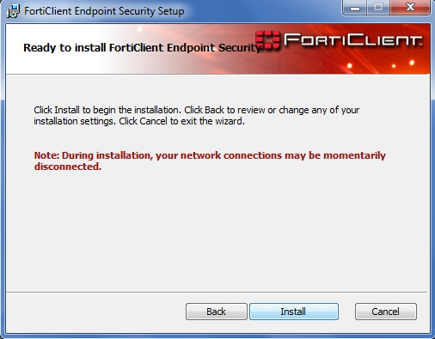

- Next step after the installation completed is the configuration wizard.

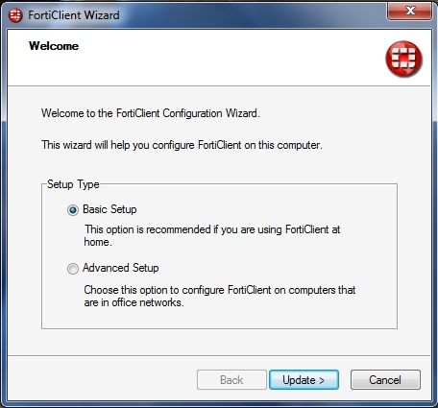

- Select “Basic Setup”, click “Update”. At this point, the installation is completed.

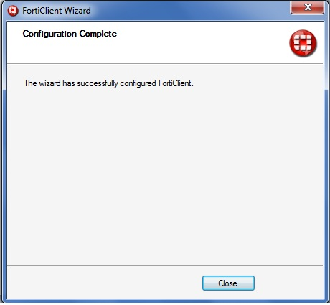
Running the application for the first time

- From the same website of Fortinet, right click the file “HE_VPN.vpl.txt”. Select “Save target as”. In the “Save As” dialog window, select “Desk Top” for the folder location, remove the “.txt” from the file name. Change the “Save as type” to “All Files”. Click “Save”.
(In case you can’t see the .txt part of the file name, open Control Panel > Folder Options > View tab. Un-check “Hide extensions for known file types”)

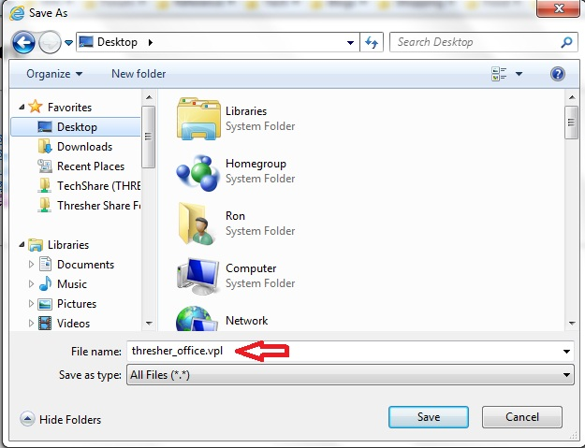

- FortiClient application should be already open after the installation. Click “VPN” on the left of the window.

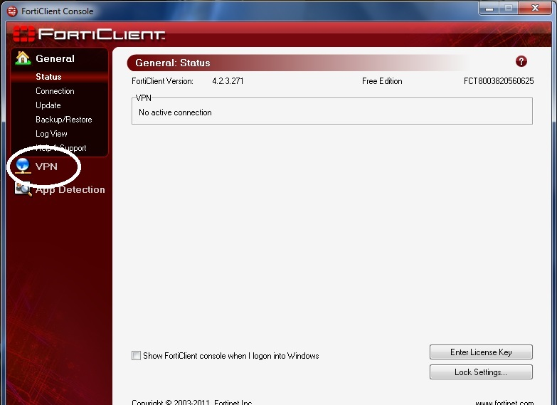
- Click “Advance” button. Select “Import”.

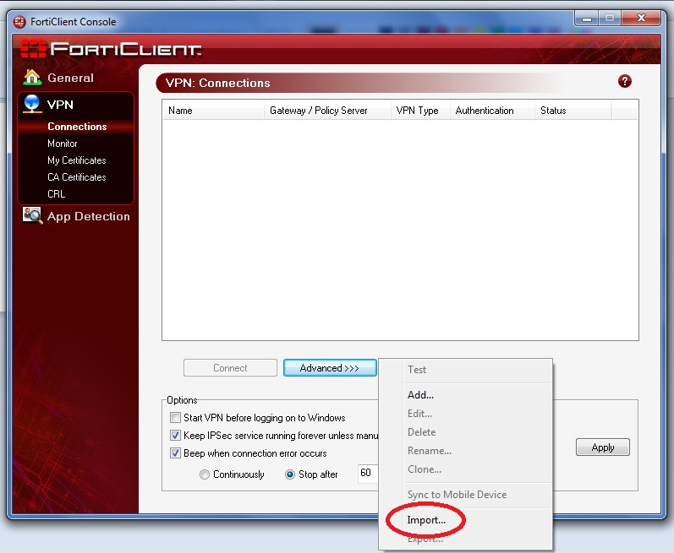

- In the “Open” dialog window, select “Desktop” in the “Look in” drop-down list. Select the downloaded .vpl file. Click “Open”.

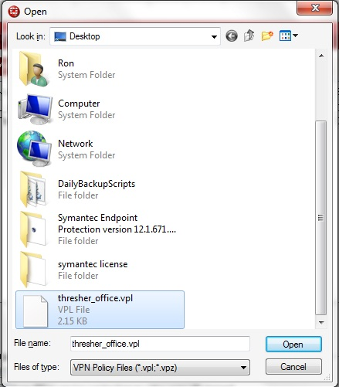
- The configuration is completed.

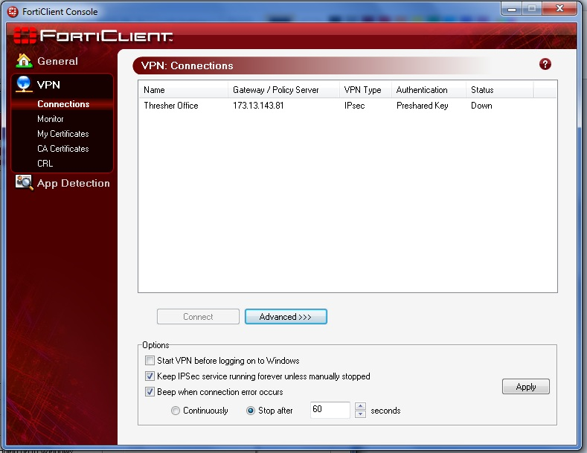

Making VPN connection

- High light the “Hurricane Electric VPN”, click “Connect”. The application requires login to Thresher account, enter account name and password when asked. Click “OK” to continue.

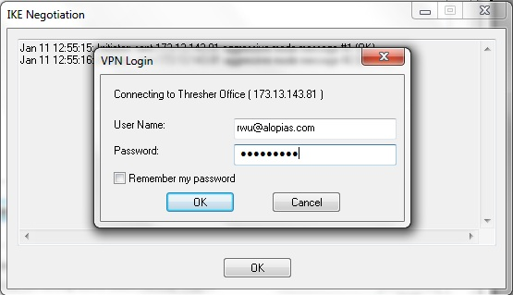

- During the negotiation phase, you will see two “Negotiation Succeeded” messages. That indicates the connection is made. The up time in the Status field is also an indication. Open “Remote Desktop” for your session.

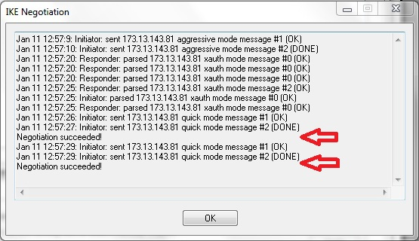

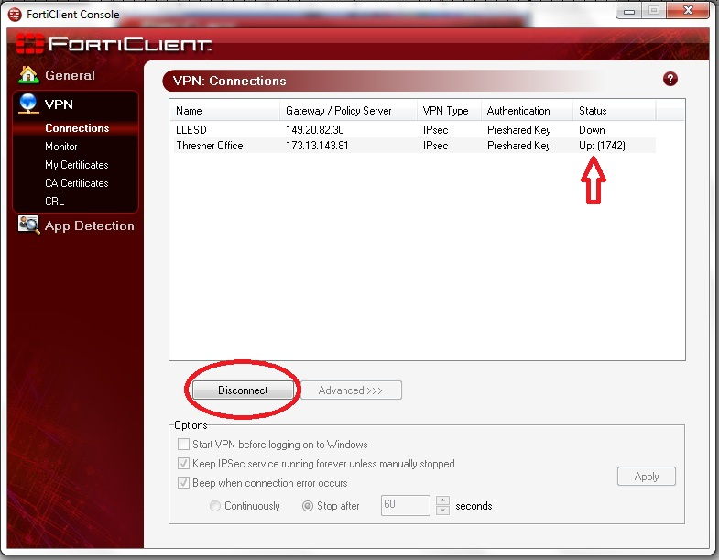

3. When you are done, go to FortiClient windows, click “Disconnect” to end the connection. NOTE: In some cases multiple disconnect tries may be needed.

