1. Click the Apple logo in the upper left hand corner and select “System Preferences…”

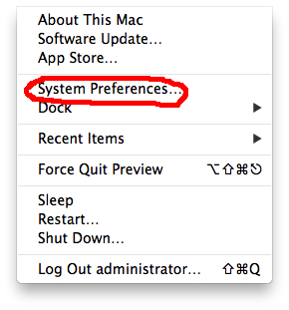

1. Select “Network”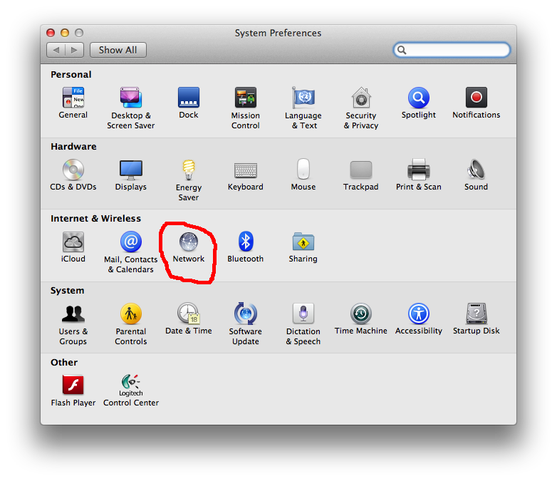
2. Choose the plus sign to add the VPN interface

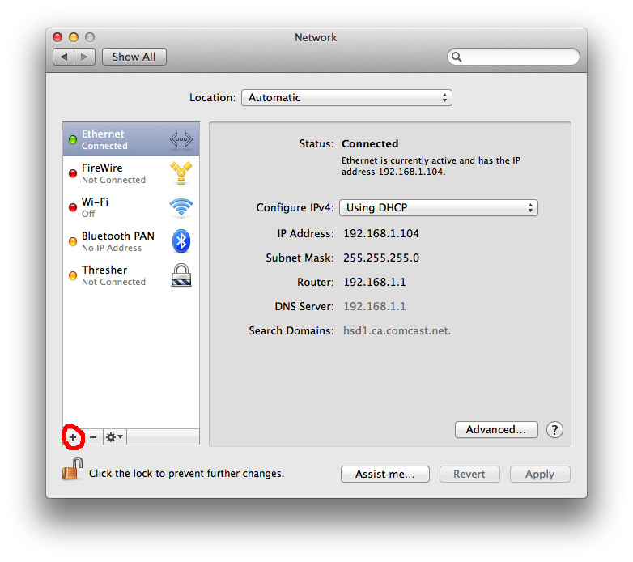

1. Choose VPN

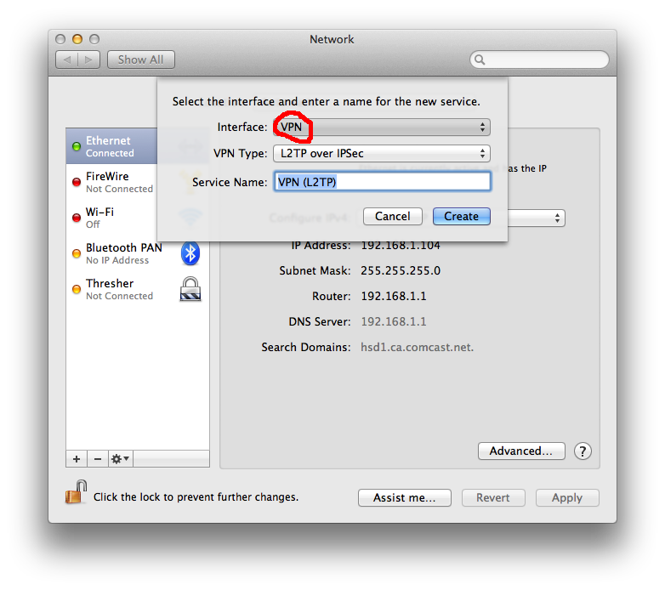

1. Type is Cisco IPSec and name the connection “Thresher”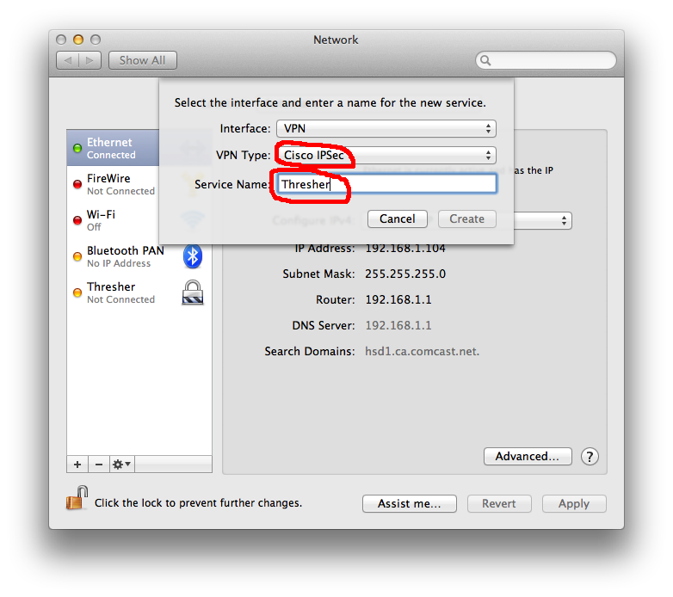
2. Click “Create”. Enter the “Server Address” and the “Account Name”. Click the option to “Show VPN Status in menu bar”.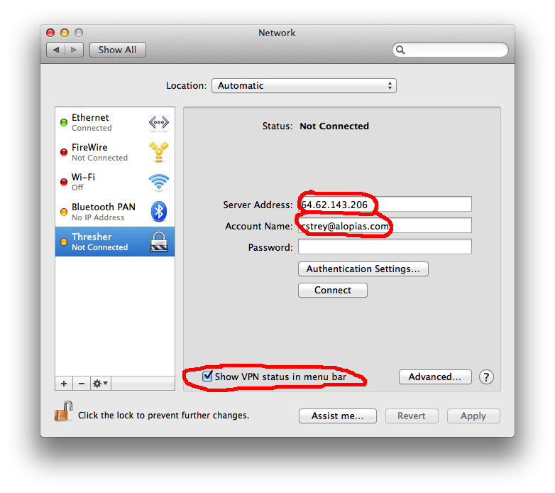
3. Click “Authentication Settings…” enter the “Shared Secret” - 1234abcd5678 the “Group Name” is apple.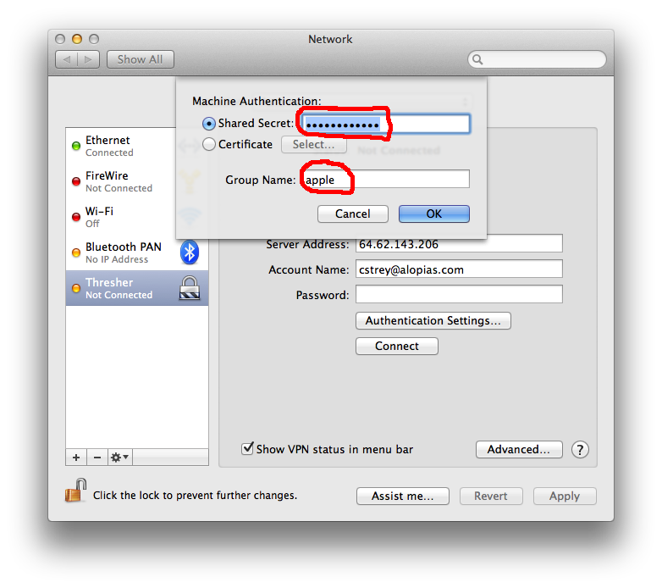
4. Click OK and Apply and then close the “System Preferences” window. In the top bar, click the icon for the VPN and then “Connect Thresher”

