Project Module 3 Adding New Pages and Database Backend

Web Application Development

Nicholas Shaffer

Rasmussen College

GITHUBURL : <https://github.com/Rasmussen-CIS3801/module-03-course-project-adding-new-pages-db-backend-nicholiae/blob/master/Projects/nshaffer_mod3Project_4212019.docx>

WEBSITE URL: <http://nicholiae.centralus.cloudapp.azure.com/pages/datadisplay.php>

Via <http://nicholiae.centralus.cloudapp.azure.com/index.html>

Create new Database and tables

SQL STATEMENT:

*CREATE DATABASE shaffertechsolns,*

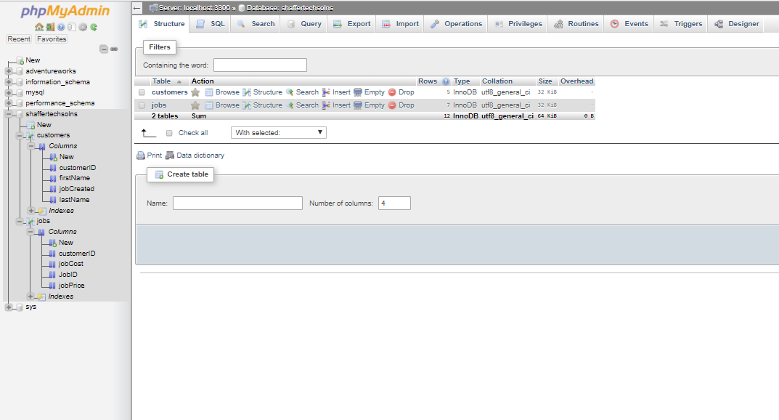

Creating tables

CREATE TABLE customers,

firstName VARCHAR(24)

lastName VARCHAR(24)

customerID BIGINT(20) UNSIGNED NOT NULL AUTO_INCREMENT,

jobCreated date

PRIMARY KEY(customerID)

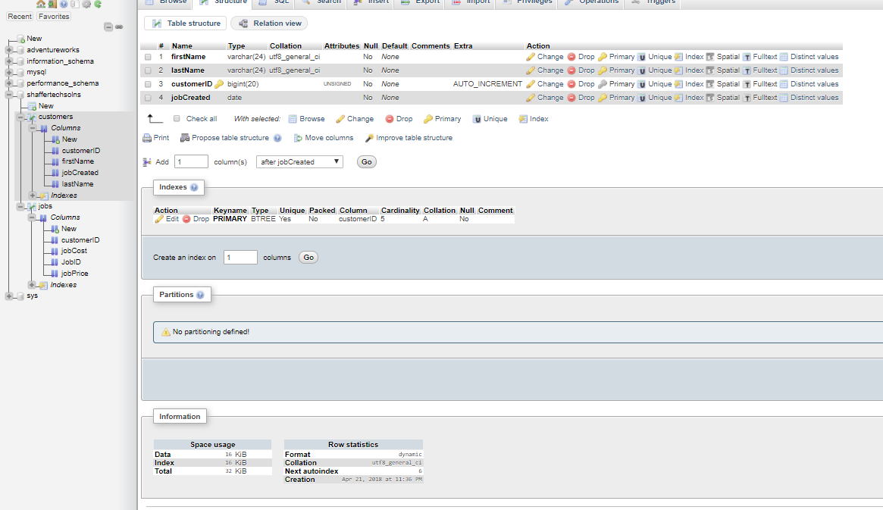

CREATE TABLE Jobs,

customerID BIGINT(20) UNSIGNED NOT NULL AUTO_INCREMENT,

JobID BIGINT(20) UNSIGNED NOT NULL AUTO_INCREMENT,

jobPrice FLOAT,

jobCost FLOAT,

PRIMARY KEY JobID,

FOREIGN KEY (customerID) REFERNCE (customers.customerID)

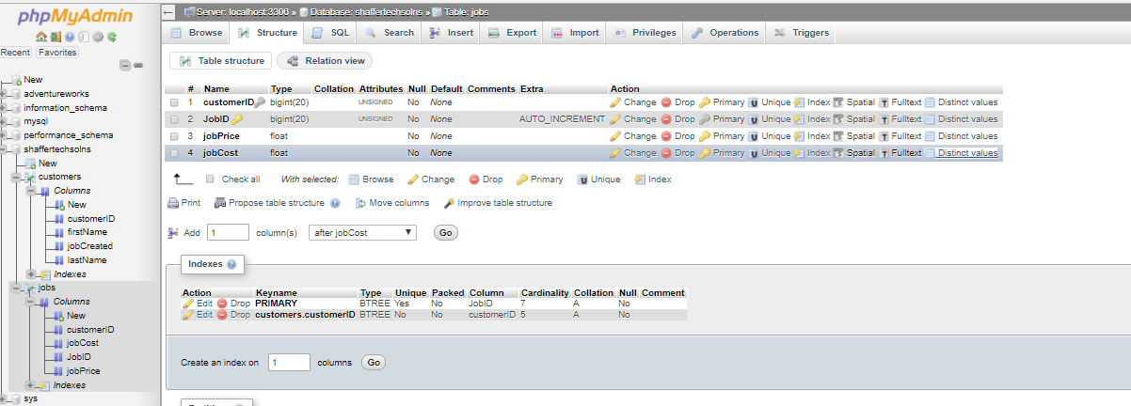

Search Query showing at least 3 tables

SELECT `customers`.*, `jobs`.`customerID`

FROM `customers`

LEFT JOIN `jobs` ON `jobs`.`customerID` = `customers`.`customerID`

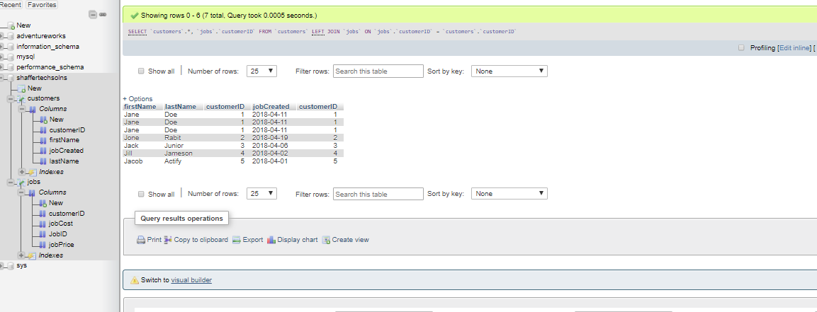

Web Page Displaying query



Additional below

