Activity Module 3 Wire frame of other pages

Web Application Development

Nicholas Shaffer

Rasmussen College

Wire frame of Process page

Link : https://wireframe.cc/KSgS8E
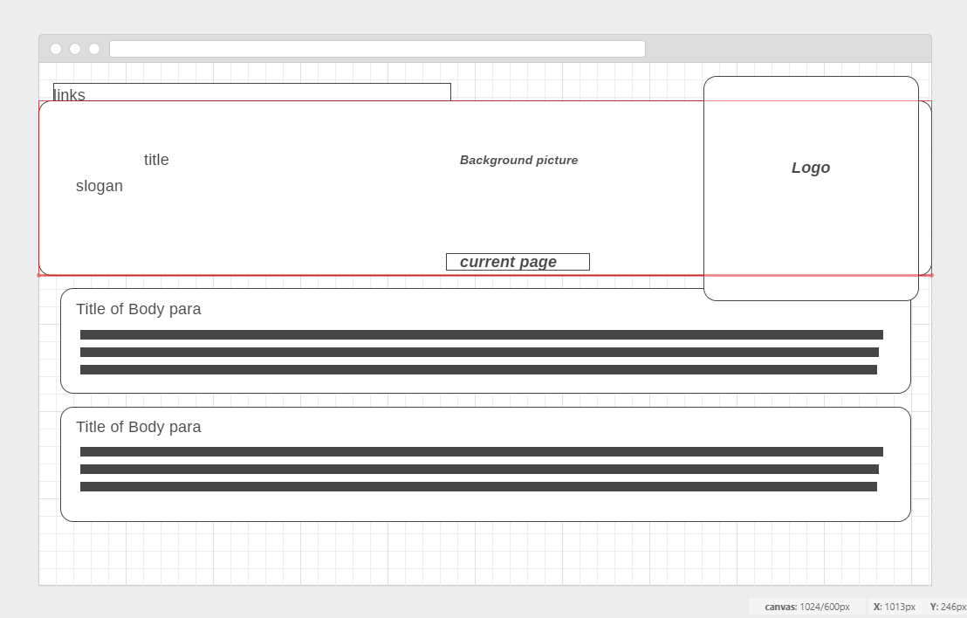
Wire Frame of Affiliate page
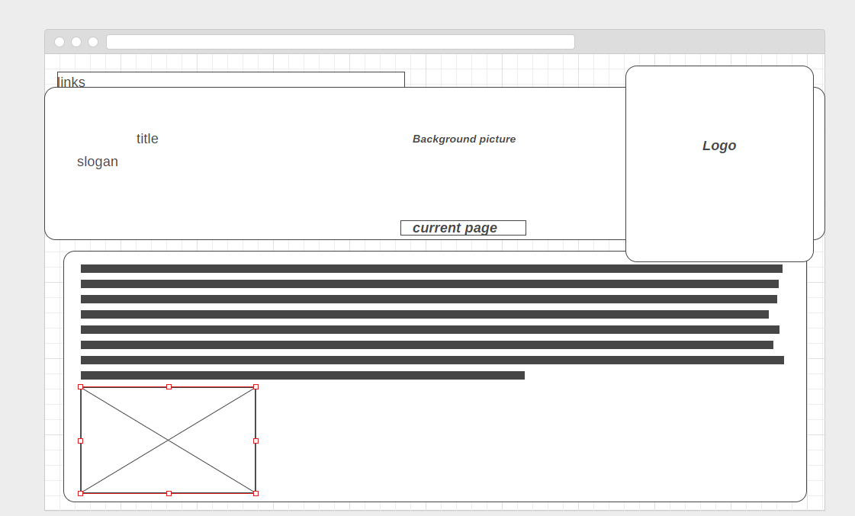

Wire Frame of Contact us page
