Activity Module 1 Configure Environment

Web Application Development

Nicholas Shaffer

Rasmussen College

GETHUB REPOSITORY URL <https://github.com/nicholiae/WebAppDev>

Website URL <http://nicholiae.centralus.cloudapp.azure.com/>

Step 1 setting up Azure

Data storage account and Virtual Machine

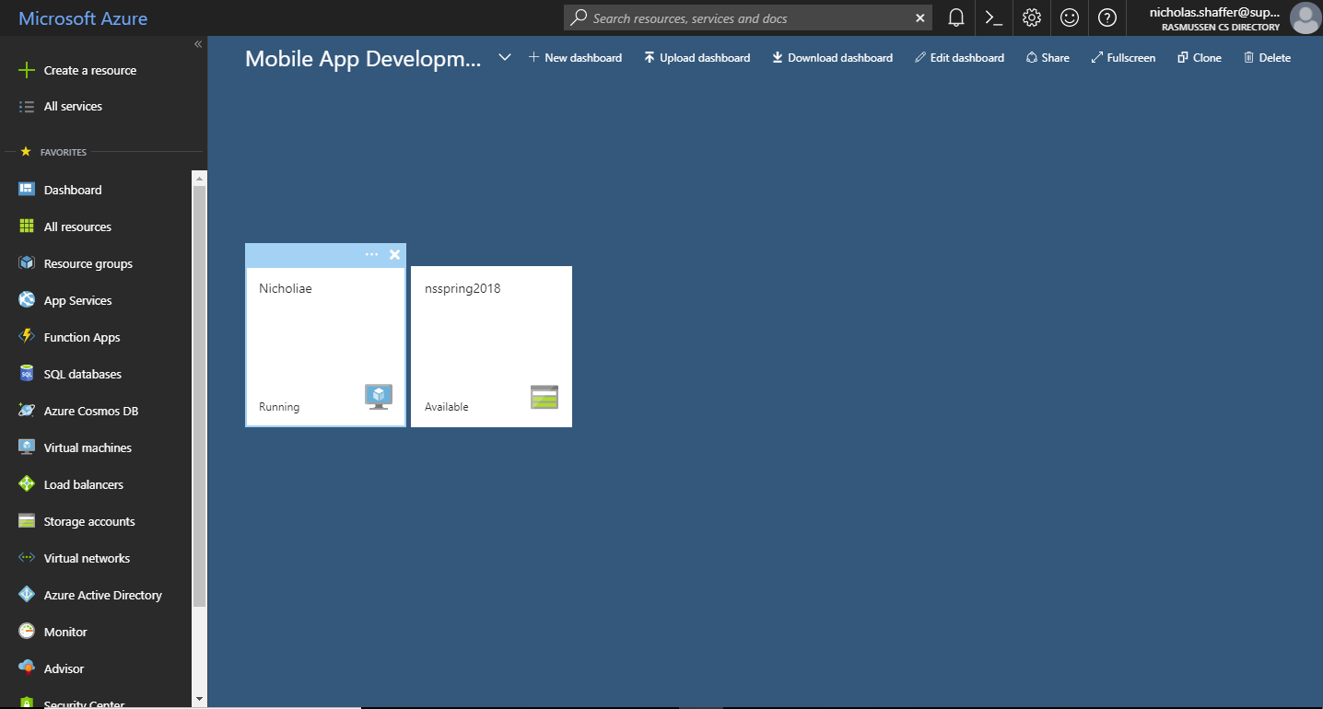

Virtual Machine overview including DNS name

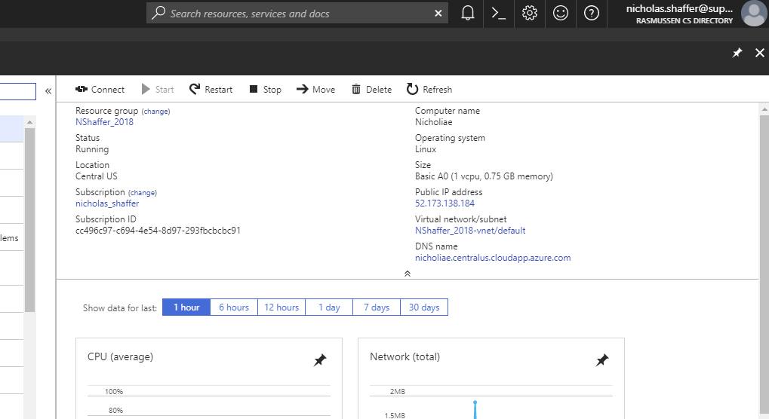

Connecting through putty and phpmyadmin

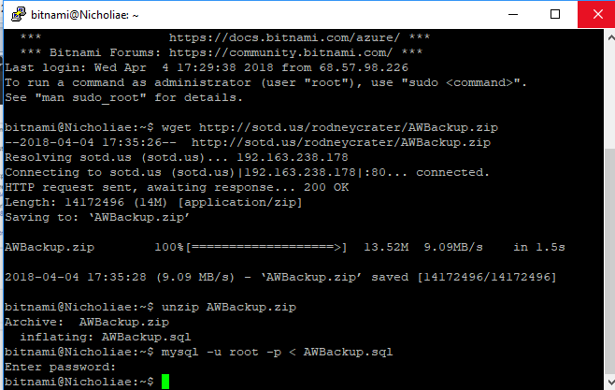

Phpmyadmin

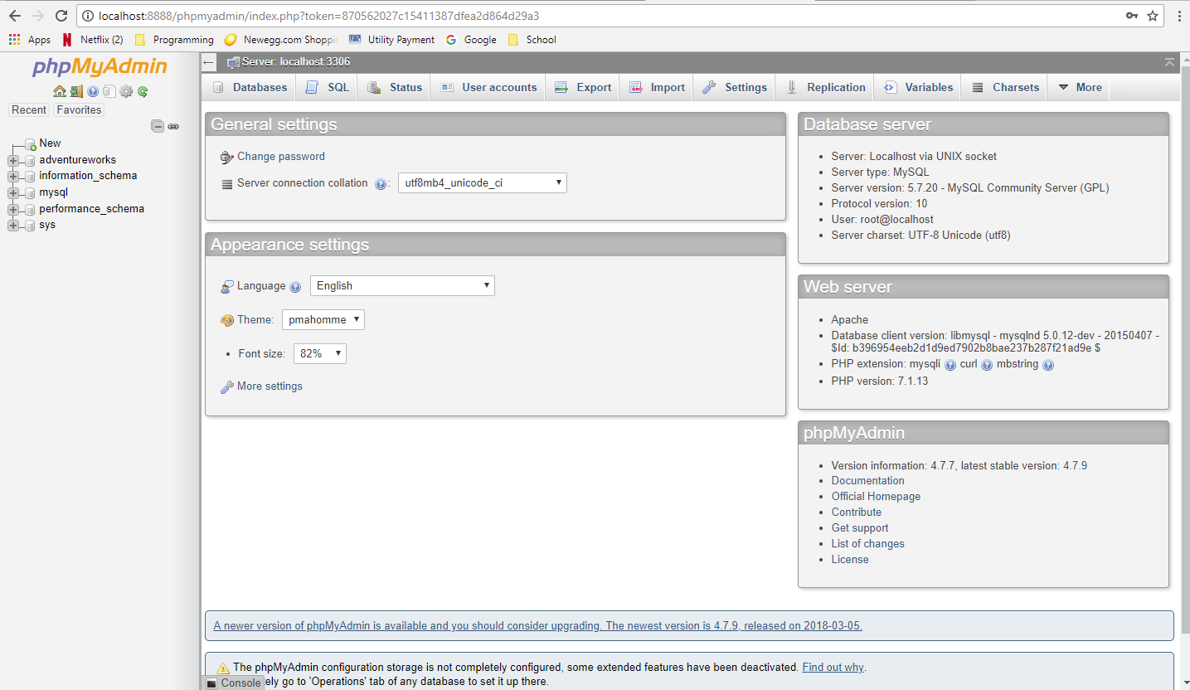

GitHub repository changes and first commit

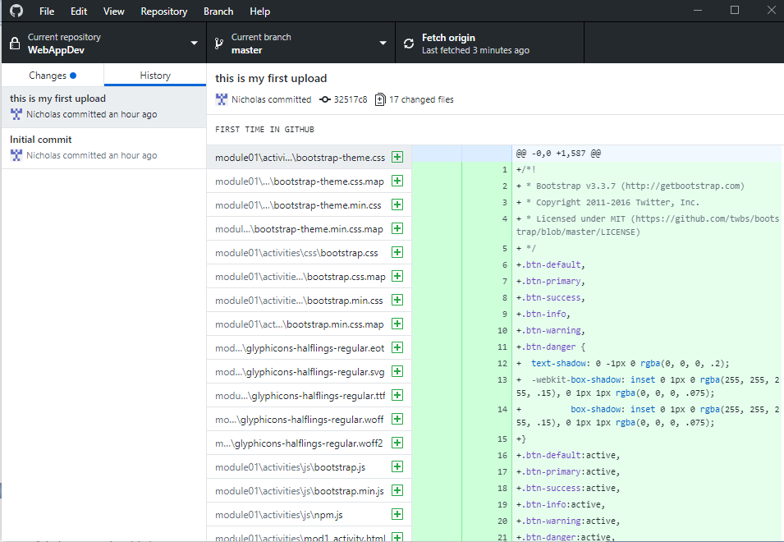

FileZilla upload

