Activity Module 4 project

Web Application Development

Nicholas Shaffer

Rasmussen College

WEBSITE URL:
http://nicholiae.centralus.cloudapp.azure.com/index.html

Githup Repo URL :
https://github.com/Rasmussen-CIS3801/module-04-course-project-adding-navigation-nicholiae.git

Iphone 5
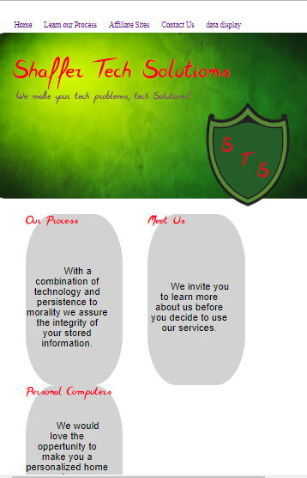

Landscape


Ipad


Ipad landscape
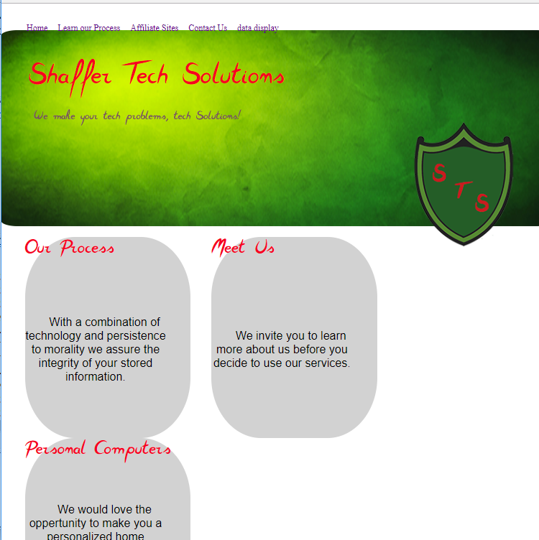

Dimensions of 375*667 LANDSCAPE


