Activity Module 5 Activity

Web Application Development

Nicholas Shaffer

Rasmussen College

WEBSITE URL:
http://nicholiae.centralus.cloudapp.azure.com/index.html

GitHub URL:

Landscape 320*568

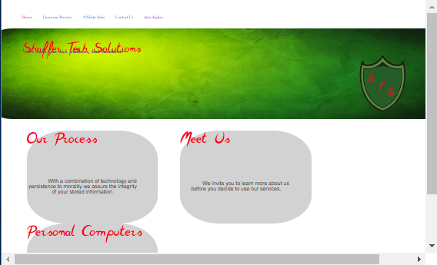

An issue that I can see is the text over lap and the small size of the navigation header.

375*667 Portrait
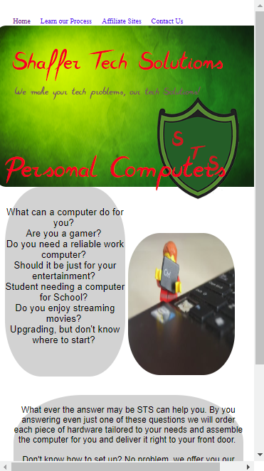

The text overlap with the picture logo can be corrected by lowering the size of the page title.

Desktop Size 1440*990
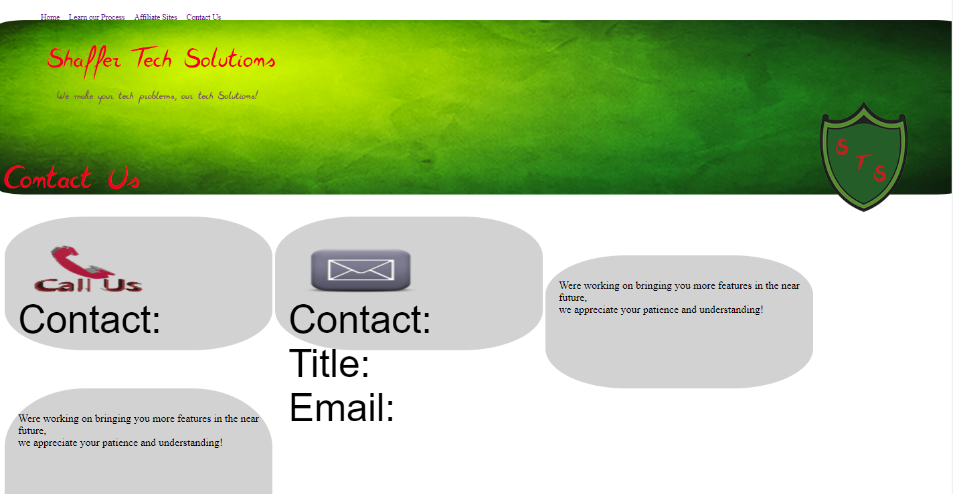
The issues with this display is the grid system with the ending tiles and also the text size.

