Module 5 Project

Web Application Development

Nicholas Shaffer

Rasmussen College

WEBSITE URL:
http://nicholiae.centralus.cloudapp.azure.com/index.html

GitHub URL:

Editing CSS
Before CSS change Small navigation buttons
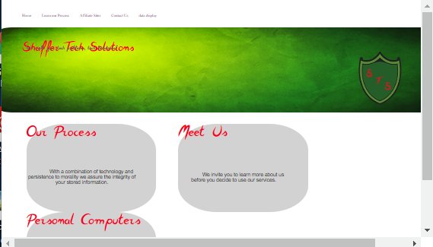

After

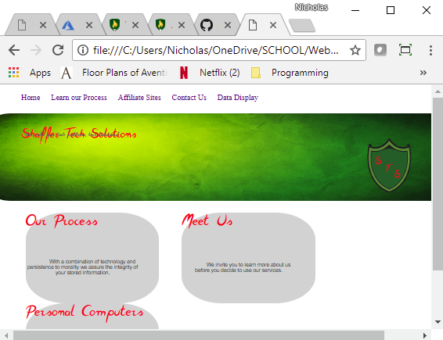

Made the navigation slightly bigger to enhance visibility, will implement this change to the final application.

Overlapping text display
Before

After

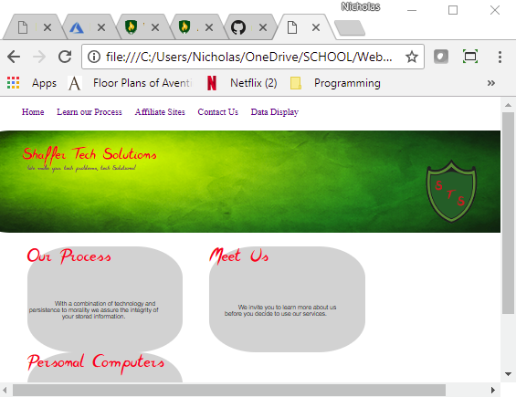

Adjusted text to not over lap when re-sizing the display size. Will be implementing this change to the final.

.

Text overlapping with logo photo
Before
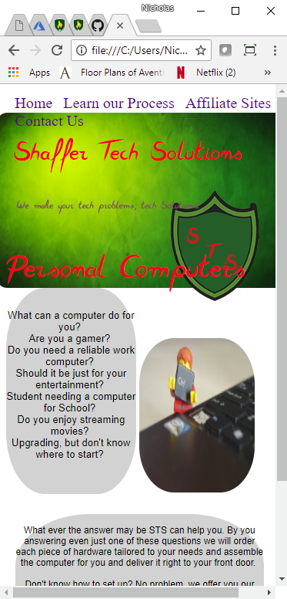

After
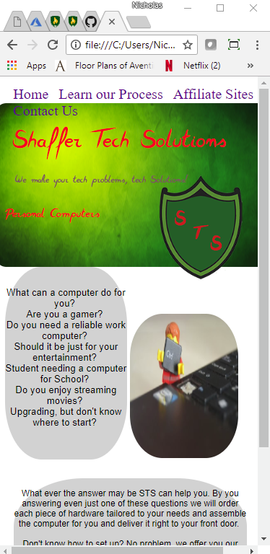

Readjusted the size of the text and position based upon height and width of the display screen. Will be implementing this change into the final application.

