UMLs
Below is the use case diagrams which correlate with the use cases:

USE CASE 1:
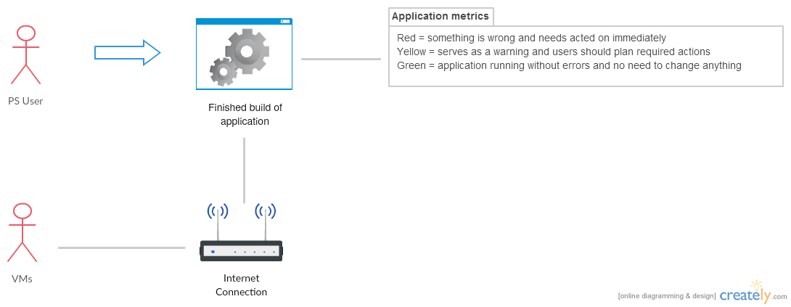

USE CASE 2:
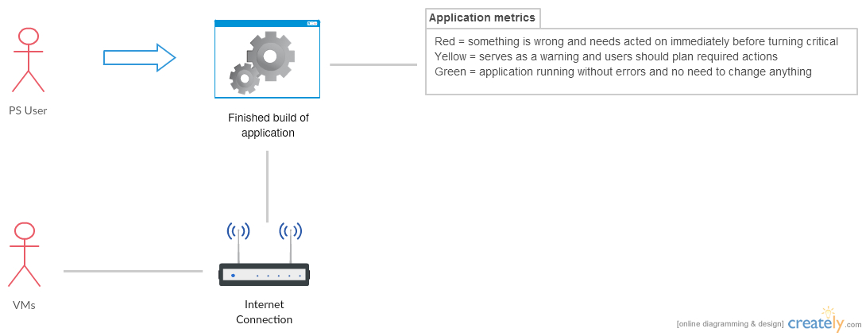

USE CASE 3:

