Goal: Make a simple adventure game

\* array, double array, push/pop/indexOf

\* switch-case statement

\* for/while/if statement

Statement:

Supposed that you were given a chance to navigate someone’s mind and to travel through that person’s memory. It is a setting we can frequently meet in the scientific fiction/ cyberpunk film like Minority Report(2002), Being John Malkovich (1999), or more recently InsideOut (2015). What if we could rewind the time and make that person another decision to have different experience? We will replicate the adventure game (ch. 4) but create a different space that can shape as a virtual cube. The options you can choose is your sides (#2-north/ #3-south/ #4-east/ #5-west) but also up. The side options will have the identical timeline as where you are standing (let’s say #6) but the choice of “up” will lead you to a time-travel (future or past, to #1). So the world map would look like this in 2D:

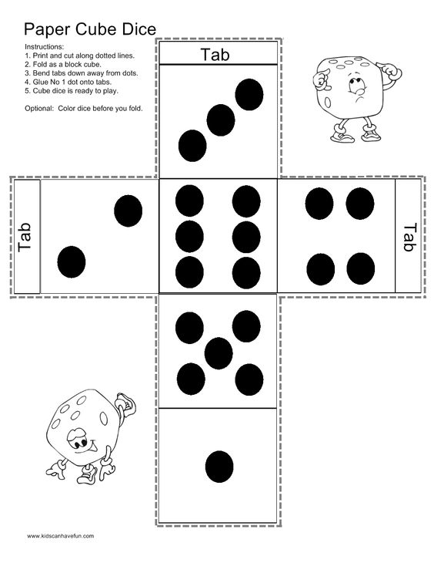

When we explore your game, we can see a picture of the scene in someone’s memory or a picture of the scene in the current place where the person is (ex. Griffin Hall 231). At each location (#1 to #6), we can remember (=pick) one emotion, we can forget (=drop) the emotion, and express(=use) the emotion to the world. And if you use a certain emotion (happy = smile), the world reacts to the emotion expressed (ex. the rain stops). You may create your own item set other them emotions.

Step0: Preparing Assets

1. You will have 6 spaces to navigate; each space has a background image, the description of the space (sentences), and the emotion to pick (maybe unique about the space).

Pick the background theme; collect the images; edit them in the same size, resolution, and similar graphic style (color, filter). Save them in the folder “images” under the working directory.

\* Each space may have the different reactions to each emotion (sentences)

1. Interface in <html>

* Id to show the background
* Id to show the description of the space
* Id to show the item available
* Id to show the items you acquired
* Id to show the input box
* Id to show button

Step1: the map

* Create arrays (p.198-200)
* Set the player’s start location (p.201 – 203) + moving around
* finding the players’ action (p. 204 – 207)
* Checking the boundaries (p.211 – 215)

Step2: implement game items (p.215 – 227)

* Pick (remember)
* Drop (forget)
* Use (express)

Step3: present with image + description + emotions available + inventory(emotions)

Step4: Apply CSS to improve overall look&feel and usability

-----------------------------------------------------------------------------------------------------------------------

Lab04: Choose your own adventure

Rubrics:

(3 points) implement the map with images/description/navigation

- successfully showing each space with every elements

(2 points) implement user interaction

- successfully navigating to north/south/east/west/top by entering sentences

- (I will test just one step for each direction)

(3 points) implement the item functions/reaction

- successfully remembering the emotion (1point)

- successfully forgetting the emotion (1point)

- successfully expressing the emotion + getting reactions(1point)

(2points) display the inventory

(extra 2 points) nice transition between the spaces, such as a smooth transition leftward if the user turned to right

\* Please submit your zip file (html, js, css, image folder) and active URL of your work.