Treetop detection on the Ulaanbaatar site: connected components and Mask R-CNN

Summary
Four detectors were compared under the same leave-one-block-out cross-validation on 921 annotated crowns: the connected-component treetop detector on the LiDAR and on the photogrammetric (P1) canopy height model, and Mask R-CNN on the LiDAR CHM and on the RGB mosaic. The best F1 was 0.877, for Connected components, P1 CHM; the highest recall was 91.0%, for Connected components, P1 CHM and Mask R-CNN, RGB mosaic. The whole field spans 2.7 F1 points, while a single method's F1 varies by 0.02-0.03 from one block to the next.
Compared block by block, the connected-component detector beats Mask R-CNN on most blocks (7/8, 6/8, 7/8, 6/8 of the paired comparisons), by 1.7-3.0 F1 points on average, but none of these differences is significant (p = 0.08-0.15 over eight blocks). On this site no method is reliably better at F1; the point detector is at least as good as Mask R-CNN, not measurably better.
What does separate them is cost and the kind of error. The connected-component detector needs no training data and runs in seconds; Mask R-CNN needs annotated crowns from the same kind of stand and about an hour per cross-validation on a GPU.
For the connected-component detector the tree-level analysis is clear: its lost precision is split crowns and canopy-level detections outside any drawn polygon, which are likely unannotated trees, far more than detections on the ground; and the crowns it misses are small crowns in crowded canopy. The same analysis for Mask R-CNN needs its predictions, which the runs so far did not save. Its logs give only the totals: on LiDAR, 9.5% of detections are repeats inside a found crown and 8.5% fall outside every crown; on RGB, 11.8% of detections are repeats inside a found crown and 8.4% fall outside every crown.

Data and evaluation protocol
The site covers 3.2 ha near Ulaanbaatar, with 921 hand-drawn crowns (median area 12.8 m²). Three rasters cover it: a LiDAR CHM (2025), a CHM derived photogrammetrically from the DJI Zenmuse P1 imagery (2026), and the P1 RGB orthomosaic. Alignment between all layers was measured by normalised cross-correlation at about 0.1 m, so no correction was applied.
The area is split into 8 spatial blocks of about 63 x 64 m. Each fold holds one block out, fits on the rest, and scores only the held-out block, so no method is ever scored on crowns it was fitted or tuned on. The learned models also set aside one training block as a validation block, used to pick the score threshold and never for fitting; the connected-component detector tunes its parameters on all seven training blocks.
Scoring is at the crown level. Each detection is reduced to a point; a point inside several overlapping crowns goes to the smallest; the highest-scoring point in a crown is a hit and any others are repeats; a point in no crown is a false positive. Recall is hits over crowns, precision hits over detections. A crown counts in the fold whose block holds its centroid, so every tree is scored exactly once. The same function scores every method.

How each algorithm works

Connected-component treetop detection
A 40 m window slides over the CHM. In each window heights are stretched between the window's own lower percentile and its 99th, then eroded, which removes the low connecting canopy so that crowns begin to separate. Each connected blob large enough to hold a tree is then walked down in height steps: at every step it is thresholded and relabelled, and any sub-blob appearing for the first time contributes its highest pixel as a new top. The descent is what does the work, since crowns are separate near their tops and fused near the ground, so the level at which two trees split is found rather than assumed.
Tops from all windows are then merged. Two tops are the same tree if they are within a search radius and the canopy between them never dips more than a set depth below the lower of them — the saddle rule. Measured on this site, tops within one crown sit a median 0.25 m apart with no dip between them, while tops in neighbouring crowns sit 5.8 m apart with a median dip of 6.6 m, so the depth separates the two cases far better than distance does. With the detector settings held fixed, replacing the original distance-only merge by the saddle rule raised F1 on the LiDAR CHM from 0.794 to 0.868 (tuned and scored on the whole area).

Mask R-CNN
torchvision's Mask R-CNN with a ResNet-50 FPN v2 backbone, pretrained on COCO, with its heads replaced for a single tree class. For a one-channel CHM the first convolution's three RGB filters are summed; the RGB mosaic uses the pretrained stem as it is. Tiles are 512 px at 0.05 m with 50% overlap, trained for 40 epochs with AdamW and a one-cycle schedule, augmented only by flips and 90-degree rotations, the transformations a nadir canopy image is genuinely invariant to. Predictions from overlapping tiles are merged by non-maximum suppression in world coordinates, and the score threshold is chosen per fold on the validation block.

Pseudo-crowns
The point detector returns tops, not crowns. Pseudo-crowns turn tops into outlines: the canopy mask, thresholded at the local 20th percentile, is cut along the Voronoi edges of the tops, and each top takes its piece. Where the canopy is crowded the bounding box is shrunk toward the largest square the distance transform guarantees is inside the canopy.

Tests performed
The evidence is: a sweep of 108 detector and merge settings for Connected components, LiDAR CHM, scored on the whole area; a sweep of 108 detector and merge settings for Connected components, P1 CHM, scored on the whole area; leave-one-block-out cross-validation of Connected components, LiDAR CHM, Connected components, P1 CHM, Mask R-CNN, LiDAR CHM, Mask R-CNN, RGB mosaic.
The sweeps tune and score on the same crowns, so they show which settings to try and how far recall can be pushed, but their F1 values are optimistic. Every comparison between methods in this report uses the cross-validated figures.
The connected-component cross-validation was corrected during this work. The first version tuned each fold by running the detector on the training blocks with the held-out block zeroed out, which put an artificial cliff at every block edge and damaged trees along it. The corrected version runs each setting once over the whole area and scores each fold from those detections; the held-out crowns are still never consulted during tuning. On the LiDAR CHM F1 moved from 0.868 to 0.875. The earlier figures are shown for reference only.

1. The best result for each algorithm
method | recall | precision | F1 | per-block F1 sd
Connected components, P1 CHM | 91.0% | 84.7% | 0.877 | 0.026
Connected components, LiDAR CHM | 87.5% | 87.4% | 0.875 | 0.035
Mask R-CNN, LiDAR CHM | 90.0% | 82.0% | 0.858 | 0.021
Mask R-CNN, RGB mosaic | 91.0% | 79.8% | 0.850 | 0.026
Table 1. Cross-validated results, held-out blocks only.
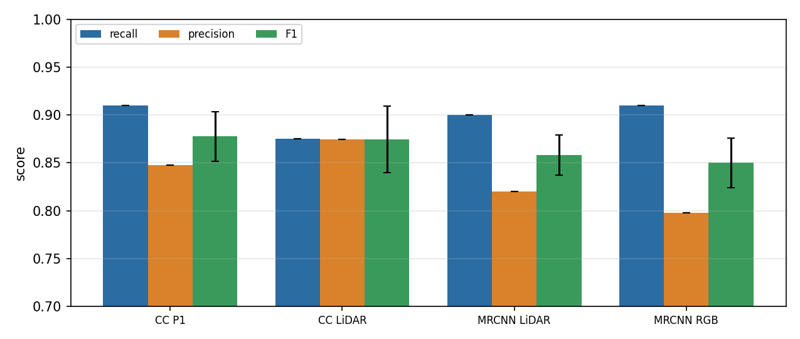
Figure 1. Cross-validated recall, precision and F1. Error bars on F1 are the standard deviation across the eight blocks.
For a high-recall operating point the sweeps are more informative than the cross-validation, which optimises F1. Table 2 gives three points per CHM. Recall can be pushed well past 90%, but the last crowns are expensive: on CC LiDAR, going from 90.0% to the sweep's highest recall of 95.4% finds 50 more crowns for 240 more detections, and precision falls from 86.5% to 73.4%; on CC P1, going from 90.3% to the sweep's highest recall of 95.4% finds 47 more crowns for 215 more detections, and precision falls from 86.5% to 74.7%. An earlier, wider sweep on the LiDAR CHM that included no erosion at all reached 98.2% recall, at 35.4% precision.
CHM | point | settings | recall | precision | F1
CC LiDAR | best F1 | pct 20, minTop 0.12, step 0.12, erode 2, drop 0.3 | 88.3% | 88.9% | 0.886
CC LiDAR | best precision at recall >= 90% | pct 20, minTop 0.06, step 0.12, erode 2, drop 0.2 | 90.0% | 86.5% | 0.882
CC LiDAR | highest recall | pct 10, minTop 0.06, step 0.12, erode 1, drop 0.2 | 95.4% | 73.4% | 0.830
CC P1 | best F1 | pct 10, minTop 0.25, step 0.25, erode 1, drop 0.5 | 91.6% | 86.2% | 0.888
CC P1 | best precision at recall >= 90% | pct 20, minTop 0.25, step 0.25, erode 1, drop 0.3 | 90.3% | 86.5% | 0.884
CC P1 | highest recall | pct 10, minTop 0.06, step 0.12, erode 1, drop 0.2 | 95.4% | 74.7% | 0.838
Table 2. Operating points from the sweeps (tuned and scored on the whole area, so optimistic).
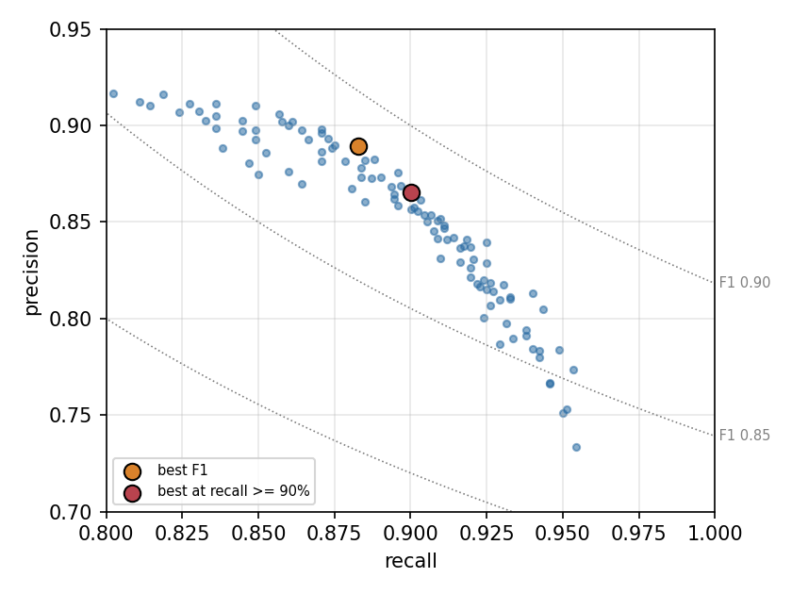
Figure 2. Every swept setting for Connected components, LiDAR CHM as a recall/precision point. Dotted lines are constant F1.
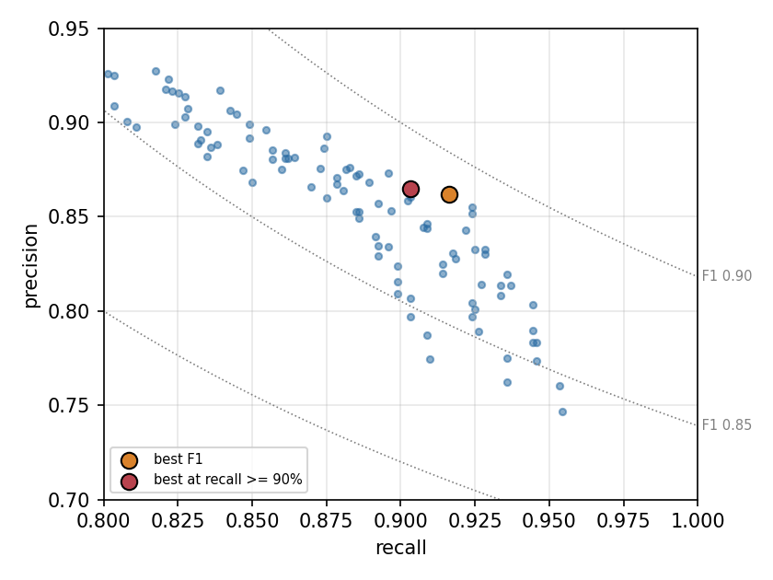
Figure 3. Every swept setting for Connected components, P1 CHM as a recall/precision point. Dotted lines are constant F1.

Are the differences real?
Blocks differ in difficulty more than methods differ from each other, so pooled F1 is a weak test. Pairing by block compares methods on the same trees: Table 3 gives, for each pair, the mean difference in F1 across blocks, how many of the eight blocks the first method won, and a Wilcoxon signed-rank p-value. With eight blocks the smallest attainable p-value is 0.008, and a real difference of one F1 point would need many more to show.
first | second | mean F1 difference | blocks won | p
CC LiDAR | CC P1 | -0.002 | 4/8 | 0.74
CC LiDAR | MRCNN LiDAR | +0.017 | 7/8 | 0.15
CC LiDAR | MRCNN RGB | +0.027 | 6/8 | 0.15
CC P1 | MRCNN LiDAR | +0.020 | 7/8 | 0.08
CC P1 | MRCNN RGB | +0.030 | 6/8 | 0.08
MRCNN LiDAR | MRCNN RGB | +0.010 | 6/8 | 0.15
Table 3. Paired comparison over held-out blocks.
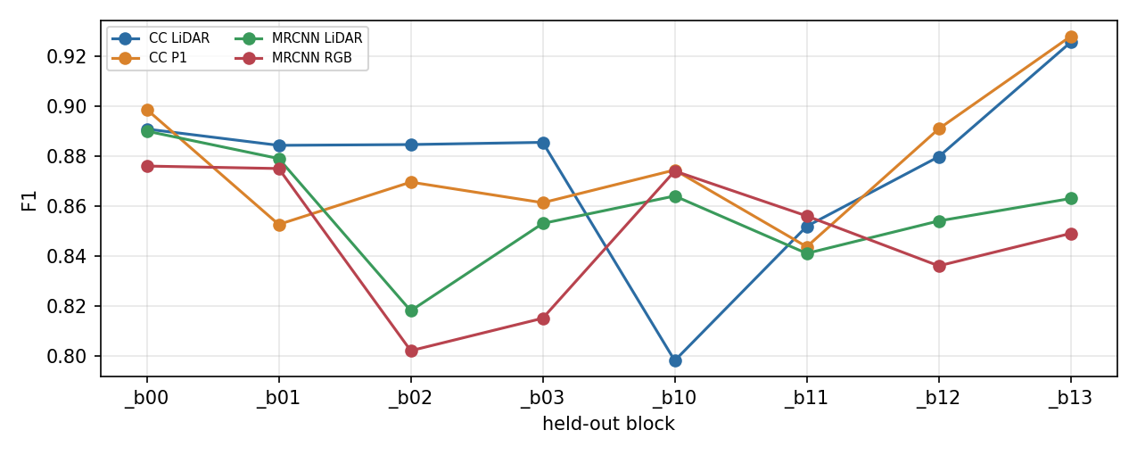
Figure 4. F1 on each held-out block. The lines cross repeatedly: which method wins depends on the block.

Mask R-CNN: CHM or RGB mosaic?
On the LiDAR CHM Mask R-CNN reached F1 0.858 (recall 90.0%, precision 82.0%); on the RGB mosaic 0.850 (recall 91.0%, precision 79.8%). The CHM version won 6 of 8 blocks, by +0.010 on average (p = 0.15). The RGB model finds slightly more trees but splits more of them: 11.8% of its detections are repeats inside an already-found crown against 9.5% for the CHM model, while false positives outside crowns are about the same (8.5% and 8.4%). Height separates touching crowns at their saddle, which colour does not, so this is the error one would expect RGB to make.
The score threshold chosen on the validation block ranged from 0.20 to 0.80 across folds. A single validation block of 10-25 tiles is too little to fix the threshold reliably, and some of the fold-to-fold variation in Mask R-CNN's precision comes from that rather than from the model.

2. Where are the missed trees?
Table 4 compares the crowns each method missed with those it found, on the held-out predictions stitched across all folds. Missed crowns are consistently smaller, and slightly lower and more crowded. Size dominates: the missed crowns' median area is little more than half that of the found ones, while their median height is only one to two metres lower.
method | missed | median area m² (missed / found) | median height m | nearest crown m
CC LiDAR | 110 | 7.7 / 13.8 | 17.3 / 18.7 | 3.39 / 3.91
CC P1 | 74 | 7.8 / 13.5 | 17.1 / 18.6 | 3.57 / 3.86
Table 4. Missed versus found crowns.
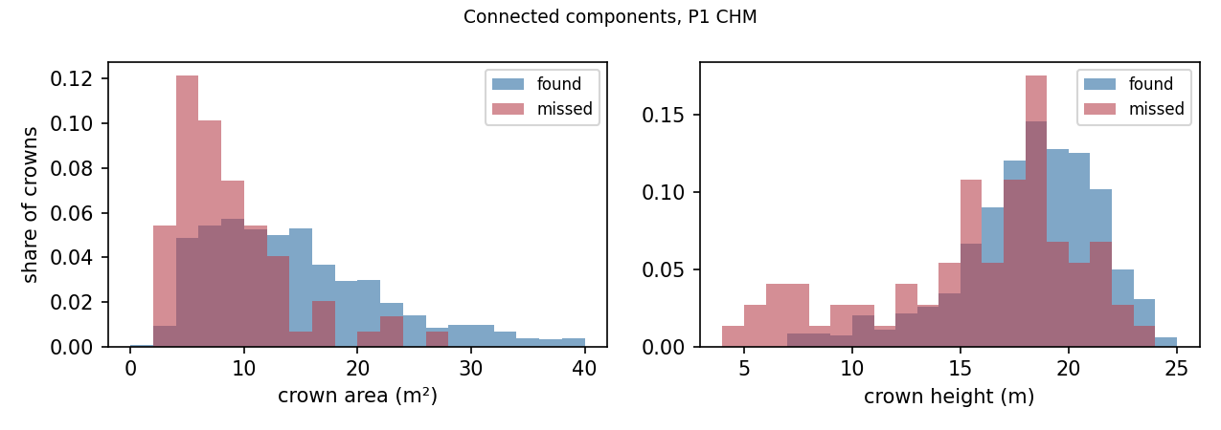
Figure 5. Area and height of found and missed crowns, Connected components, P1 CHM. The missed crowns sit at the small end of the size distribution but across most of the height range.
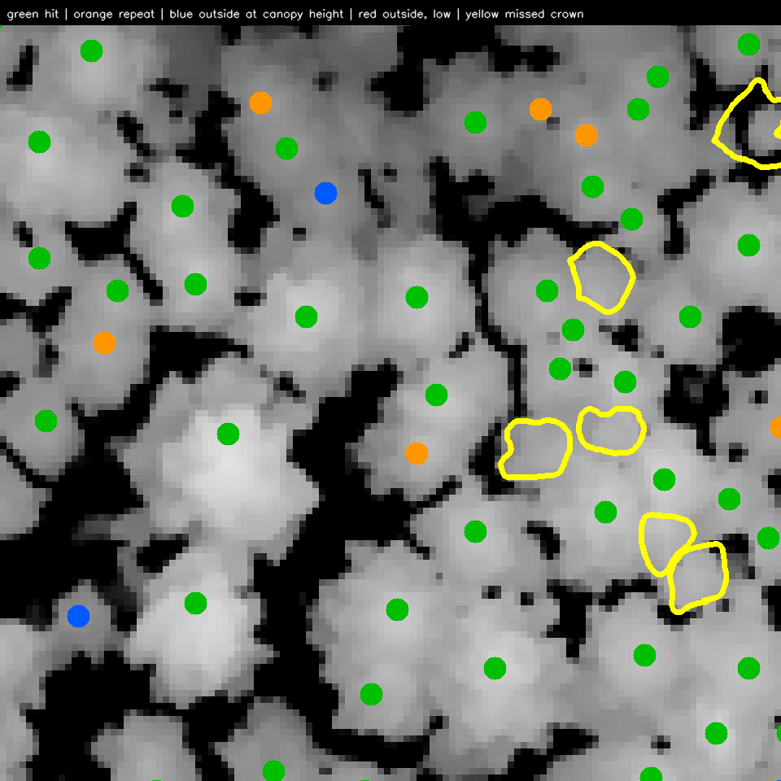
Figure 6. The tile where Connected components, P1 CHM misses most, chosen as a worst case rather than a typical one. Yellow outlines are missed crowns: small crowns pressed against larger neighbours.
Not yet available: the same breakdown for Mask R-CNN. This needs the learned models' predictions, which runs made before prediction saving was added do not contain. The commands in the last section re-run them, and re-running this report afterwards fills this part in.

3. Where does the precision go?
A detection that is not a hit is one of three things, and they need different fixes. A repeat is a second detection inside a crown that already has one: a crown split in two. A detection outside every crown but at the height of the confirmed trees around it (at least 70% of the median hit height within 12 m) is most likely a tree nobody drew. One well below the local canopy is scrub, a branch or the ground: the genuine false positive.
method | detections | hits | repeats | outside, canopy height | outside, low
CC LiDAR | 922 | 88.0% | 5.5% | 5.7% | 0.8%
CC P1 | 989 | 85.6% | 7.3% | 5.9% | 1.2%
Table 5. What every held-out detection turned out to be.
Genuine false positives are at most 1.2% of detections for any method. The rest of the lost precision is split crowns and canopy-level detections, and if those canopy-level detections are trees missing from the annotation, precision as scored understates the real figure by several points.
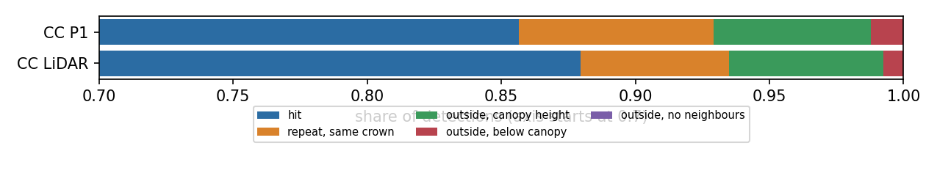
Figure 7. Detection fates by method.
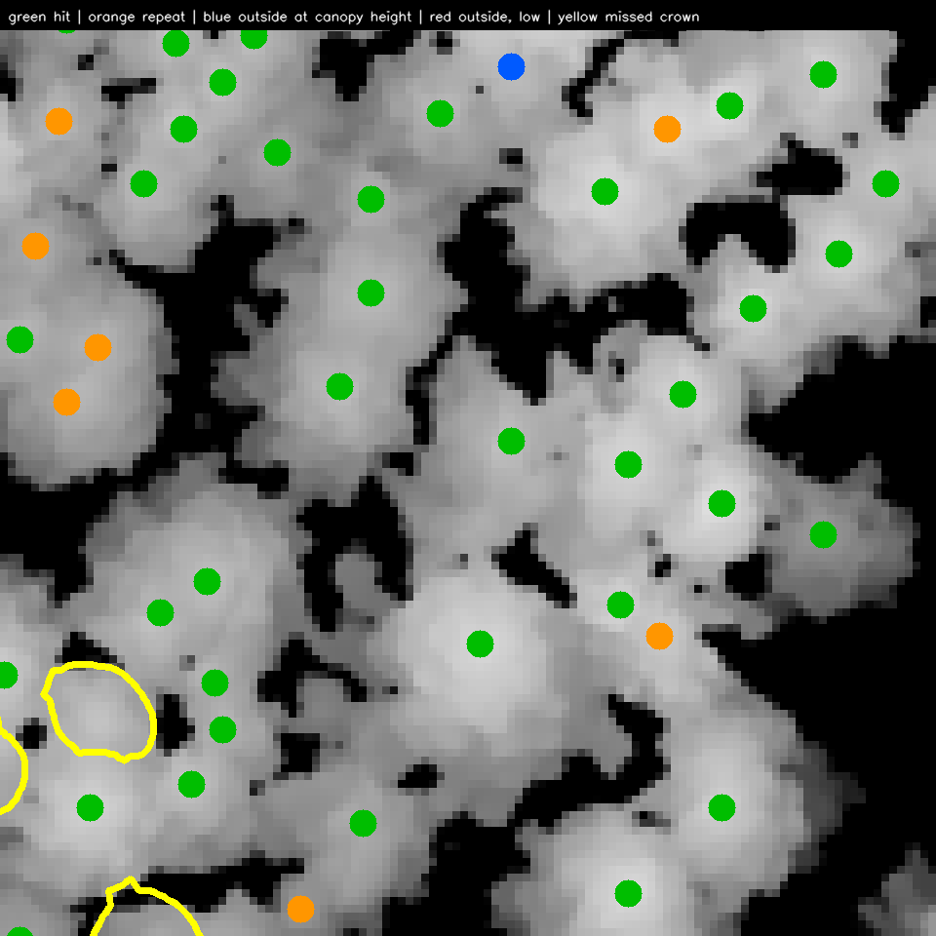
Figure 8. The tile where Connected components, LiDAR CHM's non-hits concentrate. Blue detections sit on bright crowns with no polygon: most look like real, unannotated trees.

4. Does using different data sources help?

CC LiDAR and CC P1
crowns found by | count | median area m² | median height m | nearest crown m
both | 784 | 13.9 | 18.7 | 3.92
only CC LiDAR | 27 | 9.3 | 18.4 | 3.58
only CC P1 | 63 | 7.9 | 17.9 | 3.37
neither | 47 | 6.7 | 16.0 | 3.56
Table 6. Which crowns each found.
The two agree on 784 crowns. Together they find 874 of 921 (94.9%), so combining them can recover at most 2.9% of recall over the better one alone. The crowns only one of them finds are small, and the ones neither finds are smaller still.
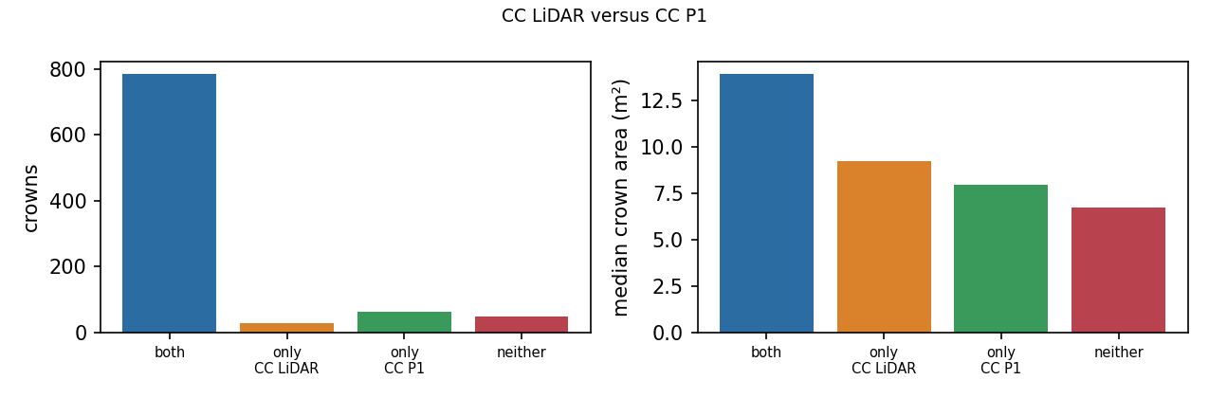
Figure 9. Crowns by which method found them, and their median size.
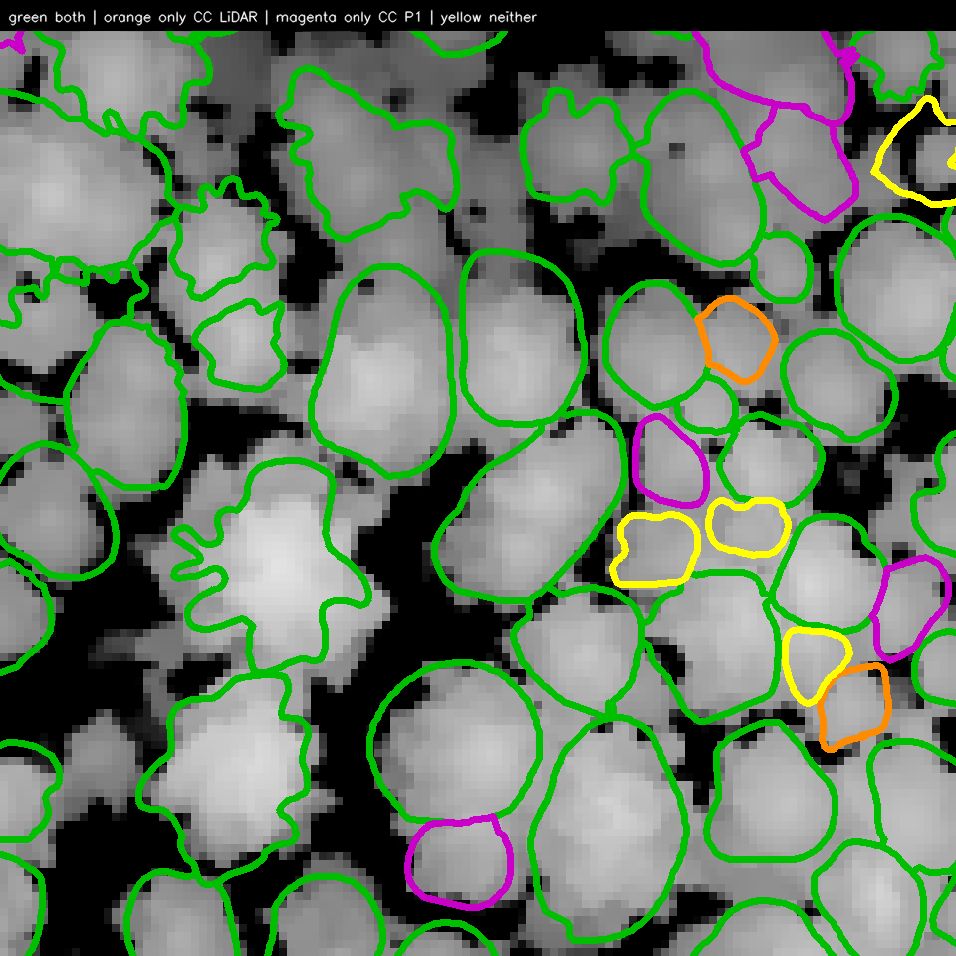
Figure 10. The tile where CC LiDAR and CC P1 disagree most, chosen as a worst case.
Not yet available: the same comparison for Mask R-CNN on the CHM against the RGB mosaic, and for Mask R-CNN against connected components. This needs the learned models' predictions, which runs made before prediction saving was added do not contain. The commands in the last section re-run them, and re-running this report afterwards fills this part in.

5. What each approach produces
The point detector returns a location per tree; Mask R-CNN returns a box and a mask. For the point detector the outline comes from the pseudo-crowns. Table 7 scores each hit's shape against its crown: box IoU against the crown's bounding box, shape IoU against the crown polygon itself.
method | outline from | median box IoU | median shape IoU | shape IoU > 0.5
CC LiDAR | pseudo-crown | 0.615 | 0.580 | 68.4%
CC P1 | pseudo-crown | 0.573 | 0.558 | 61.1%
Table 7. Shape agreement of hits with their crowns.
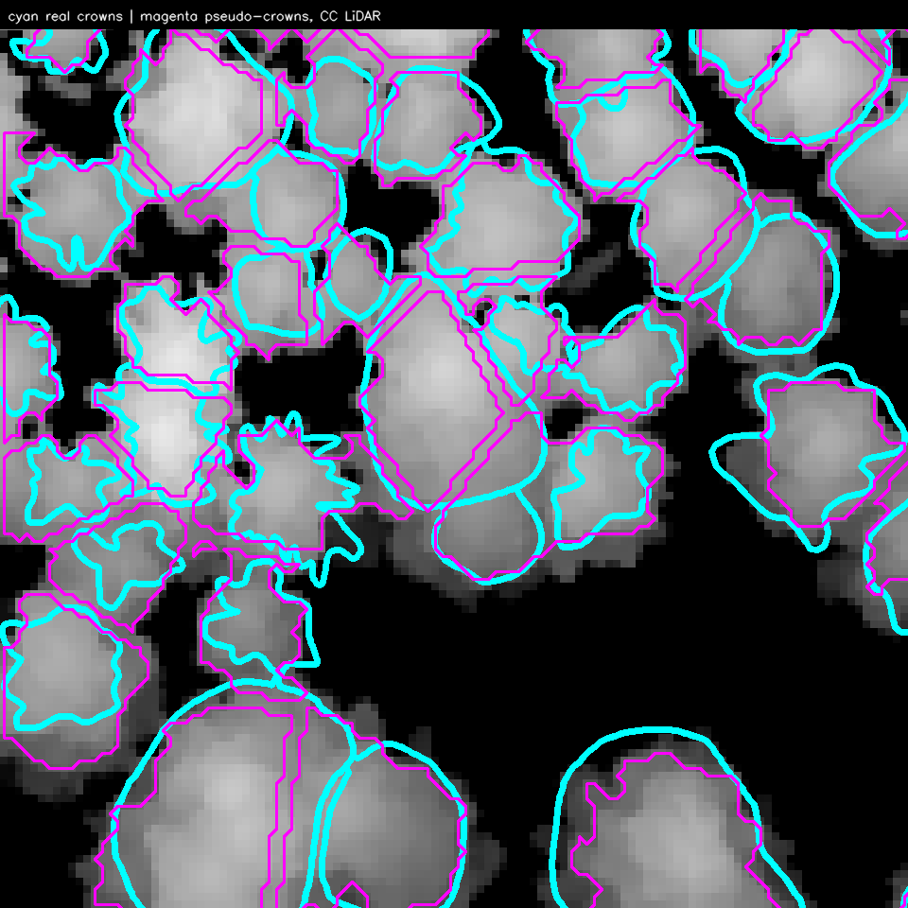
Figure 11. Real crowns (cyan) and pseudo-crowns (magenta) from the held-out tops. Pseudo-crowns follow the Voronoi cells, so they are straight-edged where two trees meet.
Not yet available: whether Mask R-CNN's boxes and masks match the crowns better than the pseudo-crowns. This needs the learned models' predictions, which runs made before prediction saving was added do not contain. The commands in the last section re-run them, and re-running this report afterwards fills this part in.

Combining the methods
Four combinations were implemented, each with every parameter, the thresholds included, tuned per fold on that fold's validation block and applied unchanged to its test block. Confirmed keeps a box at one score threshold if a connected-component top lies inside it and at another if none does, which is the general form of giving boxes with a top extra score. Agreement keeps only confirmed boxes, the precision extreme. Box-merged points fuses the tops that fall inside the same box into the highest of them, so the box does the merging the saddle rule approximates. Union keeps every box and every top no box covers, the recall extreme.

CC P1 tops as the box role, CC LiDAR tops as points
With no boxes available yet, the same code was run on the two CHMs: CC P1's tops were given square boxes, their size tuned per fold with the rest, and combined with CC LiDAR's tops. Scores here are heights, not confidences, so no thresholds were applied.
strategy | recall | precision | F1 | vs CC P1 alone (mean, wins)
union | 93.8% | 83.2% | 0.882 | +0.004, 6/8
CC P1 alone | 91.0% | 84.7% | 0.877 | -
agreement | 85.6% | 89.7% | 0.876 | -0.001, 3/8
CC LiDAR alone | 87.5% | 87.4% | 0.875 | -0.002, 4/8
boxMergedPoints | 87.2% | 87.6% | 0.874 | -0.004, 4/8
Table 8. Cross-validated combinations.
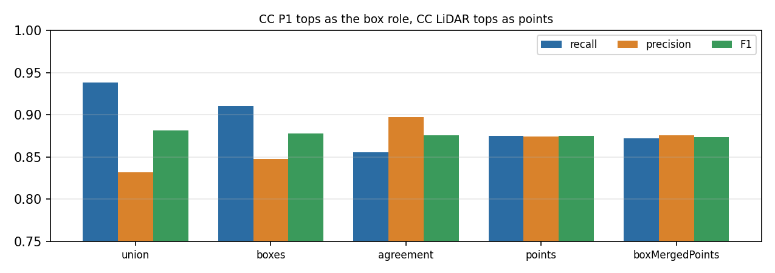
Figure 12. Combinations, cross-validated.
Union reaches recall 93.8% at precision 83.2%. The F1 differences between strategies are within the block-to-block noise; what a combination changes reliably is where on the recall/precision trade-off it sits, not how far from the curve.
Not yet available: the combinations with Mask R-CNN boxes. This needs the learned models' predictions, which runs made before prediction saving was added do not contain. The commands in the last section re-run them, and re-running this report afterwards fills this part in.

Limitations
Everything here comes from one stand of 921 crowns in 3.2 ha. Per-block F1 varies by two to three points, so differences of a point or two between methods cannot be established on this site, and none of the tuned settings has been tested on another. The second annotated area is what would show whether any of them generalise.
The Mask R-CNN runs reported here were made before two changes. They trained on tiles that torchvision silently upscaled from 512 to 800 px, whereas the current code runs at the tile's native size, as YOLO does; and they did not save predictions, which is why the tree-level sections cover only the connected-component detector. Mask R-CNN's test tiles are those centred in the held-out block, so a tree on the block's edge may be seen only partially; this slightly disadvantages it against the point detector, which sees the whole area.
The tree-level tables stitch held-out predictions across folds, which counts a detection just inside one block that lands in a crown centred in the next as a hit. Their totals therefore run about half a point above the per-fold figures in Table 1, which remain the ones to quote.

Reproducing and completing this report
The package is tt. Every run needs repeating once with the current code, which saves the predictions the tree-level sections and the combinations are built from: the two connected-component runs take minutes, the two Mask R-CNN runs about an hour each. The last command then writes this report with every section complete.
LIDAR=Data/chm_lidar_l2_2025_clipped_modified_last.tif
P1=Data/CHM_P1_2026_clipped_last.tif
CROWNS=Data/shp/annotation_new_0925.shp
AREA=Data/shp/area_p1.shp
python -m tt.dl concomp --dataset ds/lidar --output runs/ccLidar \
--percentiles 20,30 --minTopAreas 0.12,0.06 --topSteps 0.12,0.25 \
--erosions 1,2 --saddleDrops 0.2,0.3,0.5
python -m tt.dl concomp --dataset ds/p1 --output runs/ccP1 \
--percentiles 10,20 --minTopAreas 0.25,0.12 --topSteps 0.12,0.25 \
--erosions 1,2 --saddleDrops 0.2,0.3,0.5
python -m tt.dl maskrcnn --dataset ds/lidar --output runs/mrcnnLidar \
--epochs 40 --batchSize 4 --device 0
python -m tt.dl maskrcnn --dataset ds/rgb --output runs/mrcnnRgb \
--epochs 40 --batchSize 4 --device 0
python -m tt.report --lidarChm $LIDAR --p1Chm $P1 --crowns $CROWNS \
--boundary $AREA --dataset ds/lidar \
--cv ccLidar=runs/ccLidar --cv ccP1=runs/ccP1 \
--cv mrcnnLidar=runs/mrcnnLidar --cv mrcnnRgb=runs/mrcnnRgb \
--sweep ccLidar=sweepLidar.json --sweep ccP1=sweepP1.json \
--output report

