title: “UBDC CCTV blog 21 04” author: “Nick Bailey” date: “26/04/2021” output: html_document —

# The easing of lockdown in Glasgow

### Nick Bailey, UBDC - 03/05/2021

The city centres of Britain’s largest urban areas have been particularly badly hit by lockdown restrictions. At the end of February, footfall in the centres of London, Birmingham, Manchester and Glasgow was down more than 80% on pre-lockdown levels, according to the Centre for Cities’ ‘High street recovery tracker’ (<https://www.centreforcities.org/data/high-streets-recovery-tracker/>). The numbers present in the evenings was down by more than 90%. The impact on retail and hospitality sectors has been enormous.

On Monday 26th April, some of the lockdown restrictions were eased in Scotland. In particular, non-essential shops were allowed to re-open, while pubs and restaurants could offer food inside and alcohol outside. Similar changes had occurred in England two weeks earlier.

In Glasgow, we can get a near-real-time picture of the impact of these changes thanks to a unique partnership between the Urban Big Data Centre, Glasgow City Council and the Glasgow Centre for Population Health. As explained in an earlier blog (<https://www.ubdc.ac.uk/news-media/2020/july/creating-open-data-counts-of-pedestrians-and-vehicles-using-cctv-cameras/>), UBDC is using spare capacity in the Council’s CCTV system to produce counts of the number of pedestrians present at a range of locations across the city. Images are captured on a half-hourly cycle, and analysed within the Council’s secure facilities. All processing is done using open source tools so could be easily replicated by other authorities.

The resulting data are made publicly available on a daily basis (see details below). Here, we use these data to examine average daily counts of the number of pedestrians during daytime (10am and 4pm) and evenings (6pm to 10pm). Figures for the most recent week (in green) are compared with the those for the same days over the previous 16 weeks of lockdown (in grey).

## City centre

In the city centre, we can see that daytime footfall in the week after restrictions eased was clearly higher than all or almost all of the previous sixteen weeks but not, perhaps, by as much as might have been expected. There is perhaps some hesitancy to return to the city centre or challenges in getting there, given we are still being encouraged to avoid public transport. An initial rush on the Monday was followed by a bit of a lull on the Tuesday before footfall picked up again. By the end of the week, however, there is a stronger sense of a return with Saturday particularly busy in most locations.

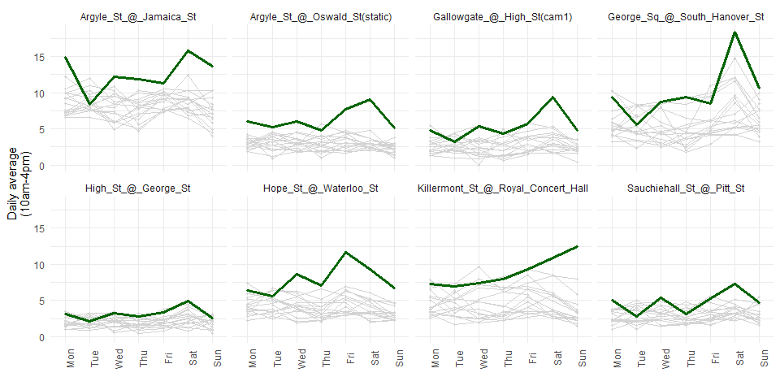

There is a similar story with the evening economy. Looking at footfall between 6pm and 10pm, numbers don’t really get well above the levels of the previous weeks until Friday and Saturday.

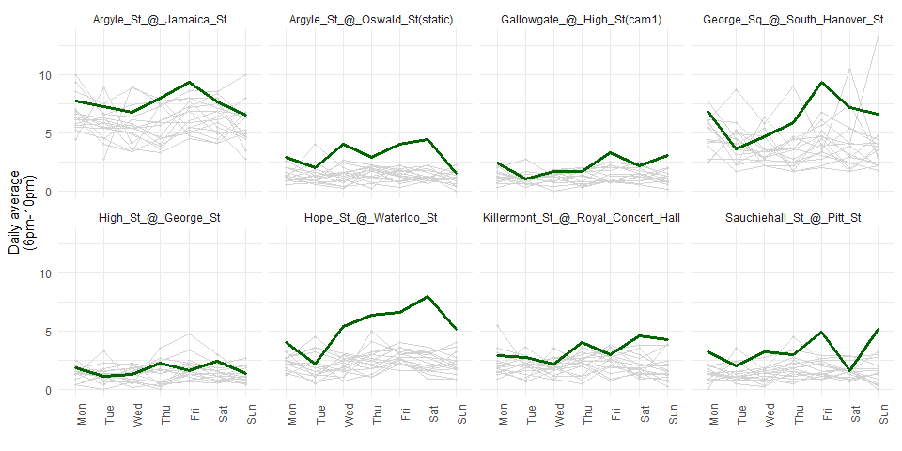

## Other high street locations

We capture numbers at other high street locations across the city, and here we show four of them with footfall in daytime and evenings. There is a more mixed picture here. Byres Road in the Westend shows high footfall, particularly in the evenings. For the other three, there is much less sense that numbers are recovering.

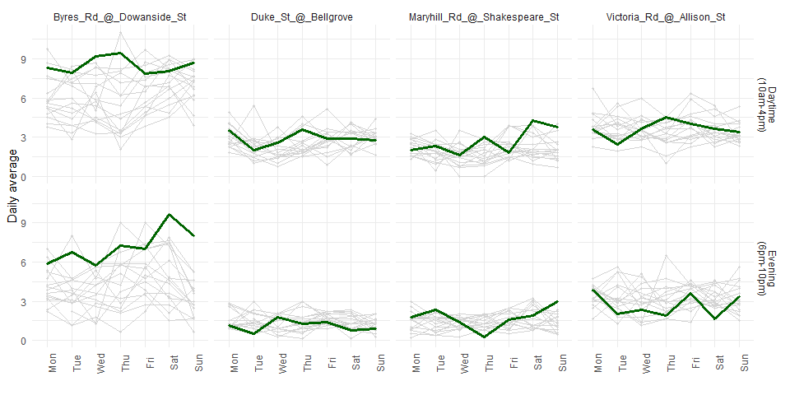

## Parks

One feature of the lockdown period has been the increased use of parks and opens spaces. With the opening up of alternatives such as shops and cafes, we might expect to see a drop in the usages of these places. That appears to be the case in Glasgow, at least for two of the largest parks - Glasgow Green and Kelvingrove.

It should be noted that the early days of easing have been marked by a drop in temperatures compared to the previous week and that might also be a factor here. But footfall is down on almost all the previous sixteen weeks. At last, people have other places they can be!

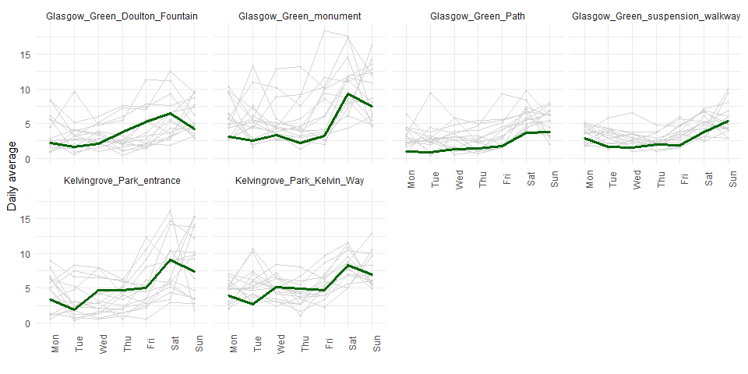

## The riverfront

We see a similar story along Glasgow’s riverfront which has also been a popular destination over lockdown for walking, cycling or just hanging out. As with the parks, footfall has been lower this week overall than in many of the previous weeks.

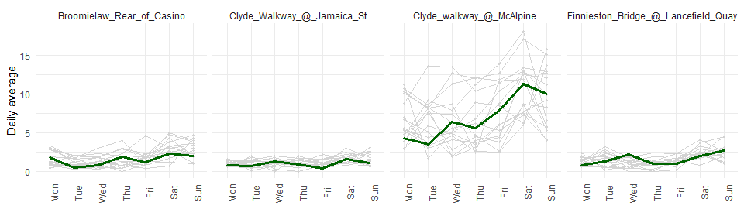

## Summary

We can make one measure of the recovery over the last week by comparing footfall then with the average for the previous sixteen weeks. Doing this, the scale of the change in the city centre looks more impressive - a near-doubling in numbers both in the daytime and in the evenings. Numbers are up in other high street locations but by less. Of course, the city centre is recovering from a particularly low base. It is dominated by “non-essential” shops which have been required to remain closed whereas other high street locations have a greater mix, with more food retailers as well as cafes which could continue with take away sales. Nevertheless it is a promising start.

## # A tibble: 4 x 3  
## # Groups: Location [4]  
## Location Daytime Evening  
## <fct> <dbl> <dbl>  
## 1 City centre 91 84  
## 2 Other centre 21 24  
## 3 Parks -14 14  
## 4 River/canal -12 3

### Further information

More information on our work using CCTV to assess daily activity on city streets is available here: <https://www.ubdc.ac.uk/research/research-projects/urban-sensing-analytics/using-spare-cctv-capacity-to-monitor-activity-on-city-streets/>. Current developments include enhancements to the capture of vehicles and cycling, as well as the development of video analysis to let us capture behaviours in more detail - for example, whether people spend time in certain places or just pass through.

The data from the CCTV analysis are available here as open data: <https://api.ubdc.ac.uk/cctv/>. They are made available under an Open Government Licence. The attribution is:

“Glasgow CCTV Automated Object Detection Counts, Glasgow City Council / Urban Big Data Centre at the University of Glasgow, 2020, copyright © Glasgow City Council 2020”

The code to re-produce this analysis is available here: <https://github.com/nick-bailey/UBDC-CCTV-data>.

### Project Team

The data examined here are the result of a project involving a team of people, including:

* UBDC: Dr Mark Livingston (lead); Luis Serra; Dr David McArthur; Dr Andrew McHugh; Maralbek Zeinullin
* Glasgow City Council: Kimberley Hose; Keith Scott; Kalim Uddin
* Glasgow Centre for Population Health: Bruce Whyte