Acceleration perception and location reproduction, Pre-registration document
Nick Simpson¹, Kirsten Rittershofer^{1,2}, Emma K. Ward¹, Matan Mazor^{3,4,#}, & Clare Press^{1,#}
¹ Experimental Psychology and Functional Imaging Laboratory, University College London
² School of Psychological Sciences, Birkbeck - University of London
³ Department of Experimental Psychology, University of Oxford
⁴ All Souls College, University of Oxford
# Shared Contribution

Author note
Correspondence concerning this article should be addressed to Nick Simpson, Experimental Psychology, University College London. E-mail: nicholas.simpson.23@ucl.ac.uk

Acceleration perception and location reproduction, Pre-registration document

Motivation
In previous studies (https://doi.org/10.17605/OSF.IO/3MW9S), we have found an expectation effect of gravity on reported acceleration perception such that downward moving stimuli are reported as less accelerating than upward moving stimuli - a repulsion from the expectation that objects normally accelerate toward the ground. This experiment aims to further understand the relative perceptual and decisional contributions to the effect. We therefore employ a paradigm where perception is measured via reproduction of perceived locations, rather than decisions about the acceleration profile. In this way, expectations about acceleration can be observed through participant reproduction of a location as opposed to decisions about the acceleration itself. In post-hoc analysis of a pilot study (https://doi.org/10.17605/OSF.IO/BV3N2) we have found evidence for the same perceptual repulsion in a reproduction task. In this study we will use the post-hoc analysis to understand if the effect replicates.

Methods

Participants
We will recruit 150 included participants through the Prolific platform to complete the experiment online. The experiment lasts around 15 minutes and participants will be paid £2, approximately equivalent to £8/hour.

Study Design
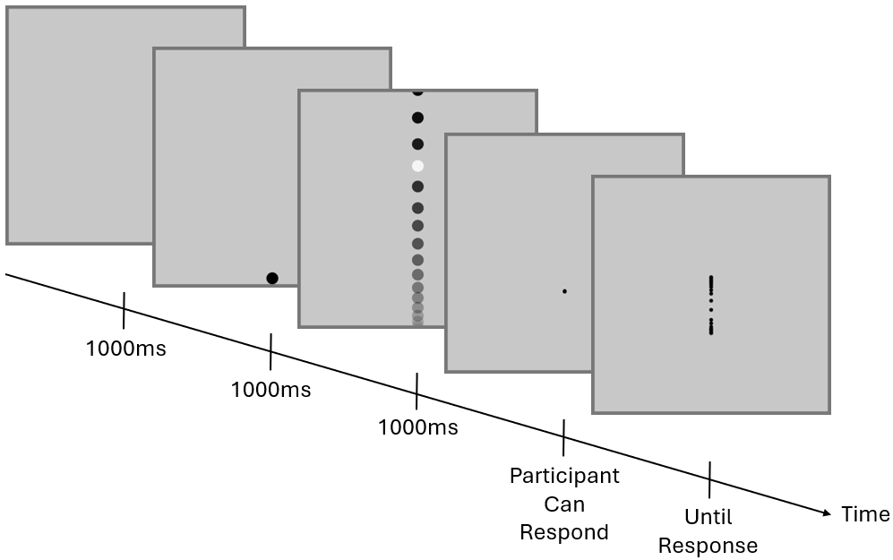
Figure 1. Study Design. Participants see a light grey square covering 80% of their screen height. After 1000ms a ball appears at the top or the bottom of the screen. After 1000ms of the stationary ball, the ball begins to move vertically at a constant acceleration. The start speed is varied such that the ball moves on the screen for 1000ms. Along the trajectory, the ball changes colour for 50ms at a location between 20% and 80% of the light grey square height. Once the ball has left the screen, the participant’s mouse controls a small black circle and the participant is asked to click where they saw the ball flash.
Participants are presented with a plain grey screen before a black ball appears at the top or bottom of the screen for 1000ms (Figure 1). After 1000ms, the ball moves vertically at a constant acceleration, up if the ball is at the bottom and down if the ball is at the top. Along the trajectory, at a location between 20% and 80% of the screen height, the ball flashes grey for 50ms. After the ball has left the screen, the participant is able to move a cursor vertically along the balls trajectory and they are asked to click where they thought the ball flashed.
Balls are presented with a range of acceleration values (Figure 2) and the start and end speeds are altered such that the ball always remains on the screen for 1000ms. The acceleration values for trials are identical between the upward and downward conditions, meaning any difference in responses between the two is due to the expectation of gravity’s influence on acceleration. The distance of the flashes are randomised on each trial with a uniform distribution between 20% and 80% of the screen height. Each direction has 100 trials, resulting in 200 total trials for each participant.
At the beginning of the study participants are given detailed instructions and 4 practice trials where they get trial by trial feedback on the absolute distance between their response and the true flash. During the testing trials, trials are presented in 10 blocks of 20 trials and participants are given a mean absolute difference for the block between their response and the true flash. The practice trials will be removed from the analysis.
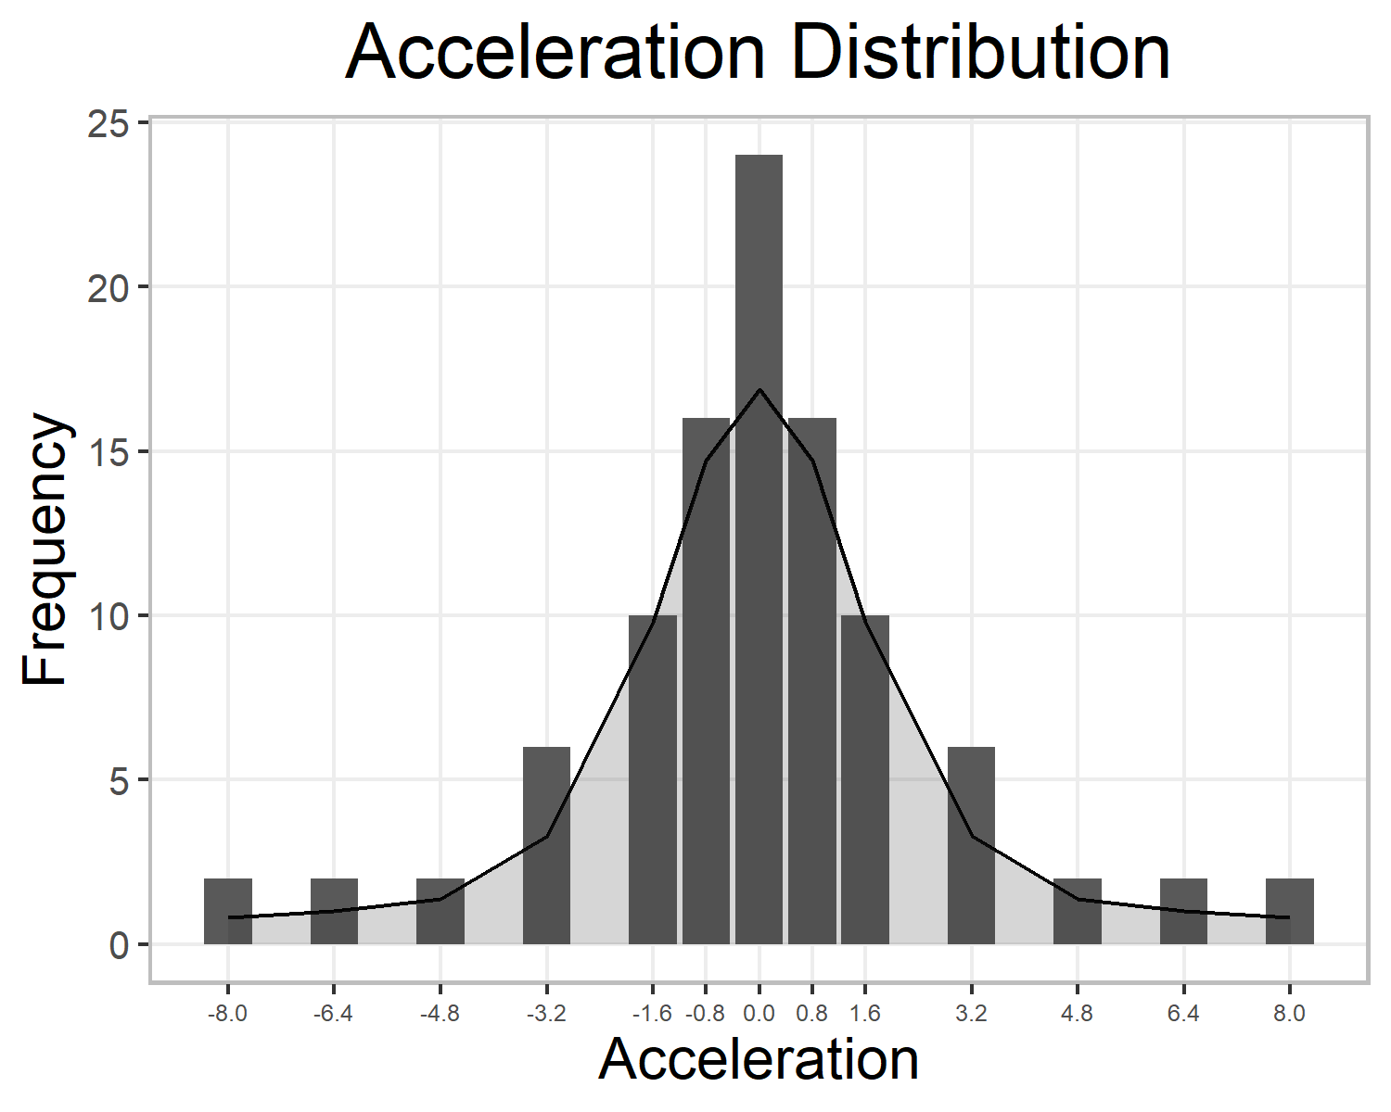
Figure 2. Acceleration Distribution. Participants are presented with trials of the same acceleration distribution for up and down trials. The distribution is approximately normally distributed centred around constant velocity. There are a total of 100 trials for each direction.

Randomization.
The order of trials and the flash distance will be determined pseudo-randomly by the Mersenne Twister pseudorandom number generator, initialized in a way that ensures registration time-locking (Mazor, Mazor, & Mukamel, 2019).

Data analysis

Rejection criteria.
In order to remove inattentive participants, we will remove participants with a correlation lower than 0.3 between their clicked location and the true flash locations.

Hypothesis and analysis plan.
This study is designed to test the perception of acceleration comparing upward and downward moving trials. To measure how gravitational expectations are influencing their responses, we will calculate the overshoot. The overshoot will be calculated as (position participant clicked from start point - true flash location from start point)/(screen size). The overshoot is positive when participants click further along the trajectory than the true flash (click lower on the screen for downward and higher on the screen for upward), and negative when participants click earlier in the trajectory. By scaling due to screen size, we can control for participants taking part on different computers.
In order to understand whether acceleration expectations are being incorporated into the location reproduction, we will need to use the interaction between flash distance and direction. This interaction will describe how overshoot values differ between the top and bottom of the screen for each direction. Following the expectation of gravity, objects moving upward should decelerate, while those moving downward should accelerate. This creates a bias where objects near the ground, or lower on the screen, are expected to move faster. If perception aligns with this expectation, we may perceive lower balls as further along their trajectory than higher balls. Thus, when participants report the location of a flashed ball, a greater overshoot (clicking further along the trajectory) when the ball is lower on the screen would indicate an attractive perceptual bias toward gravitational acceleration, and the reverse would indicate a repulsion away from the acceleration expectation.
We will analyse the data by looking at how the flash distance and overshoot are correlated for each direction and each participant. There should be no difference between the correlations if there is no impact of expectation on reproduced location (Figure 3, No Effect). However, an attraction effect would be shown if the overshoot is larger at eary distances for downward moving stimuli and late distances for upward moving stimuli - this would result in a more negative correlation for upward moving stimuli than for downward moving stimuli (Figure 3, Attraction). Conversely, a repulsion effect will be demonstrated with a more negative correlation for downward moving stimuli compared to upward moving stimuli (Figure 3, Repulsion).
In a pilot study, we found a larger variance in reproduced location than anticipated. Therefore, the trials with more extreme flash distances (within the top and bottom 25%) result in participants unable to respond as far in one direction as they can in the other. This creates an artificial negative relationship between flash distance and overshoot value which potentially overshadows our effects of interest. Thus, we have decided to restrict our analysis to trials where the flash distance is between 25% and 75% of the screen height.
Hypothesis 1 (Analysis of the Direction by Flash Distance Interaction): We will test the null hypothesis that the change in overshoot over the size of the screen is identical for upward and downward moving stimuli. For each participant, we will calculate the correlation between flash distance and overshoot separately for upward and downward moving trials. To compare the groups, we will use a two-sided paired t-test between correlation coefficients for up and down trials with a significance value of 0.05.
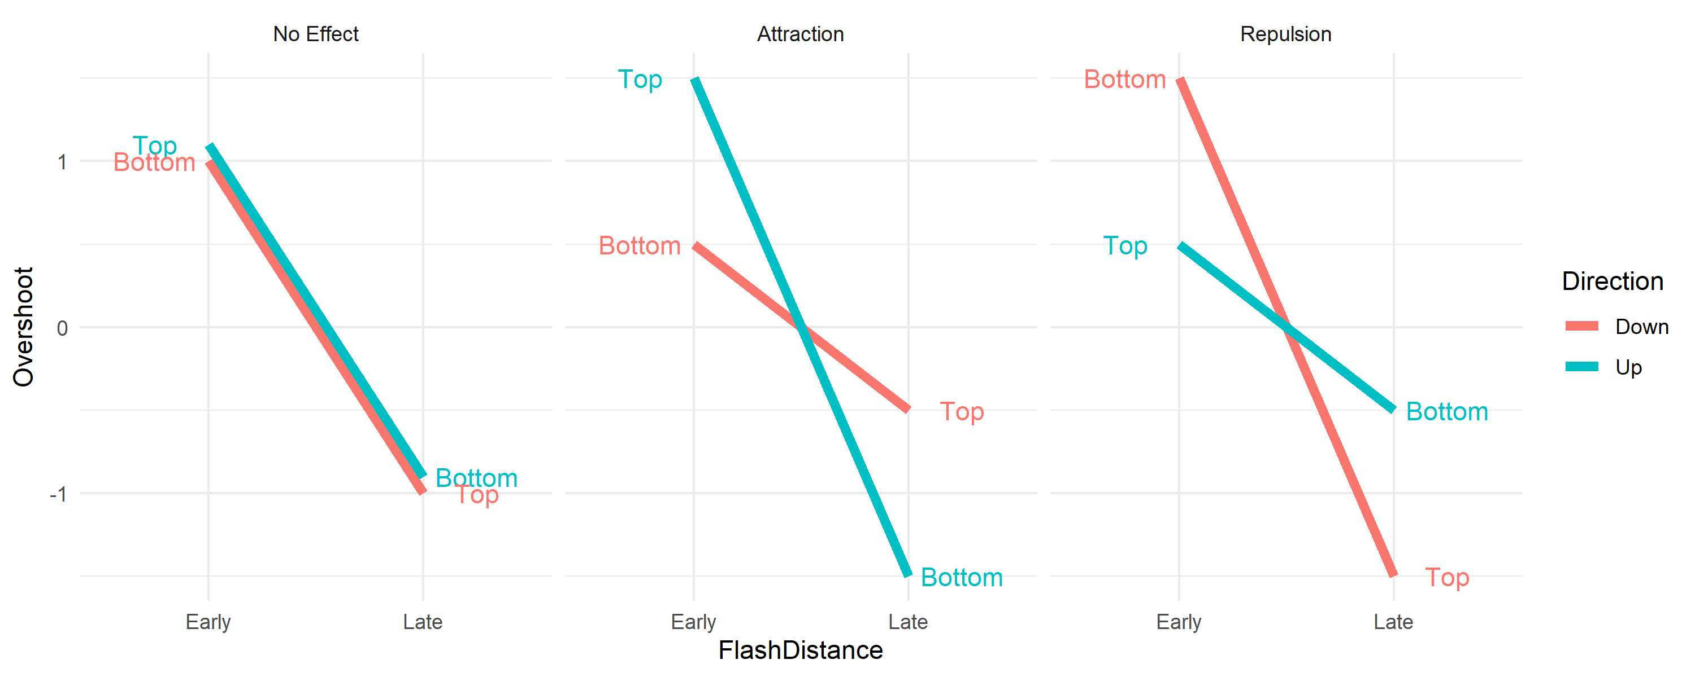
Figure 3. Example predictions based upon expectation attraction and repulsion.

References
Mazor, M., Mazor, N., & Mukamel, R. (2019). A novel tool for time-locking study plans to results. European Journal of Neuroscience, 49(9), 1149–1156.

