Acceleration perception and location reproduction, Pre-registration document
Nick Simpson¹, Kirsten Rittershofer^{1,2}, Emma K. Ward¹, Matan Mazor^{3,4,#}, & Clare Press^{1,#}
¹ Experimental Psychology and Functional Imaging Laboratory, University College London
² School of Psychological Sciences, Birkbeck - University of London
³ Department of Experimental Psychology, University of Oxford
⁴ All Souls College, University of Oxford
# Shared Contribution

Author note
Correspondence concerning this article should be addressed to Nick Simpson, Experimental Psychology, University College London. E-mail: nicholas.simpson.23@ucl.ac.uk

Acceleration perception and location reproduction, Pre-registration document

Motivation
In previous studies (https://doi.org/10.17605/OSF.IO/3MW9S), we have found an expectation effect of gravity on reported acceleration perception such that downward moving stimuli are reported as less accelerating than upward moving stimuli — a repulsion from the expectation that objects normally accelerate toward the ground. This experiment aims to further understand the relative perceptual and decisional contributions to the effect. We therefore employ a paradigm where perception is measured via reproduction of perceived locations, rather than decisions about the acceleration profile. In this way, expectations about acceleration can be observed through participant reproduction of a location as opposed to decisions about the acceleration itself. Post hoc analysis of a pilot study (https://doi.org/10.17605/OSF.IO/BV3N2) revealed evidence for a repulsion in this reproduction paradigm and a follow up study (https://doi.org/10.17605/OSF.IO/6TRCX) found a marginal effect of the pre-registered analysis. To determine whether there really is a reliable repulsion, we want to replicate the study with a larger sample size and add an additional analysis approach.

Methods

Participants
We will recruit 500 included participants through the Prolific platform to complete the experiment online. The experiment lasts around 20 minutes and participants will be paid £2.70, approximately equivalent to £8/hour.

Study Design
The study design is identical to our previous pre-registered study https://doi.org/10.17605/OSF.IO/6TRCX.

Data analysis

Rejection criteria.
In order to remove inattentive participants, we will remove participants with a correlation lower than 0.3 between their clicked location and the true flash locations.

Hypothesis and analysis plan.
Participants are presented with a ball moving up or down on the screen and the ball briefly flashes a different colour. Participants are asked to click where they saw the ball flash. The response overshoot will be calculated as (position participant clicked from start point - true flash location from start point)/(screen size). The overshoot is positive when participants click further along the trajectory than the true flash (click lower on the screen for downward and higher on the screen for upward), and negative when participants click earlier in the trajectory.
From previous literature, we expect representational gravity and representational momentum to impact the participants’ reported locations. Representational gravity is a persistent downward bias in responses which is found for both stationary and moving objects (Hubbard, 2020). When comparing the overshoot between upward and downward motion, representational gravity will result in a more positive overshoot for downward motion than for upward motion irrespective of the motion dynamics. Representational momentum is a reported overshoot that is positively correlated with the size and speed of the object (Freyd & Finke, 1986). An accelerating object will therefore have a larger overshoot at the end of the motion than it would at the beginning because it is speeding up, however there should be no representational momentum differences between upward and downward motion. Figure 1 No Effect shows simulated responses to a constant velocity trial travelling upward and downward with only representational gravity and representational momentum affecting the response. The reported positions are drawn downwards and further along the trajectory. The overshoots are constant across the distance travelled by the ball.
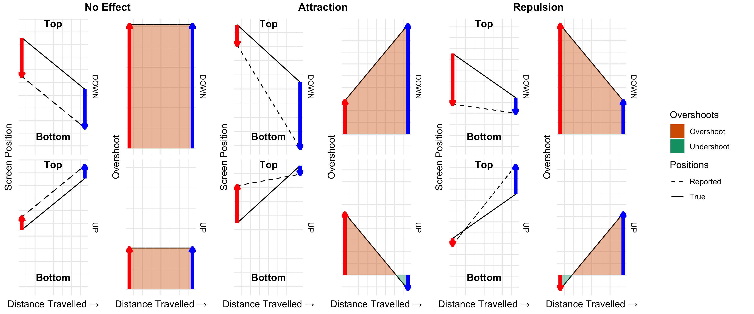
Figure 1. Simulated participant responses in line with representational gravity, representational momentum, and an effect of acceleration expectation. When No Effect of acceleration exists, there is a main effect of direction on overshoot, but no change across distance travelled. An attraction results in a more positive gradient between overshoot and distance travelled for downward compared to upward motion. A repulsion results in a more negative gradient between overshoot and distance travelled for downward compared to upward motion.
In addition to representational gravity and representational momentum, we predict a repulsive effect of acceleration expectation. As downward motion is expected to accelerate, the object should be travelling faster at the end of the motion than it is at the beginning of the motion. As larger overshoots are expected for faster motion, an attractive expectation effect would reveal a larger overshoot at the end of downward motion than at the beginning. The converse is true for upward motion which is expected to decelerate. By adding in this effect of acceleration expectation, simulated data in Figure 1 Attraction shows that overshoots for downward motion get larger as the ball has travelled further and overshoots for upward motion get smaller. The opposite pattern of results is predicted by a repulsive effect (Figure 1 Repulsion) and these patterns also exist for both accelerating and decelerating motion. To determine whether there is an effect of acceleration expectation on the reported overshoots, we will use the correlation between overshoot and distance travelled. We will calculate the correlation coefficient for each participant and motion direction and perform a paired t-test to see if there is a difference between the upward and downward correlations. More positive correlation coefficients for downward motion than upward motion would demonstrate an attraction, and the reverse pattern shows a repulsion.
As the participants are unable to respond off the screen, there is an edge effect on the reported overshoots. This edge effect distorts the correlation pattern when including flashes that occur too close to the edge of the screen, however removing too many trials results in noise due to fewer trial numbers. Therefore, in the exploratory pilot study, we analysed a range of ‘window-sizes’ for which data to include where the window size is the proportion of the screen either side of centre. Figure 2 Exploratory shows the t-values of the correlation analysis for increased window-sizes. For the follow up experiment, we selected to analyse the largest significant window-size to include the maximum data (Window size = 0.25). In this follow-up experiment, the window-size analyses showed a significantly large cluster of window-sizes for which there was a difference in correlation between upward and downward trials, however the pre-registered window-size (0.25) was not significant (Figure 2 Replication). Therefore, in this third experiment, alongside the previously selected window size, we will use the window-size analysis and permutation tests of the resulting t-values to determine whether there is an effect.
Hypothesis 1 (Permutation Test over all Window-Sizes):
We will test the null hypothesis that the change in overshoot over the size of the screen is identical for upward and downward moving stimuli. For each participant, we will calculate the correlation between flash distance and overshoot separately for upward and downward moving trials. This analysis will be carried out with an increasing window-size from 40-60% until 20-80% of the screen size in steps of 0.1%. The t-values from a paired t-test between upward and downward correlations will be used in a permutation test across window size with a significance threshold of 1.65. A significantly large cluster above the significance threshold will have a corrected p-value < 0.05.
The permutation test uses 1000 iterations of sign switching to test whether the difference in correlation for UP and DOWN trials is significant across participants. For each participant, the overshoot by flash distance correlation coefficient for UP (CORup) and DOWN (CORup) trials is calculated for each window size. The correlation difference is calculated as CORup - CORdown. A t-test against the mean correlation difference = 0 is calculated for each window size and the observed cluster masses above the p<0.05 threshold are found. To generate a null distribution, the sign of the correlation difference is flipped for all window sizes of a random subset of participants with 1000 different random flips. For each iteration, t-tests are run for each window size and the largest cluster mass is added to a null distribution of cluster mass sizes. The corrected p-values for the observed cluster masses are found as the proportion of null cluster masses that exceed the observed mass.
# Observed data is a data frame with column of PID, window_size, and correlation_diff
run_permutation <- function(observed_data) {
pids = unique(observed_data$PID)
n_participants = length(pids)
t_threshold = qt(1 - 0.05, df = n_participants - 1)
# Find observed clusters
observed_clusters = observed_data %>%
group_by(window_size) %>%
#Find the observed t values
reframe(t_values = mean(correlation_diff, na.rm = TRUE) / (sd(correlation_diff, na.rm = TRUE) / sqrt(sum(!is.na(correlation_diff))))) %>%
ungroup() %>%
#Ensure we are looking across window sizes
arrange(window_size) %>%
#Find above threshold t-values
mutate(significant = as.numeric(t_values > t_threshold)) %>%
# Find the edges of the clusters
mutate(cluster_beginning = as.numeric(c(TRUE, diff(significant) != 0))) %>%
# Assign IDS
mutate(cluster_ids = cumsum(cluster_beginning))
# Find observed significant cluster masses
observed_cluster_masses = observed_clusters %>%
filter(significant == TRUE) %>%
group_by(cluster_ids) %>%
# Find the sum of t-values over the significant cluster
reframe(cluster_mass = sum(t_values))
perm_max_clusters = numeric(n_perm)
for(perm in 1:n_perm) {
#Randomly select some participants to flip
sign_flip = data.frame(
PID = pids,
sign = sample(c(-1, 1), length(pids), replace = TRUE)
)
permuted_clusters = observed_data %>%
#Flip the signs of the selected participants
left_join(sign_flip, by = "PID") %>%
mutate(correlation_diff = correlation_diff * sign) %>%
#Same cluster mass identification as above
group_by(window_size) %>%
reframe(t_values = mean(correlation_diff, na.rm = TRUE) / (sd(correlation_diff, na.rm = TRUE) / sqrt(sum(!is.na(correlation_diff))))) %>%
ungroup() %>%
arrange(window_size) %>%
mutate(significant = as.numeric(t_values > t_threshold)) %>%
mutate(cluster_beginning = as.numeric(c(TRUE, diff(significant) != 0))) %>%
mutate(cluster_ids = cumsum(cluster_beginning)) %>%
filter(significant == TRUE) %>%
group_by(cluster_ids) %>%
reframe(cluster_mass = sum(t_values))
#Add a 0 if there are no significant clusters, or the max size
perm_max_clusters[perm] = ifelse(
nrow(permuted_clusters) > 0,
max(permuted_clusters$cluster_mass),
0
)
}
# Find the corrected p value
cluster_df = observed_cluster_masses %>%
rowwise() %>%
mutate(corrected_p = mean(perm_max_clusters >= cluster_mass))
output = observed_clusters %>%
left_join(cluster_df, by = "cluster_ids") %>%
mutate(t_threshold = t_threshold)
return(output)
}
Hypothesis 2 (Large Pre-specified Window-Size):
Following the analysis of the previous study (https://doi.org/10.17605/OSF.IO/6TRCX), we will test the null hypothesis that the change in overshoot over the size of the screen is identical for upward and downward moving stimuli. For each participant, we will calculate the correlation between flash distance and overshoot separately for upward and downward moving trials. We will constrain our analysed window to between 25% and 75% of the screen size. To compare the groups, we will use a one-sided paired t-test between correlation coefficients for up and down trials with a significance value of 0.05. The alternative hypothesis is that the correlation coefficient of upward trials is larger than that of downward trials. Given this was the analysis approach preregistered for our previous study, and the previous study was identical in design, we will also perform a combined analysis of this data set with the previous one.
Hypothesis 3 (Representational gravity):
We will test the null hypothesis that there is no difference between the overshoots for upward and downward motion. We will compare the mean overshoot values for upward and downward trials with a two-sided paired t-test with a significance value of 0.05.
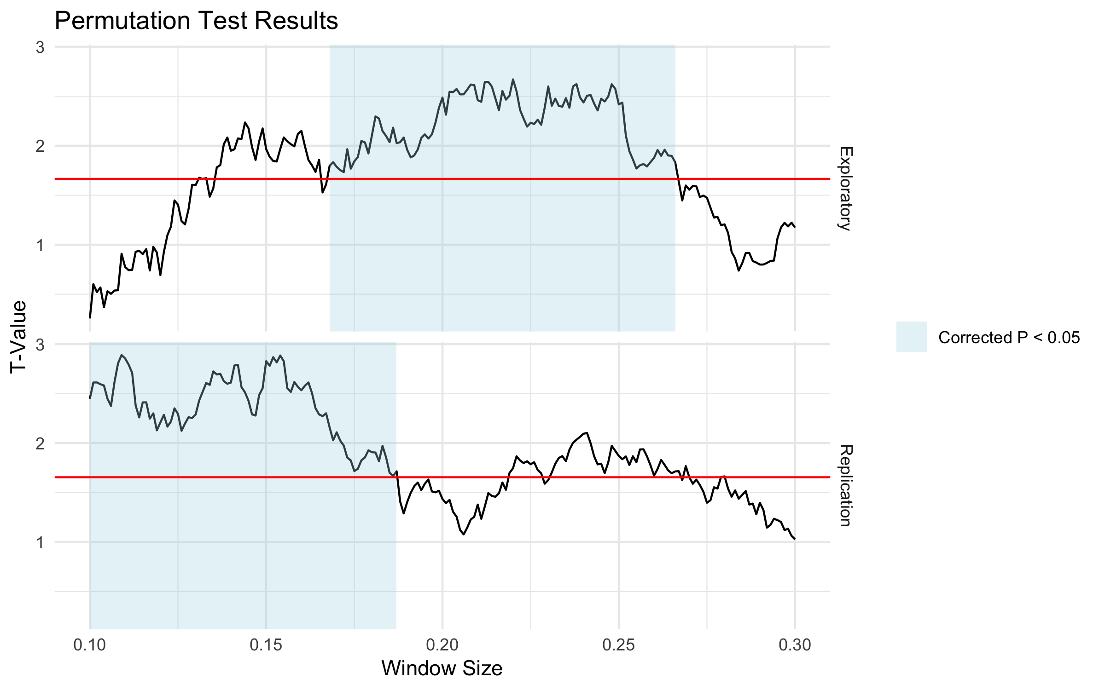
Figure 2. Permutation test results from the pilot study and initial replication. Significantly large clusters above the set threshold are highlighted in blue.

References
Freyd, J. J., & Finke, R. A. (1986). A velocity effect for representational momentum. In Bulletin of the Psychonomic Society (Vol. 985, pp. 443–446).
Hubbard, T. L. (2020). Representational gravity: Empirical findings and theoretical implications. Springer. https://doi.org/10.3758/s13423-019-01660-3

