2025 ELECTRONIC LUNCH N LEARN SERIES  
PROPELLER CLOCK

Course Title: AVAST ELECTRONICS PROPELLER CLOCK LUNCH & LEARN SERIES

Instructors:

Nick Chaloux ([nicholas.chaloux@whoi.edu](mailto:nicholas.chaloux@whoi.edu))

Ben Weiss ([bweiss@whoi.edu](mailto:bweiss@whoi.edu))

Beckett Colson ([bcolson@whoi.edu](mailto:bcolson@whoi.edu))

Brett Longworth ([blongworth@whoi.edu](mailto:blongworth@whoi.edu))

Brian Kelly (avast-tech@whoi.edu)

Office: AVAST 108 - 508-289-3921

Office Hours: 9 to 5, Monday through Friday

Meeting Day and Time: Wednesdays from 11 to 1

Location: David Center, room 113

Course Description :

Throughout this series of Lunch & Learn events, we will learn electronic assembly and soldering skills while building an actual product from idea to finished assembly.

The class will have two purposes: First, it will familiarize everyone with some of the techniques needed for electronic assembly, programming, testing, repair, etc. Second, these techniques will be applied to a complete product design, from concept to finished usable assembly.

March 5th:

Course Introduction

Software required:

KiCAD <https://www.kicad.org/>

Shapr3D <https://www.shapr3d.com/>

Arduino <https://www.arduino.cc/>

Github [Link](https://nam02.safelinks.protection.outlook.com/?url=https%3A%2F%2Fgithub.com%2Fnick-chaloux%2FAVAST-Propeller-Clock&data=05%7C02%7Cbkelly%40whoi.edu%7C57571250accc49e3d7b508dd5bf74ff5%7Cd44c5cc6d18c46cc8abd4fdf5b6e5944%7C0%7C0%7C638767839934182567%7CUnknown%7CTWFpbGZsb3d8eyJFbXB0eU1hcGkiOnRydWUsIlYiOiIwLjAuMDAwMCIsIlAiOiJXaW4zMiIsIkFOIjoiTWFpbCIsIldUIjoyfQ%3D%3D%7C0%7C%7C%7C&sdata=gOebfRhunxJzw58YcVk9qFeQPRBhHWmafbhsC3zAnIQ%3D&reserved=0)

Slack [Link](https://nam02.safelinks.protection.outlook.com/?url=https%3A%2F%2Fjoin.slack.com%2Ft%2Favastelectron-dng7201%2Fshared_invite%2Fzt-31cd74u9v-hAqcEnufbrX0yBR~V9ZJZA&data=05%7C02%7Cbkelly%40whoi.edu%7C88288dc426d74fffb2a008dd5fed06e6%7Cd44c5cc6d18c46cc8abd4fdf5b6e5944%7C0%7C0%7C638772193808814163%7CUnknown%7CTWFpbGZsb3d8eyJFbXB0eU1hcGkiOnRydWUsIlYiOiIwLjAuMDAwMCIsIlAiOiJXaW4zMiIsIkFOIjoiTWFpbCIsIldUIjoyfQ%3D%3D%7C0%7C%7C%7C&sdata=13yuPZkdx%2F5SCEFhkfpJCFT46TutmFyfD2ql6bmAmZU%3D&reserved=0)

Other Helpful websites:

KiCAD symbol libraries [Link](https://www.google.com/url?sa=t&source=web&rct=j&opi=89978449&url=https://www.kicad.org/libraries/download/&ved=2ahUKEwjm47Pt3ZOMAxUJlIkEHXGyNqUQFnoECAkQAQ&usg=AOvVaw33C5n2_G7BSfn232fF8MT6)

SnapEDA symbol libraries [Link](https://www.google.com/url?sa=t&source=web&rct=j&opi=89978449&url=https://www.snapeda.com/kicad/&ved=2ahUKEwjm47Pt3ZOMAxUJlIkEHXGyNqUQFnoECBsQAQ&usg=AOvVaw0z_g6UbXAnOuQXhoXhySiv)

Digikey symbol libraries [Link](https://www.google.com/url?sa=t&source=web&rct=j&opi=89978449&url=https://www.digikey.com/en/resources/design-tools/kicad&ved=2ahUKEwjm47Pt3ZOMAxUJlIkEHXGyNqUQFnoECCAQAQ&usg=AOvVaw1YkSRZRy1i-cy-22ycU5wu)

Ultra Librarian symbol libraries [Link](https://www.google.com/url?sa=t&source=web&rct=j&opi=89978449&url=https://www.ultralibrarian.com/cad-vendors/kicad/&ved=2ahUKEwjm47Pt3ZOMAxUJlIkEHXGyNqUQFnoECCIQAQ&usg=AOvVaw1oKgjRr64XVf4MyV5pwjE2)

March 19:

* Review last week
  + Come as often as you wish
  + No requirement to be at every lunch n Learn
  + Questions and comments
* Start a project
* Familiarity with electronic schematic software
* Schematic design

* Place components
* Build a Project or Personal Library
  + Download symbols, footprints, 3D files
  + Add the downloaded symbols to the Personal/Project Library
  + Add this library to the project
  + Connect the symbols
* March 26:
* Review last week
  + Come as often as you wish
  + No requirement to be at every lunch n Learn
  + Questions and comments
* Build layout files
  + Design circuit board layout
  + Route the board
  + Try auto router
* Circuit board design

* April 2:
  + Build circuit board fabrication files and a bill of materials

* April 9:
  + Review
  + Part Sourcing
* Session 5
  + Surface mount component assembly and soldering

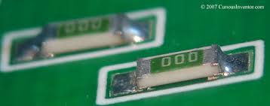

Session 6

* Through-hole component assembly and soldering

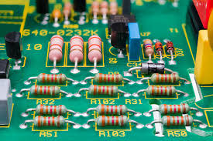

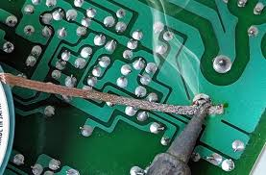 

* Methods of board cleaning and inspection

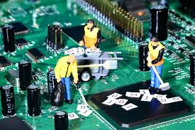

* Wire handling, stripping, crimping and tinning

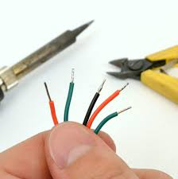

* Familiarity with Arduino programming software

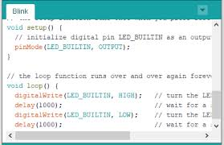

* Circuit board test and verification utilizing an oscilloscope and multimeter

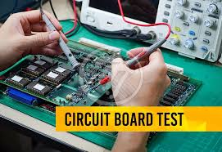

* Familiarity with essential mechanical drafting software

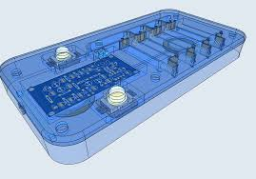

* Packaging design
* Final product assembly

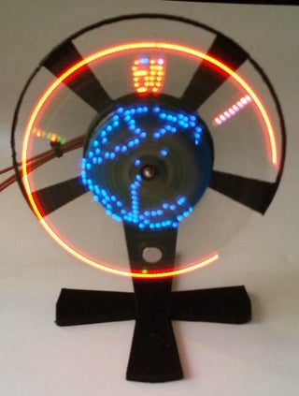

* + Software:
    - KiCAD
    - Shapr3D
    - Arduino Integrated Design Environment (IDE)
  + Component libraries:
    - <https://github.com/digikey/digikey-kicad-library/archive/master.zip>
    - [https://www.digikey.com/en/resources/design-tools/snapeda?_gl=1*13zb9pj*_up*MQ..*_gs*MQ..&gclid=EAIaIQobChMIi8yeg4iIiwMVUjcIBR39vwPoEAAYASAAEgJX-_D_BwE&gclsrc=aw.ds](https://www.digikey.com/en/resources/design-tools/snapeda?_gl=1*13zb9pj*_up*MQ..*_gs*MQ..&gclid=EAIaIQobChMIi8yeg4iIiwMVUjcIBR39vwPoEAAYASAAEgJX-_D_BwE&gclsrc=aw.ds)
    - https://www.digikey.com/en/product-highlight/a/accelerated-designs/ultra-librarian?_gl=1*13zb9pj*_up*MQ..*_gs*MQ..&gclid=EAIaIQobChMIi8yeg4iIiwMVUjcIBR39vwPoEAAYASAAEgJX-_D_BwE&gclsrc=aw.ds
* Preparing software and preparing for schematic design
  + Tutorials:
    - KiCAD

[https://www.digikey.com/en/resources/design-tools/kicad?_gl=1*t170s2*_up*MQ..*_gs*MQ..&gclid=EAIaIQobChMIi8yeg4iIiwMVUjcIBR39vwPoEAAYASAAEgJX-_D_BwE&gclsrc=aw.ds](https://www.digikey.com/en/resources/design-tools/kicad?_gl=1*t170s2*_up*MQ..*_gs*MQ..&gclid=EAIaIQobChMIi8yeg4iIiwMVUjcIBR39vwPoEAAYASAAEgJX-_D_BwE&gclsrc=aw.ds)

* + - Shapr3D

<https://www.google.com/url?sa=t&source=web&rct=j&opi=89978449&url=https://support.shapr3d.com/hc/en-us/articles/12208897524380-Video-tutorials&ved=2ahUKEwiCmpPtiYiLAxXShYkEHctlDrAQFnoECAwQAQ&usg=AOvVaw3Ih5JC9I_fXEh_bHfS65jN>

* + - Arduino IDE

<https://docs.arduino.cc/tutorials/>