GEOBIOCHEM  
R Workshop

“Simple plots in GGPLOT2”

The following link will aid you in your quest to customize your ggplots:  
http://r-statistics.co/Complete-Ggplot2-Tutorial-Part2-Customizing-Theme-With-R-Code.html#1.%20Adding%20Plot%20and%20Axis%20Titles

* Reading in data as before

1. As always, set working directory to where you will bring in data from and where you want plots to go to
2. Open new R script, title it whatever you want by saving it
3. Open any packages that are needed. For today, we will use package ggplot2
   1. Also, import the file ‘R_example_meeting’to R Studio

* Getting started

1. To set variables in R, which can be used for downstream processing, use ‘<-‘ or ‘=’:
   1. Ex. **PLOTNAME** <- ggplot(…….)
2. Let’s start with the most basic plot

Plot1 = ggplot(Name_of_file, aes( , Depth))

1. Simple axis numbering
   1. If you want to go from, say 0 to 20 and you don’t care about the interval, you could use: limits=c(0,20) within the scale_y_continuous command

**this command will only work in multiples of 4

* 1. If you want to customize the interval from 0 to 20, use:

breaks=seq(0,2,4,6,8,10,12,14,16,18,20)

1. Adding color
   1. To specify a specific color, there are 657 options. Type: **colors()** into the console to bring up a list of all 657.
   2. geom_point()
      1. INSIDE the aes command with ‘ ’ adds a default color and whatever is in the ‘’ will be the name on the legend

Example: geom_point(aes(color=‘Temp’))

* + 1. OUTSIDE the aes command you can designate a specific color inside ‘ ’, but there will not be a legend

Example: geom_point(aes(…), color=‘cyan’)

* + 1. To color by a specific function, in our case let’s use the sampling period, you can color=Date INSIDE the aes command. No ‘’ are needed. Notice, a default legend is made for you.

Example: geom_point(aes(color=Date))

* 1. geom_path: connects the values in the order in which they appear in the data.
  2. geom_line: connects the values in the order of the variable on the x axis

**\*BE CAREFUL!! Make sure data points are connected with _path and make sure there are no funky line connections with _line.**

1. Changing line type
   1. To change line type by a specific function, in our case date, use linetype=Date INSIDE the aes command

Example: geom_path(aes(linetype=Date))

* 1. To change line type of all lines, use linetype=# OUTSIDE of aes command

Example: geom_path(aes(…), linetype=4)

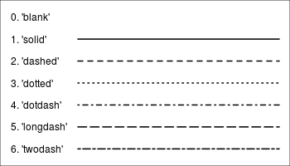

1. Changing shape type
   1. This follows the same rule as line type as far as inside or outside the aes command. The command for shape is: shape=XXX

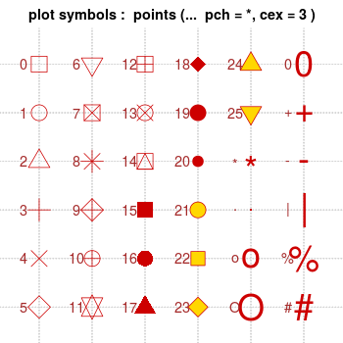

1. Changing point sizes for geom_point.
   1. This is quite simple. Use the size=# OUTSIDE of the aes command. The # can be anything of your choice.
   2. Say you wanted to change the size of points based on the value, you could do size=DIC_mM so the sizes change relative to their value
2. Adding plot titles and modifications
   1. In general, I would use the labs() command.

Example: labs(title="Area Vs Population", y="Population", x="Area", caption="Source: midwest")

* 1. To modify these components, give your plot a “name” by using the <- or = like we learned before. Then, do: PLOTNAME + theme().

Examples of modifications:

PLOTNAME + **theme**(

plot.title=element_text(size=20, face="bold", family="American Typewriter", color="tomato", hjust=0.5, lineheight=1.2), # Graph title

plot.subtitle=element_text(size=15, family="American Typewriter", face="bold", hjust=0.5), # Subtitle under heading

plot.caption=element_text(size=15), # Caption

axis.title.x=element_text(vjust=10, size=15), # X axis title

axis.title.y=element_text(size=15), # Y axis title

axis.text.x=element_text(size=10, angle = 30, vjust=.5), # X axis text

axis.text.y=element_text(size=10)) # Y axis text

1. Modifying legends
   1. When using the geom_XXX commands, you should have seen that legends are automatically drawn for you.
   2. If you want to modify the color of the points, use scale_color_manual(). Inside, use the labels command to make a new name, and the values command to make new colors.

Example: PLOTNAME + scale_color_manual(name="Legend Title",

labels=c("April '17", "July '17", "May '17", "September '17"),

values=c("red", "orange", "green", "purple"))

* 1. You may notice that by doing this, you get one another legend for the shapes that we made earlier. No worries! In order to “merge” the two, use the scale_shape_manual() command. **Make sure all name and labels are identical!** Otherwise, they will not merge.

Example: PLOTNAME + **scale_color_manual**(name="Field Campaign", labels=c("April '17", "July '17", "May '17", "September '17"),

values=c("red", "orange", "green", "purple")) +

**scale_shape_manual**(name="Field Campaign", labels=c("April '17", "July '17", "May '17", "September '17"),

values=c("April_2017"="circle", "July_2017"="triangle", "May_2017"="square", "September_2017"="plus"))

1. Faceting (my personal favorite part of graphing because it is simple and drastically transforms your data).
   1. Facet_grid: lays out panels in a grid
   2. Fact_wrap: wraps a 1d ribbon of panels into 2d
   3. Modifying labels and their backgrounds: http://www.cookbook-r.com/Graphs/Facets_(ggplot2)/
2. Saving a graph
   1. Use the export button above the graph. You can make any size/file type modifications there.