Debugging Exercise 1

## Original Code

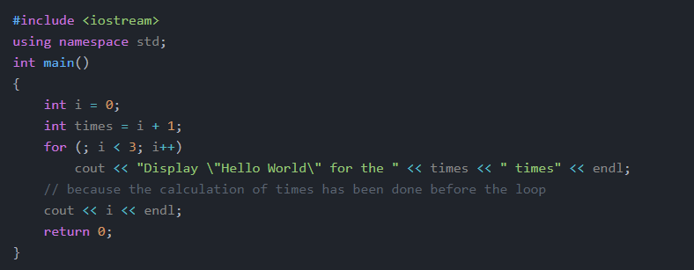

## Modified Code

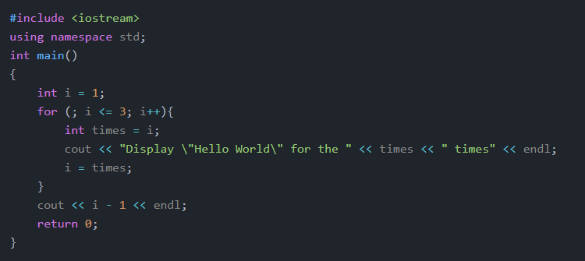

## Modifications

1. changed variable i to 1 to prevent statement displaying 0 first
2. added curly braces to for loop to allow for multiple lines to fit inside it
3. declared and initialized variable times to i **inside for loop**
4. set i equal to times
5. changed second to last line to display i - 1 rather than i (the way the for loop is structured would result in i being 4 rather than 3 in the end)