**CMSC203**

**Assignment 0 Part 5– JavaFX Setup**



**Installing JavaFX, Create, and run Eclipse JavaFX example**

* Install JavaFX
* Create Eclipse JavaFX example
* Compile and Run Java FX Example

**Step 1 – Java FX Installation**

**Use the following link to install JavaFX:** [**https://openjfx.io/openjfx-docs/#gradle**](https://openjfx.io/openjfx-docs/#gradle)

## JavaFX and Eclipse

This section explains how to create a JavaFX application in Eclipse. JavaFX 17 and Eclipse 2021 were used for the IDE screenshots.

Download an appropriate JDK for your operating system and set JAVA_HOME to the JDK directory. Refer to [Install Java](https://openjfx.io/openjfx-docs/#install-java) section for more information.

Include the new JDK as Installed JREs in Eclipse -> Preferences -> Java -> Installed JREs -> Add.

You can create a JavaFX modular or non-modular project and use the IDE tools, Maven or Gradle build tools.

### **Non-modular projects**

#### **IDE**

Follow these steps to create a JavaFX non-modular project and use the IDE tools to build it and run it. Alternatively, you can download a similar project from [here](https://github.com/openjfx/samples/blob/master/IDE/Eclipse/Non-Modular/Java).

Download the appropriate [JavaFX SDK](https://gluonhq.com/products/javafx/) for your operating system and unzip it to a desired location, for instance /Users/your-user/Downloads/javafx-sdk-17

Create a new User Library under Eclipse -> Window -> Preferences -> Java -> Build Path -> User Libraries -> New.

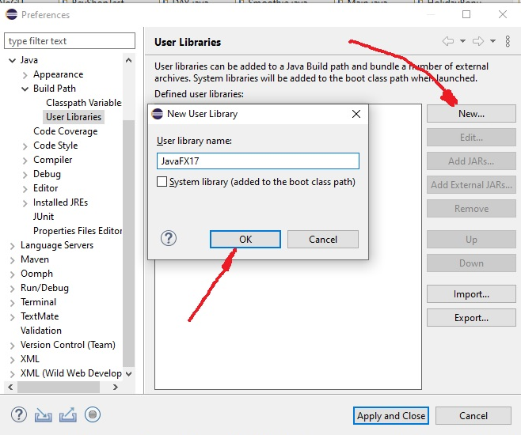 Name it JavaFX17 and click OK button.



then Select JavaFX17, and click a button “Add External JARs” and include the jars under the lib folder from JavaFX 17 unzipped folder click Open

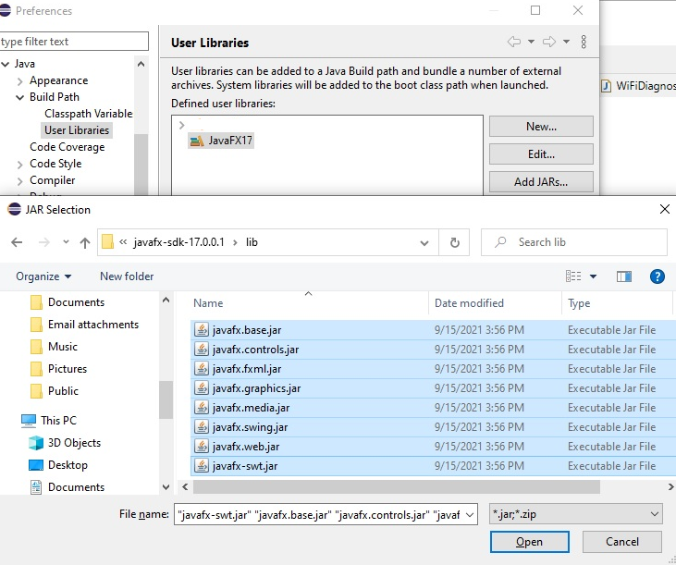



##### 



Click a button “Apply and Close”

##### **1. Create a Java project**

Select File -> New -> Java Project, and provide a name to the project, like HelloFX, and a location.



Make sure JDK 14 or greater is selected. Click a button “Next”.



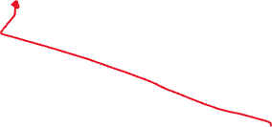

You don't need to add a module-info.java file, so uncheck a box “Create module-info.java file”

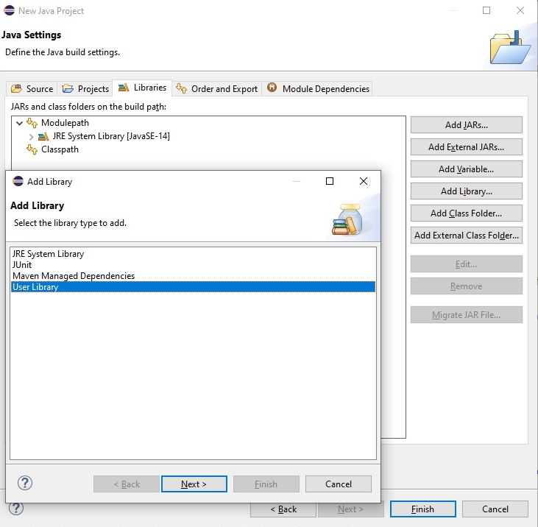



You can include the JavaFX17 library into the classpath, click a tab “Libraries”, then click “Classpath”, click a button “Add Library”, select User Library, and click a button “Next””

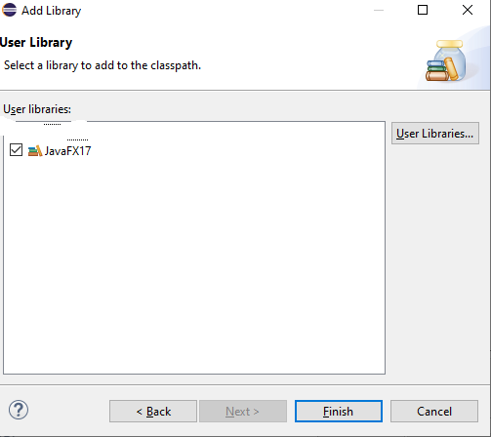



Select JavaFX17 and clicl Finish



Click a buttom “Finish”



An empty project will be opened. Then copy the attached file HelloWorldFX.java, right click “src” folder and paste it to the Project HelloFX.



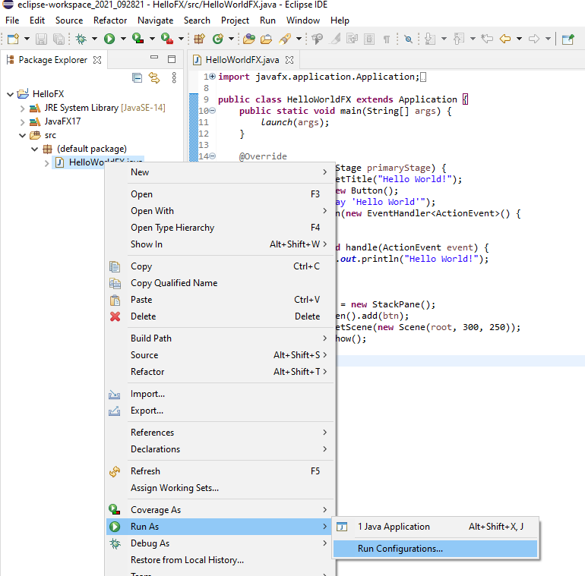



Then right click HelloWorldFX.java and click “Run As”, Run Configuration



Select Java Application “HelloWorldFX”, click a tab “ (x)= Arguments”, add these VM arguments:

Linux/Mac:

--module-path /path/to/javafx-sdk-17.0.0.1/lib --add-modules javafx.controls,javafx.fxml

Windows:

--module-path \path\to\javafx-sdk-17.0.0.1\lib --add-modules=javafx.controls

Example:

--module-path C:\Users\JavaFX_17\javafx-sdk-17.0.0.1\lib --add-modules=javafx.controls

You need to substitute \path\to\javafx with your path to favafx lib folder:



**Warning:**Make sure the checkbox **"Use the -XstartOnFirstThread argument when launching with SWT"** is not checked.

Click apply and close the dialog.



##### **2. Run the project**

Click Run -> Run As -> Java Application -> to run the project.

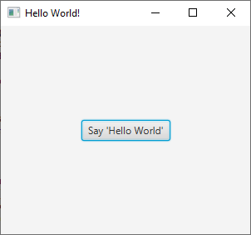

**Deliverables**

Upload the word document containing the screen shots to Blackboard.

**Submit:**

Screenshots showing:

JavaFX

* 1. Project screenshot
  2. Running example screenshot
  3. Java Source Code File

**References**

<https://openjfx.io/openjfx-docs/#gradle>

<https://www.javatpoint.com/javafx-with-eclipse>