**Requirements Statement**

Chess Game – Specifications:

Develop a locally played chess game. Two players should make alternating moves on one game board. The program will process each move and determine if moves are legal.

Board and Pieces:

The board is an 8x8 grid as shown below, each row is called a rank (1-8).

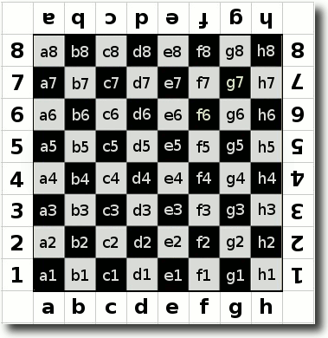

Source: http://www.chess-game-strategies.com/images/annotated-chess_algebraic_naming-squares.gif

There are a total of 32 pieces and 6 classes: king, queen, rook, bishop, knight, and pawn. Each player starts with 16 pieces spread out across two rows as shown below:

* (1)king = K
* (1)queen = Q
* (2)rook = R
* (2)bishop = B
* (2)knight = N
* (8)pawns = Fill rows 2 and 7.

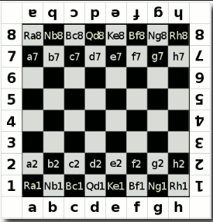

Source: http://www.chess-game-strategies.com/chess-notation.html

How to Move:

Each piece has a unique way of moving across the board:

* K - King can move one space in any direction; except when in check.
* Q - Queen can move any number of spaces in any direction.
* B - Bishops can move any number of squares diagonally.
* N - Knights can move only in an L-shape; one square up and two over or, two squares down and one up… or any combination of these. This is the case even if other pieces are in its path.
* R - Rooks can move any number of squares up and down or side to side
* P - Pawns can only move forward. The can move two or one spaces forward on their first move and one space forward on all subsequent moves. Pawns may move one space forward diagonally to capture another piece.

Special Moves/Rules:

* All moves are restricted by opponents pieces blocking their path, with an exception to the Knight.
* A player cannot move a piece to a square occupied by a piece of the same color.
* A player can move a piece to a square occupied by a piece of another color; this is called a capture.
* When a player captures a piece that piece is removed permanently from the board.
* Castling – Once a game each player has to option to castle his or her King. Castling involves moving the King and one of the Rook pieces. The King is moved two spaces to the left or right and the Rook is placed besides the King on the opposite side of where it started. 4 conditions must be met in order to castle your King.

1. All squares between the King and Rook have to be empty
2. King cannot be under attack
3. King and Rook were not moved previously
4. All squares through which the King is moving cannot be under attack.

* Promotion - When white pawn makes it to 8th rank or a black pawn makes it to 1st rank it is promoted to the owner’s choice of Queen, Rook, Bishop or Knight.

Optional Features:

* En-Passant – If a pawn moves out two squares on its first move, and by doing so lands to the side of an opponent’s pawn (effectively jumping past the other pawn’s ability to capture it), that other pawn has the option of capturing the first pawn as it passes by. This special move must be done immediately after the first pawn has moved past, otherwise the option to capture it is no longer available.
* Timed moves - Time limit per turn and/or for the overall match.
* Server Play - Play over LAN.
* Player Ranking - Track the wins and losses.
* AI Player - Play against AI instead of a human player.
* Stalemate - Game can end in a draw under the conditions:
  + King vs King
  + King and bishop vs King
  + King and Knight vs King
  + King and bishop vs King and bishop with bishops on same square color.
  + Any player can offer a draw, if it’s accepted.
* Undo - Ability to undo a move.
* Choose different board/piece colors.
* Add a sound when a piece is moved and/or captured.

How the game ends:

The game ends when one player capture’s the other player’s King also known as Checkmate. If an opponent’s piece is threatening to capture the King, the King is said to be in check. A King cannot move into a square that would put it in check.

When in check, the player whose King is in check has to do one of three things:

1. Move the King out of check
2. Block the attacking piece to remove the check condition
3. Capture the attacking piece.

If none of these actions can be performed to remove a King from check the game ends in a Checkmate.