COS214 Practical 5

Team:
- u25443705
- u25108582
- u25245962

System Description
Our Campus Guard system starts with the client reporting an incident. Once an Incident is reported, depending on the type of incident it is, the status of the incident will become either dispatched or escalated, and then eventually resolved. If the state becomes Dispatched then depending on what unit (medical response, security or staff) needs to be dispatched, it will be dispatched and the respective unit will then do what they need to do. The access properties of the building may also change if the Incident is a bomb threat or an intruder. For a bomb the building will go on partial lockdown, for an intruder, full lock down. A Pa announcement will be sent out for all incidents.

UML Diagram
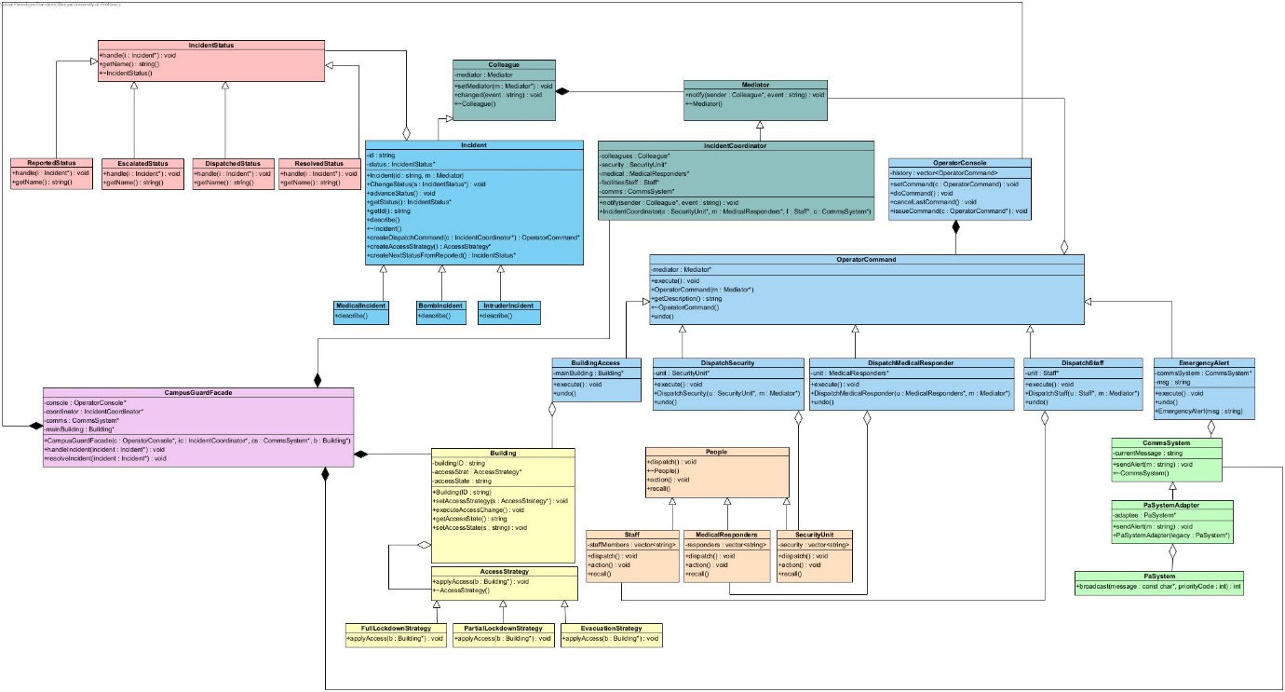

GoF Participants
Command
- Command – OperatorCommand
- ConcreteCommands – BuildingAccess / DispatchSecurity / DispatchMedicalResponder / DispatchStaff / EmergencyAlert
- Recievers – Staff, MedicalResponders, SecurityUnit
- Invoker – OperatorConsole

Mediator
- Mediator
- Colleague
- ConcreteMediator – IncidentMediator
- ConcreteColleague – Incident

Adaptor
- Adaptee – PaSystem
- Target – CommsSystem
- Adapter – PaSystemAdapter

Facade
- Facade – CampusGuardFacade

Added Design Patterns
State
- State – IncidentStatus
- ConcreteStates – ReportedStatus / EscalatedStatus /DispatchedStatus / ResolvedStatus
- Context – Incident

Strategy
- Strategy – AccessStrategy
- ConcreteStrategies – FullLockdownStrategy / PartialLockdownStrategy / EvacuationStrategy
- Context – Building

Relationships and Ownership decisions:
Most relationship and ownership decisions were made based off how the certain design patterns work. The façade has a composite relationship with OperatorConsole, the CommsSystem, Building and IncidentCoordinator. The OperatorConsole owns an OperatorCommand which has 4 subclasses that inherit from it (concrete commands) which each hold objects that correspond with that command. Incident has 3 subclasses that inherit from it and it holds a pointer to an IncidentStatus object. Incident inherits from collegue, and every colleague owns a mediator.

Design Pattern Interactions
The campusGuardFacade is connected to the operatorConsole which controls building access, dispatching units and the PA system, The concrete Commands each hold a pointer to an object that they perform actions on like changing building access permissions, dispatching units and sending out announcements. The state of an incident is what allows for certain steps to take place like FullLockDown a building or to dispatching . The IncidentCoordinator (concrete mediator) holds references to all the colleagues ( the units ). These subclasses notify the mediator. The concrete strategies override the applyAccess function to dynamically change the access permissions of a building object. The concrete States all have handle functions to control the state transitions (advanceStatus and changeStatus). The current state is what controls which operations can be executed.

Diagrams

Sequence Diagrams:
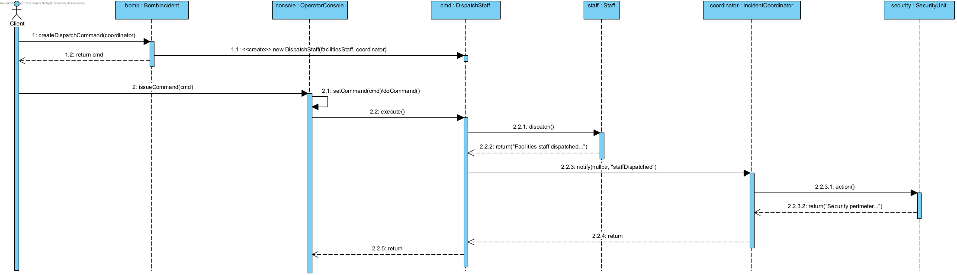
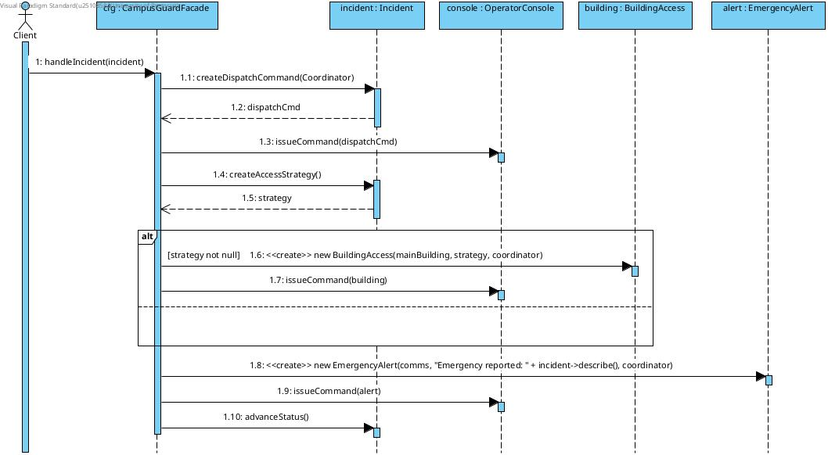

Behavioural Diagram: 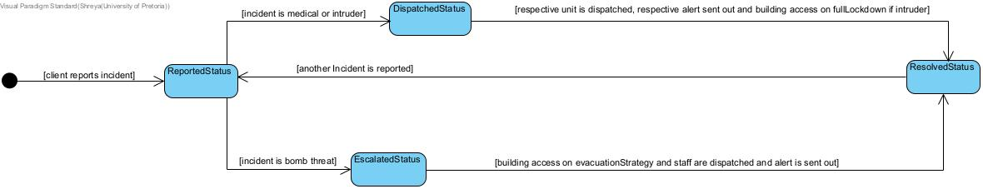

GDB and Valgrind
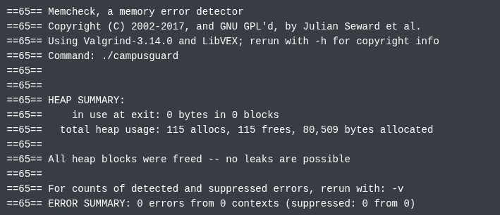

GitHub
https://github.com/nick-on-fleek/COS214-Prac5

