SQBS: A User’s Guide to Doing Basic Statistics with SQBS for the Fall Novice Tournament

Donald Taylor (University of Illinois)
Dwight Wynne (University of California – Irvine)

TABLE OF CONTENTS

1. Introductory Remarks…………………………………………………………………………. 2
2. Creating a New Tournament…………………………………………………………………... 3
3. Entering Divisions…………………………………………………………………………….. 4
4. Entering Rosters……………………………………………………………………………….. 5
5. Entering Games……………………………………………………………………………….. 7
6. Substitutions…………………………………………………………………………………… 10
7. Creating Reports………………………………………………………………………………. 11
8. Publishing Results…………………………………………………………………………….. 15
9. Forfeits and Overtime…………………………………………………………………………. 16
10. Playoffs………………………………………………………………………………………. 18
11. Closing Remarks……………………………………………………………………………... 22

1. Introductory Remarks

For the Fall Novice Tournament, you will be required to keep and post team and individual statistics for the entire tournament, including preliminary rounds, playoff rounds, and if played, finals. Initially, you may think that this is not a problem; you can get by with putting all the relevant data into Excel. Trust us: it has been tried, and it does not work.

Thankfully, Chris Sewell developed SQBS (Sewell’s Quiz Bowl Statistics), a user-friendly program for keeping quiz bowl statistics. Since its initial release in 2001, it has become the most widely used quiz bowl statistics program in the nation, not least because it is free to use and runs on any Windows-based computer. If you do not already have the program, you should download the program by clicking the “Download” link on the SQBS page.

This is not intended to be a manual for using SQBS. If you are looking for one, please see Chris Sewell's Concise Manual or the built-in Help System. Rather, this is intended as a step-by-step guide to keeping statistics for the Fall Novice Tournament using SQBS. Accordingly, we will skip over many topics that can be found in the manual, in the Help System, or by playing around with the program.

The writers of this guide have immense experience in the use of SQBS as an aide in running quizbowl tournaments. Donald Taylor has done stat entry for a large number of tournaments, including five of the events at Chicago Open 2008, as well as ACF Nationals 2009 and a large number of events hosted by the Academic Buzzer Team. Dwight Wynne has used SQBS for both high school and college tournaments in a variety of formats since 2005, and performed triple duty as tournament director, moderator, and statskeeper at ACF Fall West 2008. If you have any questions about SQBS or anything related to it, please e-mail us at dtaylor4@illinois.edu or dpwynne@gmail.com.

2. Creating a New Tournament

To create a new tournament, click File → New Tournament from the menu, or hit Ctrl-N. This will open the Options dialog box, which gives you several options for your tournament. You should note the following boxes:
-Question Values: Any tossup values other than zero should be checked. In this tournament, we are using 10’s and -5’s, so keep those checked, and uncheck the 15.
-Track Toss-Ups Heard: This is useful if you are running a timed tournament in which different games will have different tossups heard. However, for this tournament, each game will have 20 regulation tossups, so uncheck the box.
-Track Power and Neg Stats: For this tournament, there are no powers; therefore, the statistics output when this box is checked are meaningless and may confuse some newer teams. Accordingly, uncheck the box.
-Track Lightning Round Stats: We are not using a lightning round, category round, directed round, or any other round in which teams are read questions without having earned a tossups, so leave this box unchecked.
-Use Divisions: If you have multiple divisions (e.g. two prelim brackets), then check the box. If not, leave the box unchecked.
-Bonus Conversion Tracking: The default setting is Automatic, in which the program will automatically convert bonus conversion from the final score and the number of tossups answered. Manual allows you to enter the number of bonuses heard and bonus points manually, for instance, if you want to express the “bonus heard” as the number of possible bonus points. Manual with Bouncebacks allows you to calculate bonus conversions in formats with bounceback bonuses. Unless you are using a format with bouncebacks, you should leave this box on the default, Automatic, for this tournament. If you are using bounceback/rebounding bonuses, please see page 9 for information on how to use Manual with Bouncebacks.

See Figure 1 below for how your Options dialog box ought to look before the tournament.
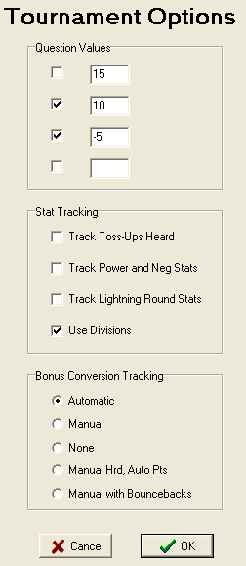
Figure 1. The Options dialog box should look like this before you click OK.

3. Entering Divisions

If you are running a tournament with divisions, there will be a Divisions Entry box. List each division or bracket name (e.g. “George Washington” and “Abraham Lincoln”) on a separate line (Figure 2, below). Then click Enter and minimize the dialog box.
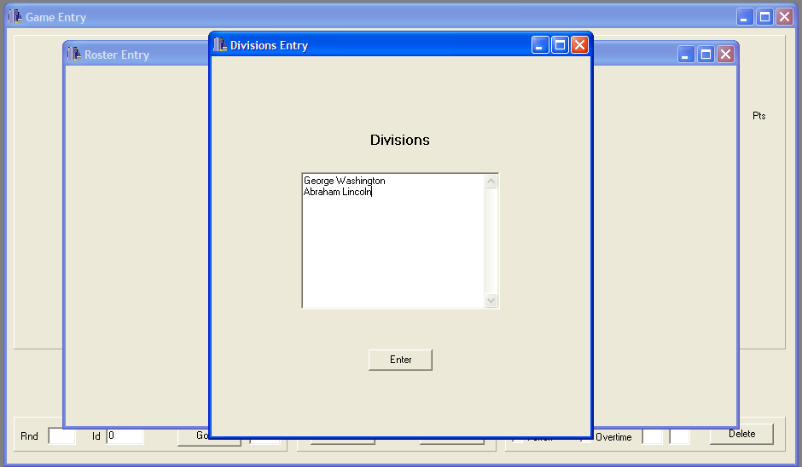
Figure 2. The Divisions Entry dialog box just before clicking the Enter button.

4. Entering Rosters

Find the Roster Entry dialog box. In Figure 2 it is just behind the Divisions Entry box, so it should show up when you minimize the Divisions Entry box. Under Team, you should type the team name. Then, click the drop-down menu under Division to select the division. If the team is an exhibition team (for instance, there are players from multiple schools or who do not meet the eligibility rules), check the Exhibition Team box. Finally, enter all the players on the team in the Players box, on separate lines. To save the team and go to the next team, click the Next button.

Figure 3 below demonstrates how a team should look once entered.
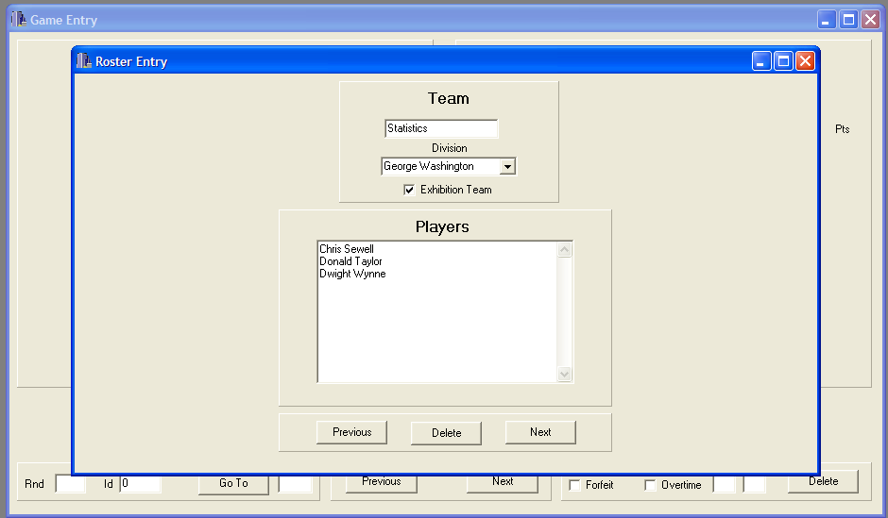
Figure 3. Statistics High School is in the George Washington bracket, is an exhibition team, and has three players: Chris Sewell, Donald Taylor, and Dwight Wynne.
To delete a team, click Delete. To go back to a previous team and revise information, click Previous and Next to get to that team. Remember, every time you change information, you need to click either Previous or Next for the change to register.

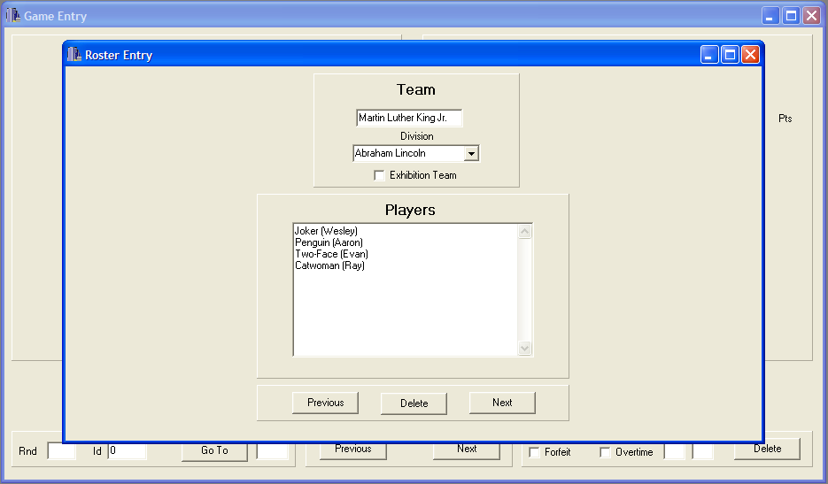
Figure 4. Martin Luther King Jr. High School's team is playing as Batman villains, but you can still identify which player is which by placing their real names in parentheses.
You may have teams that play under pseudonyms. This is not a problem, just enter those pseudonyms where player names would go. If your area requires players to use their real names, or someone switches names in the middle of the tournament, you can write each player’s real name, or additional names the player is playing under, in parentheses. See Figure 4, above, for an example of this.

Once you have all teams entered, minimize the Roster Entry box and wait for scoresheets to come in.

5. Entering Games

Once you have a scoresheet come in, it’s time to enter it into the program. Start by selecting the two participating teams from the drop-down menus on either side of the Game Entry dialog box (Figure 5, below). You will notice that the players’ names appear below the team name.
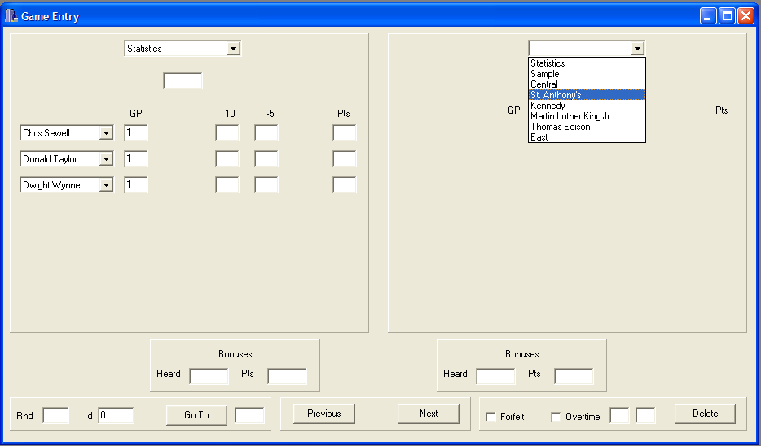
Figure 5. The game Statistics vs. St. Anthony's, just as St. Anthony's is selected.
In the box just below the team name, enter the team’s total score. Then, enter the number of 10’s and -5’s earned by each player on the team. If a player did not have a 10 or did not have a -5, that box can be left blank. Note that you do not enter the total points scored by the player; SQBS will automatically calculate that.

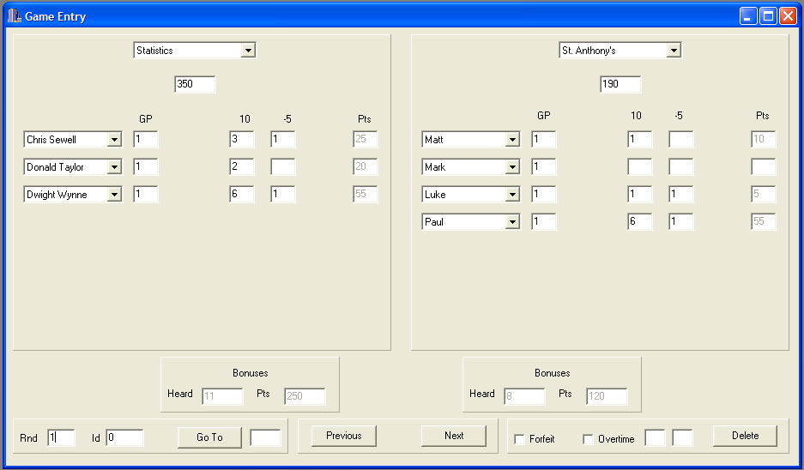
Figure 6. A properly filled-out Game Entry dialog box. Statistics defeated St. Anthony's, 350-190, in Round 1.
In Figure 6 above, Mark from St. Anthony’s did not score any points; SQBS will interpret the empty boxes as him having no 10’s and no -5’s for a total of 0 points. Notice that after each number you enter in the individual section, the “Bonuses” section automatically updates. The “Heard” will be the number of tossups answered by the team (the total number of 10’s) and the “Pts” will be the total points minus the tossup points you have entered into SQBS for that team.

Once you have entered the total score and individual 10’s and -5’s for each team, label the game with a round number and click Next to enter the next game. The program does not automatically record the game as entered until you go to another game by clicking either Previous or Next, so even if you have entered the last game, click Next to make sure the game is recorded.

The “Id” next to the round number is a designator used to identify the specific game that has been entered. The default Id assigned by SQBS is 0, 1, 2, and so on; however, you can manually change these Ids to anything else. One good strategy is to obtain a copy of the tournament schedule and mark each game on the schedule with an Id before the tournament starts. For instance, if room 241 is a game room, you can mark all the games in that room with Ids 1-241, 2-241, and so on; then just change the default Id when you enter the corresponding scoresheet. The Go To button allows for any game to be pulled up based on its Id.

If your tournament allows for bounceback/rebounding bonuses, in which the opposing team gets a chance to answer a bonus part if the controlling team misses that part, then you will want to have selected Manual with Bouncebacks under “Bonus Conversion Tracking” in the Options dialog box (see page 2).
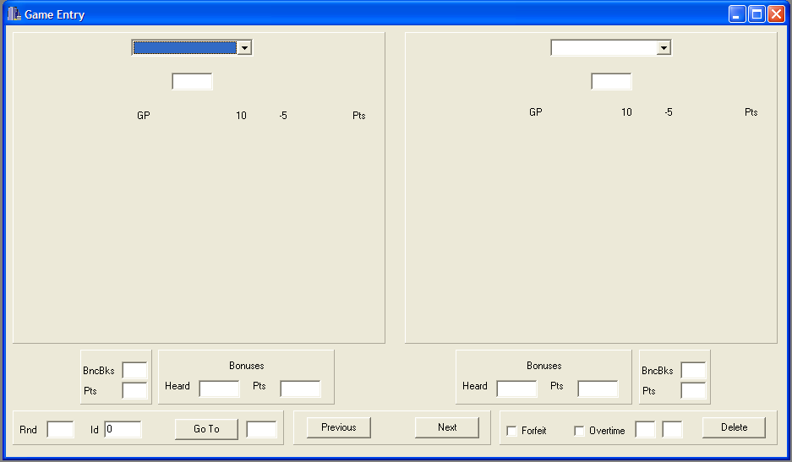
Figure 7. Blank Game Entry box for Manual with Bouncebacks setting.
The Game Entry box (Figure 7, above) looks quite similar to the Game Entry box for Automatic Bonus Conversion Tracking. The only new part of this Game Entry box is to the left (on the left side) and right (on the right side) of the Bonuses entry area. This is where you enter bouncebacks. First, enter the number of bonuses controlled (by getting a tossup) under “Heard” in the Bonuses entry area, and the number of bonus points earned on those bonuses only in the “Pts” section to its right. Under “BncBks,” enter the number of bonus parts attempted due to the opposing team missing the part. For this tournament, this can be found by multiplying the opponent’s bonuses heard by 30, subtracting the opponent’s bonus points, and dividing the result by 10. In the “Pts” section directly underneath, enter the number of points earned on those bouncebacks.

SQBS will give you an error message if the total of a team’s tossup points, bonus points, and bounceback points does not equal the total score you entered for that team.

6. Substitutions

Some teams will bring more than four players and rotate them in and out of games. If a player does not play in a game, enter 0 in the GP column, for Games Played. The program will automatically zero out any 10’s and -5’s. See Figure 8 below for an example.
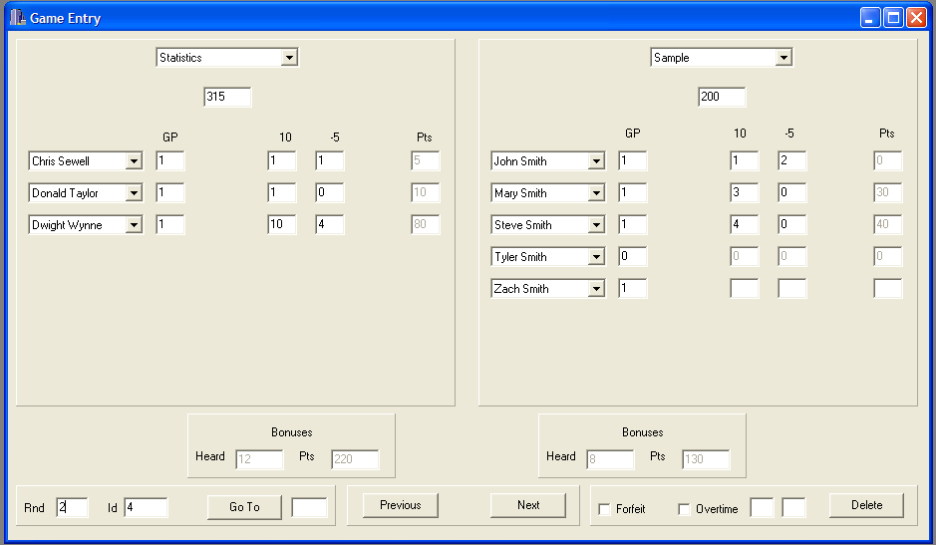
Figure 8. Tyler Smith did not play in Sample's Round 2 loss to Statistics.
Other times, a team with multiple players may substitute a player into the game at halftime. If this happens, mark both the player that was subbed in and the player that was subbed out with 0.5 GP (games played). See Figure 9 below for an example. You can also enter fractions in the GP column, for instance, if a player was substituted out after tossup 14, he would have played (14/20) games.
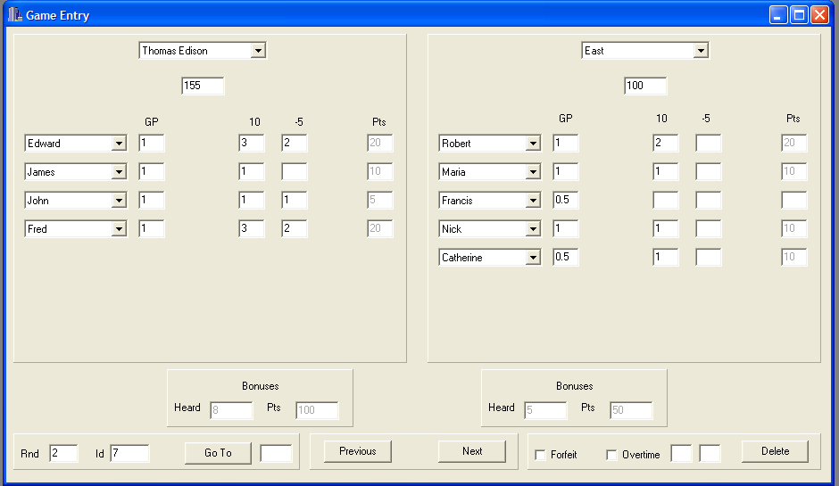
Figure 9. Francis and Catherine each played half a game for East in Round 2.
7. Creating Reports

Before you do anything, with this, you want to Enable Round Reports. This can be done by selecting Settings → Reports from the menu, then checking Include Round Reports. See Figure 10 below.

Round Reports give a round-by-round snapshot of how the average team at the tournament performed. Round Reports will also allow you to group games by the round played.
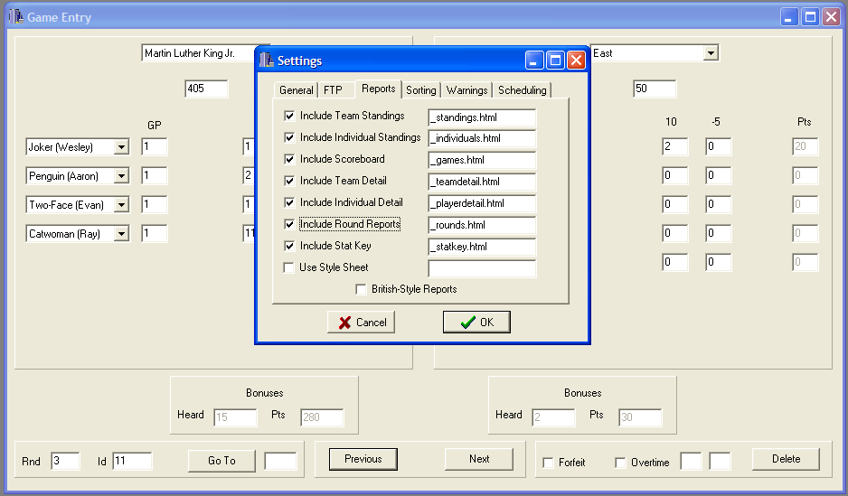
Figure 10. Enabling Round Reports.
There are three QuickPrint reports and one Full Web Report that can be generated using the Reports menu: Teams displays the team standings, Individuals displays the individual standings, and Games displays the results of all games played. Select the QuickPrint report that you wish to print, and it will display. Then, click Print Report to send the report to the printer.

Note that games against an exhibition team count in the exhibition team’s record and individual statistics, but not in the record or individual statistics of the teams playing the exhibition team. Accordingly, in Figure 11 below, Statistics is listed with a 3-0 record, but the other three teams are listed as having played two games each.
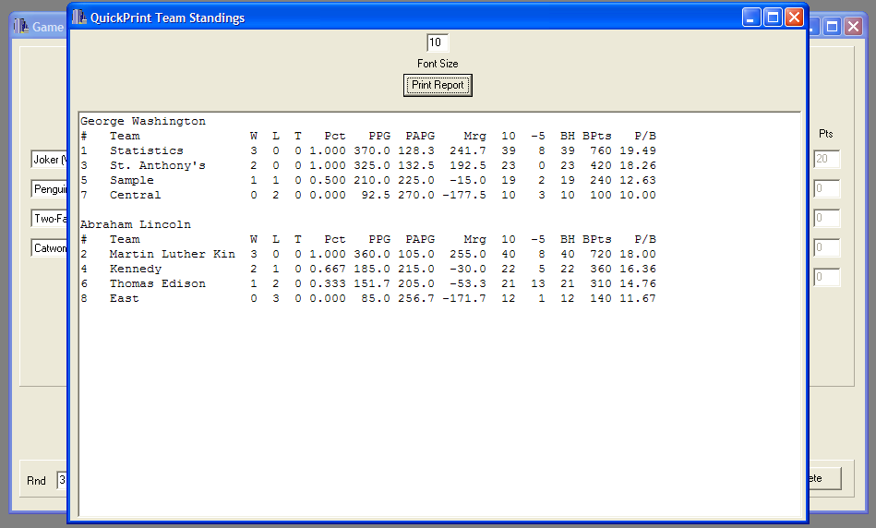
Figure 11. Standings after Round 3. East High School went 0-3 with 85 PPG, had twelve 10’s and one -5, and had a bonus conversion of 11.67.
In the QuickPrint Team Standings above, the first column is a number denoting each team’s overall placement. Ties in record are broken by PPG. Accordingly, Statistics is in place 1 after three rounds due to having 10 PPG more than Martin Luther King Jr. The second column is the team. Note that the team name may cut off. Then comes wins, losses, and ties, followed by winning percentage. PPG is points per game scored by the team, PAPG is points per game scored by that team’s opponents, and Mrg is the average margin of games involving that team. It also shows the number of 10’s and -5’s scored by the team, the number of bonuses each team heard, the number of points earned on those bonuses, and the bonus conversion (P/B, the last column). If you are using bounceback bonuses, you will also see the columns BBH, BBPt, and P/BB, which correspond to the number of bouncebacks heard, the points received on those bouncebacks, and the points per bounceback. Note that P/B is out of 30, but P/BB is out of 10.
In the Individual Standings box (Figure 12, below), the first column denotes the player’s rank, followed by the player’s name or pseudonym, the team he or she plays for, and the division that team is in. GP is games played; note that games against exhibition teams only count for the exhibition team and not for the other team, so Paul from St. Anthony’s only has two games played. Following that are the number of 10’s and -5’s the player accumulated over those games, the total number of points scored, and the player’s overall points per game.
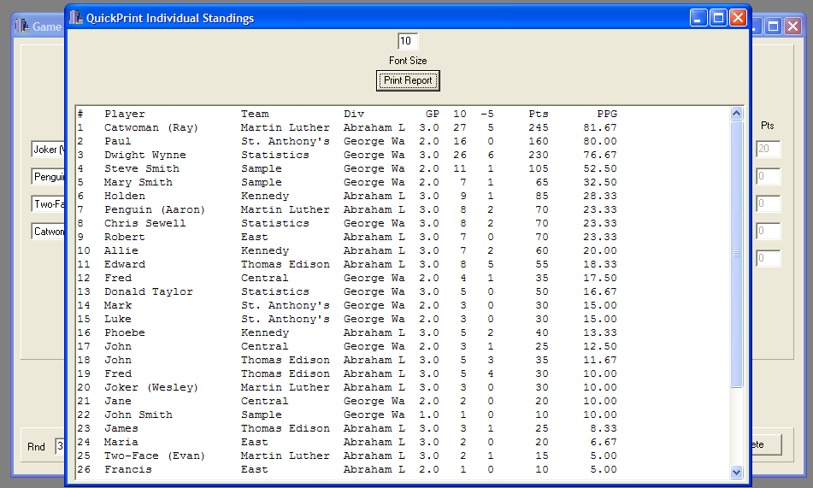
Figure 12. Individual Standings after Round 3.

The Game Results box (Figure 13, below) outputs the result of every game played, with the winner and its score in the left column and the loser and its score in the right column. If Round Reports are enabled, then the games will be grouped by round.
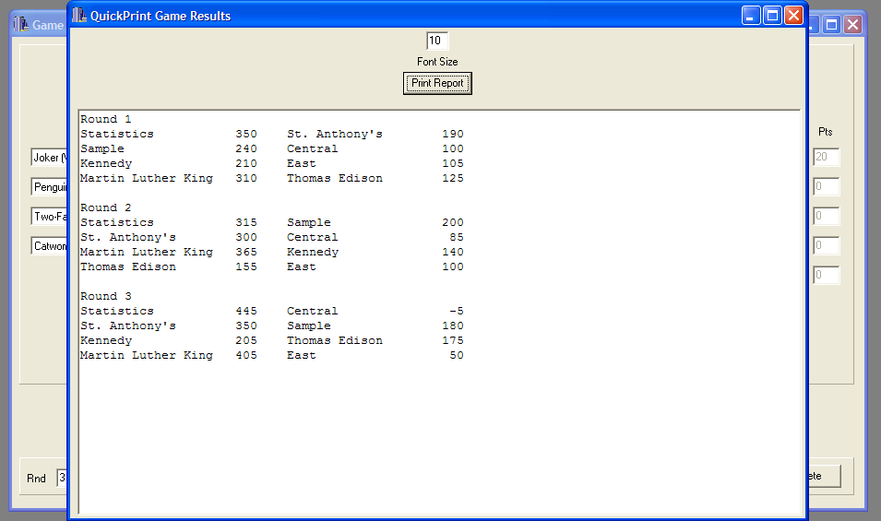
Figure 13. Results of each game through Round 3.
During your tournament, teams may want to know the standings during the tournament. For this purpose, only the team and individual standings need to be printed. Plus, this allows the participants to serve as a check in case the person entering the stats made an error.
8. Publishing Results

As part of the requirements for hosting the tournament, you are to post the results from the tournament on the internet for the public to view. After selecting Reports → Full Web Report (Figure 14, below), you will be asked to choose a location to save the reports and a file name. We suggest making a specific folder for this purpose, and if your tournament involves rebracketing or other playoffs, a new folder with two folders inside: one for the prelims, and one for the playoffs (Figure 15, below).
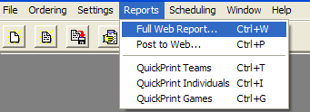
Figure 14. One of two ways to create a Full Web Report. The other way is by clicking the hand-holding-paper icon just to the left of the Reports menu.
You should save this file in the Prelims folder as (Your Tournament)_Prelims. This will lead to the creation of a set of html files, which are ready to be uploaded. If you have your own permanent webspace, then feel free to upload them there. If not, you can go to http://tc.scobo.net/tc/tcapp/new.aspx and obtain webspace for hosting the files. The files should all be placed within the same folder, for easy access. After this is done, simply indicate to us (either through email or a post on hsquizbowl.org) the URL for the uploaded Standings page. From the Standings page, all other pages can be accessed.
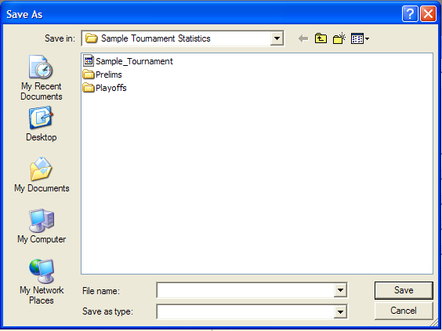
Figure 15. The Sample Tournament Statistics folder has the SQBS file for the tournament and folders for web reports for Prelims and Playoffs.
9. Forfeits and Overtime

Occasionally you will have games that do not end after 20 tossups. These occur if a team forfeits, or if the game is tied after 20 tossups and requires a tie-breaker tossup to determine the winner.

If a team forfeits, place the forfeiting team on the right side and the winner by forfeit on the left side. Then, check Forfeit in the bottom right corner. The team on the left gets a W and the team on the right gets an L (Figure 16, below). Neither team gets any games played for team or individual statistics.
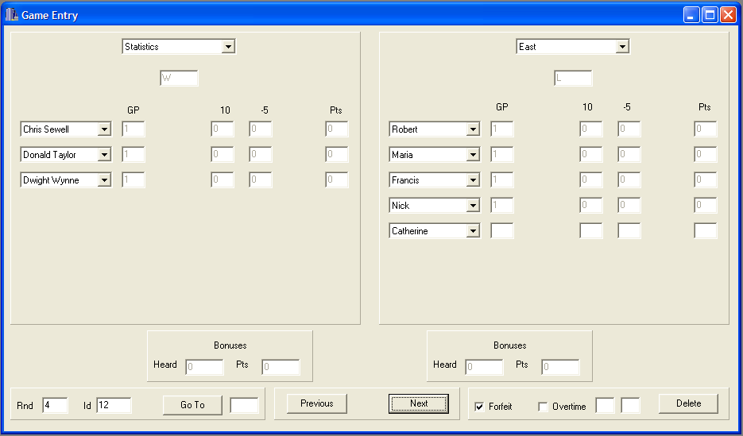
Figure 16. Statistics earns a forfeit win over East.

If a game is tied after 20 tossups, a tie-breaker tossup will be read. This will usually be denoted on the scoresheet in some way, for instance, by a row that says “Overtime” or “21.” If you are unclear as to whether a close match went into overtime, you can look at the cumulative score as of Tossup 20. If the game was tied at that point, then the match is an overtime match.

Enter the scores and the individual 10’s and –5’s as you would for a normal game. Then, check the Overtime box to the right, and in the two boxes to the right of that enter the number of tossups converted in Overtime by each team (Figure 17, below). Unfortunately, we have not found a way for SQBS to indicate -5’s that occurred in overtime; if a team negs in overtime, it will just show up as five fewer bonus points.
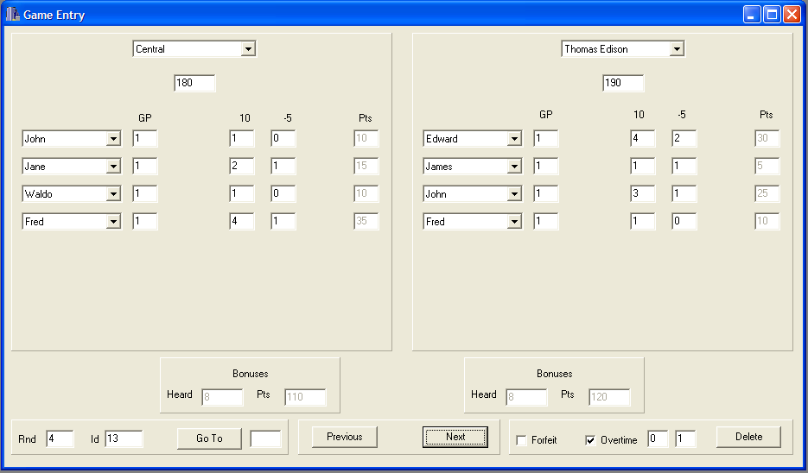
Figure 17. Thomas Edison defeats Central in overtime. Thomas Edison scored one tossup in overtime, while Central did not score.
10. Playoffs

Your tournament is likely to have playoffs. The most common, and most recommended, playoff format for most field sizes is a bracketed round robin.

Before starting the playoff round robin, you will want to save your prelims file. Hit Ctrl-A or click File → Save Tournament As… to save the file. You will want to save this file in your Prelims folder. This file name should be (Your Tournament)_Prelims (Figure 18, below).
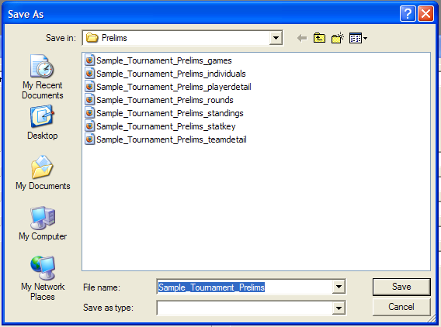
Figure 18. Saving the preliminary round file. Note that the Full Web Report files are already saved in this folder.
Next, hit Ctrl-A or click File → Save Tournament As… to create another file. This time, save the file in the Playoffs folder as (Your Tournament)_Overall (Figure 19, below). Now you have your Prelim matches saved, and can edit the file without overwriting that data.
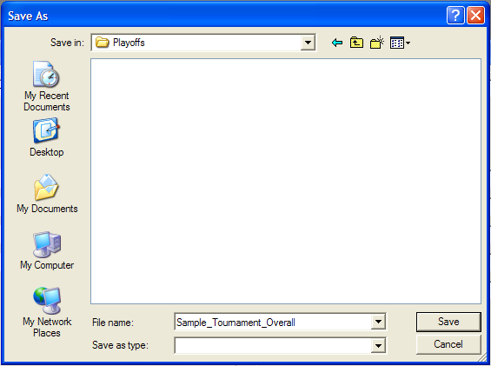
Figure 19. Saving the tournament in the Playoffs folder.
Bring up the Divisions Entry box again (you should have minimized it) and rename your divisions into playoff brackets. The top playoff bracket should be on the first line, the second bracket on the second line, etc. Click Enter once all playoff bracket names are entered, then minimize the box again.

Next, bring up the Roster Entry box again (you should have minimized it as well) and re-classify teams into the new divisions (Figure 20, below).
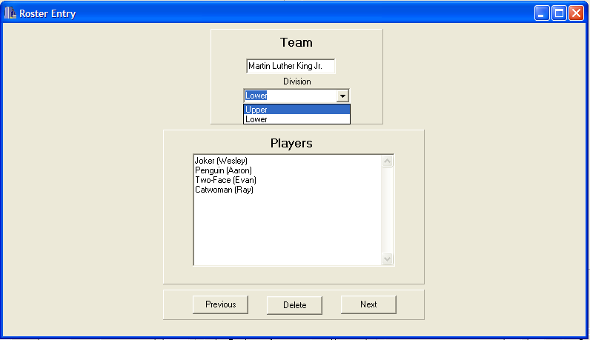
Figure 20. Martin Luther King Jr. was in the Abraham Lincoln bracket in the prelims, and so was automatically placed in the Lower playoff bracket. Click the pull-down menu and select "Upper" to change the division.
Once all teams have been classified into their new playoff brackets, you can begin entering playoff games, just as you would enter normal games.

However, you may choose to have preliminary games among teams in the same bracket carry over, i.e. cross-bracket playoffs. In that case, save the preliminary file in the Playoffs folder as (Your Tournament)_Playoffs, then delete all games that are not among teams in the same playoff bracket, and enter new games as they come in.

You can create an overall report by clicking Reports → Full Web Report, like you did with the Prelims. Save this overall report in the Playoffs folder as (Your Tournament)_Overall if it contains all games, or (Your Tournament)_Playoffs if it contains only playoff games.

If you created two distinct files for the prelims and playoffs, and want to generate one file with both, then have one of them open, click File → Merge Files, and choose the other one. This gets hairy if you carried over some of the preliminary games, as the games that are carried over are duplicated, and thus counted twice. In this case, you will have to find the duplicated games and delete one of them. This can be easily done by changing the ID of carried-over preliminary games in the playoffs file to C1, C2, C3, etc., then using the Go To button to find them.
To create a playoff-rounds-only report from a combined file, click Settings → General to open up the Settings box. Then, under “Rounds Included in Reports,” click Rounds and in the boxes to the right of that, input the first playoff round and the last playoff round (Figure 21, below). Then click okay.
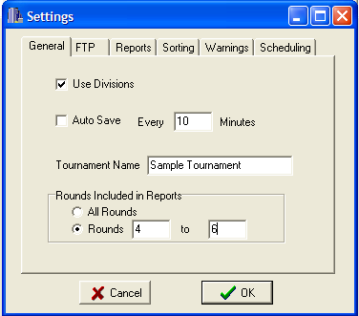
Figure 21. Rounds 4-6 (the playoff rounds) are now the only rounds in the report.
Now, any QuickPrint or Full Web Reports you create will only display data from the playoff rounds. In Figure 22 below, the top two and bottom two teams in each prelim bracket played a playoff round robin. Note that Statistics, as an exhibition team, was ineligible for the top bracket despite its 3-0 prelim record.
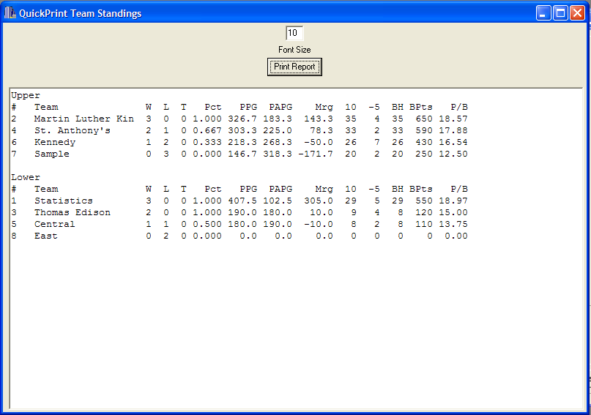
Figure 22. A QuickPrint Team Standings Report for playoff games only.
Now create a Full Web Report the same way you created the Prelims and Overall reports (Reports → Full Web Report). Save this report in the Playoffs folder as (Your Tournament)_Playoffs (Figure 23, below).

Finally, upload the Playoffs and Overall html files to the same website as the Prelims html files (see 8. Publishing Results) and indicate to us (either via e-mail or a post on hsquizbowl.org) the new URLs for the Playoffs and Overall Standings pages.
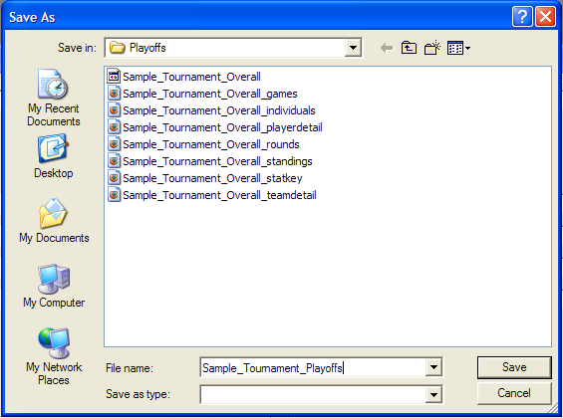
Figure 23. Creating the Full Web Report for the playoff rounds only.

Once you have uploaded all three Full Web Reports (Prelims, Playoffs, Overall), you should e-mail participating teams with the URLs for each of the three Standings pages. Teams may e-mail back with corrections, for instance, if you accidentally recorded a team’s score in a game as 170 when in fact it was 270. Hopefully, these errors will not affect the recorded results of any games; however, if you are prompt in printing out the QuickPrint Team and Individual Standings, teams will usually catch errors before the end of the day. If a team catches an error in the statistics after the end of the tournament, please be responsive, fix the error in the Prelims and/or Overall files, create new reports (you can overwrite the old ones), and upload the new reports. We all make errors, but it is important to report team and individual statistics as accurately as possible.

11. Closing Remarks

The role of stat entry may seem like a menial task, but ultimately, the statkeeper can heavily influence a tournament as either a boon or a burden. Efficient, accurate statkeepers generate easy-to-read statistics pages and contribute significantly to keeping a tournament running on time, while inefficient, inaccurate statkeepers often cause major delays when tournament directors need to wait to assign playoff brackets or when teams camp outside the stats room to complain about a wrongly entered result.
We suggest that you take some time before the tournament and play around with SQBS to get used to it. Similar to playing quizbowl, one of the best ways to get better at using SQBS is to sit down and do it. Once you learn and understand SQBS, you will be a valuable addition to the staff of any tournament you assist with.

We would like to thank you for running the Fall Novice Tournament, thus contributing to the growth of good quizbowl in your area. Finally, we would like to thank Chris Sewell for developing this program and making it freely available for tournament use. Without his efforts, this guide would never exist.

