The Pyxis of Cordoba: A Symbol of Women’s Power and Culture in Islamic Spain

This work of art is known as the Pyxis at the Metropolitan Museum in New York City. It is a jewelry box shown at the bottom and is carved from a large piece of ivory spanning over four inches in diameter. All rolled out the work spans sixty-five square inches, just about the size of a chessboard or sheet of paper. Close to the size of Missing its lid, the piece was found as part of an excavation of the palace of Abd al-Rahman III just outside of the city of Cordoba in Spain in a place called Madinat al-Zahra. Though the artist is unknown, it is theorized to have been carved around 950 during Abd al-Rahman’s reign and its significance ties into the idea of the unique role and freedoms expressed by certain political women in Cordoba at the time. This possibly was a result of the recently conquered Christian ideals mixing with the new Islamic faith. The delicate work done creating this artwork proves the elevated social status of political women in the region.

The name Pyxis roughly translates to box or compass. This piece of artwork shares its name with the Pyxis Nautica constellation in the southern sky. The first interpretations of a pyxis were found in ancient Minoan sites made from clay (Anonymous). Pyxides also show up in Christian contexts where the Eucharistic bread would be stored before communion (Britannica). Though Spain had recently be a largely Christian country, meaning the Pyxis could’ve been used in a similar way, the Islamic invasion meant that this one was a merely a jewelry box probably given as a gift. The Pyxis of al-Mughira held at the Louvre was a gift to the then eighteen-year-old al-Mughira as a coming-of-age present on his birthday (Makariou). Shifting to more visual analysis, the first thing one’s eyes are drawn to when viewing this artifact is the striking nature of its construction. It possesses a repeating pattern of animals woven together with flowering vines. My guess is it took at least a month or more to carve out by a skilled craftsman (Anonymous). The medium for this jewelry box is an elephant tusk measuring over four and a half inches in diameter. Ivory is composed mostly of dentine, a tough substance made from collagen fibers that form deep inside bones. Something mentioned once during a Friday lecture was that as time went on, ivory pieces shrank considerably to conserve the rare material as finding large elephant tusk became harder and harder to find. The shear size of this piece leads me to believe it was extraordinarily expensive to use the entire circumference. Traditionally, ivory was usually carved using knives, chisels, and files. Artists may have used rulers and templates to create the geometric patterns and motifs. The repeated pattern on its outer face is indicative of an Islamic art form found all over Cordoba. From the time ivory is harvested from the elephant, it shrinks and cracks as it loses water and dries out. A large crack is visible on the bottom of the box. Ivory is generally not fragile but can be damaged or tarnished easily with heat or chemicals. It had to have taken at least a month or more to carve out by a skilled craftsman. Four pairs of parrots, lions, and gazelles with gaps in between filled with vine like plants bearing fruit and flowers. It also has the shape of a ribbon carved toward the top and bottom of the work. Lions symbolized success, power, and royalty. Floral imagery showed abundance, fertility, and femininity (Prado-Vilar). The Pyxis depicted in this essay is not one of a kind. There are many pyxides like it. Some more intact than this one. Some with lids and some with Arabic writing on the side. The reason to write about this one has more to do with the location where it was found. Buried underneath a forgotten palace.

The Umayyad caliphate was a theocratic monarchy that claimed modern-day Spain and Northern Africa. The caliphate was headed by a caliph and assisted by ministers. Abd al-Rahman III established the Umayyad caliphate in Cordoba in 929. Abd al-Rahman III is also said to have led the caliphate to its most prosperous and succeeded by his son al-Hakim II. The next successor, al-Mansur led the caliphate to glorious military victories at the price of increasing unrest back home in Spain. This would usher in the end of the caliphate as the increased hostilities with its neighbors on all side. During its peak, Islamic Spain was the most populus country in all of Europe. The site where the Pyxis was found, Madinat al-Zahra was sacked and later abandoned when the caliphate collapsed. It was originally planned and built to become the governmental and political center of the entire caliphate for forty years after its completion. During that time, important ceremonies like receiving ambassadors, celebrating military victories, and where Abd al-Rahman named his son heir. Al-Mansur would later move the government to his own palace in Medina Zahira. The site until now has only been halfway excavated. Madinat al-Zahra had reception halls, congressional mosques, and gardens alongside the caliph’s palace.

Most images portrayed of Islamic regimes are oppressive toward women. Examples include the Taliban expelling all women from schools in Afghanistan after taking control from the national government (Al Jazeera) as well as women only until recently be prohibited from driving alone in Saudi Arabia under King Salman (Al Jazeera). Cordoba back then in contrast was a much more liberating place to be a woman. Al-Andalus where Cordoba was located was known for the freedom and self-initiative of its women. Some scholars attribute this to the Christian society that proceeded the Muslim society. They believe the Muslim Conquest of 711 had little lasting impact on society’s roles of men and women. This feminine liberation extended to politics too. This trend of empowerment came from Tarub, the mother of one of the heirs to Abd al-Rahman II’s throne. It is said a decision from Tarub was never overruled by Abd al-Rahman even until his death. Later Abd al-Rahman III built the site of the palatine city Madinat al-Zahra where the Pyxis was found after his beloved al-Zahra. Another woman of interest was Aurora the Basque who was said to have brought drastic change to the criteria of royal ascension as well as sow the seeds of a civil war that destabilized the region, doing so all from being the wife of al-Hakim II al-Mustisir bi-Ilah (Mourtada-Sabbah). These women held not only the caliphs’ minds, but also the power they shared having far-reaching implications on Muslim rule. A clear contrast from more traditional Islamic societies further east.

The Pyxis is a gorgeous work of art that embodies the values in Islamic Spain. It provides the viewer with valuable insight regarding the elevated social status of women. Made with ivory, the long-forgotten artist paid most attention to detail and precision. The delicate craftsmanship and motifs such as parrots, lions, and floral designs, reflect the symbols of power, abundance, and femininity, further emphasizing its artistic purpose. The piece shows clear links to traditional Islamic art styles with patterns flowing seamlessly into one another. The jewelry box excavated from the once lush compound is proof of the duality of both Christian and Islamic culture. The political climate in Cordoba during the Umayyad Caliphate gave certain women serious influence. Figures like Tarub and Aurora the Basque played crucial roles in politics and changed the rules for royal ascension. This contrasts with more traditional Islamic societies even today, where women's roles are often limited. The Pyxis and many works like it represent a broader cultural shift in Cordoba by artistic achievement as well as social change for political women.

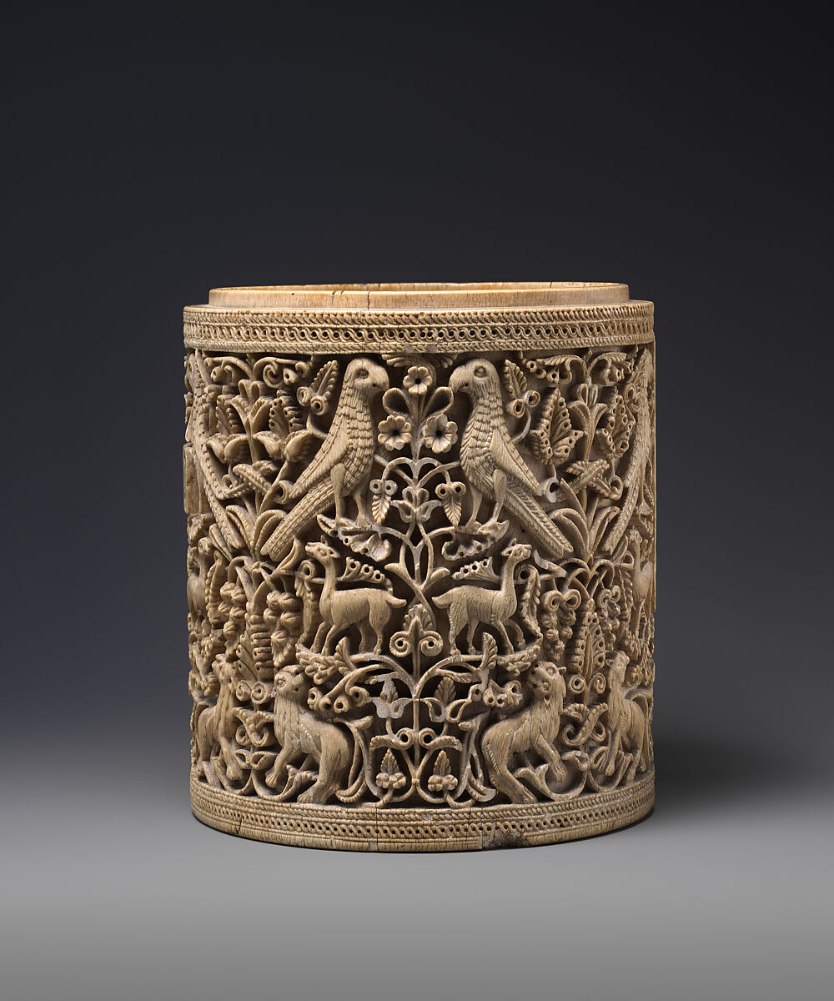

Figure 1. Pyxis, Met Museum

References:

Al Jazeera. 2022. “Afghanistan 2022: A Year of Restrictions on Women’s Rights.” Al Jazeera, December 31, 2022. https://www.aljazeera.com/gallery/2022/12/31/afghanistan-2022.

Al Jazeera. 2018. “Saudi Women Hit the Road as Driving Ban Is Lifted.” Al Jazeera, June 24, 2018. 1. https://www.aljazeera.com/news/2018/6/24/saudi-women-hit-the-road-as-driving-ban-is-lifted.

Anonymous. Early Minoan Cylindrical Pyxis with Lid. 2006-38-8A-B. Ceramic. University of Colorado Boulder, Classics Department, 5.

Anonymous. Pyxis (Cylindrical Container). Late 11th–early 12th century. Stonepaste; luster-painted on incised, opaque white glaze. The Metropolitan Museum of Art, New York. 3. Nuha N. N. Khoury. “The Meaning of the Great Mosque of Cordoba in the Tenth Century.” *Muqarnas* 13 (1996): 80–98. https://doi.org/10.2307/1523253.

Britannica, T. Editors of Encyclopedia. "Caliphate of Córdoba." Encyclopedia Britannica, September 21, 2023. https://www.britannica.com/place/Caliphate-of-Cordoba.

Britannica, T. Editors of Encyclopedia. "Ivory carving." Encyclopedia Britannica, July 1, 2019. https://www.britannica.com/art/ivory-carving.

Britannica, T. Editors of Encyclopedia. "Pyx." Encyclopedia Britannica, May 15, 2020. https://www.britannica.com/topic/pyx.

Makariou, Sophie. "The al-Mughīra Pyxis and Spanish Umayyad Ivories: Aims and Tools of Power". In Umayyad Legacies, (Leiden, The Netherlands: Brill, 2010) https://doi.org/10.1163/ej.9789004184749.i-560.78

Mourtada-Sabbah, Nada, and Adrian Gully. “‘I Am, by God, Fit for High Positions’: On the Political Role of Women in Al-Andalus.” *British Journal of Middle Eastern Studies* 30, no. 2 (2003): 183–209. http://www.jstor.org/stable/3593222.

Prado-Vilar, Francisco. “Circular Visions of Fertility and Punishment: Caliphal Ivory Caskets from Al-Andalus.” Muqarnas 14 (1997): 19–41. https://doi.org/10.2307/1523234.