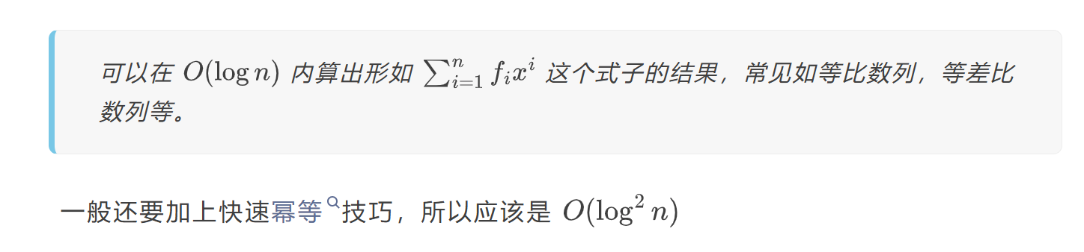
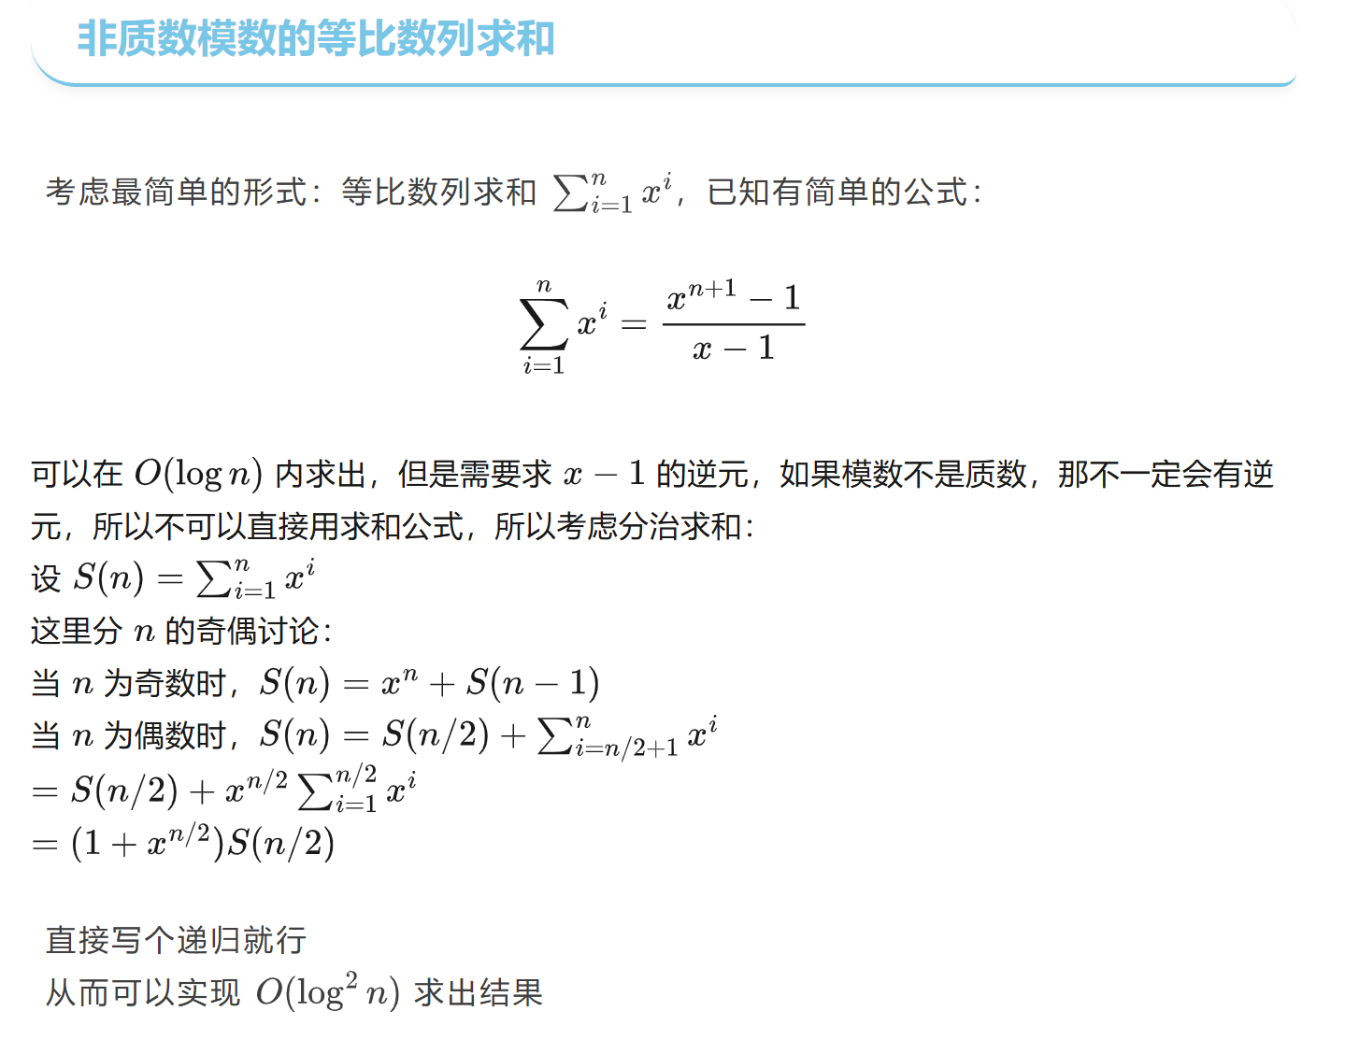
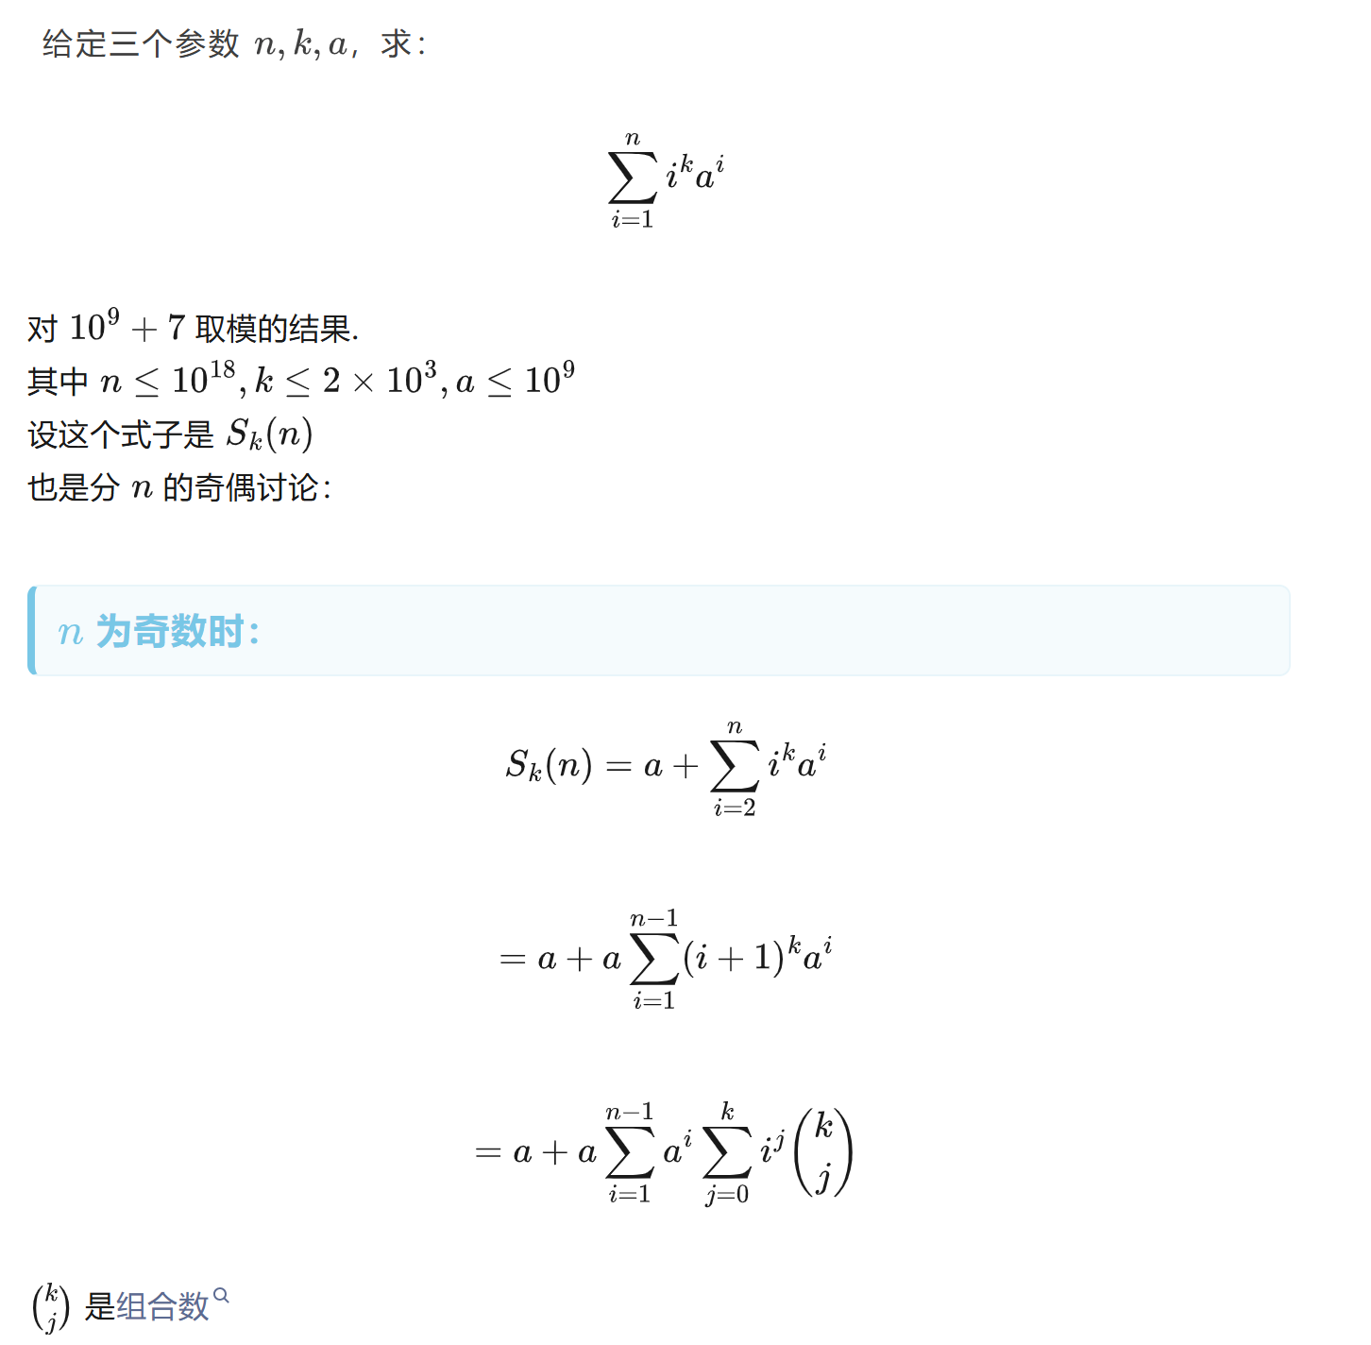
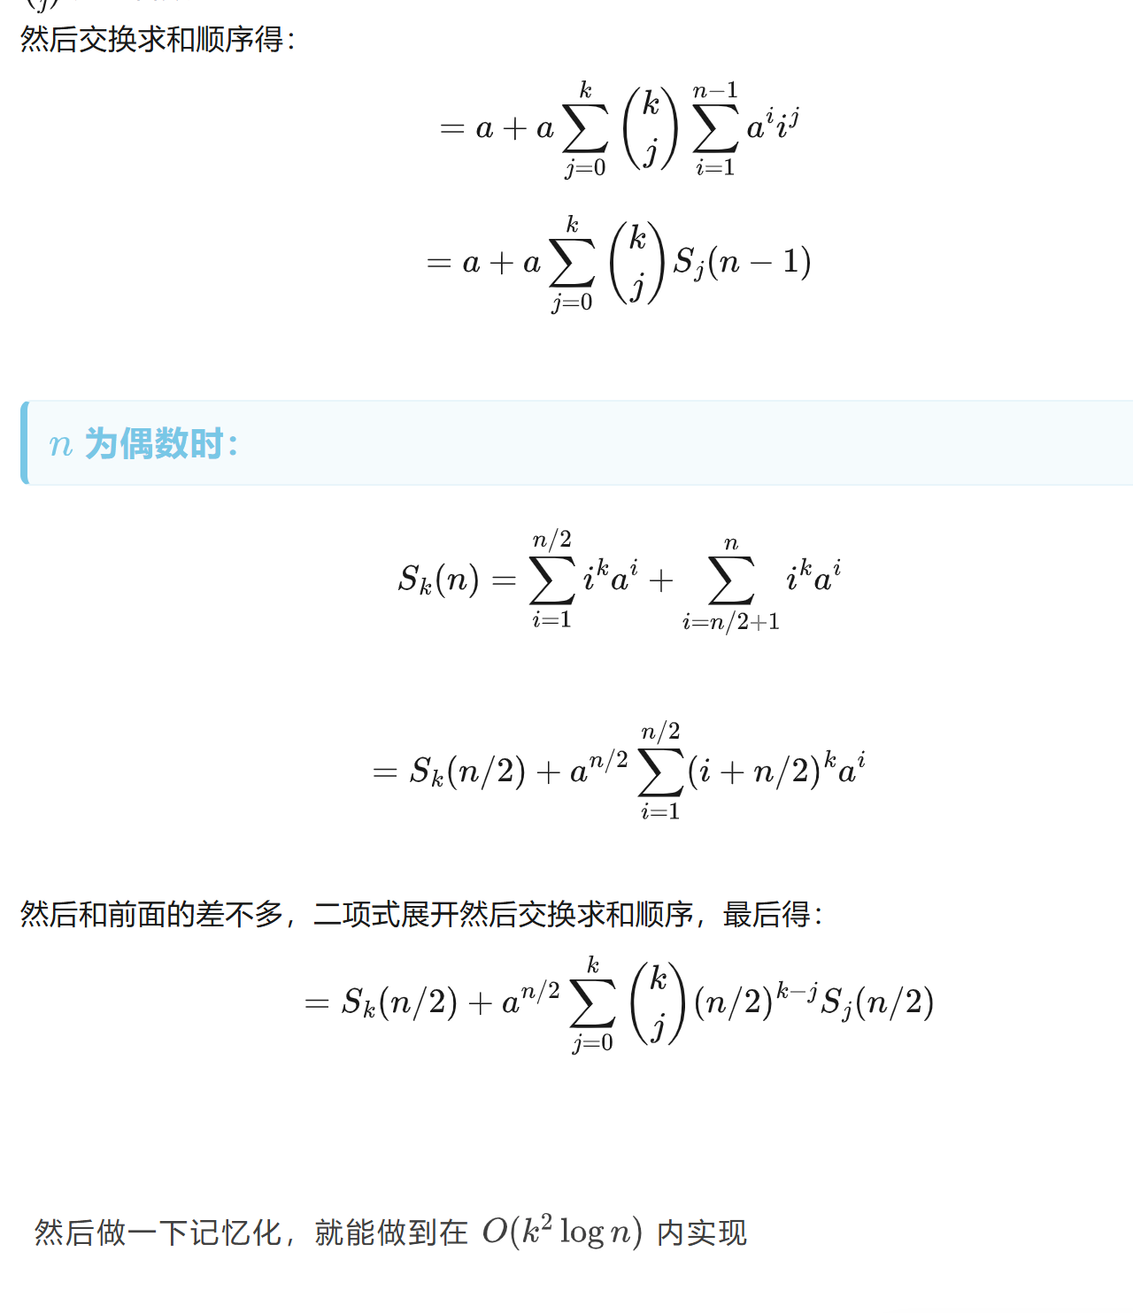
#include<bits/stdc++.h>
using namespace std;
#define int long long

const int mod = 1e9 + 7;
const int maxn = 2e3 + 10;
int n, a, k;
int c[maxn][maxn];

void init()
{
for(int i = 0; i <= k; i++)
{
c[i][0] = c[i][i] = 1;
for(int j = 1; j < i; j++)
c[i][j] = (c[i - 1][j - 1] + c[i - 1][j]) % mod;
}
}

int quickpow(int a, int b)
{
int res = 1;
while (b)
{
if (b & 1) res = (res * a) % mod;
a = (a * a) % mod;
b >>= 1;
}
return res;
}

// 考虑记忆化这个 k 来优化
vector<int> solve(int n)
{
if (n == 1)
return vector<int>(k + 1, a);
vector<int> S(k + 1);
if (n & 1)
{
auto T = solve(n - 1);
for (int i = 0; i <= k; i++)
{
int res = 0;
for (int j = 0; j <= i; j++)
res = (res + (c[i][j] * T[j]) % mod) % mod;
S[i] = (a + ((a * res) % mod)) % mod;
}
}
else
{
auto T = solve(n >> 1);
int base = quickpow(a, n >> 1);
for(int i = 0; i <= k; i++)
{
int res = 0, p = 1;
for(int j = i; j >= 0; j--, p = (p * ((n >> 1) % mod)) % mod)
res = (res + (((c[i][j] * p) % mod * T[j]) % mod)) % mod;
S[i] = (T[i] + (base * res) % mod) % mod;
}
}
return S;
}

signed main()
{
cin >> n >> a >> k;
init();
vector<int>ans = solve(n);
cout << ans[k];
return 0;
}

