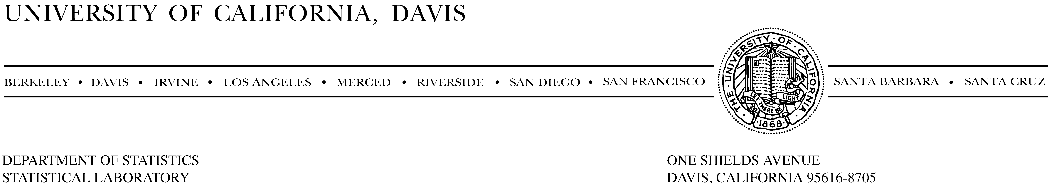
September 12, 2003

Dear Conference Participants:

It’s is a distinct pleasure to welcome you to the Ninth Annual U. S. Army Conference on Applied Statistics. When the organizing committee asked me to look into the possibility that this year’s conference might be hosted by the University of California, Davis, I answered immediately with an enthusiastic yes (especially since they weren’t asking for any money!). I began by looking into three venues for the conference, the first being the Davis campus itself, with the other two being “remote” locations – conference facilities in Lake Tahoe and in the Napa Valley. It did not take long for us to see that the Napa Valley location offered an excellent combination of value and convenience, and it won hands down on that account! And of course, there are also the viticultural accouterments. Even though I would have enjoyed the opportunity to have you all visit us on campus, I had to agree with the organizers that we had found an outstanding venue for the conference, one, incidentally, that the Davis campus has successfully used a number of times for off-campus meetings and retreats. While these final arrangements make UCD’s hosting of the conference almost invisible, I take pleasure in the thought that your comfort and enjoyment has been maximized. The environment and ambiance at the Napa Valley Marriot Hotel and Spa will no doubt contribute to an eminently successful conference.

The Army Conference on Applied Statistics has a rich and storied history, being the continuation of a conference begun in the early 50s at the instigation, and with the leadership, of one of the giants of our field, Sam Wilks. This year’s conference is patterned after its predecessors, as it is centered on real problems in modeling and data analysis and, especially, on problems of relevance to the Army’s statistical needs and challenges. Unique to the conference, from the beginning, are the clinical sessions in which defense personnel discuss recent or ongoing work with a view towards benefiting from the interaction and feedback generated by a broadly based audience of statisticians. These sessions are complemented nicely by special invited talks and by the presentation of a diverse collection of contributed papers. The conference has traditionally been small enough to ensure that the level of interaction among participants is high. For this reason, and also because of its unfailingly stimulating program, it has become one of my favorite conferences among the dozens of statistical meetings available each year. I hope you all find this year’s conference to be as good as it looks on paper. I’m confident that you will!

Again, on behalf of the University of California, Davis, and in particular, UCD’s Department of Statistics, I join the organizing committee in extending you a warm welcome to this year’s ACAS.

Sincerely,

Francisco J. Samaniego
Professor of Statistics

