CAIS-0339
Homework #7

General Description

Complete a Banker’s Algorithm code that handles a single request for resources from a process based on the current resource allocation state as represented below.

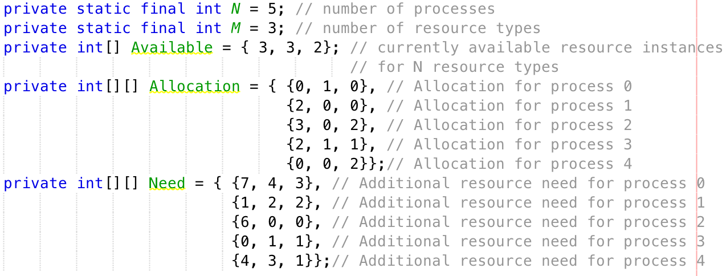

The template for the code is provided, and you need to complete two methods within the code: i.e. resourceRequestAlgorithm and safetyAlgorithm. resourceRequestAlgorithm must follow the logic as shown by the comments within, and likewise for safetyAlgorithm. These algorithms are based on information found on slide 33 and 32 for Chapter 07 respectively.

User Interaction

The following shows a snapshot of interaction where process 0 requests for (0, 2, 0) instances of resource types 0, 1, and 2 respectively.

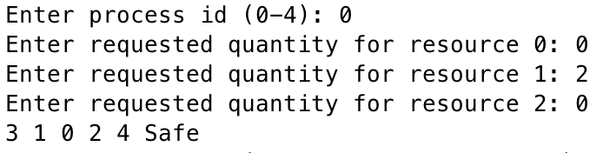

The program handles only one request, and exits.

Special Note

Do not declare/define any new variables, methods or classes within the template.
Do not add any new file to your submission.
IF ANY OF THESE REQUIREMENTS IS BROKEN, YOU WILL GET NO CREDIT FOR THIS HOMEWORK.

Program Submission

You must submit the completed Java template file.

