postgres-connector.json介紹:

{
"name": "postgres-connector",
"config": {
"connector.class": "io.debezium.connector.postgresql.PostgresConnector",
"database.hostname": "postgres",
"database.port": "5432",
"database.user": "postgres",
"database.password": "postgres",
"database.dbname": "demo",
"topic.prefix": "postgres",
"plugin.name": "pgoutput",
"publication.name": "dbz_publication",
"slot.name": "debezium_slot"
}
}
- Connector 類型
"connector.class": "io.debezium.connector.postgresql.PostgresConnector"
使用 PostgreSQL CDC connector

- DB 連線資訊
"database.hostname": "postgres",
"database.port": "5432",
"database.user": "postgres",
"database.password": "postgres",
"database.dbname": "demo"

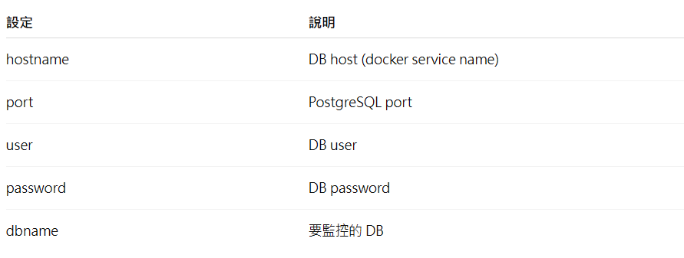

- Kafka Topic prefix
"topic.prefix": "postgres"
會替kafka topic 會加上前綴
格式：
<topic.prefix>.<schema>.<table>
例如:
postgres.public.orders
postgres.public.customers

- PostgreSQL logical decoding plugin
"plugin.name": "pgoutput"
代表使用pgoutput 這是 PostgreSQL 官方 logical replication plugin。
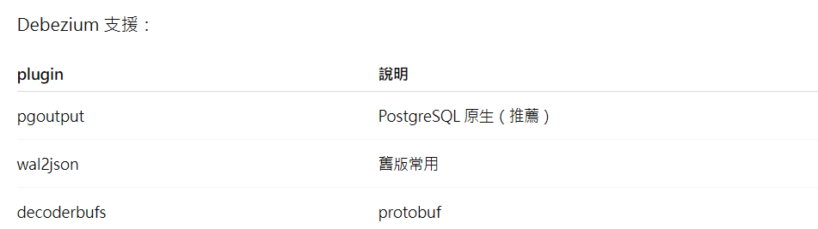

- Publication
"publication.name": "dbz_publication"
對應 DB 裡的：
CREATE PUBLICATION dbz_publication FOR ALL TABLES;
註. publication 是PostgreSQL logical replication 的 table 清單。

- Replication Slot
"slot.name": "debezium_slot"

slot 是：記錄 replication 讀到哪個 WAL 位置。
好處：
- Debezium crash 不會漏資料
- 可以從最後位置繼續讀

