October 20th, 2022

@ 2:30 pm to 4:15 pm

Attendance

Nicholas Moen

Dawson Sires

Kevin Robles

Praise Chinedu-Eneh

Martin Liu

Not show

Fayyaz, Sheikh

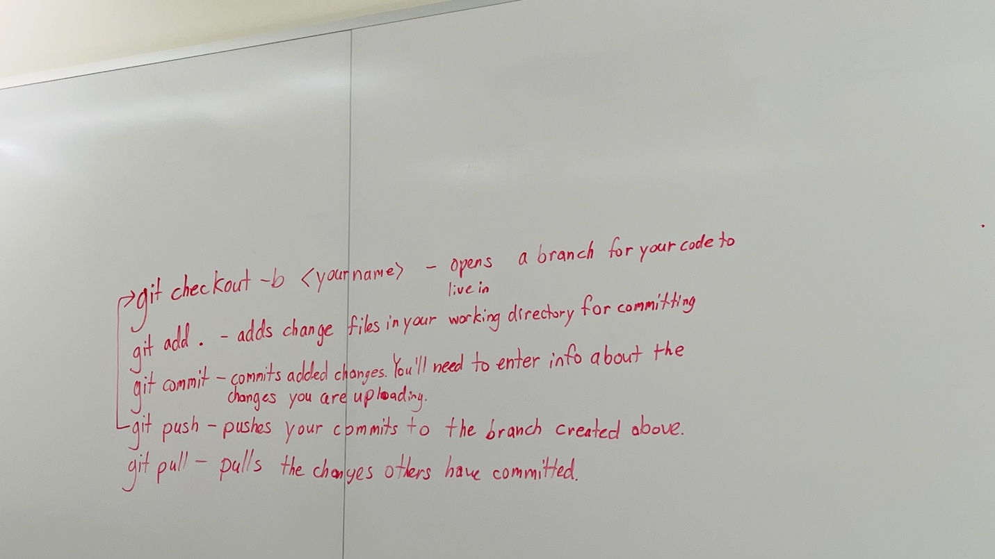

For Monday creating

• login/ create credential

• menu

• dummy credential

• dummy food items

SQL database

October 24th, 2022

@ 8:00 pm to 8:55 pm

Create a employee table

Create a employee menu

Backend

Kevin

Land page

Login

Not show

Fayyaz, Sheikh

October 25th, 2022

@ 2:30 pm to 3:30pm

Nicholas Moen

Dawson Sires

Kevin Robles

Praise Chinedu-Eneh

Martin Liu

Not show

Fayyaz, Sheikh

We working on the code to make progress.

October 27th, 2022

@ 2:30 pm to 3:30pm

Nicholas Moen

Dawson Sires

Kevin Robles

Praise Chinedu-Eneh

Martin Liu

Not show

Fayyaz, Sheikh

November 1th,2022

@ 2:30 pm to 3:45pm

Nicholas Moen

Dawson Sires

Kevin Robles

Martin Liu

Not show

Fayyaz, Sheikh

Praise Chinedu-Eneh

November 3th,2022

@ 2:30 pm to 3:55pm

Nicholas Moen

Dawson Sires

Kevin Robles

Praise Chinedu-Eneh

Martin Liu

Not show

Fayyaz, Sheikh

November 7th,2022

@ 2:30 pm to 3:55pm

Nicholas Moen

Dawson Sires

Kevin Robles

Praise Chinedu-Eneh

Not show

Fayyaz, Sheikh

Martin Liu

November 10th,2022

@ 2:35 pm to 3:45pm

Nicholas Moen

Dawson Sires

Kevin Robles

Praise Chinedu-Eneh

Martin Liu

Not show

Fayyaz, Sheikh

November 15th,2022

@ 2:35 pm to 3:05pm

Nicholas Moen

Dawson Sires

Kevin Robles

Praise Chinedu-Eneh

Martin Liu

Not show

Fayyaz, Sheikh

November 17th,2022

@ 2:30 pm to 3:30pm

Nicholas Moen

Dawson Sires

Kevin Robles

Praise Chinedu-Eneh

Martin Liu

Not show

Fayyaz, Sheikh

November 26th,2022

@ 6pm to 7pm

Nicholas Moen

Dawson Sires

Kevin Robles

Praise Chinedu-Eneh

Martin Liu

Not show

Fayyaz, Sheikh

November 28th,2022

@ 6pm to 7pm

Nicholas Moen

Dawson Sires

Kevin Robles

Praise Chinedu-Eneh

Martin Liu

Not show

Fayyaz, Sheikh