**Digital Retail**

**User guide for Supplier Composition**

This document is property of:

**CoC AG**

|  |  |
| --- | --- |
| Application | DRP Portal |
| Applicable for application release: | 16.8.0 |
| Application release date: | 2016-12-05 |
|  |  |
|  |  |
|  |  |
|  |  |

**Document revisions and changes**

Changes and revisions within this document

|  |  |  |  |
| --- | --- | --- | --- |
| **Date** | **Author** | **Version** | **Change / revision** |
| 05/12/2016 | Mykola Sedletskyi | 0.1 | Initial creation |

Contents

1 Introduction 4

1.1 Scope of this document 4

1.2 Structure of this document 4

1.3 Coverage of this document 4

2 Application Overview 5

2.1 Compositions 5

2.2 Ability to create compositions for Suppliers 5

3 Supplier Compositions 6

3.1 Supplier Composition overview 6

3.2 Permissions in compositions 6

3.3 Filtering 7

3.4 Clone compositions 7

4 Markets availability 8

5 Composition revision 9

6 Supplier Deployment 10

7 Copyright remarks 11

# Introduction

This document describes the structure of the application DRP supplier composition and how to use it.

## Scope of this document

The scope of the document is to:

* Have a document which can everybody use as a how to of the application.
* This document is only relevant for applications with a GUI

## Structure of this document

Please see the table of contents to get an overview of the structure. Please do not change the structure of the document. Any additional information that does not fit into one of the sections can be added as an appendix in the end of the document. Please set a reference in the corresponding section – if applicable.

## Coverage of this document

This document is applicable to and effective for all Digital Retail applications running and operated for AUDI AG.

# Application Overview

This section explains the overall structure of the application as well as how to use it.

## Compositions

In DRP user can create and modify the compositions which are the basis for the Deployments.

User can create the composition which includes component for specific product, define environment on which it should be Deployed and select dedicated machines - markets, on which the composition is expected to be Deployed.

## Ability to create compositions for Suppliers

Audi suppliers has their own systems, where they can test and verify their products. To be able to Deploy their products in the same way as it is done on production – suppliers can use DRP. For this they need to be able to create own compositions, that will not affect production.

The new composition type is «Developer» and it allows suppliers to create their own compositions.

Suppliers will also have an access and ability to run the Deployment for their compositions.

# Supplier Compositions

## Supplier Composition overview

User can create a new composition. Every composition created by Supplier will have status “Developer”, when composition created by Composition Manager has status “Draft”.

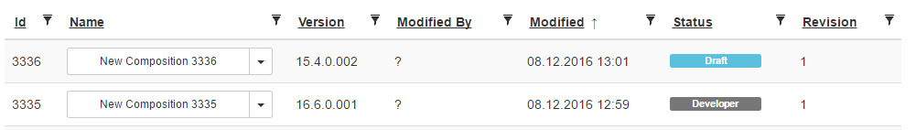

**Figure 1. Composition status depending on its creator.**

User can filter composition by each column or can search compositions with specific field value.

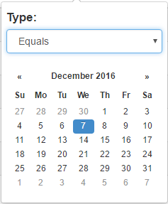 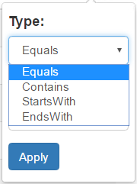 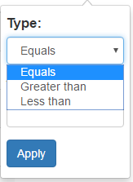

**Figure 2. User can filter compositions by different parameters.**

## Permissions in compositions

Supplier can edit and delete only compositions created by himself, but at the same time he can view all existing compositions.

Composition manager has permission to edit, delete and view all compositions including “Developer” compositions.

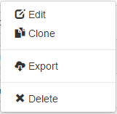

**Figure 3.1 Actions permitted for Composition Manager.**

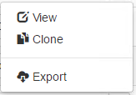

**Figure 3.2 Actions permitted for Supplier.**

Note - when Composition manager edit an existing composition – its status does not change (for “Developer” compositions it remains “Developer”).

## Filtering

User can filter list of displayed composition. If check box “Show Developer Composition” is checked - Compositions with status “Developer” are displayed. When its unchecked – only compositions with status “Draft” are displayed.



**Figure 4. Check box for changing list of displayed compositions.**

Note

If user role is Supplier - compositions with "Developer" Status are displayed by default.

If user role is Composition Manager – compositions with “Developer” status aren’t displayed by default.

## Clone compositions

Each User can clone own composition or composition created by other suppliers and composition managers. Composition that was cloned will be marked as copy.



**Figure 5. Cloned composition marked as Copy.**

If composition was cloned by Composition Manager its status will be “Draft”. Composition cloned by supplier has status “Developer”.

# Markets availability

While creating a new composition or changing an existing one, user can select markets from Market regions. List of available markets is different depending on role of user. For Suppliers – only list of markets on which they can deploy composition is displayed.

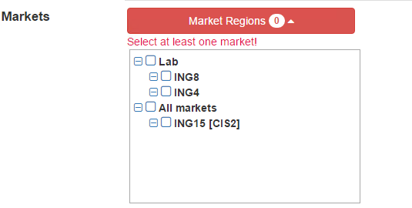

Figure 6: Supplier view for the markets. Only available markets displayed.

Permission for the markets are also checked via the API. This allows to avoid adding supplier compositions to production markets – only to supplier related markets.

# Composition revision

Composition revision is a counter that counts the number of times the composition was changed. When composition was created – value in the field is 1. It increments every time when composition was changed both via UI and API.

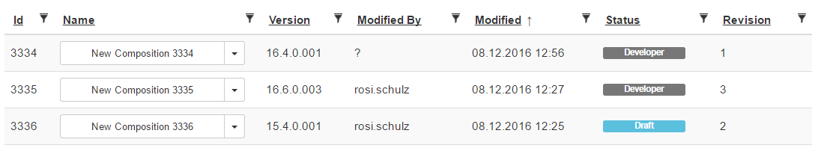

**Figure 7. Value in the field revision depending on number of time the composition was changed.**

# Supplier Deployment

Supplier has access to Deployment menu item and can see list of all deployments. Also he can create deployment using composition with “Developer” status.

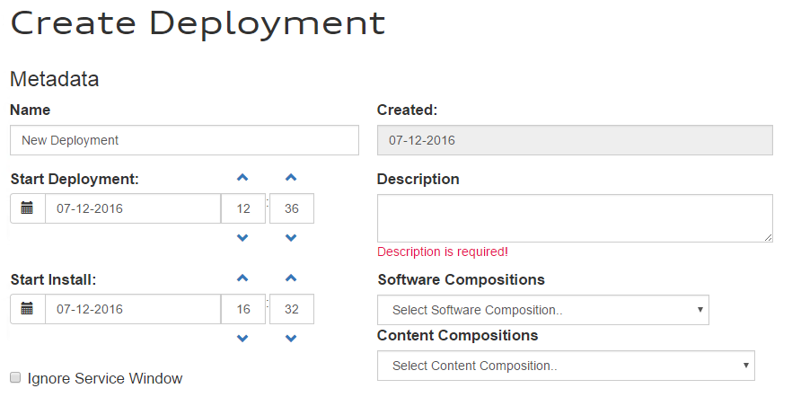

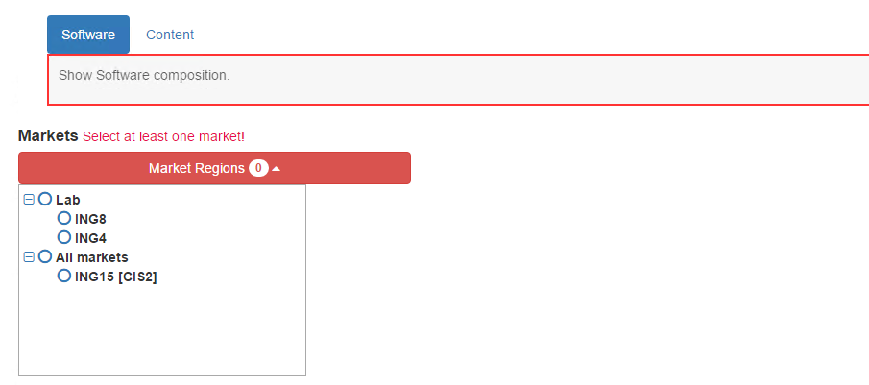

**Figure Supplier**

# Copyright remarks

This document is confidential. Any dissemination to third parties in a written or non-written form requires the approval of AUDI AG. The compositions and contents herein are not to be copied, reproduced, printed, published, posted, displayed, incorporated, stored in or scanned into a retrieval system or database, in whole or in part without the prior express written permission of the sole author, who is, unless otherwise denoted. Unauthorized duplication is strictly prohibited and is an infringement of National and International Copyright laws.

The use of this document for third parties is only allowed for Audi internal matters such as RFPs. Pre-condition for this is an NDA between Audi AG and the 3rd party.

Any transmission of this document is only allowed in a secure way such as encrypted email. In addition to the general disclaimer about the content of this document is the disclaimer is also effective for this document itself.