**HACKERRANK CODECHECKER BUNDLE FOR TEXTMATE 2**

Developed By: Nick Arduini

Date: 3/16/15

**I. BRIEF DESCRIPTION**

This bundle allows a user to use the HackerRank Code Checker by pressing **cmd-H** from a programming source file open in the TextMate 2 Editor. This command will open a GUI application written in Python 2.7 that allows the user to either scrape a HackerRank code challenge URL to get test cases or to enter custom test cases. Once a list of inputs and expected outputs has been acquired, the program contacts the HackerRank CodeChecker through its API. After receiving the JSON response, the program parses this data, and outputs the result.

**II. CONFIGURATION DETAILS**

TextMate 2 can be downloaded here: <http://macromates.com/download>. To install the bundle, just double-click on the hackerrank.tmbundle package.

The program requires Python 2.7 to run. The top line of the source code is a shebang: “#!/usr/local/bin/python2.7”. If your Python 2.7 doesn’t live here or you use a virtual environment, you’ll need to update accordingly. You can edit a bundle’s source code by clicking on the Bundles menu in TextMate and clicking edit bundle. On the window that comes up, select hackerrank from the list of bundles and then click on Run Code Checker in Menu Actions.

The application imports two modules that do not come with the standard installation of Python: requests and selenium. Information on how to install these can be found easily on the web.

To scrape the HackerRank test cases, the application uses PhantomJS as a headless browser. In order to get PhantomJS to work correctly, I had to include the following on line 63 of the source code:

“driver = webdriver.PhantomJS("/usr/local/bin/phantomjs", service_log_path='/var/log/phantomjs/ghostdriver.log')”

The first argument here is the path to where PhantomJS lives in my environment. The second is a log file I had to create so that PhantomJS didn’t throw an exception. Additionally, I had to chmod this log file to 777.

**III. KNOWN ISSUES AND BUGS**

There is no validation right now on URL entered by user, and application will throw an exception if it can’t find what it expects to see on a HackerRank challenge page.

Occasionally (but rarely), the headless browser will click the Run Code button before the code stub on HackerRank has been entered. When this happens, the application will incorrectly believe that the compile error thrown is actually expected input.

The application determines which language to send the Code Checker by the extension of the source file. As such, the application will not work for an unsaved file or a file with a non-standard extension.

**IV. SCREENSHOTS**

First screen provides the option to either enter URL of a HackerRank problem or enter custom IO.

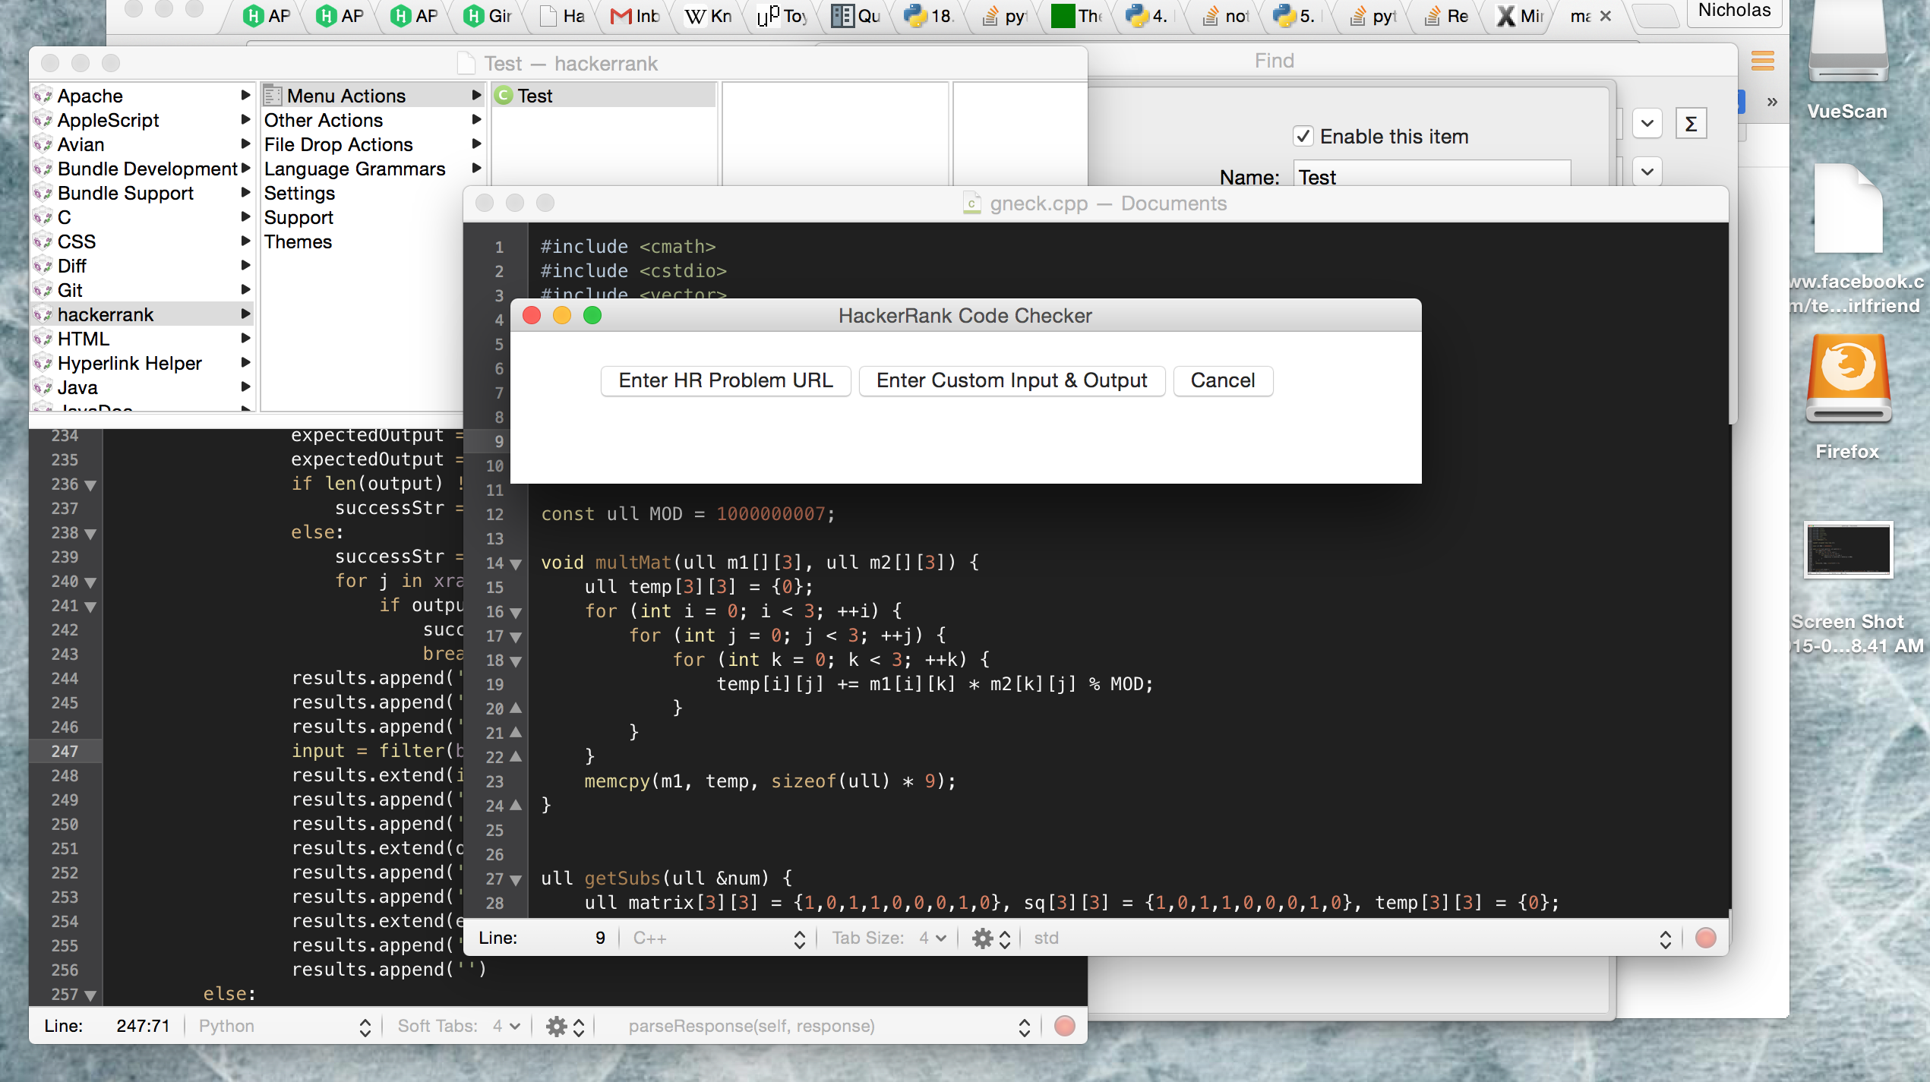

User enters the desired URL: note that due to the time it takes to open the headless PhantomJS browser and scrape the required data, it sometimes takes about a half a minute to advance to the next screen here after pressing the DONE button.

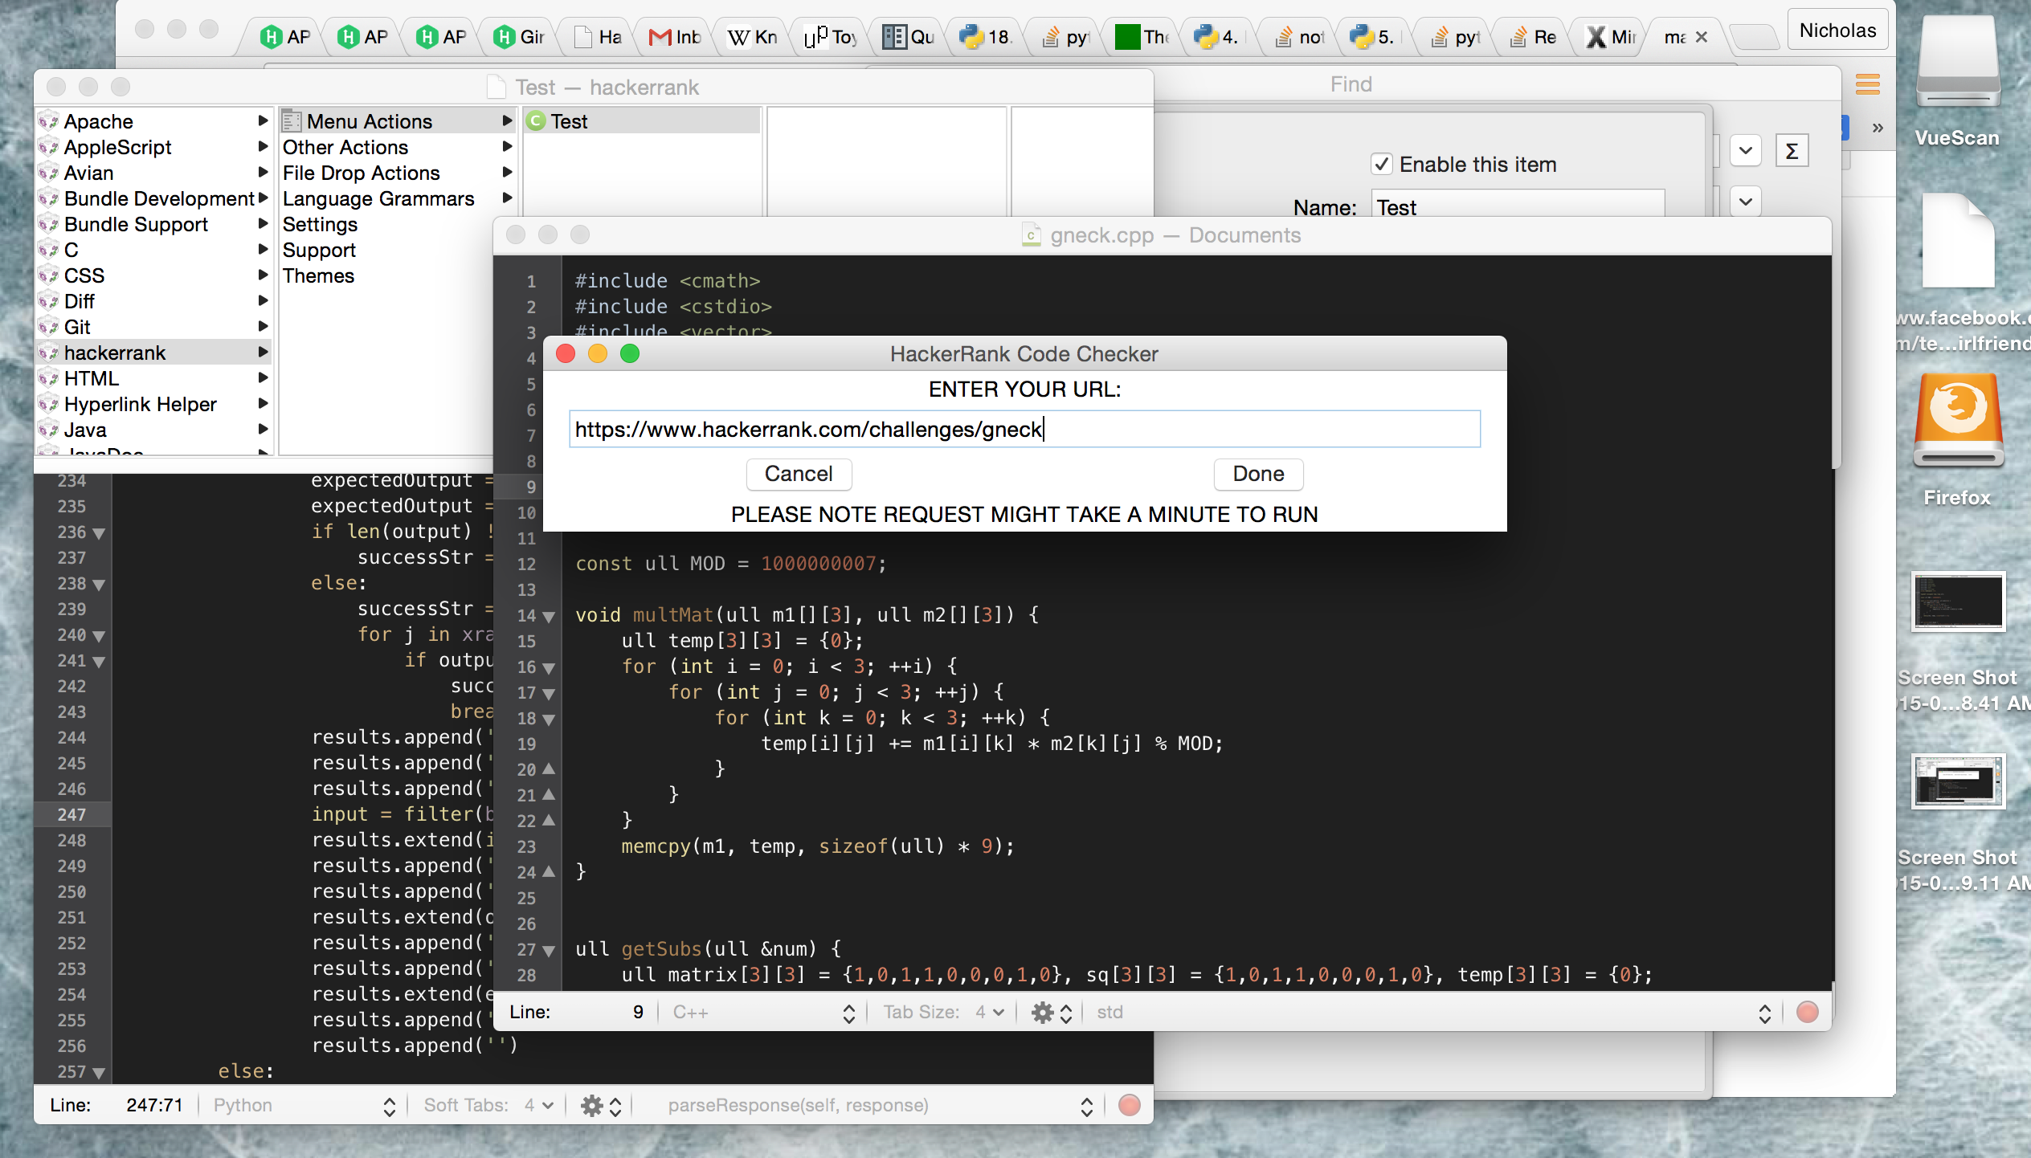

Results for each test case are displayed in a scroll pane.

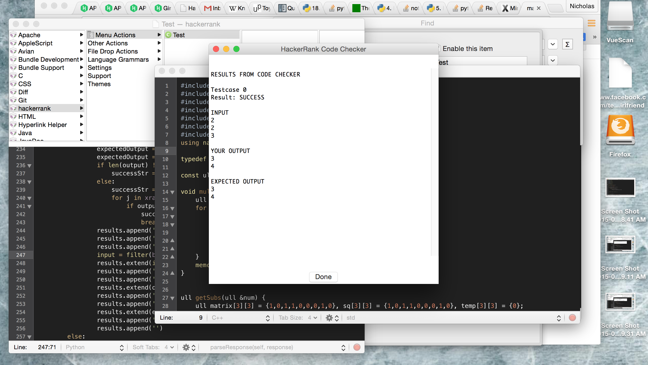

User can also enter custom input and expected output.

